Project 2
Shanti O’Neil
2025-11-11
Table of Contents

Plot 1
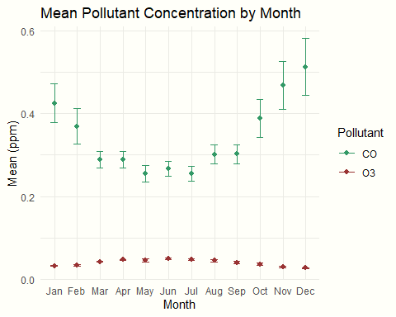

Plot 2
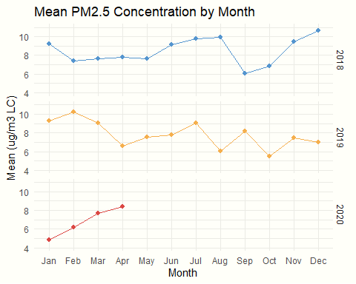

Github Repository Link
https://github.com/shantioneil/Project-2---BIOSTAT-721.git

