# Peripherals and Interfacing Laboratory

**CSE-3104**

Project name: Industrial Clock

Submitted by:

Mahedi Hasan (1407005)

Shanto Kumar (1407009)

Supervised by:

Shaheena Sultana

Assistant Professor

Department of CSE, KUET

Saifuddin Mahmud

Assistant Professor

Department Of CSE, KUET

# DESCRIPTION:

Our project consists of two parts. The first part is making a 7 segment display clock. For this we will need 8 seven segment display for showing hour, minute, second and temperature. Each will need 2 display. For this we are going to use RTC DS1307 clock IC. This will calculate the exact time and show the time in segment display. The time can be easily customized by two setup buttons for hour, minute.

This second part is a temperature sensing as well as alarm circuit. The circuit raises an alarm whenever the temperature crosses a certain limit. Temperature monitoring is a very important and frequently used application in industries and in many other places where the temperature should be kept below a maximum allowable level. This circuit comes to our rescue when a situation of that sort arises.

The circuit is made to be low cost and reliable so that we can make it with less resources and without compromising on the performance. Although it is not an industry level calibrated circuit, it is quite sufficient where it is not a mission critical application. Another advantage of this circuit is that the circuit has a flexibility to adjust the temperature level to which it should be set. This means that you can set the temperature above which the circuit should activate the alarm.

The element in the circuit that senses the temperature of the environment is a thermistor module (LM35). The name itself has its meaning. Thermistor means thermal + resistor. It means that the resistance of the thermistor varies with change in temperature. The relationship between the resistance of the thermistor and temperature is inversely related. This means that if the temperature in the atmosphere increases, the resistance offered by the thermistor decreases and if the temperature outside decreases, the resistance of the thermistor increases. This property of the thermistor helps us to make use of it to sense the temperature of the surroundings.

# LEARNING OBJECTIVES:

* + To be familiar with **Timer IC**.
  + To know the working principle of **Timer IC**.
  + Study on **Seven Segment Display**.
  + To know how to adjust time with the **Push Button.**
  + To know the working principle of **Temperature Sensor**.

# PROJECT OBJECTIVES:

* To make a digital display clock.
* To protect an industry from rise in temperature by an alarm.

# REQUIRED COMPONENTS:

|  |  |  |  |
| --- | --- | --- | --- |
| Serial NO. | Name of The Components | Model Name | Quantity |
| 1 | Real Time Clock module | DS 1307 | 01 |
| 2 | 7 Segment display | - | 08 |
| 3 | Multiplexer | 74138 | 01 |
| 4 | Temperature sensor module | LM35 | 01 |
| 5 | Continuous tone buzzer | AUD-00002 | 01 |
| 6 | Breadboard | - | As required |
| 7 | Arduino UNO | ATmega328P | 01 |
| 8 | Connecting wires | - | As required |

# COMPONENTS IN DETAILS:

Real Time Clock module: A **real-time clock** (**RTC**) is a [computer](https://en.wikipedia.org/wiki/Computer) [clock](https://en.wikipedia.org/wiki/Clock) (most often in the form of an [integrated circuit](https://en.wikipedia.org/wiki/Integrated_circuit)) that keeps track of the current [time](https://en.wikipedia.org/wiki/Time). Although the term often refers to the devices in [personal computers](https://en.wikipedia.org/wiki/Personal_computer), [servers](https://en.wikipedia.org/wiki/Server_(computing)) and [embedded systems](https://en.wikipedia.org/wiki/Embedded_system), RTCs are present in almost any electronic device which needs to keep accurate time. The term *real-time clock* is used to avoid confusion with ordinary [hardware clocks](https://en.wikipedia.org/wiki/Clock_signal) which are only [signals](https://en.wikipedia.org/wiki/Signal_(electrical_engineering)) that govern [digital electronics](https://en.wikipedia.org/wiki/Digital_electronics), and do not count time in human units. RTC should not be confused with [real-time computing](https://en.wikipedia.org/wiki/Real-time_computing), which shares its [three-letter acronym](https://en.wikipedia.org/wiki/Three-letter_acronym) but does not directly relate to time of day.

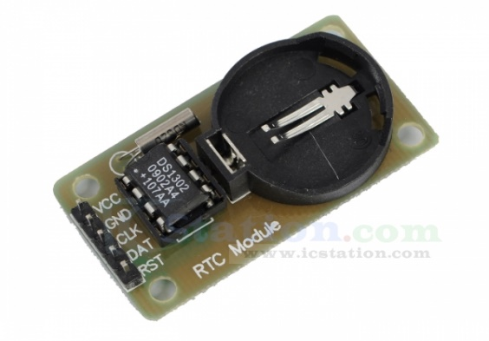

Fig 1: RTC module DS 1307

7 Segment Display: A **seven-segment display** (**SSD**), or **seven-segment indicator**, is a form of electronic [display device](https://en.wikipedia.org/wiki/Display_device) for displaying [decimal](https://en.wikipedia.org/wiki/Decimal) [numerals](https://en.wikipedia.org/wiki/Numeral_system) that is an alternative to the more complex [dot matrix displays](https://en.wikipedia.org/wiki/Dot_matrix_display). Seven-segment displays are widely used in [digital clocks](https://en.wikipedia.org/wiki/Digital_clock), electronic meters, basic calculators, and other electronic devices that display numerical information. The seven elements of the display can be lit in different combinations to represent the [arabic numerals](https://en.wikipedia.org/wiki/Arabic_numerals" \o "Arabic numerals).

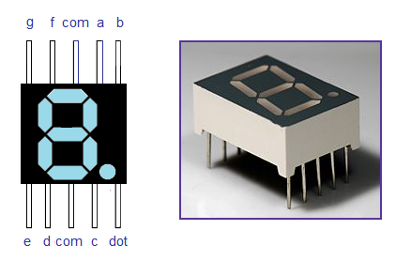

Fig 2: 7 segment single display

Often the seven segments are arranged in an [*oblique*](https://en.wikipedia.org/wiki/Oblique_type) (slanted) arrangement, which aids readability. In most applications, the seven segments are of nearly uniform shape and size (usually elongated [hexagons](https://en.wikipedia.org/wiki/Hexagon), though [trapezoids](https://en.wikipedia.org/wiki/Trapezoid) and [rectangles](https://en.wikipedia.org/wiki/Rectangle) can also be used), though in the case of [adding machines](https://en.wikipedia.org/wiki/Adding_machine), the vertical segments are longer and more oddly shaped at the ends in an effort to further enhance readability. The numerals 6 and 9 may be represented by two different glyphs on seven-segment displays, with or without a 'tail'.

Temperature Sensor Module : The **LM35** is a **temperature** sensor with a calibrated accuracy of 1 ° C. Its measuring range ranges from -55 ° C to 150 ° C. The output is linear and each degree Celsiuc equals 10 mV. The LM35 does not require additional circuits to calibrate it externally. The low output impedance, its linear output and its precise calibration make it possible to integrate it easily into a control circuit. Due to its low power supply, a very low self-heating effect is produced. It is found in different types of encapsulation, the most common is the [TO-92](https://es.wikipedia.org/wiki/TO-92) , used by low-power transistors.

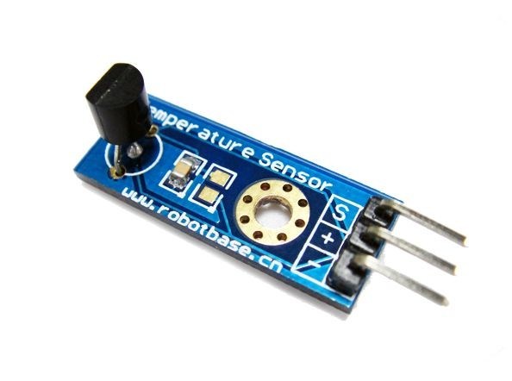

Fig 3: Temperature sensor Module LM35

# Continuous Tone Buzzer : A buzzer or beeper is an [audio](https://en.wikipedia.org/wiki/Sound) signaling device, which may be [mechanical](https://en.wikipedia.org/wiki/Machine), [electromechanical](https://en.wikipedia.org/wiki/Electromechanics), or [piezoelectric](https://en.wikipedia.org/wiki/Piezoelectricity). Typical uses of buzzers and beepers include [alarm devices](https://en.wikipedia.org/wiki/Alarm_devices), [timers](https://en.wikipedia.org/wiki/Timer), and confirmation of user input such as a mouse click or keystroke.

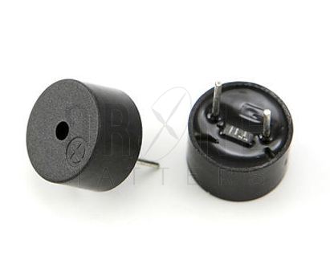

Fig 4: Buzzer AUD-00002

Multiplexer : In [electronics](https://en.wikipedia.org/wiki/Electronics), a multiplexer (or mux) is a device that selects one of several [analog](https://en.wikipedia.org/wiki/Analog_signal) or [digital](https://en.wikipedia.org/wiki/Digital_signal_(electronics)) input signals and forwards the selected input into a single line.  A multiplexer of 2*n* inputs has *n* select lines, which are used to select which input line to send to the output. Multiplexers are mainly used to increase the amount of data that can be sent over the [network](https://en.wikipedia.org/wiki/Computer_networks) within a certain amount of time and [bandwidth](https://en.wikipedia.org/wiki/Bandwidth_(signal_processing)). A multiplexer is also called a data selector. Multiplexers can also be used to implement [Boolean functions](https://en.wikipedia.org/wiki/Boolean_algebra) of multiple variables.

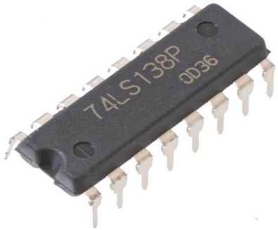 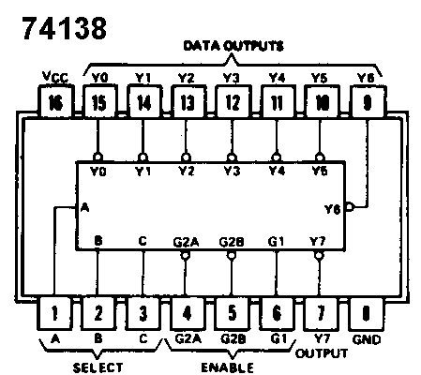

Fig 5.1: 74138 IC Fig 5.2: 74138 IC Internal Circuit

An electronic multiplexer makes it possible for several signals to share one device or resource, for example one [A/D converter](https://en.wikipedia.org/wiki/A/D_converter) or one communication line, instead of having one device per input signal. An electronic multiplexer can be considered as a [multiple-input, single-output](https://en.wikipedia.org/wiki/System_analysis#Characterization_of_systems) switch, and a demultiplexer as a [single-input, multiple-output](https://en.wikipedia.org/wiki/System_analysis#Characterization_of_systems) switch.

Arduino Uno: The **ATmega328** is a single-[chip](https://en.wikipedia.org/wiki/Integrated_circuit) [microcontroller](https://en.wikipedia.org/wiki/Microcontroller) created by [Atmel](https://en.wikipedia.org/wiki/Atmel) in the [megaAVR](https://en.wikipedia.org/wiki/MegaAVR" \o "MegaAVR) family. The Atmel [8-bit](https://en.wikipedia.org/wiki/8-bit) [AVR](https://en.wikipedia.org/wiki/Atmel_AVR) [RISC](https://en.wikipedia.org/wiki/Reduced_instruction_set_computing)-based microcontroller combines 32 kB [ISP](https://en.wikipedia.org/wiki/In-system_programming) [flash](https://en.wikipedia.org/wiki/Flash_memory) memory with read-while-write capabilities, 1 kB [EEPROM](https://en.wikipedia.org/wiki/EEPROM), 2 kB [SRAM](https://en.wikipedia.org/wiki/Static_random-access_memory), 23 general purpose I/O lines, 32 general purpose working [registers](https://en.wikipedia.org/wiki/Processor_register), three flexible timer/[counters](https://en.wikipedia.org/wiki/Counter_(digital)) with compare modes, internal and external [interrupts](https://en.wikipedia.org/wiki/Interrupt), serial programmable [USART](https://en.wikipedia.org/wiki/USART), a byte-oriented 2-wire serial interface, [SPI](https://en.wikipedia.org/wiki/Serial_Peripheral_Interface_Bus) serial port, 6-channel 10-bit [A/D converter](https://en.wikipedia.org/wiki/A/D_converter) (8-channels in [TQFP](https://en.wikipedia.org/wiki/Quad_Flat_Package) and [QFN](https://en.wikipedia.org/wiki/Quad_Flat_No-leads_package)/[MLF](https://en.wikipedia.org/wiki/Quad-flat_no-leads_package#Variants) packages), programmable [watchdog timer](https://en.wikipedia.org/wiki/Watchdog_timer) with internal [oscillator](https://en.wikipedia.org/wiki/Electronic_oscillator), and five software selectable power saving modes. The device operates between 1.8-5.5 volts. The device achieves throughput approaching 1 [MIPS](https://en.wikipedia.org/wiki/Million_instructions_per_second#Million_instructions_per_second) per MHz.

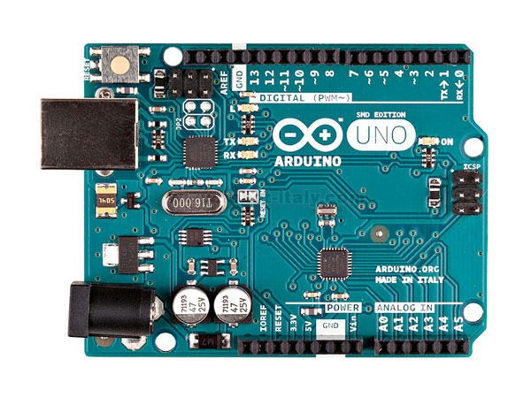

Fig 6: Arduino Uno328p

**Schematic Diagram:**

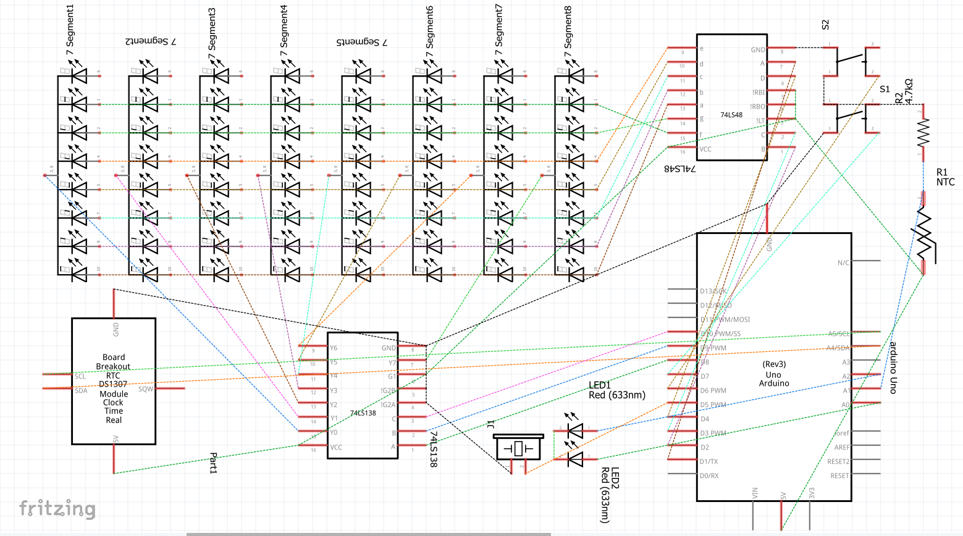

# APPLICATIONS:

* Digital clock is important for the maintenance of time. It is helpful for the workers as well as the manager to be up to date with their work.
* In most of the industries heat or temperature is required to produce their accessories. But in those industries, temperature should be in under control. Rise in temperature can cause damage of their product as well as it can be the reason of firing.

# LIMITATIONS:

* In our project , we didn’t show the temperature sign (“°C”) due to lack of seven segment display and Arduino pin.
* We haven’t show date in another 7 segment dispalys rather than used the time showing displays. So we failed to display time and date at a time.
* We didn’t use modification for hour and second rather than use only minute modification using push button. This is because lack of use of push buttons.

# FUTURE IMPROVEMENT:

* In future, We will add the temperature sign (“°C”) in addition 7 segment displays and for thid we will need one display.
* We will try to show the date separately and for this we will need 6 displays more. This will enlarge our project size and we will add more beautification in our clock.
* In future , we will add option adjust hour and date. For this we will add more push buttons.
* Also there will be display for showing A.M. and P.M. segment.

# CONCLUSION:

This is a very important project in an industry as it gives alarm when critical temperature arises which in dangerous for industries. A system which can control the temperature in an industry dully depends on our project. So this is called an industrial clock. We can use it in our home too. As it shows date and time as a normal clock. The cost of our project is not expensive. If it is provided as a complete product for commercial aspect, we will use the Arduino uno IC instead of using the Arduino uno board. This will decrease the cost of our project as complete product. The cost will not be more than 400 tk. If we become successful to provide our project/product in all industries in Bangladesh ,about 60% fire occurrence can be prevented. This will decrase the loss at most 70% created by dangerous situation like fire occurrence in a year. We were much dedicated implementing our idea. And got the success at last . Our superisors helped us much and directed us very carefully how we can make our project much important.