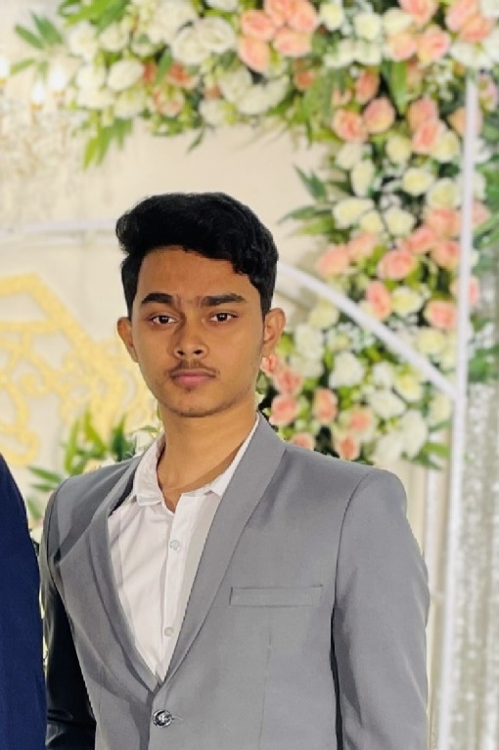

# **SKILLS:**

* Microsoft Office ( MS-Word, Power Point, Excel )
* HTML
* CSS
* Adobe Photoshop

Sheikh Omor

* Hobby : Photography, sports, music, reading, movies, tv-series etc.
* Personality : Friendly, creative, innovative, quick learner, meticulous, well organized etc.

**Hobbys & Personality:**

**Secondary School Certificate (S.S.C)**

Institute : Rajdhani High School

Group : Business studies

Result : 4.39/5.00

Board : Dhaka

Passing Year : 2021

**Higher Secondary Certificate (H.S.C)**

Institute : Mohammadpur Government collage

Group : Business studies

Result : 3.42 / 5.00

Board : Dhaka

Passing Year : 2023

**Bachelor of Business Administration BBA (Running)**

Institute : Bangladesh University

Board : Dhaka

Passing Year : 2028 (approximately)

To work in an environment where there is an opportunity of self-assessment and self-improvement in both individual and group-based work that will ultimately lead to the further development. And work hard in an organization where punctuality, sincerity, creativity and a challenging goal is its importance. To rise as high as one can & to make others feel my presence.

# **CAREER OBJECTIVE:**

# **Education:**

* Bangali: Good in speaking, listening and writing
* English: Good in speaking, listening and writing
* Hindi: Good in speaking and listening

# **Language Skills:**



**sheikhomorcse@gmail.com**



**01936532482**



**NHA Garden City Mohammadpur, Dhaka 1207**

# **CONTRACT:**