A Learner-Centered English Vocabulary Study Guide

Material

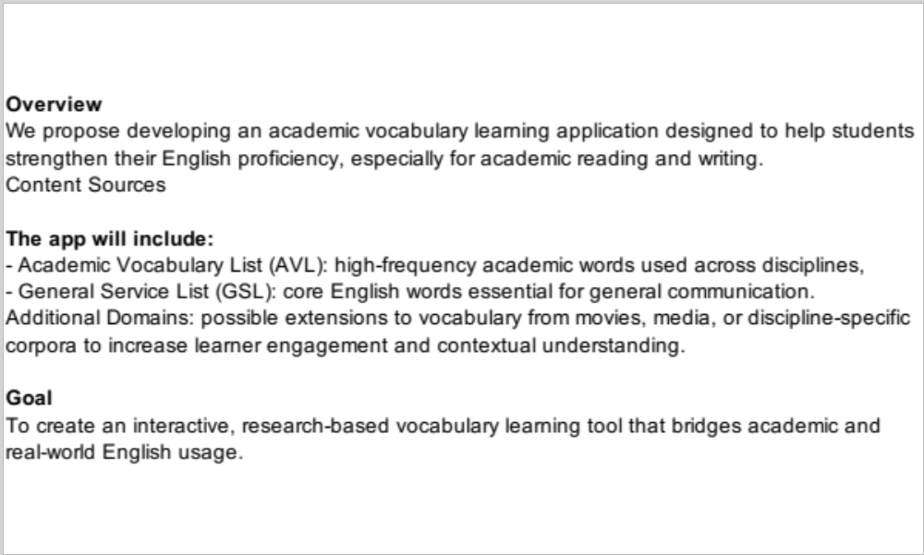

1. Introduction
Vocabulary is one of the most important parts of learning a language, especially for students who are studying in an academic environment. For students in programs like the English Language Center (ELC), learning vocabulary is not just about memorizing words, but also about understanding how to use them in real situations.
This project presents a learner-centered English dictionary and study guide designed specifically for ELC students. At the beginning, this project started as a collection of about 3,000 English words organized by level. Each word includes meaning, synonyms, antonyms, pronunciation, extensions, and example sentences. These words were selected from major vocabulary sources such as GSL, NGSL, AWL, AVL, and ELC vocabulary lists based on frequency and usefulness.
Through this course, the project developed into something more structured. It is now designed not only as a dictionary, but also as a learning tool that helps students actively study and practice vocabulary.
In addition, this project is designed with future development in mind. It is planned to be developed into a web-based platform and later into a mobile application. The goal is to create a system where students can receive vocabulary suggestions, track their learning progress, and interact with vocabulary in a more engaging way.

2. Scope and Organization
This dictionary is organized by proficiency levels based on ELC stages, from Foundation C to University Prep. The goal is to help students learn vocabulary step by step, instead of being overwhelmed with too many difficult words at once.
- Foundation C: Basic, everyday vocabulary (common nouns, verbs, and simple expressions)
- Academic A: Academic and topic-related vocabulary used in classroom settings
- Academic B: More advanced and complex vocabulary for academic communication
- University Prep: Higher-level vocabulary needed for academic readiness
This structure helps students focus on vocabulary that is appropriate for their level and allows them to gradually build their knowledge over time.

3. Description of the Dictionary and Learning System
This project is designed as both a vocabulary dictionary and a digital learning system. Each word is not only explained but also supported with multiple features to help students understand, remember, and use it correctly.
Each vocabulary entry includes:
- The word
- Level classification
- Part of speech
- Pronunciation
- A clear, learner-friendly definition
- Synonyms and antonyms
- Example sentences
- Extensions (such as related forms or additional meanings)
- Collocations
- A short practice activity
This structure reflects a more complete approach to vocabulary learning. Instead of focusing only on definitions, the entries provide multiple layers of information that support both understanding and usage.
In addition to the dictionary content, the system is designed to support interactive learning. Planned features include:
- A flashcard feature for repeated review
- A needs assessment at login to identify the learner’s level
- Vocabulary suggestions based on learner interests
- A word tracking system where users can mark words as:
  - Learning
  - Learned / Completed
- A teacher collaboration system where instructors can assign vocabulary and set learning goals
- Integration with external dictionary platforms if a word is not available
- Tones of Context with AI
- Regular assessment of the learned words
These features are intended to make the system more useful for both independent learners and classroom use.

4. How to Use This Dictionary

4.1 For Students
This dictionary is not only for looking up words. It is also a study tool.
For each word, students should:
- Read the definition carefully
- Review the pronunciation
- Study the example sentences
- Check the synonyms and antonyms
- Look at the extensions (related forms or meanings)
- Complete the practice activity
- Try to create their own sentence
- Complete activities with peers
Students should review words regularly. Learning vocabulary takes time, so it is important to come back to the words again and again. Students can also track their progress by marking words as “learning” or “learned.”

4.2 For Teachers
Teachers can use this dictionary in different ways depending on their class.
They can:
- Assign vocabulary based on student level ( Create their classroom)
- Use example sentences for speaking or discussion
- Use practice activities for quizzes or homework
- Set vocabulary learning goals for students
Teachers can also connect the vocabulary to reading, writing, and listening tasks in class. Since the materials are designed for digital use, they can be easily adapted or expanded.

5. Dictionary Entry Structure
Each word in this dictionary follows a consistent structure so students can easily understand and use it.
Each entry includes:
- Word
- Level
- Part of speech
- Pronunciation
- Definition (simple and clear)
- Synonyms
- Antonyms
- Example sentences
- Extensions (related forms, variations, or additional meanings)
- Collocations
- Practice activity
This structure helps students learn vocabulary in a deeper way, not just memorizing meanings but actually using the words.

7. Piloting and Revision
The materials still haven’t officially been tested, but it was tested with a small group of mixed students at the Foundation C and Academic A Level. Students were asked to study selected vocabulary entries and complete the practice activities.
The results showed that students found the example sentences very helpful. They reported that it was easier to understand the meaning when they could see how the word is used in context. The practice activities also helped them think more deeply about the vocabulary instead of just reading definitions.
However, some students found certain definitions slightly difficult. As a result, the definitions were revised to make them simpler and clearer. Additional attention was given to ensuring that each entry included a useful practice activity.
Overall, the revisions made the dictionary easier to use and more helpful for students.

8. Reflection
This project helped me understand that creating materials is not just about collecting information. At first, the focus was on gathering vocabulary, but through this course, it became clear that materials need to be designed with structure and purpose.
Dividing vocabulary by levels makes it easier for students to learn step by step. Another important lesson was that students need more than definitions. They need examples, practice, pronunciation, and opportunities to use the language. The context is the most important part of vocabulary learning.
The piloting process showed the importance of testing materials with real learners. What seems clear to the designer is not always clear to students. Revising the materials based on feedback made them more effective.
Finally, this project changed the way a dictionary can be understood. Instead of being only a reference tool, it can also function as an active learning resource that supports vocabulary development in a meaningful way.

