**DIGITAL DC VOLTMETER**

Circuit Flowchart Digram :

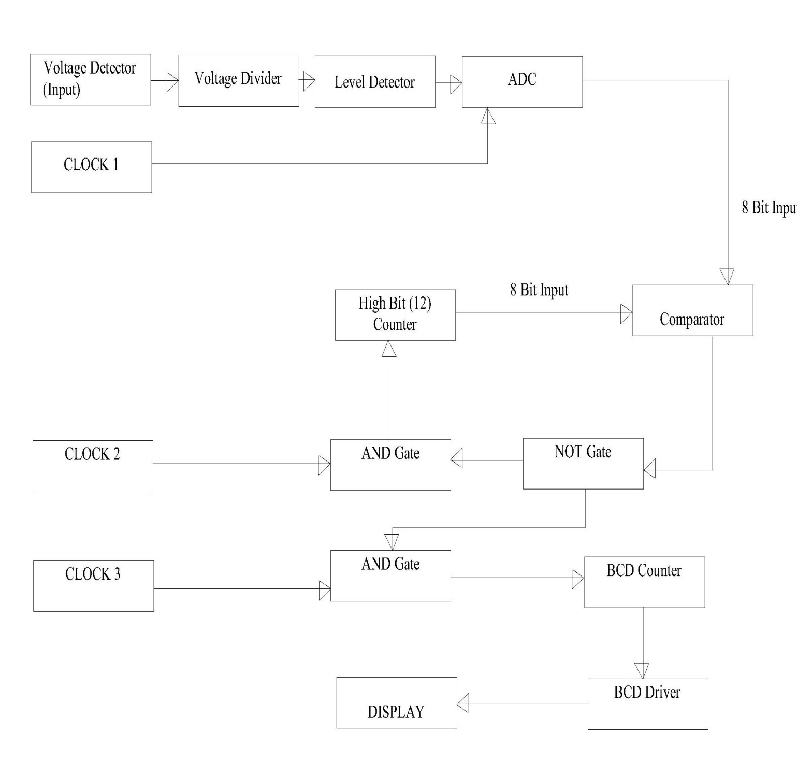

Circuit Procedure :

To understand the total circuit we divide it into 3 circuit portion .

* Circuit portion 1 :
* First the voltage to be measured is taken to the detector.
* Then it is divided by voltage divider and 1/6th of the voltage is passed through our main voltmeter ckt.
* This voltage is now taken as the input of ADC(analog to digital converter).
* CLOCK 1 is also connected to the ADC.
* 8 BIT output of the ADC is taken as the input of 2 comparator which are cascaded.
* circuit portion 2 :
* Comparator output A=B and A>B is followed to an or gate.
* The output is past through a NOT gate.
* CLOCK 2 and output of NOT gate are connected to an AND gate.
* Output of AND gate is the input of high bit counter.
* 8 bit output of the high bit counter is taken as the second input of to cascaded comparator.
* Circuit portion 3:
* Output of the NOT gate is connected to another AND gate input.
* Clock 3 is another input of the above AND gate.
* The output of AND gate is the input of the BCD counter.
* The output of BCD counter is passed to the 7 segment display through BCD Driver.

In circuit portion 1, 1/6th of the voltage is taken to the comparator. By using a high bit counter we are checking the input voltage is till determined or not. This is that what is exactly done in circuit portion 2. Now whenever the input voltage is matched, BCD counter will counting and through driver we get the actual value of the voltage to be measured which is 6 times of the voltage that entered in our main circuit.

***Notable IC’s Used in Circuit :***

* High (12) Bit Counter ~ 4040 .
* Digital to Analog Converter ~ 0808 .
* BCD Counter ~ 74192 .
* Driver ~ 7447 .
* Timer ~ 555 .

Clock Calculation :

* Time Period = 0.695 x ( Ra + 2 Rb ) x C
* Total time to count 3000 in BCD counter = Total time to count 256 in 8-bit Counter = 0.08
* Clock Time Period of BCD Counter = 26.6 u second
* Clock Time Period of 8-bit Counter = 312.5 u second
* Reset Clock Time Period = 0.1 Second [ .08 high + .02 low]

Alternative Ways :

* To use integrator instead of DAC
* To use a higher order DAC
* To use ADC instead of DAC :

Converting analog voltage to a digital value and then comparing this with a counter output using a comparator .

* BCD Counter ~ 74192 .

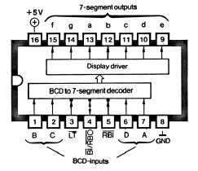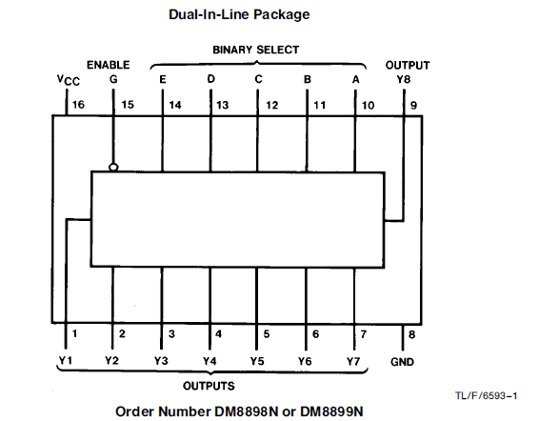

7 –Segment Display :