Another user devices under Check and Test Report : 08 Oct 2026

D:\SP Lang>spc init deme
error[E1000]: Unknown command: init
--> cli:1:1
= help: Run 'spc --help' to see valid compiler commands

D:\SP Lang>psm init demo
'psm' is not recognized as an internal or external command,
operable program or batch file.

D:\SP Lang>spm init demo
Created binary (application) package 'demo' at demo

D:\SP Lang>cd deme
The system cannot find the path specified.

D:\SP Lang>cd demo

D:\SP Lang\demo>ls
'ls' is not recognized as an internal or external command,
operable program or batch file.

D:\SP Lang\demo>spc run src/main.sp
'"clang.exe"' is not recognized as an internal or external command,
operable program or batch file.
g++.exe: error: unrecognized command-line option '--target=x86_64-w64-windows-gnu'
Compilation failed: Clang compilation failed with exit code: 1

D:\SP Lang\demo>

PS C:\WINDOWS\System32> irm https://dl.splang.shantopaul.com/sp-vscode.vsix -OutFile "$env:TEMP\sp-vscode.vsix"; code --install-extension "$env:TEMP\sp-vscode.vsix"
Installing extensions...
Extension 'sp-vscode.vsix' was successfully installed.
(node:24200) [DEP0169] DeprecationWarning: `url.parse()` behavior is not standardized and prone to errors that have security implications. Use the WHATWG URL API instead. CVEs are not issued for `url.parse()` vulnerabilities.
(Use `Code --trace-deprecation ...` to show where the warning was created)
PS C:\WINDOWS\System32>

Windows PowerShell
Copyright (C) Microsoft Corporation. All rights reserved.

PS C:\WINDOWS\System32> irm https://dl.splang.shantopaul.com/install.ps1 | iex

========================================================================
SP Programming Language - Windows Instant Installer
Version 1.0.0
========================================================================
Target Location : C:\Users\lenov\.sp
OS Architecture : AMD64
========================================================================

[1/5] Preparing installation directories...

[2/5] Deploying SP Language Core Components...
-> Downloading SP distribution package (1.0.0)...
Connecting to: https://dl.splang.shantopaul.com/sp-1.0.0-windows-x64.zip
Package downloaded successfully!
Extracting package to C:\Users\lenov\.sp...

[3/5] Configuring System / User Environment Variables...
-> SP_HOME set to: C:\Users\lenov\.sp
-> Added to PATH: C:\Users\lenov\.sp\bin

[4/5] Checking Native C/LLVM Backend Toolchain...
-> Backend C/LLVM toolchain is detected and ready.

[5/5] Performing System Verification & Smoke Test...

========================================================================
SP Programming Language System Doctor (v1.0.0)
========================================================================

[1] SP Compiler Binary:
Location: C:\Users\lenov\.sp\bin\spc.exe
Status: [OK] Operational

[2] SP Installation Home (SP_HOME):
Location: C:\Users\lenov\.sp
Environment: SP_HOME is explicitly configured in environment
Status: [OK]

[3] Standard Library (stdlib):
Location: C:\Users\lenov\.sp\stdlib
Modules: collections, fs, io, math, mem, os, process, string, time
Status: [OK] (9 standard library modules ready)

[4] Precompiled Runtime Library:
Library: C:\Users\lenov\.sp\lib\libsp_runtime.a
Headers: C:\Users\lenov\.sp\runtime\include
Status: [OK] (123622 bytes precompiled runtime ready)

[5] Backend C/LLVM Toolchain:
Target Triple: x86_64-pc-windows-msvc
C Compiler: C:\msys64\ucrt64\bin\g++.exe
Linker: C:\msys64\ucrt64\bin\g++.exe
Status: [OK] Native code generation backend operational

------------------------------------------------------------------------
Diagnosis: ALL SYSTEMS OPERATIONAL
Your computer is 100% ready to build and run native SP applications!
========================================================================

[*] Executing native smoke test (C:\Users\lenov\.sp\examples\hello.sp)...
Compilation failed: Could not open file for writing: hello.exe.tmp.ll

========================================================================
SP Programming Language Successfully Installed!
========================================================================
Quickstart Commands (open a new terminal window):
spc --version # Check compiler version
spc doctor # View toolchain health report
spc run examples\hello.sp # Build & run directly
spc build main.sp -o app.exe # Build native standalone executable
spm init my_project # Create a new SP project
========================================================================

PS C:\WINDOWS\System32> spc --version
spc (SP Programming Language Compiler) version 1.0.0
Copyright (c) 2026 Shanto Paul
Website: https://splang.shantopaul.com
Docs: https://docs.splang.shantopaul.com
Target: x86_64-w64-windows-gnu (in-process LLVM & LLD backend)
PS C:\WINDOWS\System32> spc doctor

========================================================================
SP Programming Language System Doctor (v1.0.0)
========================================================================

[1] SP Compiler Binary:
Location: C:\Users\lenov\.sp\bin\spc.exe
Status: [OK] Operational

[2] SP Installation Home (SP_HOME):
Location: C:\Users\lenov\.sp
Environment: SP_HOME is explicitly configured in environment
Status: [OK]

[3] Standard Library (stdlib):
Location: C:\Users\lenov\.sp\stdlib
Modules: collections, fs, io, math, mem, os, process, string, time
Status: [OK] (9 standard library modules ready)

[4] Precompiled Runtime Library:
Library: C:\Users\lenov\.sp\lib\libsp_runtime.a
Headers: C:\Users\lenov\.sp\runtime\include
Status: [OK] (123622 bytes precompiled runtime ready)

[5] Backend C/LLVM Toolchain:
Target Triple: x86_64-pc-windows-msvc
C Compiler: C:\msys64\ucrt64\bin\g++.exe
Linker: C:\msys64\ucrt64\bin\g++.exe
Status: [OK] Native code generation backend operational

------------------------------------------------------------------------
Diagnosis: ALL SYSTEMS OPERATIONAL
Your computer is 100% ready to build and run native SP applications!
========================================================================

PS C:\WINDOWS\System32> irm https://dl.splang.shantopaul.com/sp-vscode.vsix -OutFile "$env:TEMP\sp-vscode.vsix"; code --install-extension "$env:TEMP\sp-vscode.vsix"
Installing extensions...
Extension 'sp-vscode.vsix' was successfully installed.
(node:24200) [DEP0169] DeprecationWarning: `url.parse()` behavior is not standardized and prone to errors that have security implications. Use the WHATWG URL API instead. CVEs are not issued for `url.parse()` vulnerabilities.
(Use `Code --trace-deprecation ...` to show where the warning was created)
PS C:\WINDOWS\System32> cd "D:\SP Lang\demo"
PS D:\SP Lang\demo> spc run src/main.sp
'"clang.exe"' is not recognized as an internal or external command,
operable program or batch file.
g++.exe: error: unrecognized command-line option '--target=x86_64-w64-windows-gnu'
Compilation failed: Clang compilation failed with exit code: 1
PS D:\SP Lang\demo> spc build main.sp -o demo.exe
error[E1009]: Could not open or read source file: main.sp
--> main.sp:1:1
= help: Check that the file exists and is accessible
PS D:\SP Lang\demo> spc build src/main.sp -o demo.exe
'"clang.exe"' is not recognized as an internal or external command,
operable program or batch file.
g++.exe: error: unrecognized command-line option '--target=x86_64-w64-windows-gnu'
Compilation failed: Clang compilation failed with exit code: 1
PS D:\SP Lang\demo>

PS D:\SP Lang\demo> spc run src/main.sp
lld-link: warning: ignoring unknown argument '--target=x86_64-w64-windows-gnu'
lld-link: warning: ignoring unknown argument '-o'
lld-link: error: could not open 'main.exe': no such file or directory
clang++: warning: argument unused during compilation: '-I C:\Users\lenov\.sp\runtime\include' [-Wunused-command-line-argument]
C:\msys64\ucrt64\bin\ld.exe: C:\Users\lenov\AppData\Local\Temp\main-3b2935.o:main.sp:(.text+0x17): undefined reference to `sp_rt_println_string'
clang++: error: linker command failed with exit code 1 (use -v to see invocation)
Compilation failed: Clang compilation failed with exit code: 1
PS D:\SP Lang\demo> clang --version
clang version 18.1.8
Target: x86_64-pc-windows-msvc
Thread model: posix
InstalledDir: C:\Program Files\LLVM\bin
PS D:\SP Lang\demo> spc build src/main.sp -o demo.exe
lld-link: warning: ignoring unknown argument '--target=x86_64-w64-windows-gnu'
lld-link: warning: ignoring unknown argument '-o'
lld-link: error: could not open 'demo.exe': no such file or directory
clang++: warning: argument unused during compilation: '-I C:\Users\lenov\.sp\runtime\include' [-Wunused-command-line-argument]
C:\msys64\ucrt64\bin\ld.exe: C:\Users\lenov\AppData\Local\Temp\demo-5b8601.o:main.sp:(.text+0x17): undefined reference to `sp_rt_println_string'
clang++: error: linker command failed with exit code 1 (use -v to see invocation)
Compilation failed: Clang compilation failed with exit code: 1
PS D:\SP Lang\demo>

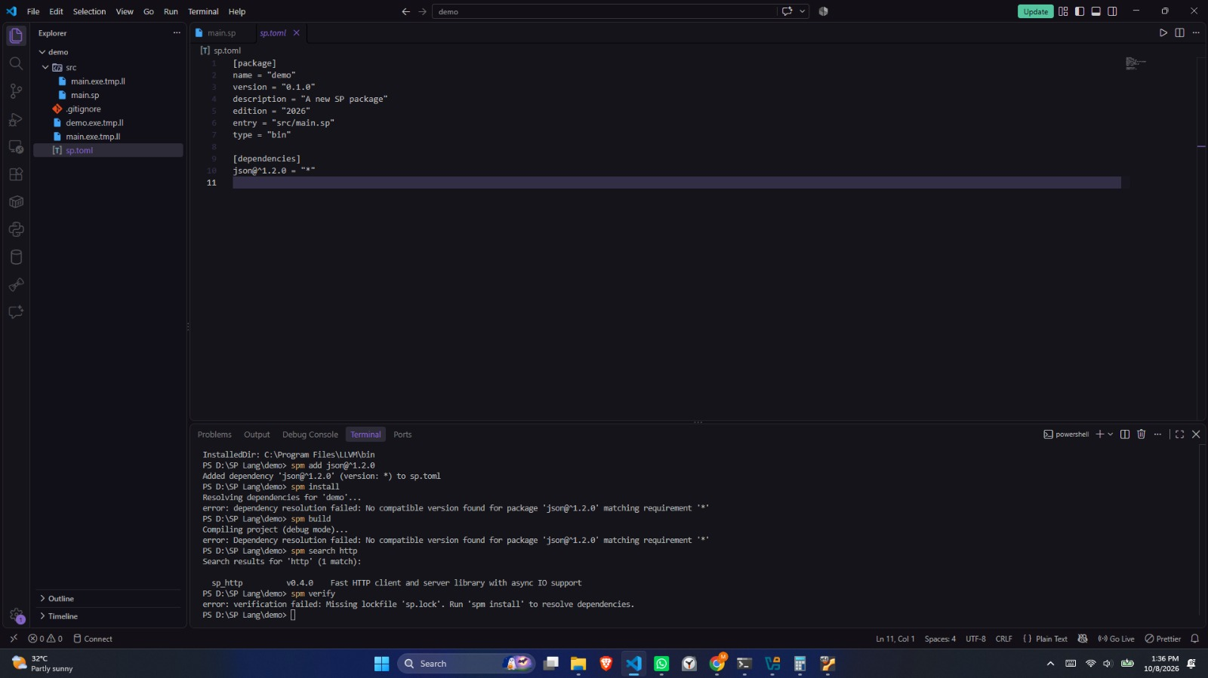

PS D:\SP Lang\demo> spm add json@^1.2.0
Added dependency 'json@^1.2.0' (version: *) to sp.toml
PS D:\SP Lang\demo> spm install
Resolving dependencies for 'demo'...
error: dependency resolution failed: No compatible version found for package 'json@^1.2.0' matching requirement '*'
PS D:\SP Lang\demo> spm build
Compiling project (debug mode)...
error: Dependency resolution failed: No compatible version found for package 'json@^1.2.0' matching requirement '*'
PS D:\SP Lang\demo> spm search http
Search results for 'http' (1 match):

sp_http v0.4.0 Fast HTTP client and server library with async IO support
PS D:\SP Lang\demo> spm verify
error: verification failed: Missing lockfile 'sp.lock'. Run 'spm install' to resolve dependencies.
PS D:\SP Lang\demo>

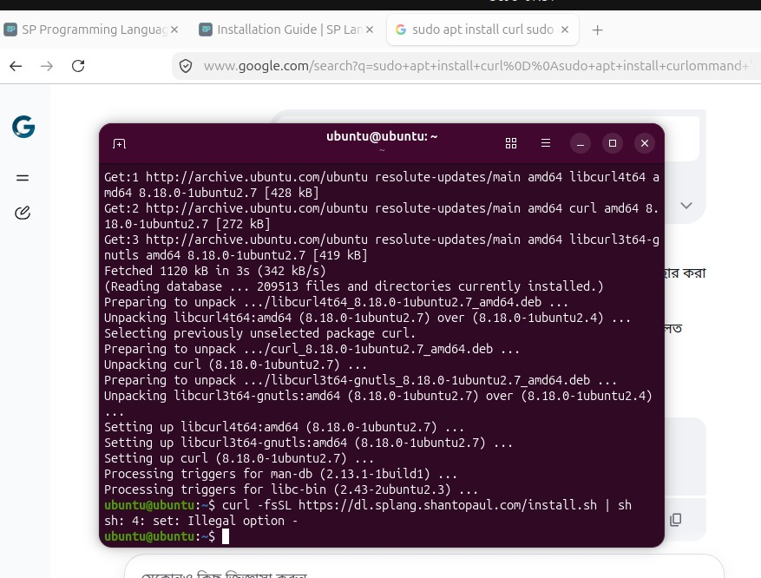

curl -fsSL https://dl.splang.shantopaul.com/install.sh | sh

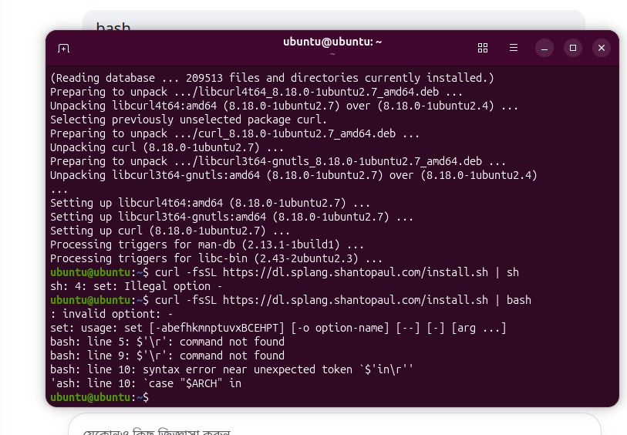
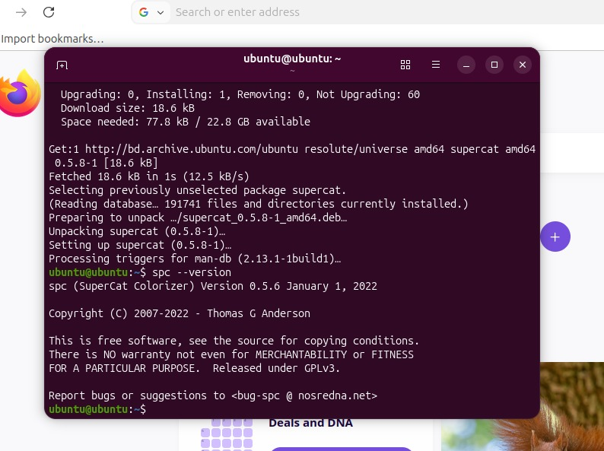
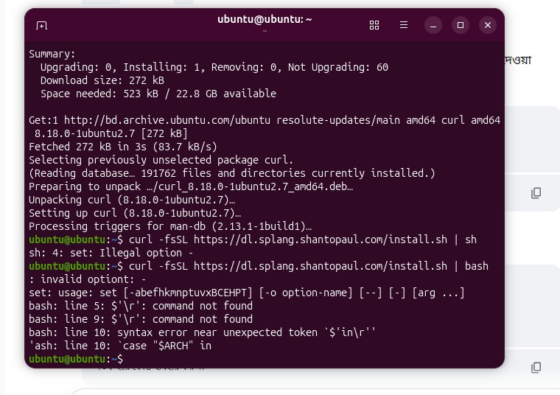
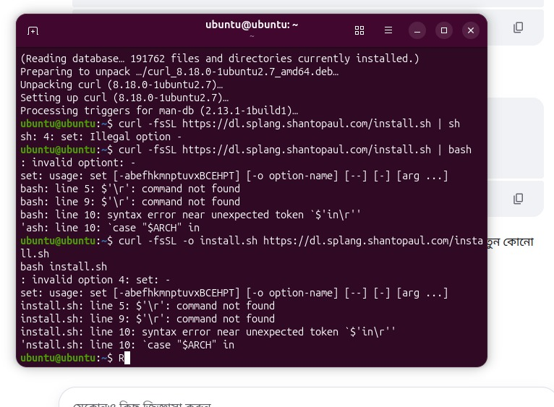
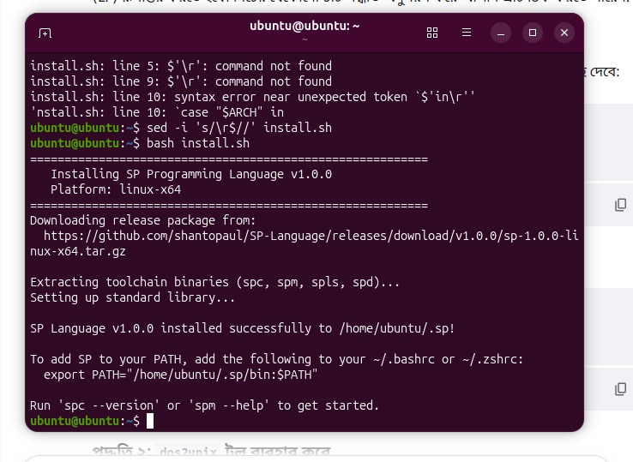

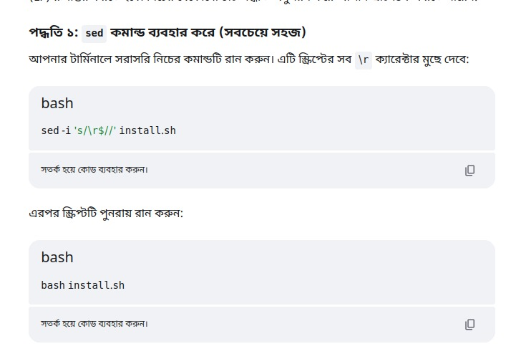

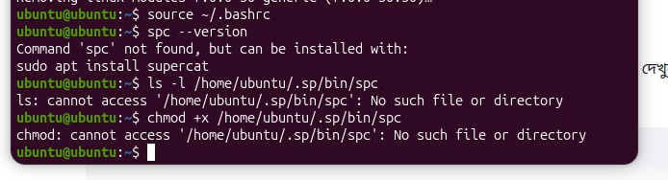
D:\SP Lang\demo>winget install SPLang.SP
No package found matching input criteria.

D:\SP Lang\demo>winget install SPLang.SP
No package found matching input criteria.

D:\SP Lang\demo>

