Product Requirements Document
AI Personal Wardrobe Assistant
Men's-first hybrid AI wardrobe assistant for daily outfit recommendations using owned clothing, body-aware analysis, calendar context, and weather.
Document Status | Draft v1.0 | Prepared For | Shan
Product Stage | MVP Prototype | Platforms | React Native (iOS + Android) and Web
Current Target | Men only | Date | 21 Apr 2026

Core product statement: Use my real clothes, understand my body, style, routine, weather, and calendar, then show me the best full outfit visually.
This PRD defines the MVP prototype for a personal wardrobe assistant that recommends one best outfit plus two alternatives using clothes already owned by the user. The system combines wardrobe item photos, body and image analysis, style preferences, calendar events, custom routines, location, weather, outfit history, and hybrid AI processing. The output is a visual outfit view built from the exact wardrobe item photos, with user-selectable display modes ranging from a simple combined item card to a realistic person-based preview.

Contents
1. Product Vision and Problem Statement
2. Goals, Non-Goals, and Success Definition
3. Target Users and Use Cases
4. Scope Decisions and Assumptions
5. Product Experience and Screen Model
6. Functional Requirements
7. User Stories and Acceptance Criteria
8. AI, Offline, and Processing Requirements
9. Data Model Overview
10. Non-Functional Requirements
11. Metrics, Risks, and Mitigations
12. Milestones and Delivery Plan

1. Product Vision and Problem Statement
Most outfit recommendation tools are either generic, shopping-first, or disconnected from the user's actual wardrobe. They often ignore the user's body shape, preferred fit, calendar context, real weather, and the practical need to decide what to wear quickly each day.
The AI Personal Wardrobe Assistant solves this by acting as a context-aware daily dressing system. It uses the user's own clothing items, understands the user's appearance and fit factors, reads the user's day, and returns a complete visual outfit recommendation instead of only text.

Product vision
Create a practical and intelligent wardrobe assistant that can recommend the right outfit, from the right owned items, for the right moment, while respecting privacy and remaining useful both online and offline.

Product promise
- Recommend from clothes the user already owns.
- Use body-aware and image-aware reasoning, not weather alone.
- Automatically understand day context through calendar, routine, location, and weather.
- Show the selected clothing item photos together as one outfit view.
- Support local/offline intelligence with optional cloud enhancement.

2. Goals, Non-Goals, and Success Definition
Primary goals | Explicit non-goals for this PRD | Success definition for MVP
Deliver one best outfit plus two alternatives from the user's owned wardrobe. | No shopping marketplace, affiliate flow, or product commerce. | User can onboard, upload wardrobe items, connect calendar, and receive daily outfit recommendations end to end.
Provide body-aware, event-aware, and weather-aware outfit logic. | No social feed, public sharing network, or stylist marketplace. | Recommendations are visually understandable and feel personalized, not generic.
Support hybrid AI with offline-first utility and user-selectable cloud usage. | No retailer integration or inventory feed from brands. | Core recommendations remain available offline using cached data and local processing.

Success metrics summary
- Recommendation relevance: users accept or save a meaningful share of recommendations.
- Wardrobe coverage: users can upload enough items to make the product useful within the first sessions.
- Daily usefulness: users open the app repeatedly for morning outfit decisions and event preparation.
- System trust: users understand why a look was recommended and can correct body or clothing detections.

3. Target Users and Core Use Cases

Initial target user scope
V1 is men only. The product is intended for all practical male users rather than a narrow niche, including students, office workers, event-going users, and daily users who want better styling support without shopping-first behavior.

Primary use cases
- Daily outfit recommendation before leaving home.
- Work or university outfit recommendation based on calendar and routine.
- Event outfit recommendation for dinner, meeting, date, gym, travel, or special occasion.
- Manual refinement such as 'make it more formal', 'use sneakers', or 'make it warmer'.
- Offline access to wardrobe, outfit history, and local image analysis when connectivity is limited.

Representative persona
Name | Practical daily user
Need | Wants quick, trustworthy outfit decisions using owned items rather than buying more clothes.
Pain points | Decision fatigue, mismatch with weather or event, poor color/fit pairing, uncertainty about what looks good on his body.
Behavior | Checks phone in the morning, accepts automation, wants optional chat guidance, and values privacy controls.

4. Scope Decisions and Assumptions

Confirmed scope decisions from stakeholder input
Decision area | Chosen direction
Platform | React Native for iOS and Android, with web support included in the product direction.
Authentication | Account and login are included in MVP.
Body analysis | All possible body-oriented analysis categories are in scope: body shape, proportions, skin tone, and face shape where feasible.
Person images | At least one full-body image is required for advanced analysis; up to six person images are supported.
Analysis mode | Automatic analysis with user correction is required.
Wardrobe detection | Auto clothing detection and all practical item tags are in scope, with manual edit support.
Recommendation output | One best outfit plus two alternatives.
Visual output | User chooses preferred outfit view mode, including simple card, mannequin-style view, or realistic person-based preview.
Calendar and automation | Calendar should read events, infer occasion and dress code, and support automatic morning suggestions.
Routine support | Custom recurring routines and time blocks such as gym, work, class, and dinner are required.
Offline and AI | Offline image analysis, local outfit generation, cached recommendations, and lightweight mobile-first local models are all required, with stronger local models on supported devices.
Cloud usage | Cloud processing is allowed but user-selectable.
History | Recommendation history, worn history, feedback, and repeat tracking are required.
Tone and assistant | App tone is user-selectable; both structured screens and chat assistant are in scope.

Working assumptions
- The MVP prioritizes product completeness over low implementation complexity; several advanced capabilities are intentionally included in V1 because they are central to the concept.
- Realistic person-based previews may vary by device capability; when local compute is limited, the app may offer reduced-fidelity local previews or user-approved cloud processing.
- Weather data and calendar data are cached to support degraded offline operation after at least one successful sync.

5. Product Experience and Screen Model
The product should feel like a practical assistant first and a stylist second. Structured screens support fast daily use, while chat supports refinements and explanations. The user should be able to understand the recommendation in seconds from a single visual outfit surface.

Experience principles
- Fast to use each morning.
- Visual first; text explanation second.
- Personalized but correctable.
- Automation by default, control on demand.
- Privacy controls visible and understandable.

Primary screens
Screen | Purpose
Home / Today | Weather summary, today's events or routine, one best outfit, two alternatives, and quick refine actions.
Wardrobe | Browse, add, edit, auto-tag, and filter owned items; see item photos and metadata.
Planner | Upcoming events, scheduled outfits, routine blocks, and pre-planned recommendations.
Assistant | Chat-based refinement, explanation, and manual requests.
Profile and Settings | Body profile, style preferences, tone selection, permissions, processing preferences, and privacy controls.
History | Previously recommended outfits, worn confirmation, favorites, and repeat alerts.

Recommendation flow overview
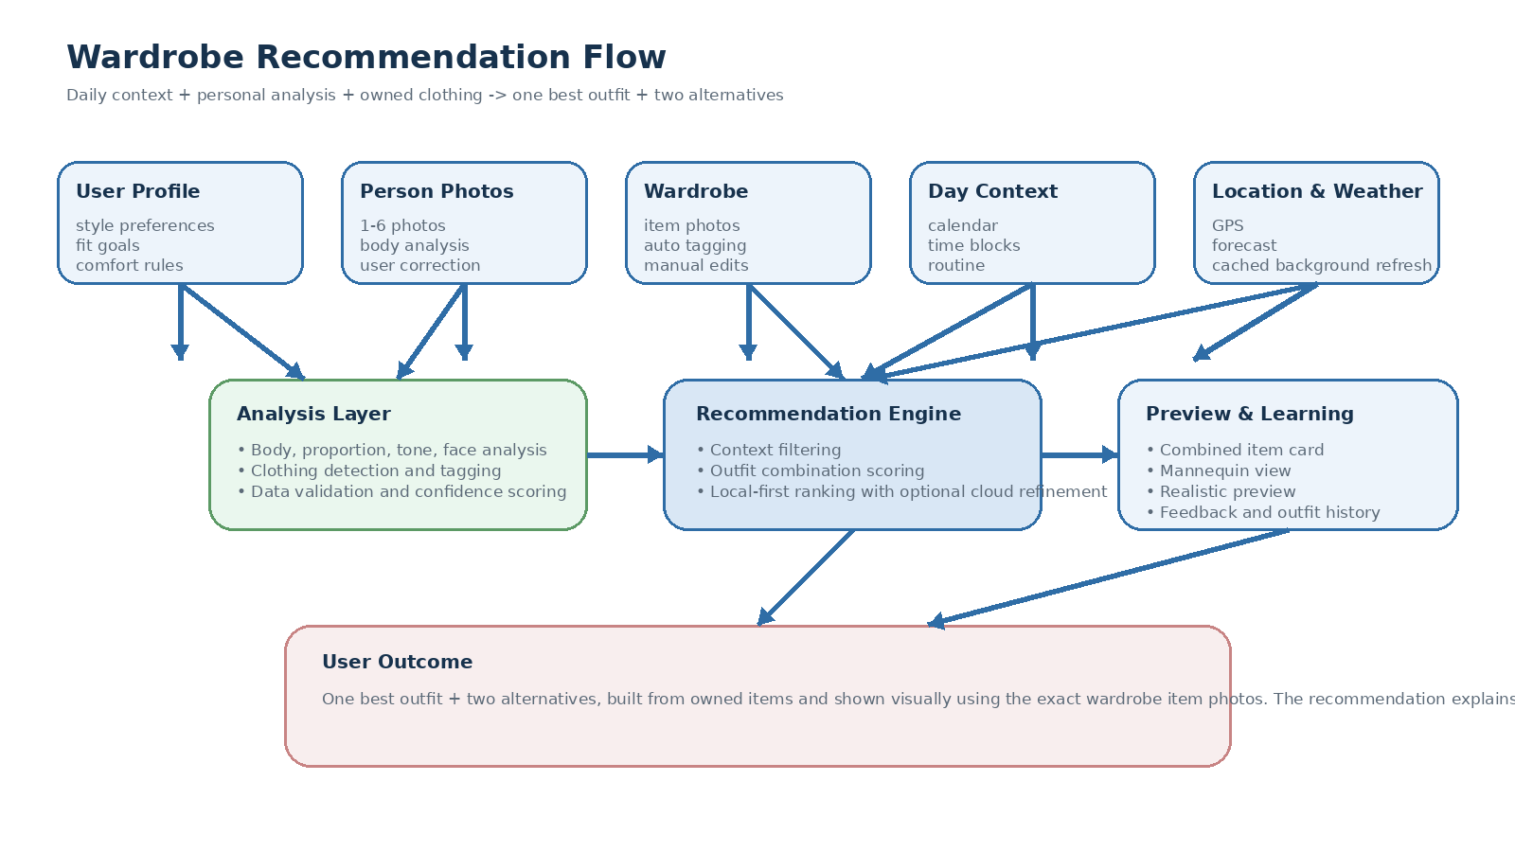
Figure 1. Wardrobe recommendation flow from user inputs to final visual outfit output.

6. Functional Requirements
The functional scope is grouped by product module. Requirements marked here are mandatory for the MVP prototype.

6.1 Account and identity
- Users must be able to create an account, sign in, and recover access.
- Users must have a profile that stores style preferences, body profile, wardrobe, routines, history, and processing preferences.
- The product should support web and mobile sessions under the same account.

6.2 Body profile and person image analysis
- The system must accept between one and six person photos, including at least one full-body image for advanced body-aware styling.
- The system must analyze body shape, proportions, skin tone, and face shape where technically feasible.
- The system must expose detections and allow user correction before those signals affect recommendation quality.
- The system must support either local or cloud processing according to user settings and device capability.

6.3 Wardrobe ingestion and auto-tagging
- Users must be able to add wardrobe items through image upload or camera capture.
- The system must automatically detect clothing items from images and propose tags such as category, color, pattern, material, season, formality, and brand when possible.
- Users must be able to edit all detected tags manually.
- The system must support all relevant wardrobe categories, including tops, bottoms, outerwear, shoes, accessories, bags, and watches or jewelry.

6.4 Context engine
- The system must integrate with the user's calendar and read event title, time, and related context.
- The system must infer likely occasion type and dress-code expectations from event context.
- The system must support custom recurring routines and time-block patterns such as work, class, gym, or dinner.
- The system must automatically obtain location and weather data in the background and cache it for degraded offline use.

6.5 Recommendation engine
- The engine must generate one best outfit plus two alternatives from the user's owned wardrobe.
- Recommendations must consider body-aware signals, style preferences, calendar and routine context, weather, time, and outfit history.
- The system must support both rule-based filtering and AI-based ranking.
- Users must be able to refine recommendations through chat or structured controls.

6.6 Visual outfit output
- The system must show the exact selected wardrobe item photos together in one outfit view.
- Users must be able to choose their preferred preview mode, including a simple combined card, mannequin-style arrangement, or realistic person-based preview.
- The product should explain why the main outfit was chosen and how the alternatives differ.

6.7 History, favorites, and repetition control
- The product must store recommendation history, worn confirmation, favorites, and user feedback.
- The product must track repeat frequency and warn when similar outfits are being reused too often if the user enables that behavior.
- Users must be able to save successful outfits and reuse them later.

6.8 Assistant and tone
- The product must provide both structured screens and a conversational assistant.
- Users must be able to select the tone of the assistant experience.
- The assistant must support direct commands such as making an outfit more formal, warmer, simpler, or based on a specific item.

7. User Stories and Acceptance Criteria
The following stories represent the baseline acceptance set for the MVP prototype.
ID | User story | Acceptance criteria summary
US-01 | As a user, I want to create an account and keep my wardrobe and preferences synced across devices. | A user can sign up, sign in, view a profile, and retrieve the same wardrobe and settings on supported platforms.
US-02 | As a user, I want the app to understand my body and appearance from photos, but let me correct it. | The system analyzes uploaded person images, displays detected body-related traits, and lets the user confirm or edit them.
US-03 | As a user, I want clothing images to be auto-detected and tagged so I do not have to manually enter everything. | Item uploads produce detected clothing items and editable metadata including category, color, and other tags.
US-04 | As a user, I want the app to know my day automatically from calendar, routine, location, and weather. | The app reads events, applies routine context, fetches weather in the background, caches results, and produces a daily context summary.
US-05 | As a user, I want one best outfit plus two alternatives using clothes I already own. | The recommendation screen shows exactly three ranked looks built from owned items.
US-06 | As a user, I want to see the recommended shirt, pants, shoes, and other items together visually. | The app displays selected wardrobe item photos together in a single outfit surface and supports multiple preview modes.
US-07 | As a user, I want to ask for changes such as more formal or warmer without starting over. | The assistant or controls regenerate or refine the outfit while preserving valid context and wardrobe constraints.
US-08 | As a user, I want the app to work offline as much as possible. | Wardrobe access, history, cached context, local image analysis, and local recommendation logic remain available offline.
US-09 | As a user, I want the app to remember what I wore and avoid too much repetition. | History records recommendations and worn confirmations, and the system can flag excessive repetition.

Detailed acceptance requirements by epic

Profile and body analysis
- Given a valid person photo set, when analysis completes, then the app shows detected traits and confidence levels.
- Given a wrong detection, when the user edits it, then future recommendations use the corrected value.
- Given privacy settings are changed, when analysis is run, then processing respects the chosen local, cloud, or hybrid mode.

Wardrobe ingestion
- Given a wardrobe image, when upload finishes, then the app proposes one or more clothing items and editable tags.
- Given multiple items appear in a single image, when detection runs, then separate items can be reviewed or rejected.
- Given a manually edited tag, when the item is saved, then the user version overrides the auto-detected value.

Context engine
- Given a calendar event in the morning, when the day starts, then the app includes the event in its recommendation logic.
- Given weather was previously fetched, when the device goes offline, then cached weather remains available until expired.
- Given a recurring routine exists, when there is no calendar event, then the routine can still drive recommendation context.

Recommendation and preview
- Given enough wardrobe coverage, when the recommendation engine runs, then one best outfit and two alternatives are returned.
- Given preview mode is changed, when the user reopens the recommendation, then the same outfit can be viewed in the chosen format.
- Given outfit history shows recent repetition, when a new recommendation is generated, then the system reduces repeat-heavy combinations where possible.

8. AI, Offline, and Processing Requirements
This product intentionally supports hybrid intelligence. Local processing is not a fallback afterthought; it is a core requirement. Cloud processing enhances quality but must remain user-selectable.

Processing modes
Mode | Behavior
Privacy/local-preferred mode | Use on-device models and cached data whenever possible, with no cloud image upload.
Hybrid mode | Use local processing first and send selected tasks to cloud only when needed or approved.
Cloud-enhanced mode | Allow cloud models to improve complex image, preview, and ranking tasks for best quality.

Local/offline requirements
- Wardrobe data must be available offline after sync.
- Outfit history and favorites must be available offline.
- Local image analysis must remain available, at minimum using the mobile-first lightweight model path.
- Local outfit generation and ranking must remain available using stored preferences, cached context, and rule-based logic.
- Devices that support stronger local models should be able to use them without changing the user experience contract.
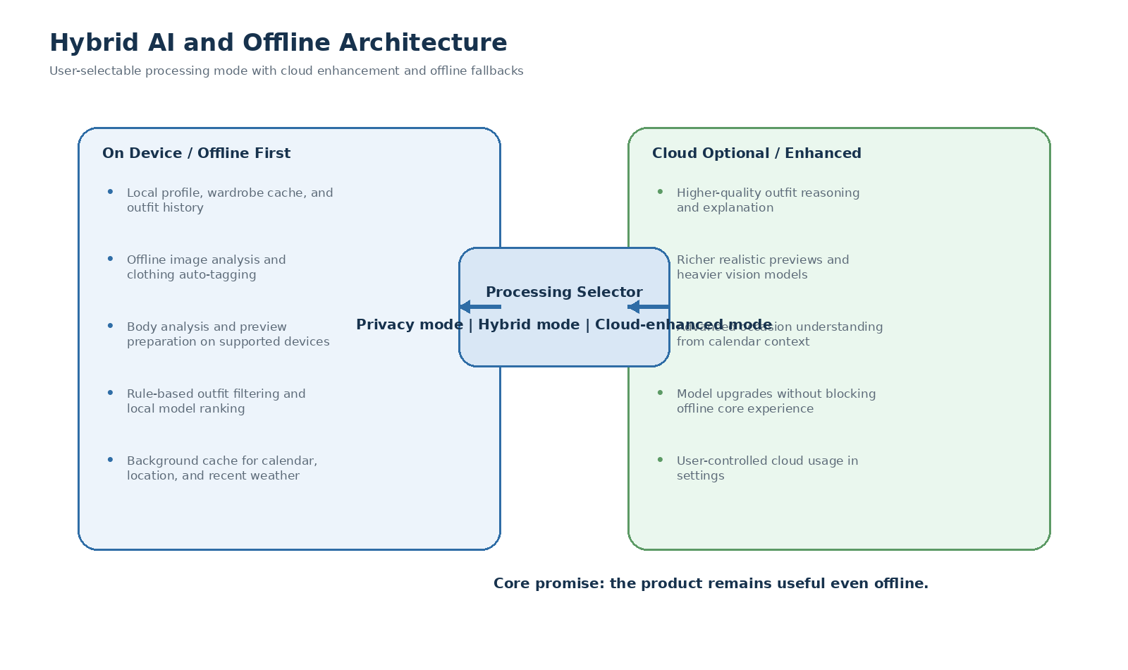
Figure 2. Hybrid AI model with local-first behavior and user-selectable cloud enhancement.

9. Data Model Overview
The MVP does not require a final production schema, but the following entities are needed for product completeness.
Entity | Key fields | Purpose
UserProfile | id, auth_id, style prefs, tone, processing mode | Stores user-level settings, styling behavior, and privacy preferences.
PersonAnalysis | photo set, body traits, proportions, skin tone, face shape, confidence | Stores automatic detections and corrected body-related signals.
WardrobeItem | image, category, color, pattern, material, season, formality, brand, tags | Represents each owned item and its editable metadata.
CalendarContext | event title, time, location, inferred occasion, inferred dress code | Converts calendar data into usable outfit context.
RoutineBlock | name, recurrence, time window, context type | Defines recurring day patterns when explicit events are absent.
WeatherContext | location, forecast, temperature, feels like, rain, wind, cache time | Provides current and near-term weather signals.
OutfitRecommendation | rank, selected items, preview mode, explanation, confidence | Stores one recommendation set and alternatives.
OutfitHistory | recommended, worn, saved, favorited, repetition markers | Tracks usage, repeat avoidance, and later reuse.
Feedback | liked, disliked, too hot, too formal, etc. | Improves future recommendations and ranking.

10. Non-Functional Requirements
Category | Requirement | Notes
Performance | Core recommendation should feel fast for daily use. | Local cached recommendations should be near-immediate; heavier preview generation may take longer but must communicate progress.
Reliability | App must tolerate connectivity loss. | Offline access to wardrobe, history, and local recommendation flow is required.
Privacy | Users must control image processing mode. | Support local, hybrid, and cloud-enhanced processing preferences.
Explainability | Recommendations must be understandable. | Show why the outfit fits the day, body, and style context.
Editability | Automated detections must be correctable. | User corrections must override AI outputs.
Cross-platform | Experience must remain coherent across mobile and web. | Not all device features need identical fidelity, but the core product contract must remain consistent.
Scalability | Architecture should allow stronger models later. | Model capability upgrades should not require redesign of product flows.
Security | Authentication and personal data storage must be protected. | Profile, photos, and history data require secure storage and access control.

11. Metrics, Risks, and Mitigations

Key product metrics
- Onboarding completion rate
- Wardrobe item upload count in first week
- Recommendation acceptance or save rate
- Refinement usage rate
- Daily and weekly active usage
- History revisit and favorite reuse rate
- Repeat-warning override rate

Key risks and mitigations
Risk | Severity | Mitigation
V1 scope is ambitious because advanced analysis and offline intelligence are both in scope. | High | Build the product around a stable baseline path: editable detections, local lightweight model, and graceful preview degradation.
Image understanding may produce wrong clothing tags or wrong body inferences. | High | Always expose detections to the user and make manual correction first-class.
Wardrobe onboarding may feel heavy. | Medium | Support auto-detection, fast batch capture, and incremental wardrobe building over time.
Realistic previews may be compute-heavy on weaker devices. | Medium | Use preview mode selection and device-capability-based model routing.
Over-automation could feel invasive if calendar or weather behavior is opaque. | Medium | Show context sources clearly and let users edit or disable automatic inference.

12. Milestones and Delivery Plan

Recommended implementation order
Milestone | Scope
Milestone 1 - Foundation | Authentication, profile, style preferences, basic wardrobe storage, settings, and core app shell.
Milestone 2 - Vision and tagging | Clothing image upload, auto detection, editable tags, and person photo ingestion.
Milestone 3 - Context engine | Calendar integration, routine blocks, background weather and location sync, cache logic.
Milestone 4 - Recommendation engine | Rule-based filtering, local model ranking, one best outfit plus two alternatives.
Milestone 5 - Visual output | Combined outfit card, mannequin view, realistic preview baseline, and history persistence.
Milestone 6 - Assistant and refinement | Chat layer, tone selection, feedback handling, and repeat control.
Milestone 7 - Offline hardening | Full offline image analysis path, stronger local model support on capable devices, and sync stabilization.

Out of scope for this PRD
- Shopping assistant or affiliate commerce
- Marketplace or brand integrations
- Social community features
- Public stylist network

Approval statement
This PRD captures the current agreed direction for the MVP prototype. It is intentionally ambitious in visual intelligence and offline capability because those traits define the product's value. Any later simplification should be treated as a delivery trade-off, not as the original product intent.

