Group B - Product and Interface Design Pack
Integrated screen flow and UI/UX specification for the AI Personal Wardrobe Assistant MVP
AI Personal Wardrobe Assistant
Prepared for Shan
Includes: detailed app flow + detailed UI/UX specification

Document purpose
This integrated Group B document combines the screen-by-screen app flow and the UI/UX specification into one design pack. It should be used as the main product-interface reference before Group C diagrams and later build-execution documents are created.
How to use this file
Use Sections 1-5 when defining flow, navigation, and QA scenarios. Use Sections 6 onward when designing screens, components, states, and cross-platform behavior.
Included documents
Included part | What it covers
Part A - Screen-by-Screen App Flow | Navigation model, end-to-end journeys, screen transitions, state changes, and worked examples.
Part B - UI/UX Specification | Visual structure, component behavior, screen rules, empty/loading/error/offline states, and accessibility notes.
The two standalone documents in Group B contain the detailed full content. This integrated file is the combined master reference for fast review.
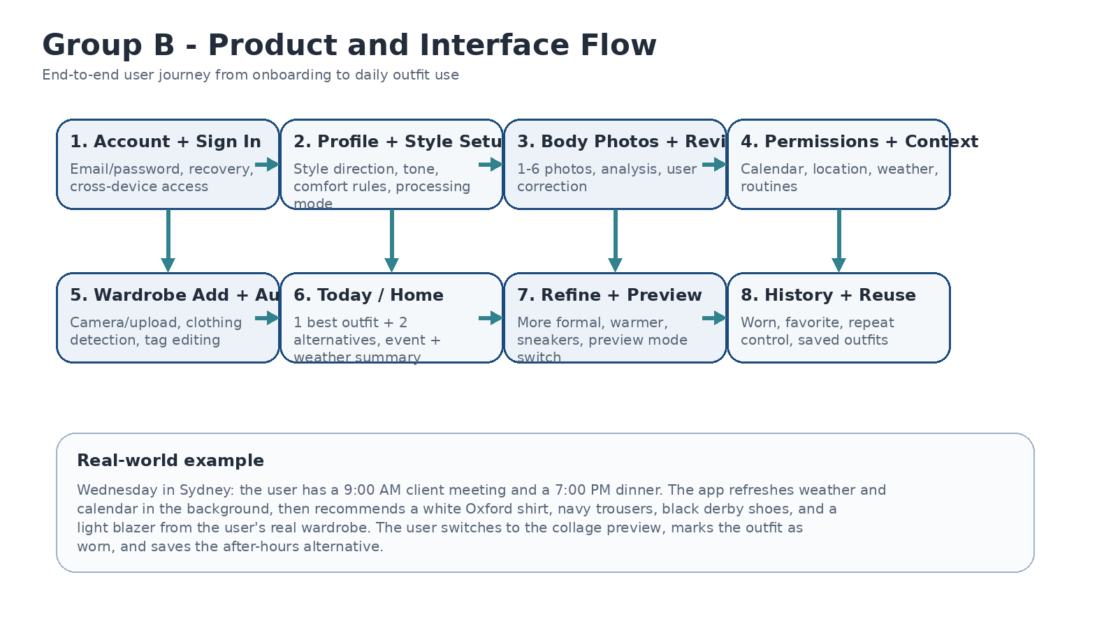
Figure B4. End-to-end flow summary.
Core UX rules that stay constant across the product
- One best outfit plus two alternatives is the base recommendation contract.
- Every recommendation must be visually understandable using real wardrobe items.
- Body analysis, clothing tags, event inference, and processing mode all remain editable or user-controlled.
- Offline-capable behavior is visible and calm, not hidden.
- Chat is additive, not required for core tasks.
Screen inventory
Screen | Purpose | Primary content | Main actions | Important states
Auth | Create an account, sign in, recover access, and continue across web and mobile. | Email/password fields, password visibility, remember me, recovery link, value statement, legal links. | Sign up, log in, reset password, continue to onboarding. | Empty form, validation error, wrong password, offline sign-in unavailable, success.
Welcome + Setup Start | Explain what the app does before asking for permissions or uploads. | Short promise, 3-step summary, privacy choice, sample outfit card preview. | Start setup, explore demo, choose tone, pick processing mode. | First launch, skipped setup reminder, returning user resume.
Style Profile | Capture aesthetic preferences, comfort rules, disliked items, and temperature tolerance. | Style chips, color preferences, fit choices, lifestyle tags, comfort sliders. | Select style, add likes/dislikes, save profile, continue. | Low-confidence profile, partial completion, edit saved values.
Body Photos + Review | Collect 1-6 user photos, run analysis, and let the user correct results before use. | Photo upload slots, quality checks, detected traits, confidence labels, correction fields. | Upload, retake, run analysis, edit results, approve profile. | Missing full-body photo, blurry image warning, local processing pending, cloud reroute, approved.
Permissions + Context | Connect calendar, location, weather, and optional background refresh in a clear order. | Permission cards, why-it-matters text, sample benefit, routine setup shortcut. | Allow access, skip for now, connect calendar, add routine, continue. | Permission denied, limited mode, later reminder, stale context.
Wardrobe Add / Review | Ingest owned clothing with auto-tagging and manual correction before recommendations start. | Camera/gallery import, detected items, tag editor, duplicate check, item category tabs. | Capture, analyze, edit tags, save item, batch add more. | Single-item success, multi-item split review, low-confidence analysis, pending offline queue.
Home / Today | Show the one best outfit plus two alternatives using real wardrobe items for today's context. | Weather summary, event summary, main outfit card, alternatives row, why-this-works summary. | Wear it, favorite, refine, switch preview mode, open detail, refresh context. | Ready recommendation, stale weather banner, no enough wardrobe, no calendar, offline cached mode.
Outfit Detail / Preview | Give the full visual outfit surface and let the user inspect, compare, and save a look. | Large preview, selected item list, explanation tags, context snapshot, swap item suggestions. | Mark worn, save outfit, compare alternatives, change preview mode, open item detail. | Preview generating, preview failed with fallback, context override active.
Planner | Show upcoming events, routine blocks, and pre-planned recommendations across the week. | Calendar summary, weekly cards, event tags, generated outfit placeholders, weather markers. | Plan ahead, pin outfit, regenerate for event, add routine block. | No future events, stale sync, event conflict, weather not yet fetched.
Wardrobe Library + Item Detail | Browse, filter, edit, archive, and inspect all saved clothing and accessories. | Grid/list toggle, filters, item cards, tag chips, wear frequency, analysis history. | Filter, edit, re-analyze, archive, set primary image, create outfit from item. | Empty wardrobe, results filtered to zero, archived item, sync pending.
History | Track what was recommended and worn, avoid repetition, and reuse successful looks. | Timeline/list, favorites, repeat warnings, context notes, before/after edits. | Mark worn, favorite, repeat this look, hide repeat warnings, compare past weeks. | No history yet, offline local history only, repeated outfit alert.
Assistant | Allow natural-language refinement and explanation without forcing the user through forms. | Conversation thread, quick prompts, context chips, selected outfit summary, privacy mode badge. | Make warmer, more formal, use sneakers, explain choice, use item X. | No recommendation yet, offline local assistant mode, cloud suggestion queued.
Profile + Settings | Manage preferences, tone, permissions, processing mode, and account choices. | Style settings, body profile summary, processing mode selector, privacy toggles, data controls. | Edit profile, switch tone, change processing mode, connect/disconnect services, export data. | Local preferred active, cloud preferred active, permission blocked, sync paused.
Main worked example
Example flow
A Sydney user opens the app on Wednesday morning. Weather and calendar are refreshed in the background, Home returns one best outfit and two alternatives, the user opens Detail, switches preview mode, asks for a warmer variant in Assistant, then marks the result as worn so History can reduce repetition later.
Deliverables in Group B
- Standalone detailed screen-by-screen app flow document.
- Standalone detailed UI/UX specification document.
- This integrated pack for fast review and alignment.

