AI Personal Wardrobe Assistant
Group C - Diagrams Pack
Eight aligned diagrams for architecture, product flow, UML, and data-flow modeling

Purpose | Give one clear visual reference set that matches the concept document, PRD, TRD, and integrated system design document.
Audience | Founder, designer, developer, AI coding agents, and future collaborators.
Scope | High-level architecture, user flow, UML use case, UML class, UML sequence, DFD Level 0, DFD Level 1, and DFD Level 2.
Reading tip | Start with the architecture and user flow first. Then use UML for software structure and DFD for data movement.

Diagram Index
Diagram | What it helps answer | Best use
1. High-Level System Architecture | How the app, backend, local AI, cloud AI, storage, weather, and calendars fit together. | Technical overview
2. User Flow Diagram | What the user does from setup to recommendation, refinement, feedback, and next-day reuse. | Product flow
3. UML Use Case Diagram | Which actors interact with the system and what core use cases exist in v1. | Requirements alignment
4. UML Class Diagram | What the main software/data objects are and how they relate to each other. | Data + domain model
5. UML Sequence Diagram | What happens step by step when the app builds a daily recommendation. | Runtime behavior
6. DFD Level 0 | What enters and leaves the system at the highest level. | System boundary
7. DFD Level 1 | How the major internal processes and data stores work together. | Functional decomposition
8. DFD Level 2 | How the recommendation and preview pipeline works internally. | Detailed data flow

1. High-Level System Architecture
Purpose: Shows the major runtime layers and integration points.
• Client apps handle the screens, local cache, and optional on-device intelligence.
• The FastAPI backend coordinates profile, wardrobe, context, recommendation, preview, and sync services.
• PostgreSQL and object storage keep structured data and media separate, while calendar, weather, and cloud AI remain external providers.
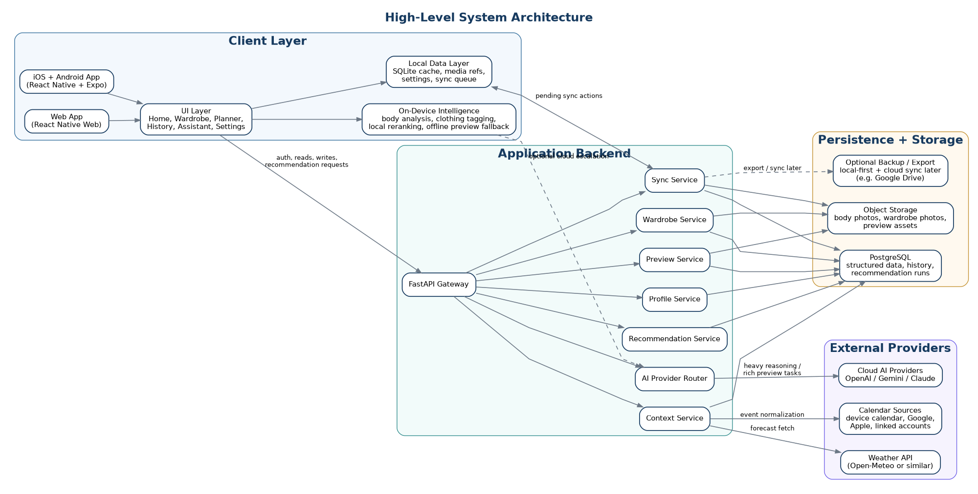
Diagram image generated for Group C; naming and structure aligned with earlier system design documents.
Example: Real-world example: the user opens the app in the morning, the app reads cached data locally, asks the backend for fresh context, then gets a ranked outfit and preview.

2. User Flow Diagram
Purpose: Shows the main end-to-end journey from account setup to repeat daily use.
• The first journey covers sign-up, profile setup, body images, wardrobe upload, and automatic tagging.
• The daily journey covers reading context, generating one best outfit plus two alternatives, and showing the chosen preview mode.
• The loop closes when the user refines the outfit, marks it worn, favorites it, or leaves feedback that updates history.
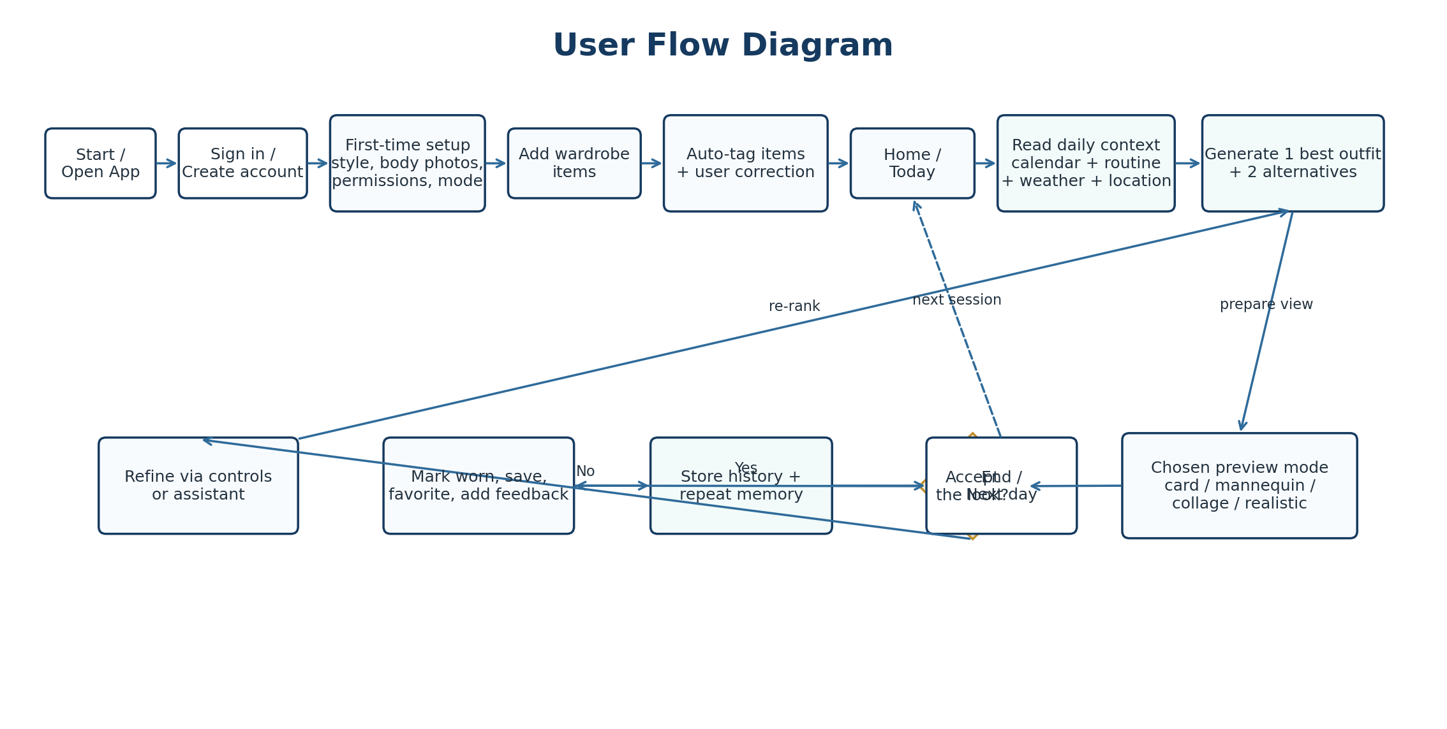
Diagram image generated for Group C; naming and structure aligned with earlier system design documents.
Example: Real-world example: if the system suggests a blazer for a meeting but the user wants something warmer, he can refine the look and trigger a re-rank without starting over.

3. UML Use Case Diagram
Purpose: Shows the main actors and the product capabilities they interact with.
• The user is the primary actor and interacts with profile, wardrobe, recommendation, preview, history, and processing settings.
• Calendar, weather, on-device models, and cloud AI are supporting actors that feed context or analysis into the system.
• This diagram is useful when checking whether the PRD requirements are actually represented in the product design.
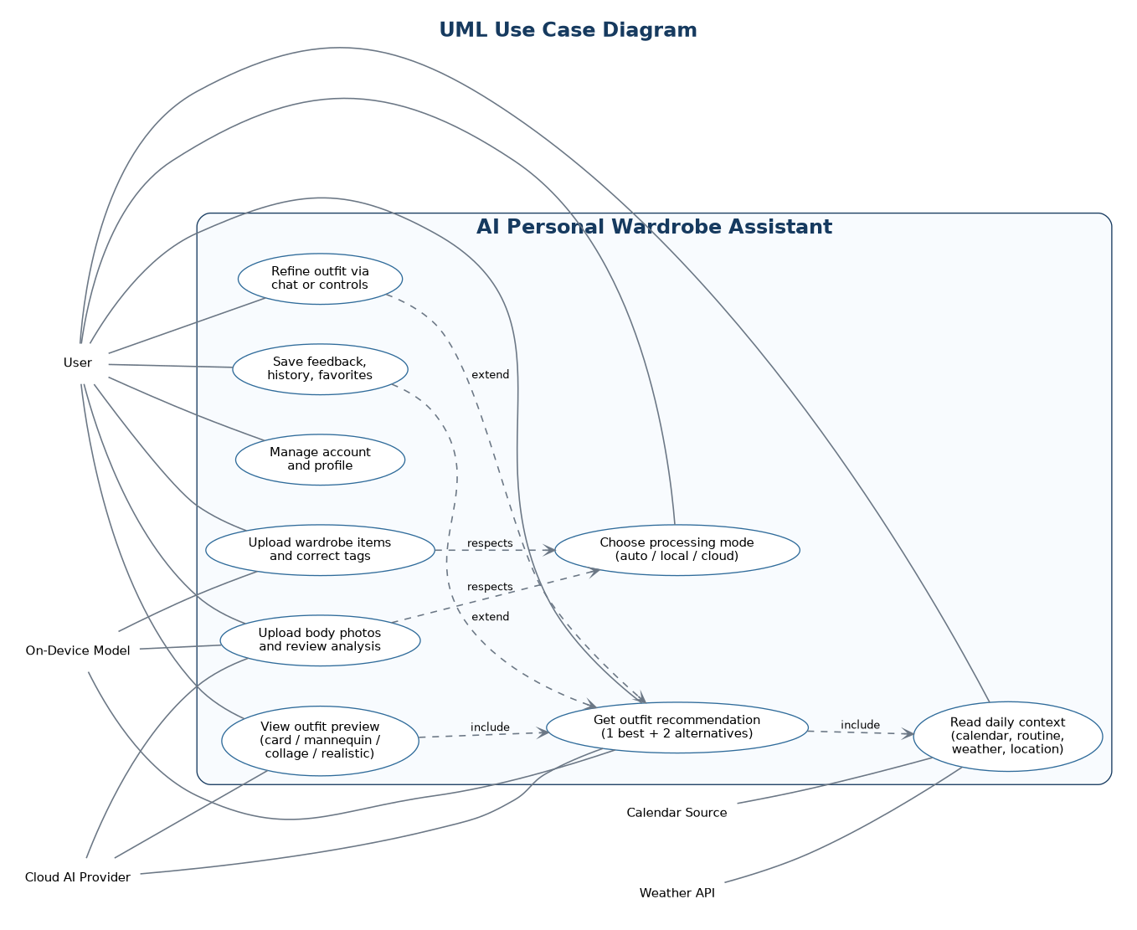
Diagram image generated for Group C; naming and structure aligned with earlier system design documents.
Example: Real-world example: body-photo analysis and wardrobe auto-tagging both respect the user-selected processing mode, whether that is auto, local-preferred, or cloud-preferred.

4. UML Class Diagram
Purpose: Shows the main domain objects and their relationships.
• User and UserProfile anchor the account, preferences, and processing mode.
• WardrobeItem, WardrobeImage, and ItemAnalysisResult capture what the user owns and how the system understands each item.
• Outfit, RecommendationRun, PreviewAsset, and OutfitHistory preserve what was suggested, how it was shown, and what happened later.
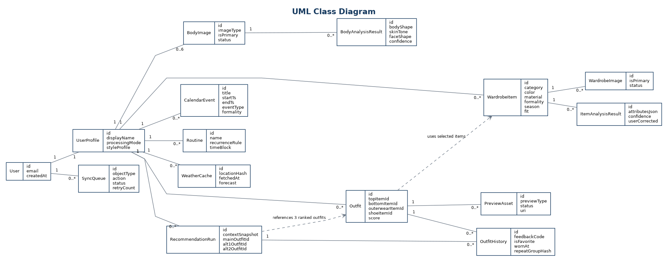
Diagram image generated for Group C; naming and structure aligned with earlier system design documents.
Example: Real-world example: one recommendation run can point to three outfits - the main recommendation and two alternatives - while each outfit can have several preview assets such as a card, mannequin, or collage.

5. UML Sequence Diagram
Purpose: Shows the runtime call order for a standard daily recommendation request.
• The app first checks local cache so the home screen can open quickly even before every remote call finishes.
• The context service then normalizes weather and calendar signals, and the recommendation service builds and ranks outfit candidates.
• The preview service fetches or generates the selected preview type before the final result returns to the app.
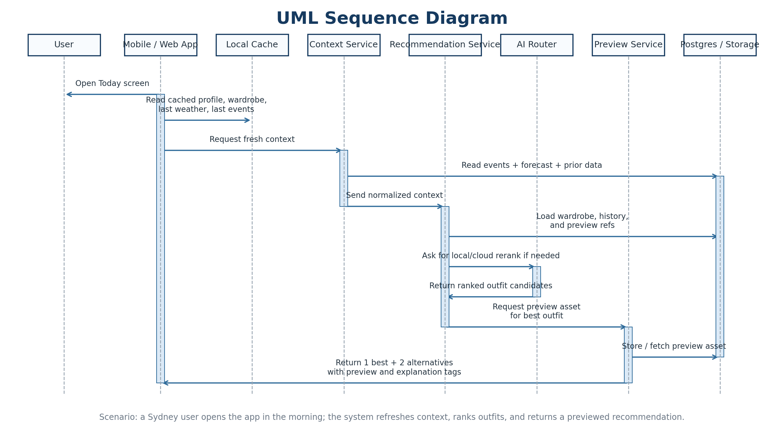
Diagram image generated for Group C; naming and structure aligned with earlier system design documents.
Example: Real-world example: a Sydney user opens the Today screen, the system reads the meeting on the calendar, checks the weather, ranks options, and returns a white Oxford shirt, navy trousers, and black shoes with a preview asset.

6. DFD Level 0 - Context Diagram
Purpose: Shows the system as a single process with its main external entities and flows.
• This is the simplest data-flow view and is useful for defining the system boundary.
• It highlights that the user, calendar, weather, local models, and cloud AI all interact with the same core product.
• Use this when explaining the product quickly to someone non-technical or when starting a design review.
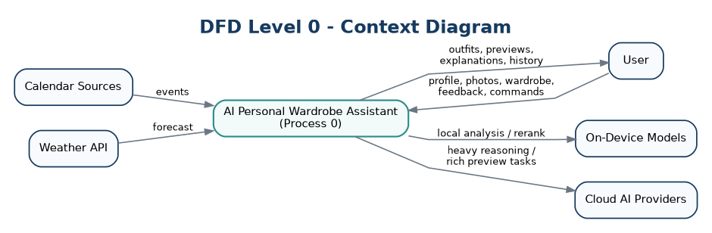
Diagram image generated for Group C; naming and structure aligned with earlier system design documents.
Example: Real-world example: the user sends wardrobe photos and receives previewed outfit recommendations, while weather and calendar data enter from separate external sources.

7. DFD Level 1 - Major Processes and Data Stores
Purpose: Breaks the single system into the main product processes and persistent stores.
• Profile management, wardrobe ingestion, context building, recommendation, and preview/feedback are shown as separate internal processes.
• Profile store, wardrobe store, context cache, outfit history, and preview assets become visible as reusable data stores.
• This is the best diagram for discussing how the system is split into buildable modules.
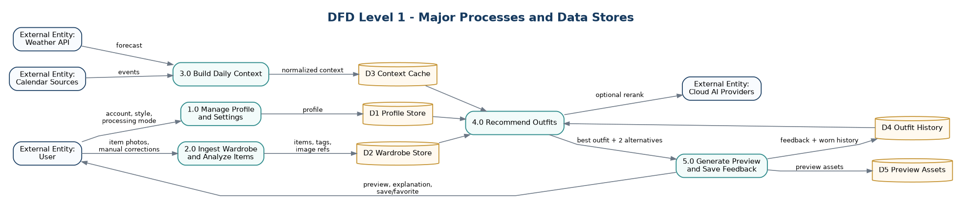
Diagram image generated for Group C; naming and structure aligned with earlier system design documents.
Example: Real-world example: wardrobe ingestion writes corrected clothing tags into the wardrobe store, then recommendation reads those items together with context cache and history before creating the final look.

8. DFD Level 2 - Recommendation and Preview Pipeline
Purpose: Decomposes the core recommendation engine into detailed internal steps.
• The flow starts by building a context snapshot and then hard-filtering items that do not fit weather, formality, or user rules.
• Candidate outfits are generated, scored, reranked, and reduced to one best outfit plus two alternatives.
• Preview creation, explanation tags, history updates, and repeat-avoidance signals are then written back for future runs.
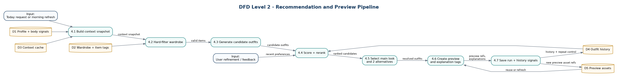
Diagram image generated for Group C; naming and structure aligned with earlier system design documents.
Example: Real-world example: if similar black-trouser looks were worn too recently, the scoring stage can penalize them and let a more varied alternative become the main recommendation.

