Sentiment Analysis for Marketing: Understanding Customer Preferences through Data

*Phase 5: Project Documentation & Submission*

-Shanttoosh.V

B.E CSE 3rd yr. 5th SEM

311421104093

Meenakshi College of Engineering - 3114

**Phase 1: Problem Definition and Design Thinking**

# PROBLEM DEFINITION:

* **Objective:** To perform sentiment analysis on a given dataset of textual data, such as customer reviews, social media posts, or comments, in order to determine the emotional tone or sentiment expressed within the text.
* **Goal:** The primary goal is to gain insights into the sentiment of customers or the general public towards a particular product, brand, service, or topic.
* **Ultimate Aim:** The ultimate aim is to leverage sentiment analysis to:
* Understand customer satisfaction and perception.
* Identify areas of improvement in products or services.
* Monitor public sentiment for reputation management.
* Inform marketing and communication strategies.
* Enhance decision-making processes with data-driven insights.
* **Methodology:** Sentiment analysis typically involves the following steps:
* **Data Collection:** Gather text data from various sources.
* **Data Preprocessing:** Clean and prepare text data.
* **Sentiment Classification:** Use NLP and machine learning to categorize text into sentiments.
* **Model Evaluation:** Assess model performance with metrics.
* **Visualization:** Create visual summaries of sentiment insights.
* **Outcome:** The expected outcomes of conducting sentiment analysis are as follows:
* **Customer Understanding:** A deeper understanding of how customers feel about products, services, or brand interactions.
* **Reputation Management:** The ability to monitor and manage online reputation by addressing negative sentiment promptly.
* **Product/Service Improvement:** Insights into areas for product or service enhancements based on customer feedback.
* **Effective Marketing:** More targeted and effective marketing campaigns that resonate with the sentiments of the target audience.
* **Customer Satisfaction:** Improved customer satisfaction and loyalty by addressing concerns and meeting expectations.

# PROBLEM DEFINITION:

1. **Data Source Selection:**

* Identify relevant datasets containing customer reviews and sentiments about competitor products. Sources may include social media, review websites, or in-house customer feedback.
* Understand the limitations and biases of the selected dataset, and consider how these might impact the analysis.

1. **Data Preparation:** Data preprocessing plays a crucial role in sentiment analysis projects, as it involves transforming raw text data into a suitable format for sentiment classification. This phase consists of several important tasks:
   1. **Data Cleaning**: Identifying and rectifying inconsistencies, as well as handling missing text values in the dataset.
   2. **Data Structuring**: Organizing the data into textual samples or documents, grouping related text together for sentiment labeling.
2. **Sentiment Analysis Techniques:** Implement various NLP techniques for sentiment analysis, such as:
   1. **Bag of Words (BoW):** Convert text data into numerical vectors representing word frequencies.
   2. **Word Embeddings (e.g., Word2Vec, GloVe**): Represent words as dense vectors capturing semantic meaning.
   3. **Transformer Models (e.g., BERT, GPT):** Utilize pre-trained models for context-aware sentiment analysis.
3. **Feature Extraction:** Use the chosen sentiment analysis technique to extract sentiment scores or labels for each review.
   1. Consider fine-grained sentiment analysis to capture emotions like joy, anger, or sadness, if necessary.
   2. Include additional features like review length, date, or user rating, which may provide context.
4. **Visualization:** Create visualizations to convey sentiment distribution and trends. Examples include:

Histograms or bar charts showing sentiment distribution (positive, negative, neutral).

Time series plots to track sentiment changes over time.

Word clouds to highlight frequently mentioned positive and negative terms**.**

1. **Insights Generation:** Analyze the visualizations and sentiment analysis results to extract meaningful insights:
   1. Identify the most common positive and negative sentiments expressed by customers.
   2. Discover patterns or trends in sentiment over time or across different products.
   3. Compare sentiment distributions for different competitors' products.

**Phase 2: Innovation**

**Sentiment Analysis Innovation :**

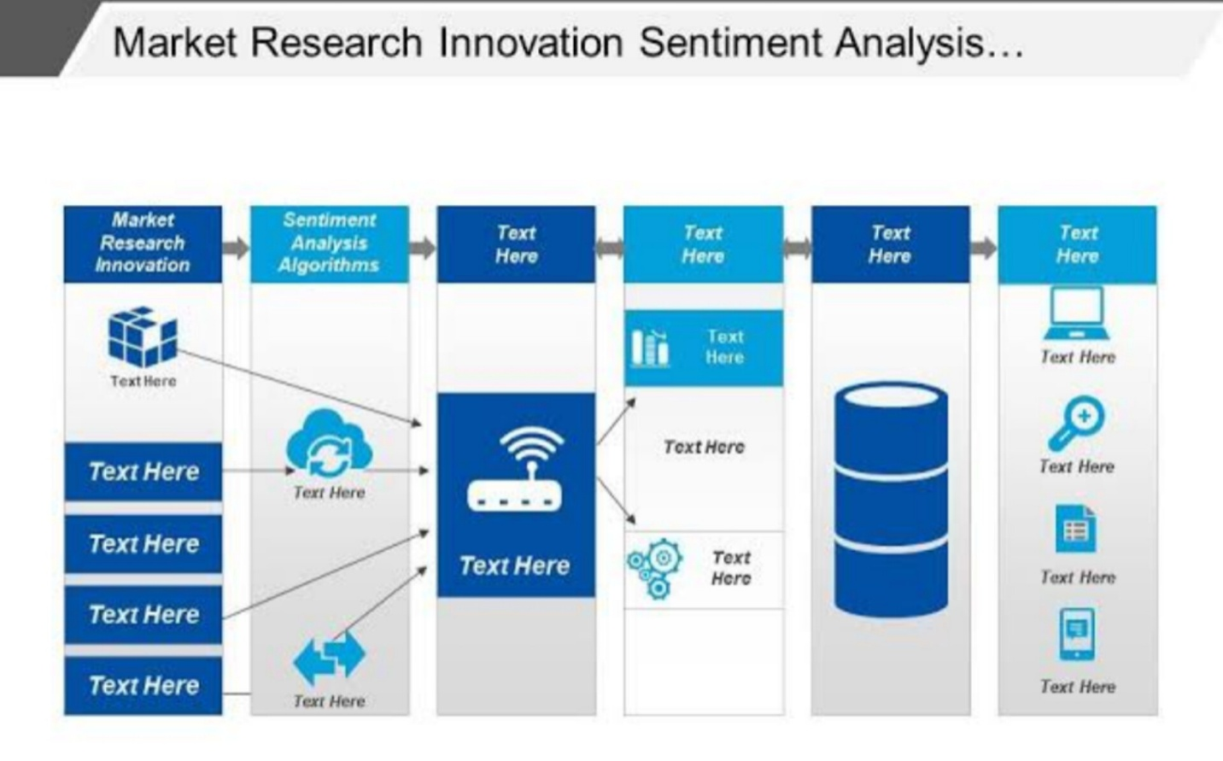

1. **Advanced Data Preparation:**

* Multimedia Data Handling: Develop techniques to preprocess multimedia data (audio, images, videos) alongside text.
* Multilingual Support: Implement multilingual capabilities to analyze sentiments in different languages, broadening the analysis scope.

1. **Continuous Learning and Adaptation:**

* Adapt to Language Trends: Develop models that adapt to changing customer communication patterns and evolving language trends.
* Semi-Supervised Learning: Utilize semi-supervised learning to reduce the need for labeled data and adapt to specific customer language.

1. **Real-time Sentiment Analysis:**

* Immediate Feedback: Create systems for real-time sentiment analysis to provide immediate feedback on marketing campaigns and product launches.
* Edge Computing: Utilize edge computing and IoT for on-the-fly sentiment analysis of in-store customer interactions.

1. **Personalized Insights:**

* Personalized Sentiment Insights: Implement AI-driven personalized sentiment insights for customers to understand their brand perception.
* Recommendation Engines: Develop recommendation engines based on sentiment analysis for customized marketing strategies.

1. **Emotional Analysis:**

* Emotion Recognition: Extend sentiment analysis to recognize a broader range of emotions (excitement, frustration, surprise) for deeper insights.
* Facial Recognition and Voice Analysis: Use technologies like facial recognition and voice analysis for emotional sentiment detection.

1. **Predictive Analytics:**

* Sentiment-based Predictions: Develop predictive models that forecast sentiment changes based on external factors and market dynamics.
* Customer Behavior Prediction: Use sentiment data to predict customer behavior and adapt marketing strategies accordingly.

1. **Explainable AI:**

* Transparency: Ensure AI models are transparent by incorporating explainable AI techniques to help marketers understand sentiment analysis results.
* Actionable Suggestions: Provide actionable suggestions based on sentiment analysis for better decision-making.

1. **Cross-Channel Integration:**

* Multi-Channel Integration: Integrate sentiment analysis across various marketing channels like email, social media, website, and customer support.
* Unified Dashboard: Maintain a unified dashboard for comprehensive sentiment tracking and analysis.

1. **Ethical Considerations:**

* Data Ethics: Prioritize ethical considerations such as data privacy, consent, and bias mitigation in AI sentiment analysis.
* Regular Audits: Conduct regular audits of AI models for fairness and accuracy in sentiment classification.

1. **Feedback Loop:**

* Continuous Improvement: Establish a feedback loop involving marketers, data scientists, and customers for continual model improvement.
* Customer Communication: Maintain open communication with customers to address concerns and improve satisfaction.

1. **Agile Development:**

* Agile Approach: Adopt an agile approach to AI model development, allowing for quick iterations and adjustments in response to changing marketing dynamics.

This innovation model emphasizes staying ahead with evolving data sources, advanced techniques, and ethical practices while providing real-time insights and personalized recommendations to drive marketing strategies based on customer sentiment.

**Conclusion:**

With this model, businesses can not only track customer sentiment but also adapt in real-time, predict behavior and provide personalized experiences, all while maintaining trust and transparency. It is a forward-looking blueprint for leveraging AI sentiment analysis to excel in the dynamic marketing landscape.

**Phase 3:**

**Development Part 1-Loading andpreprocessing the dataset**

# In Phase 3 of the "Sentiment Analysis for Marketing" project, we are focused on the initial stage of development, specifically "Loading and Preprocessing the Dataset." This phase involves the critical task of importing the "Twitter US Airline Sentiment" dataset, which serves as the foundational data source for our analysis. We are preparing the data for subsequent phases by cleaning, structuring, and organizing it, ensuring that it is in a suitable format for further analysis. This essential groundwork sets the stage for our project's success in uncovering insights from Twitter data related to airline sentiment, a valuable resource for marketing strategies.

**Table of contents**

* **Loading the dataset**
* **Text lower casing**
* **Outlier detection and treatment**
* **Handling noisy data**
* **Tokenization**
* **Stopword removal**
* **Count of airline’s, airline’s sentiment, user time zone**
* **Airline sentiment visualization**
* **Airline distribution visualization**
* **User time visualization**



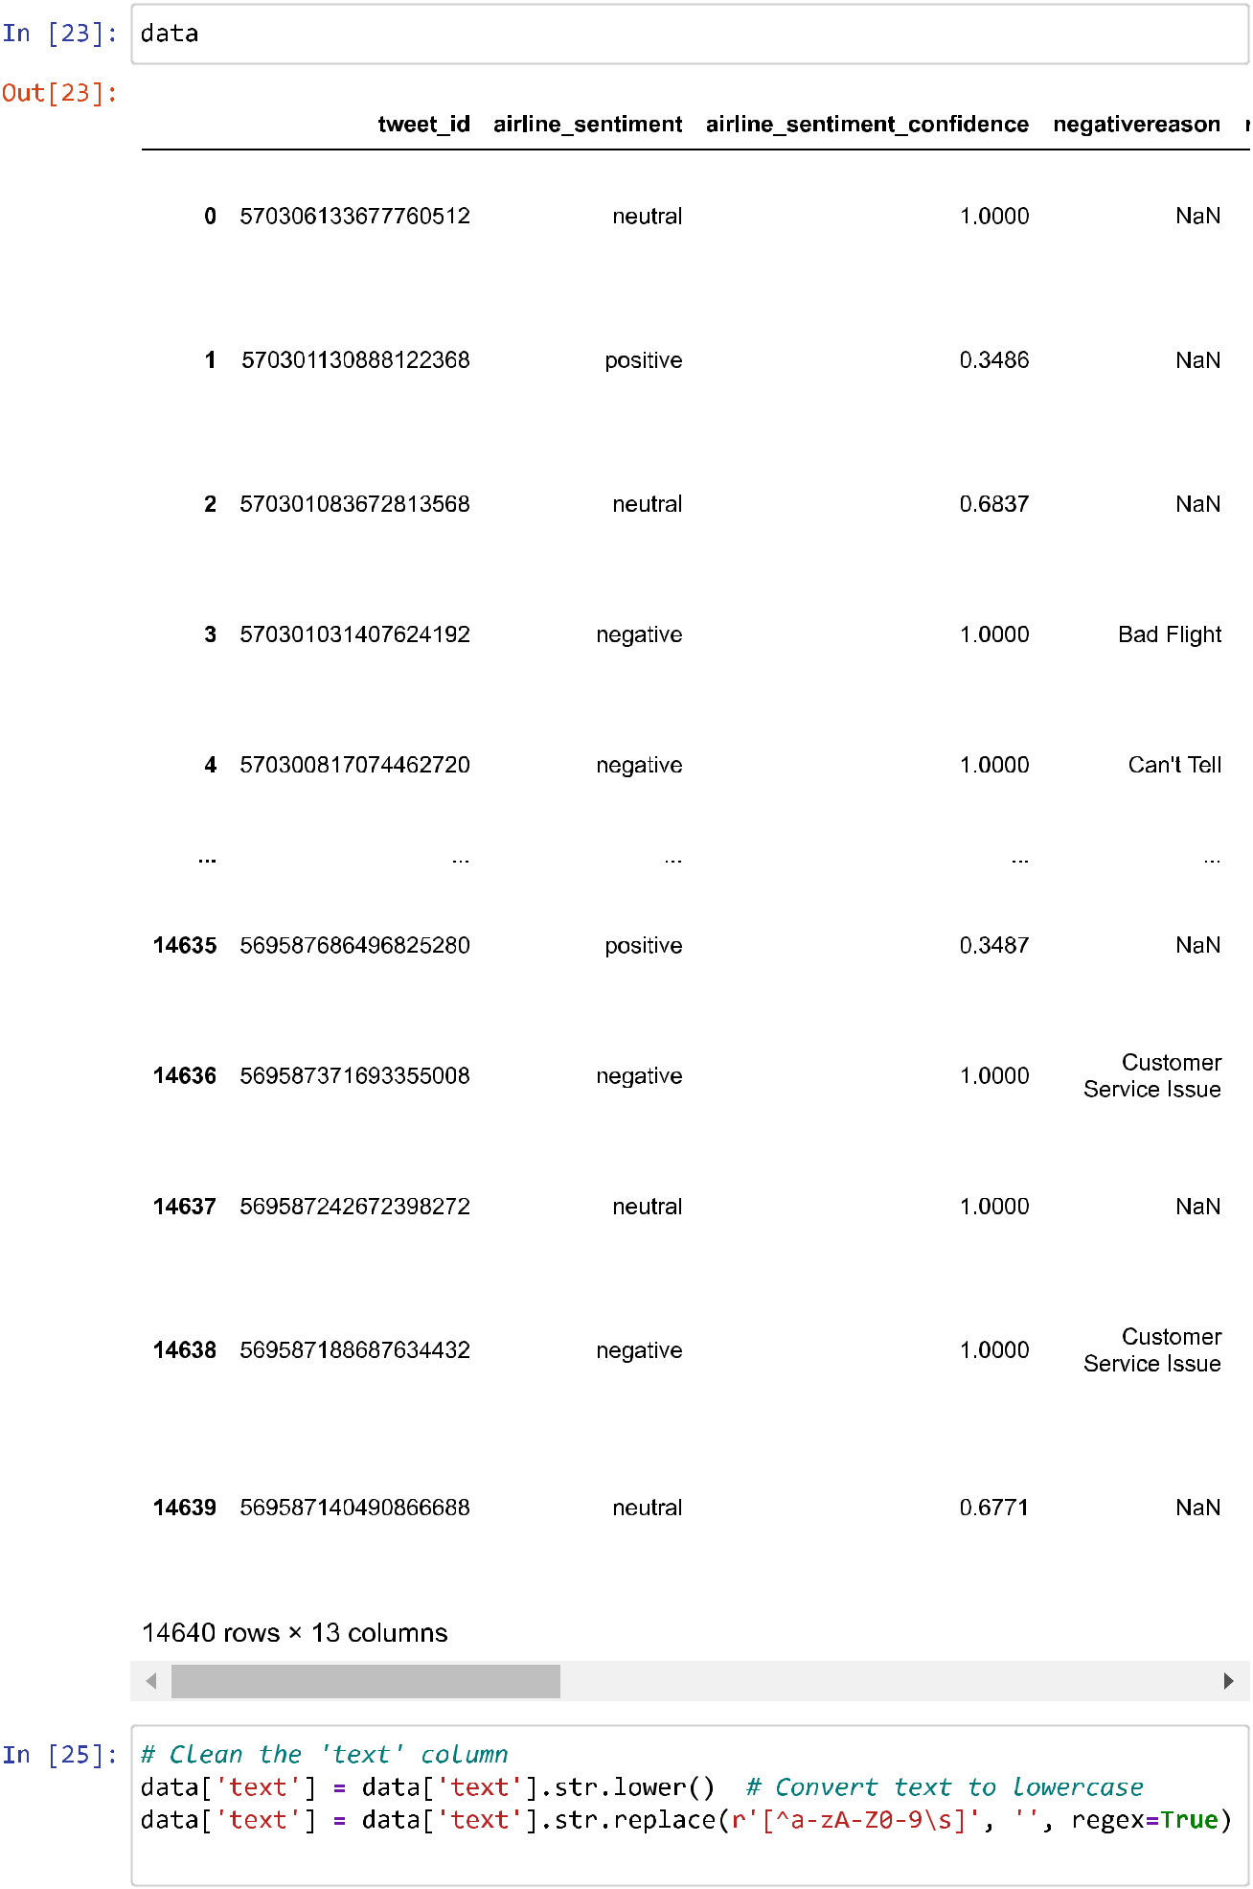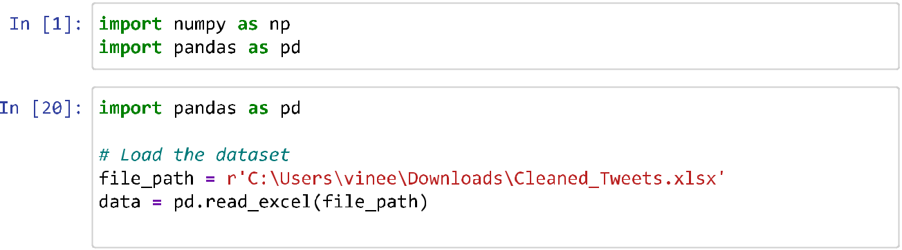

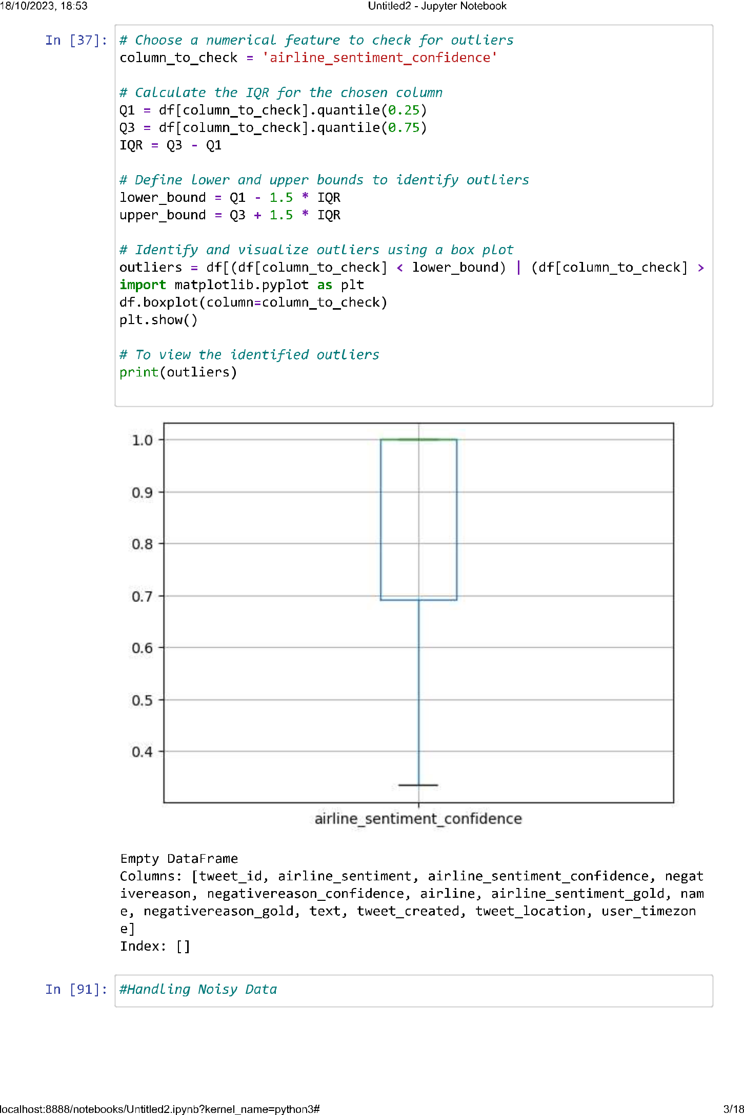

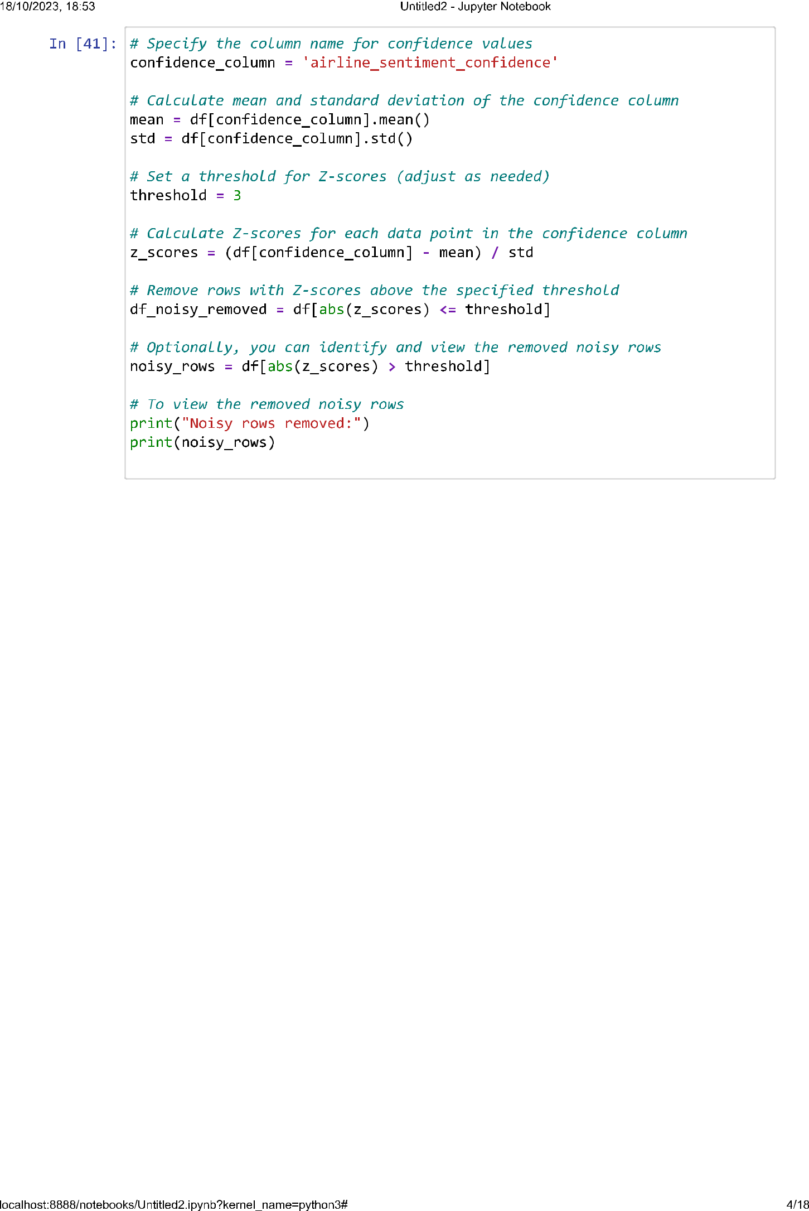

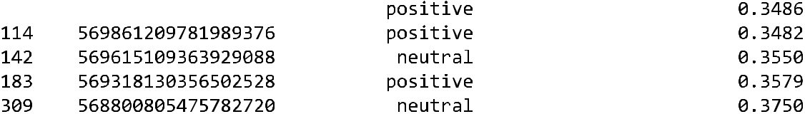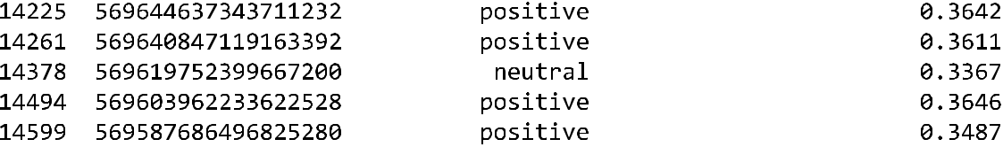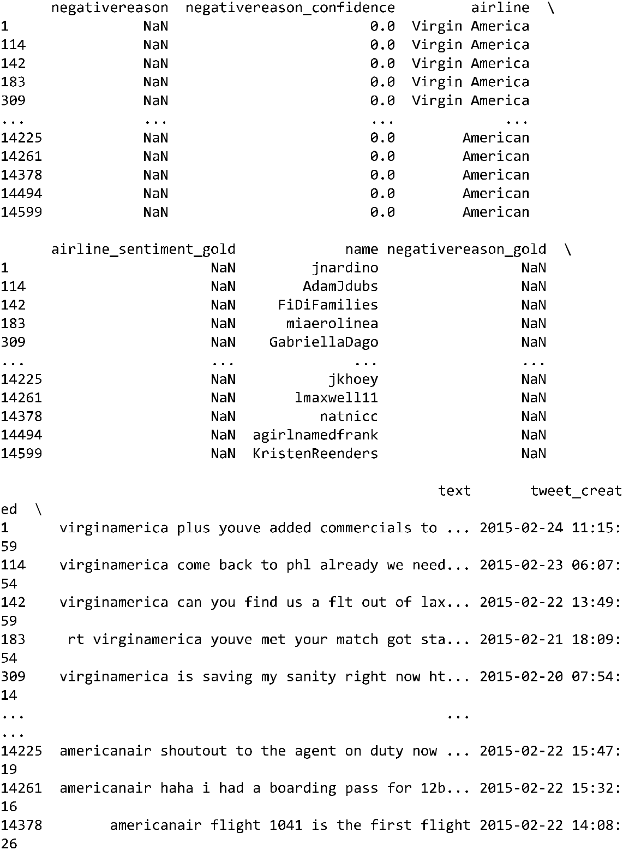

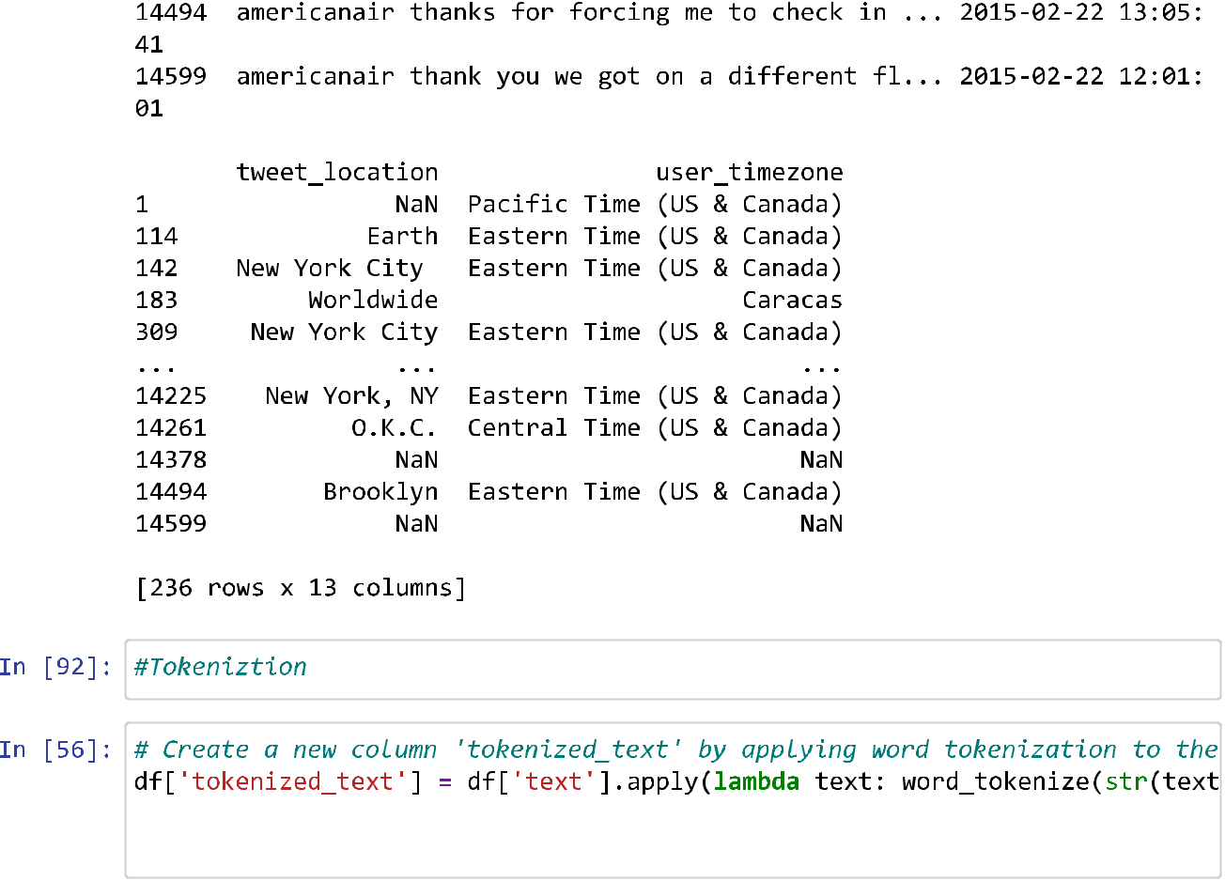

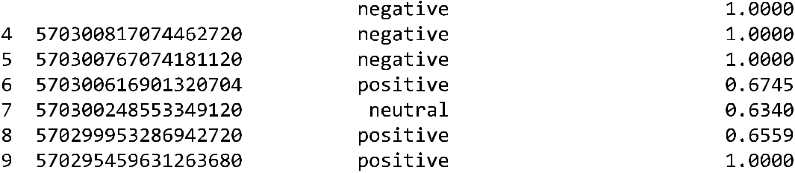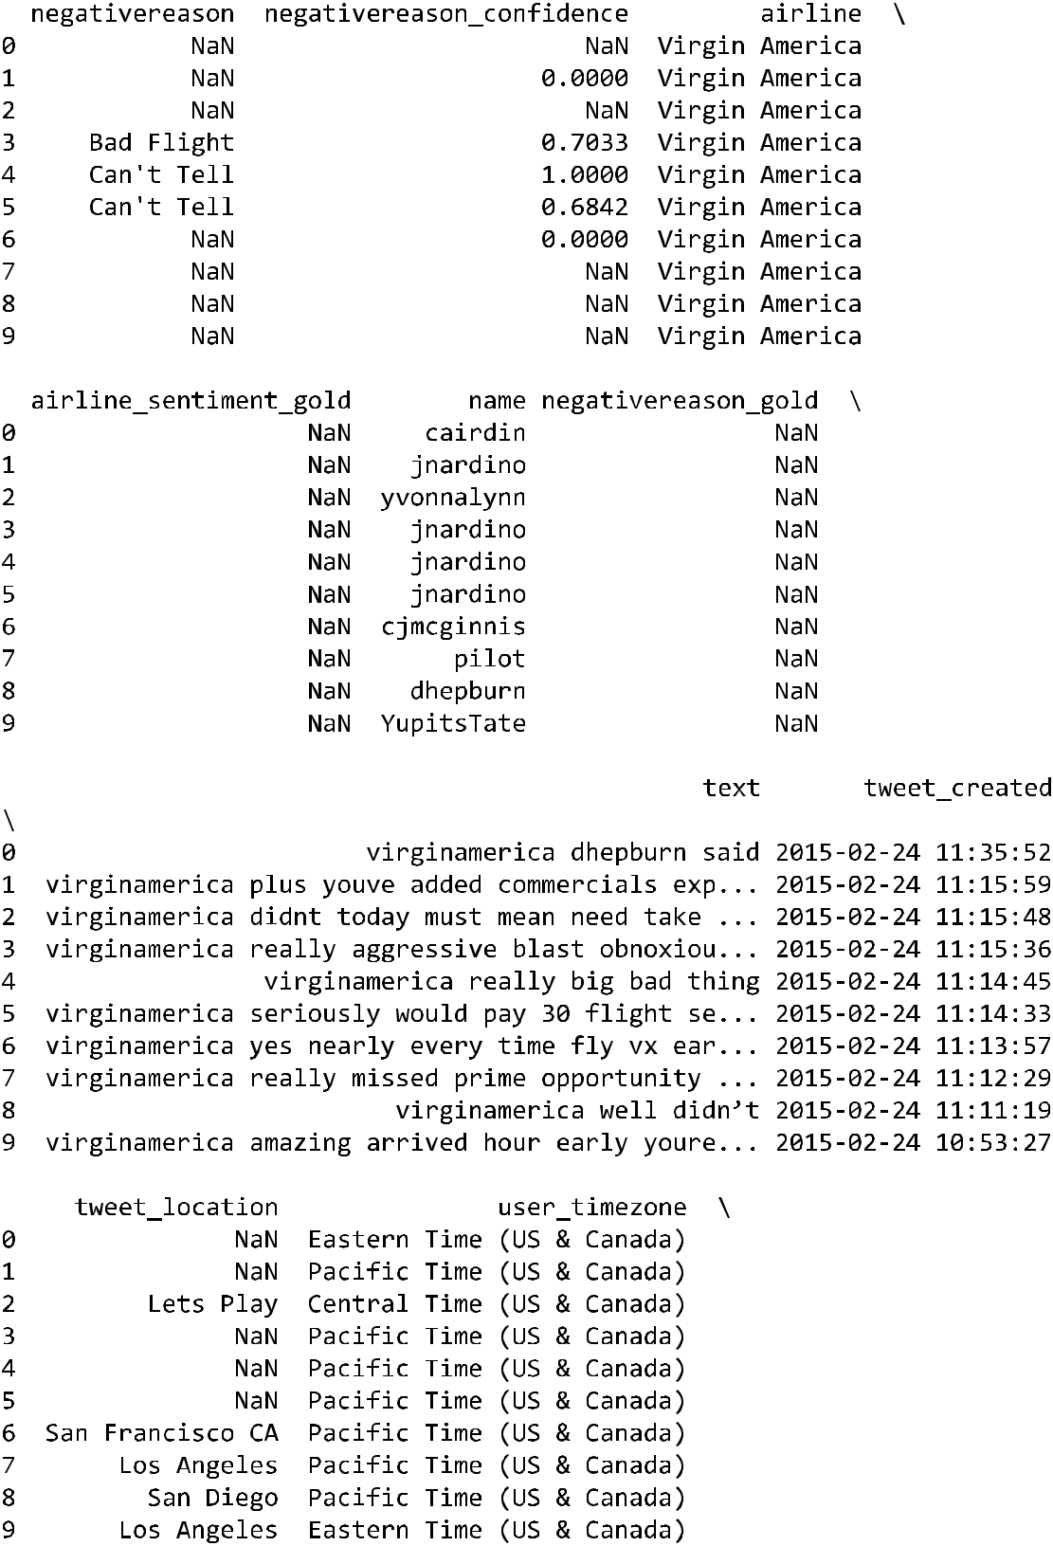

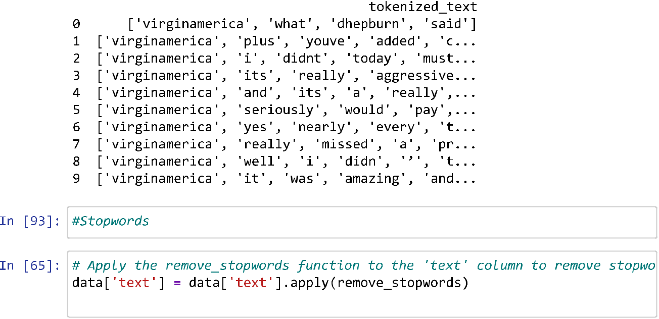

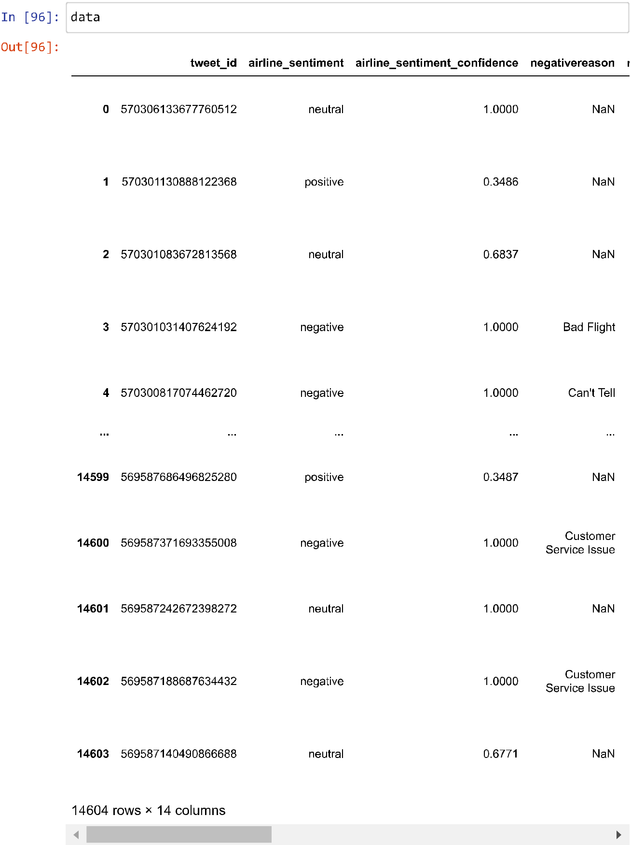

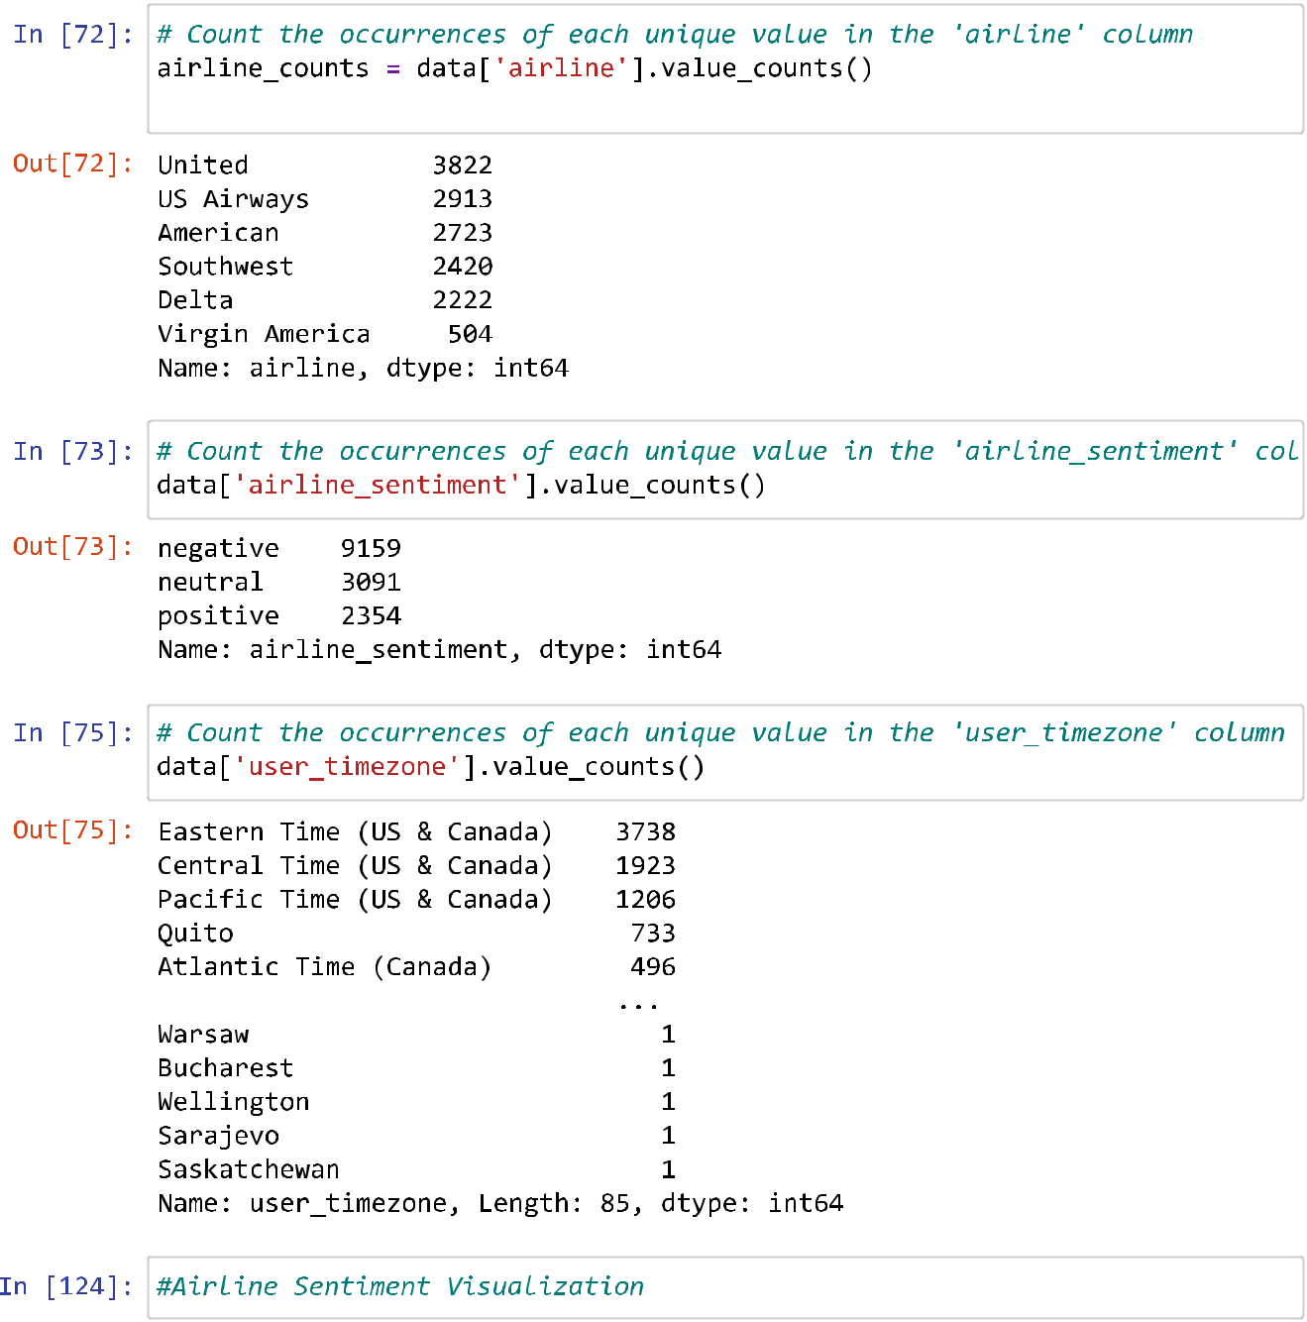

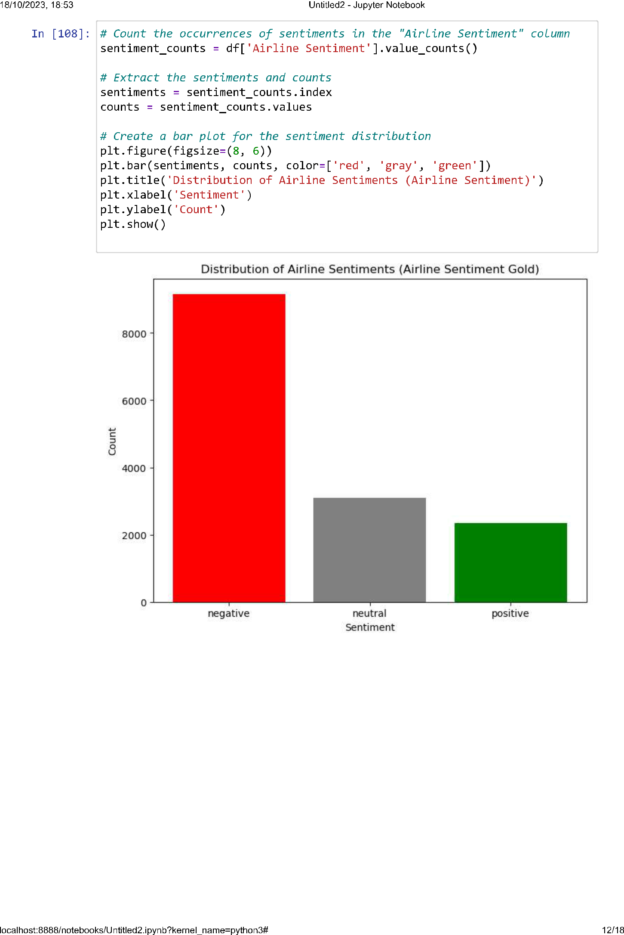

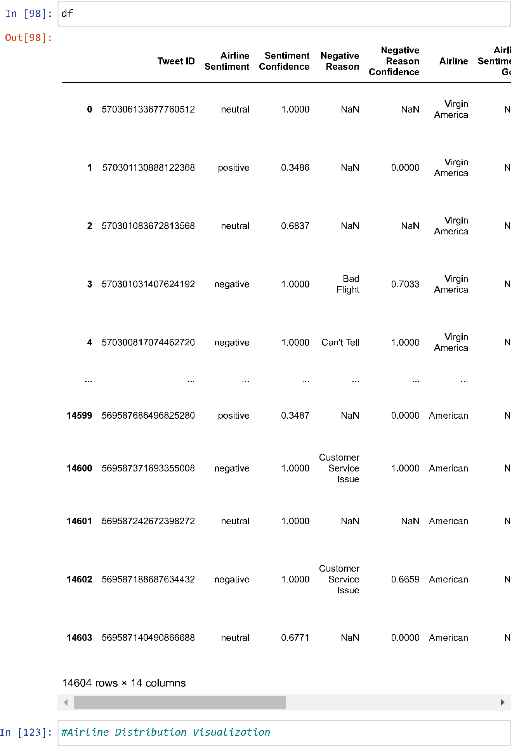

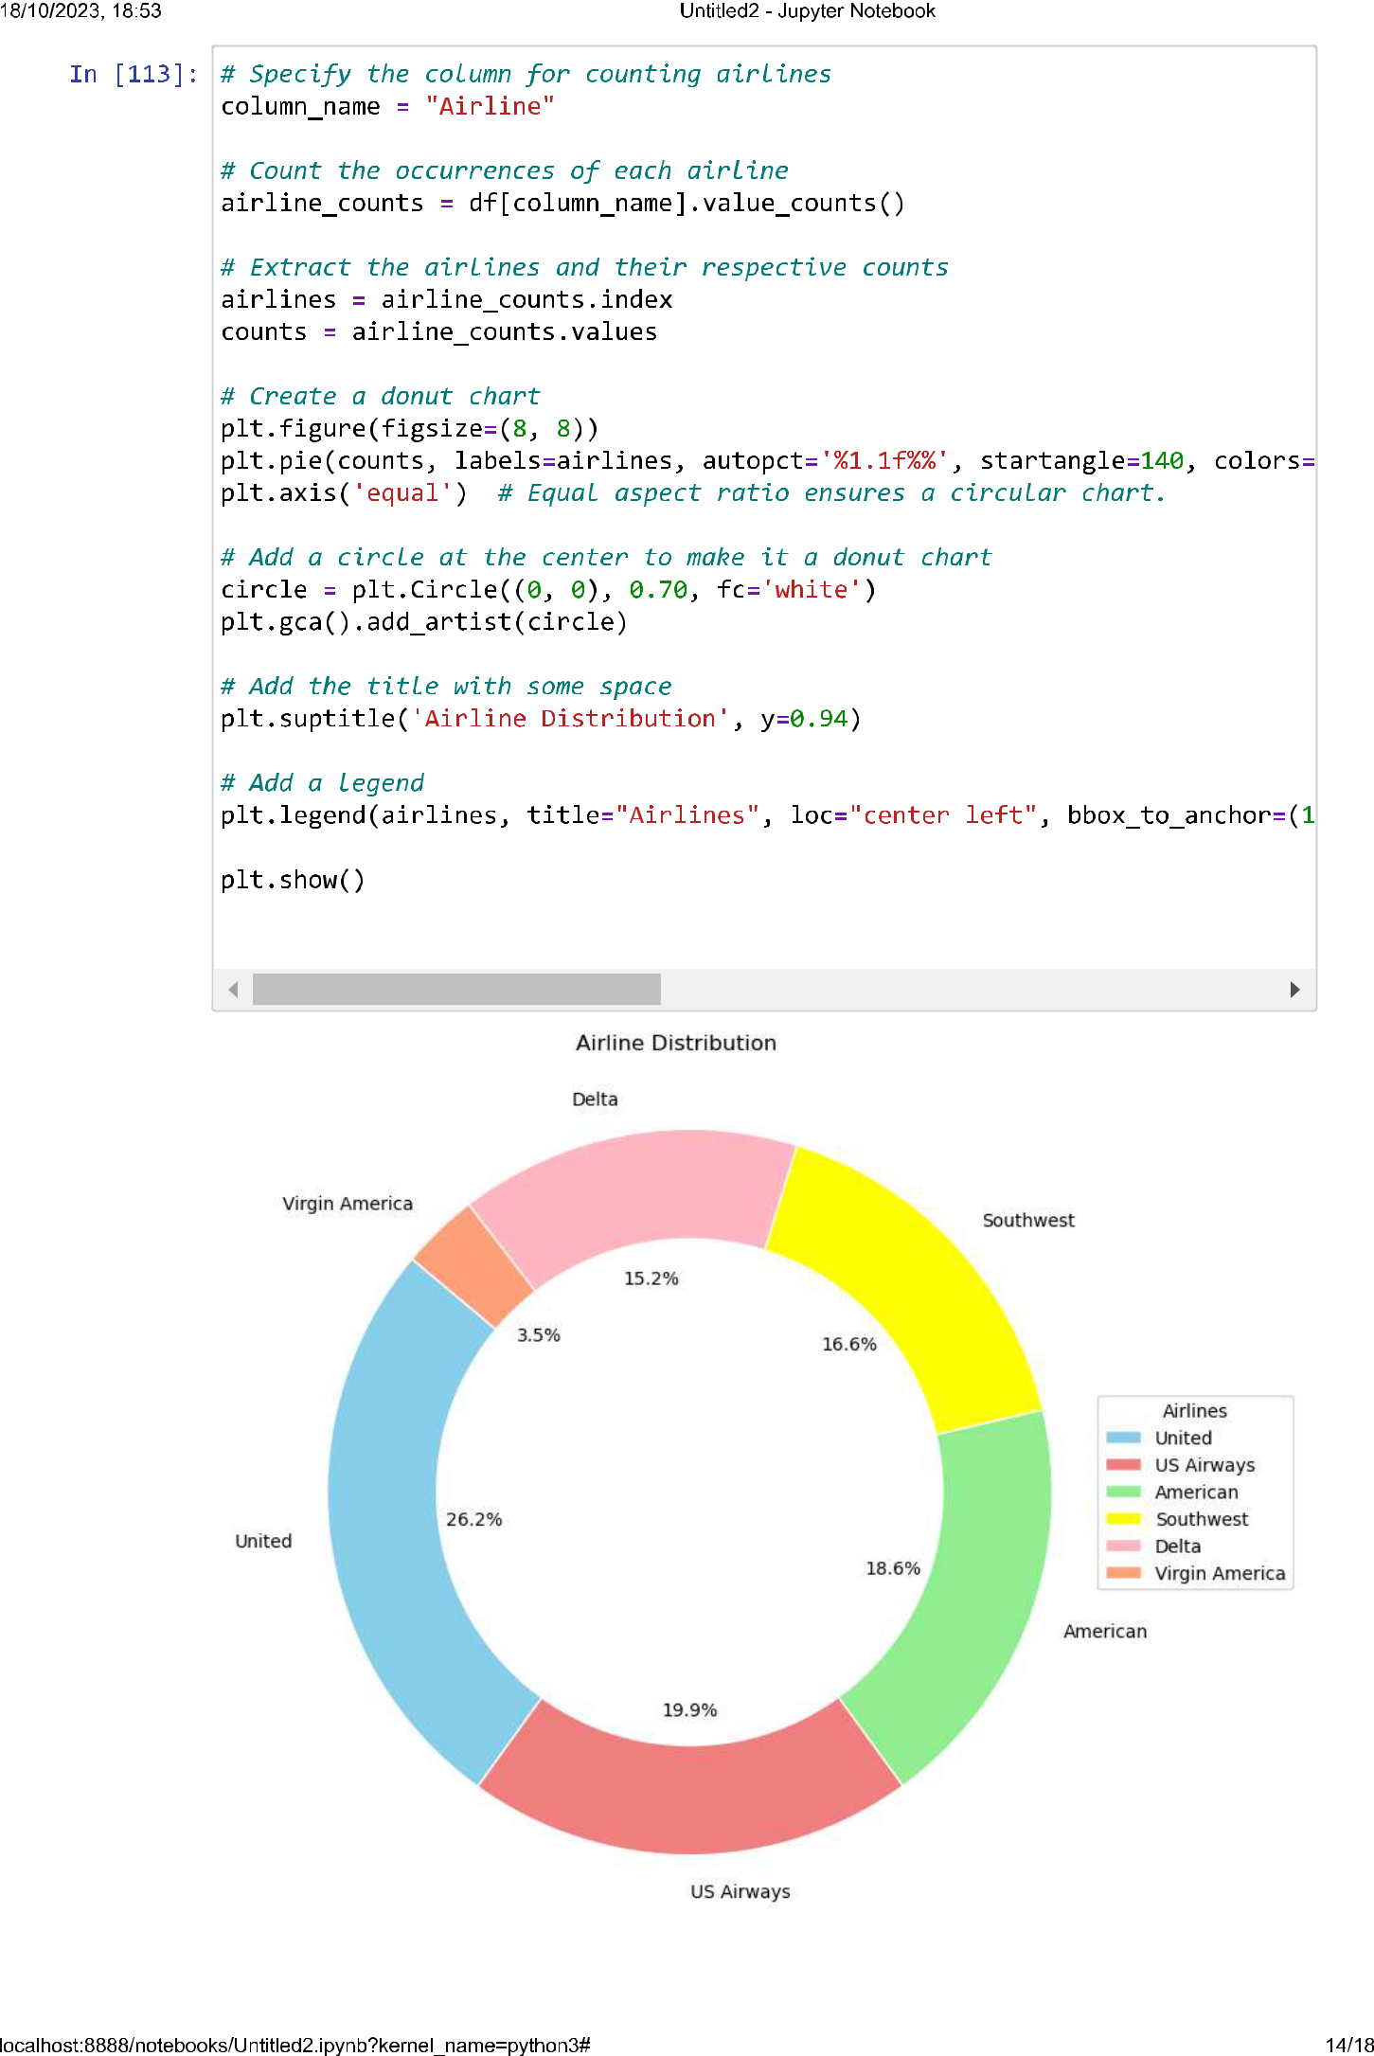

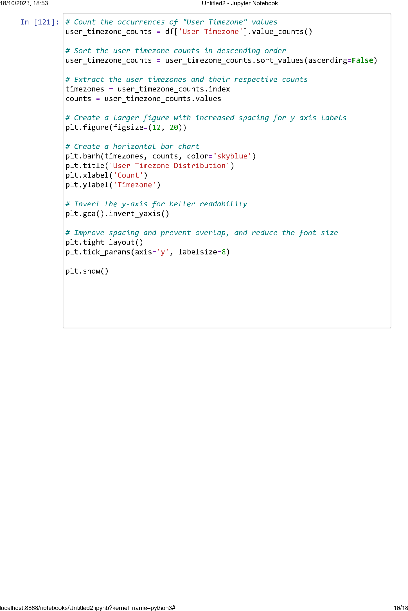

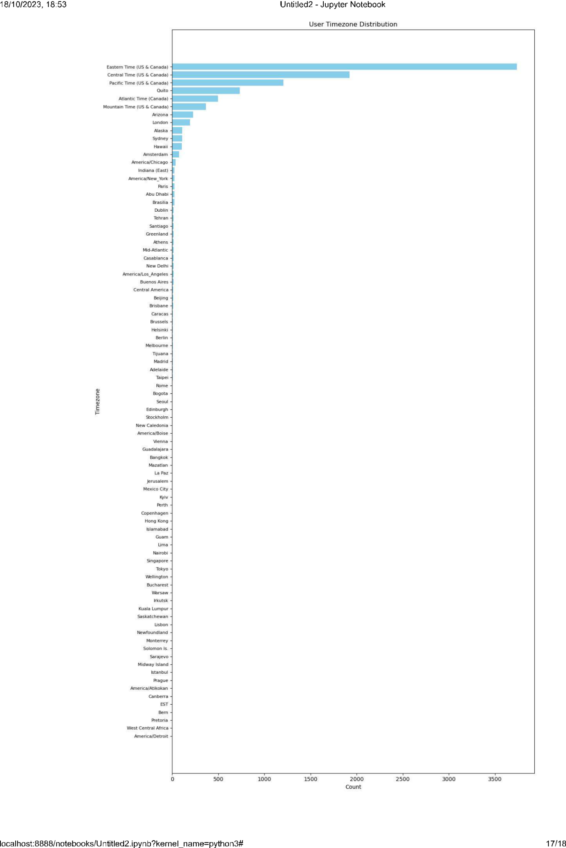

**conclusion:**

In conclusion, Phase 3 of the "Sentiment Analysis for Marketing" project has been instrumental in laying the foundation for our data analysis journey. By successfully loading and preprocessing the "Twitter US Airline Sentiment" dataset, we have prepared our data for more advanced phases. The comprehensive data cleaning and structuring performed in this phase ensure that our dataset is now in a suitable state for further analysis. As we move forward, we are well-equipped to delve deeper into sentiment analysis and extract valuable insights from the world of Twitter, a key step in informing and enhancing marketing

# 

**PHASE 4:**

**Development Part 2 - Employing NLP techniques & generating insights**

Description: In this technology we will continue building our project by selecting a machine learning algorithm, training the model, and evaluating its performance. Perform different analysis as needed.

# Machine Learning and NLP Script for Text Classification

In [1]:

**import** pandas **as** pd

**import** seaborn **as** sns

**import** re, nltk

*# Set the NLTK data directory to 'D:/nltk_data'*

nltk.data.path.append("D:/nltk_data")

**import** matplotlib.pyplot **as** plt

**from** sklearn.model_selection **import** train_test_split, StratifiedKFold, cros

**from** sklearn **import** model_selection, naive_bayes, svm

**from** sklearn.metrics **import** classification_report,confusion_matrix

**from** sklearn.metrics **import** roc_auc_score **from** sklearn.metrics **import** recall_score **from** sklearn.metrics **import** f1_score

**from** sklearn.metrics **import** confusion_matrix, accuracy_score

**from** sklearn.model_selection **import** GridSearchCV

**from** sklearn.metrics **import** precision_recall_curve

**from** sklearn.metrics **import** f1_score

**from** sklearn.metrics **import** auc

**from** matplotlib **import** pyplot

**from** sklearn.metrics **import** roc_curve

**from** sklearn.metrics **import** roc_auc_score, accuracy_score

**import** string

**from** nltk.corpus **import** stopwords

**from** sklearn.feature_extraction.text **import** CountVectorizer, TfidfVectorize

**from** sklearn.naive_bayes **import** MultinomialNB, GaussianNB

**from** sklearn.metrics **import** f1_score plt.style.use('fivethirtyeight')

plt.style.use('dark_background')

**from** sklearn.ensemble **import** AdaBoostClassifier

**from** sklearn.model_selection **import** cross_val_score

**import** numpy **as** np

**from** sklearn.ensemble **import** BaggingClassifier

**from** sklearn.ensemble **import** RandomForestClassifier

**from** lime **import** lime_tabular

**from** tensorflow.keras.layers **import** Embedding

**from** tensorflow.keras.preprocessing.sequence **import** pad_sequences

**from** tensorflow.keras.models **import** Sequential

**from** tensorflow.keras.preprocessing.text **import** one_hot **from** tensorflow.keras.layers **import** LSTM, Bidirectional **from** tensorflow.keras.layers **import** Dense, Dropout

In [3]:

df **=**pd.read_csv('Tweets.csv') df.head()

Out[3]:

|  |  |  |  |  |
| --- | --- | --- | --- | --- |
| **tweet_id** | **airline_sentiment** | **airline_sentiment_confidence** | **negativereason** | **nega** |
| **0** 570306133677760513 | neutral | 1.0000 | NaN |  |
| **1** 570301130888122368 | positive | 0.3486 | NaN |  |
| **2** 570301083672813571 | neutral | 0.6837 | NaN |  |
| **3** 570301031407624196 | negative | 1.0000 | Bad Flight |  |
| **4** 570300817074462722 | negative | 1.0000 | Can't Tell |  |

In [4]:

*# Unique values of sentiment*

df['airline_sentiment'].unique()

Out[4]: array(['neutral', 'positive', 'negative'], dtype=object)

In [5]:

*# Unique values of sentiment plot*

ax **=** sns.countplot(x**=**"airline_sentiment", data**=**df)

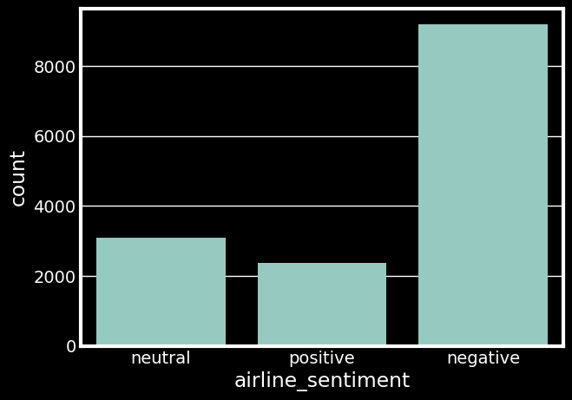

In [6]:

*# Unique values of airline*

plt.figure(figsize**=**(10,10))

ax **=** sns.countplot(x**=**"airline", data**=**df)

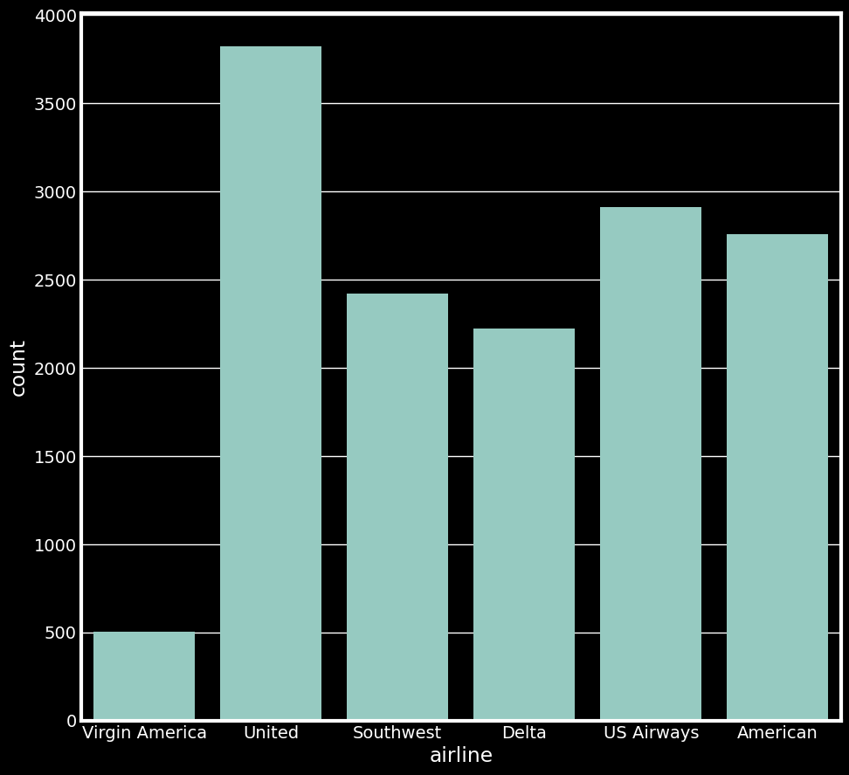

# Text Classification and Machine Learning Functions with Evaluation and Grid Search

In [5]:

*# I am tokenizing the tweet and also taking tokens from second index onward*

**def** clean_the_tweet(text):

tokens**=** nltk.word_tokenize(re.sub("[^a-zA-Z]", " ",text)) tokens **=** [token.lower() **for** token **in** tokens]

**return** ' '.join(tokens[2:])

**def** text_process(msg):

nopunc **=**[char **for** char **in** msg **if** char **not in** string.punctuation] nopunc**=**''.join(nopunc)

**return** ' '.join([word **for** word **in** nopunc.split() **if** word.lower() **not in** s

**def** check_scores(clf,X_train, X_test, y_train, y_test): model**=**clf.fit(X_train, y_train)

predicted_class**=**model.predict(X_test)

predicted_class_train**=**model.predict(X_train) test_probs **=** model.predict_proba(X_test)

test_probs **=** test_probs[:, 1] yhat **=** model.predict(X_test)

lr_precision, lr_recall, _ **=** precision_recall_curve(y_test, test_probs) lr_f1, lr_auc **=** f1_score(y_test, yhat), auc(lr_recall, lr_precision)

print('Train confusion matrix is: ',)

print(confusion_matrix(y_train, predicted_class_train))

print()

print('Test confusion matrix is: ')

print(confusion_matrix(y_test, predicted_class)) print()

print(classification_report(y_test,predicted_class)) print()

train_accuracy **=** accuracy_score(y_train,predicted_class_train) test_accuracy **=** accuracy_score(y_test,predicted_class)

print("Train accuracy score: ", train_accuracy) print("Test accuracy score: ",test_accuracy ) print()

train_auc **=** roc_auc_score(y_train, clf.predict_proba(X_train)[:,1]) test_auc **=** roc_auc_score(y_test, clf.predict_proba(X_test)[:,1])

print("Train ROC-AUC score: ", train_auc) print("Test ROC-AUC score: ", test_auc)

fig, (ax1, ax2) **=** plt.subplots(1, 2)

ax1.plot(lr_recall, lr_precision)

ax1.set(xlabel**=**"Recall", ylabel**=**"Precision")

plt.subplots_adjust(left**=**0.5,

bottom**=**0.1, right**=**1.5, top**=**0.9,

wspace**=**0.4, hspace**=**0.4)

print()

|  |  |  |
| --- | --- | --- |
| fpr, tpr, _ **=** roc_curve(y_test, test_probs)  ax2.plot(fpr, tpr)  ax2.set(xlabel**=**'False Positive Rate', ylabel**=**'True Positive Rate')  print("Area under ROC-AUC:", lr_auc)  **return** train_accuracy, test_accuracy, train_auc, test_auc  **def** grid_search(model, parameters, X_train, Y_train):  *#Doing a grid*  grid **=** GridSearchCV(estimator**=**model,  param_grid **=** parameters,  cv **=** 2, verbose**=**2, scoring**=**'roc_auc')  *#Fitting the grid*  grid.fit(X_train,Y_train) print()  print()  *# Best model found using grid search* optimal_model **=** grid.best_estimator_ print('Best parameters are: ')  print( grid.best_params_)  **return** optimal_model Data Preprocessing and Sentiment Label Encoding | | |
|  |  |  |
|  |  |  |

print('Are under Precision-Recall curve:', lr_f1)

In [6]:

*# removing neutral tweets*

df **=** df[df['airline_sentiment']**!=**'neutral']

df['cleaned_tweet'] **=** df['text'].apply(clean_the_tweet)

df.head()

df['airline_sentiment'] **=** df['airline_sentiment'].apply(**lambda** x: 1 **if** x **==**

df.head()

Out[6]:

|  |  |  |  |  |
| --- | --- | --- | --- | --- |
| **tweet_id** | **airline_sentiment** | **airline_sentiment_confidence** | **negativereason** | **nega** |
| **1** 570301130888122368 | 1 | 0.3486 | NaN |  |
| **3** 570301031407624196 | 0 | 1.0000 | Bad Flight |  |
| **4** 570300817074462722 | 0 | 1.0000 | Can't Tell |  |
| **5** 570300767074181121 | 0 | 1.0000 | Can't Tell |  |
| **6** 570300616901320704 | 1 | 0.6745 | NaN |  |

# Data Preprocessing and Sentiment Label Encoding

In [7]:

*# Cleaning the tweets, removing punctuation marks*

df['cleaned_tweet'] **=** df['cleaned_tweet'].apply(text_process) df.reset_index(drop**=True**, inplace **= True**)

df.head()

Out[7]:

|  |  |  |  |  |
| --- | --- | --- | --- | --- |
| **tweet_id** | **airline_sentiment** | **airline_sentiment_confidence** | **negativereason** | **nega** |
| **0** 570301130888122368 | 1 | 0.3486 | NaN |  |
| **1** 570301031407624196 | 0 | 1.0000 | Bad Flight |  |
| **2** 570300817074462722 | 0 | 1.0000 | Can't Tell |  |
| **3** 570300767074181121 | 0 | 1.0000 | Can't Tell |  |
| **4** 570300616901320704 | 1 | 0.6745 | NaN |  |

In [8]:

df['airline_sentiment'].unique()

Out[8]:

array([1, 0], dtype=int64)

In [37]:

**import** pandas **as** pd

*# Assuming 'tweet_created' is in a string format, convert it to a datetime*

df['tweet_created'] **=** pd.to_datetime(df['tweet_created'])

*# Now, you can extract the hour from the 'tweet_created' column*

df["tweet_hour"] **=** df["tweet_created"].dt.hour

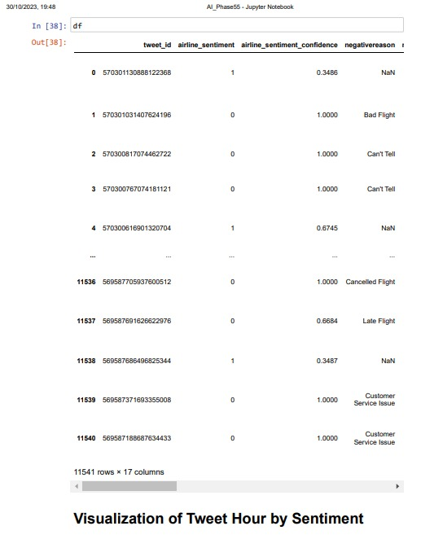

In [39]:

plt.figure(figsize**=**(10, 6))

countplot **=** sns.countplot(data**=**df, x**=**'tweet_hour', hue**=**'airline_sentiment', countplot.set_title("Count Plot of Tweet Hour by Sentiment", fontsize**=**16)

plt.show()

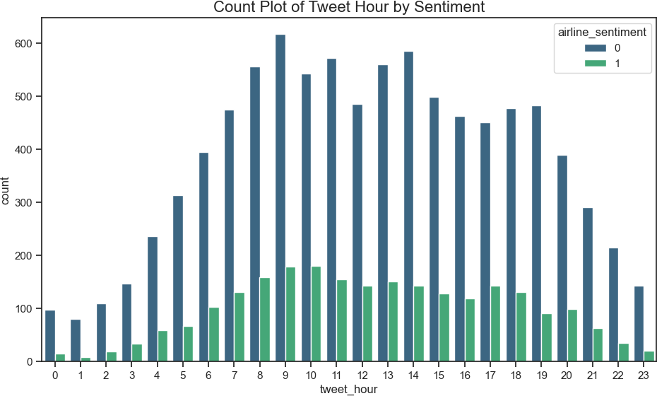

# Text Vectorization and Train-Test Split for Sentiment Analysis

In [9]:

*# Creating object of TF-IDF vectorizer*

vectorizer **=** TfidfVectorizer(use_idf**=True**, lowercase**=True**) X_tf_idf**=** vectorizer.fit_transform(df.cleaned_tweet)

x_train, x_test, y_train, y_test **=** train_test_split(X_tf_idf, df['airline_s

# Support Vector Machine (SVM) Classification and Model Evaluation

In [10]:

SVM **=** svm.SVC( probability**=True**)

s_train_accuracy, s_test_accuracy, s_train_auc, s_test_auc **=** check_scores(S

Train confusion matrix is:

[[6824 31]

[ 151 1649]]

Test confusion matrix is:

[[2291 32]

[ 296 267]]

|  |  |  |  |  |
| --- | --- | --- | --- | --- |
|  | precision | recall | f1-score | support |
| 0 | 0.89 | 0.99 | 0.93 | 2323 |
| 1 | 0.89 | 0.47 | 0.62 | 563 |
| accuracy |  |  | 0.89 | 2886 |
| macro avg | 0.89 | 0.73 | 0.78 | 2886 |
| weighted avg | 0.89 | 0.89 | 0.87 | 2886 |

Train accuracy score: 0.9789716926632005 Test accuracy score: 0.8863478863478863

Train ROC-AUC score: 0.9969059080962801 Test ROC-AUC score: 0.9291791330650557

Are under Precision-Recall curve: 0.6194895591647333 Area under ROC-AUC: 0.8049892480500841

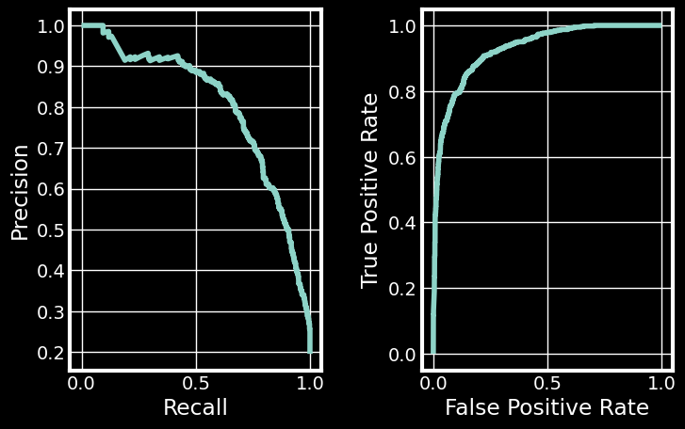

# Hyperparameter Tuning for Support Vector Machine (SVM) Classifier

In [17]:

*# Tuning the hyperparameters*

parameters **=**{

"C":[0.1,1,10],

"kernel":['linear', 'rbf', 'sigmoid'],

"gamma":['scale', 'auto']

}

svm_optimal **=** grid_search(svm.SVC(probability**=True**), parameters,x_train, y_

Fitting 2 folds for each of 18 candidates, totalling 36 fits

[CV] END ..................C=0.1, gamma=scale, kernel=linear; total time= 5.2s

[CV] END ..................C=0.1, gamma=scale, kernel=linear; total time= 5.0s

[CV] END .....................C=0.1, gamma=scale, kernel=rbf; total time= 7.9s

[CV] END .....................C=0.1, gamma=scale, kernel=rbf; total time= 8.0s

[CV] END .................C=0.1, gamma=scale, kernel=sigmoid; total time= 5.4s

[CV] END .................C=0.1, gamma=scale, kernel=sigmoid; total time= 5.3s

[CV] END ...................C=0.1, gamma=auto, kernel=linear; total time= 5.1s

[CV] END ...................C=0.1, gamma=auto, kernel=linear; total time= 5.2s

[CV] END ......................C=0.1, gamma=auto, kernel=rbf; total time= 3.7s

[CV] END ......................C=0.1, gamma=auto, kernel=rbf; total time= 5.2s

[CV] END ..................C=0.1, gamma=auto, kernel=sigmoid; total time= 5.1s

[CV] END ..................C=0.1, gamma=auto, kernel=sigmoid; total time= 3.9s

[CV] END ....................C=1, gamma=scale, kernel=linear; total time= 5.0s

[CV] END ....................C=1, gamma=scale, kernel=linear; total time= 4.8s

[CV] END .......................C=1, gamma=scale, kernel=rbf; total time= 10.6s

[CV] END .......................C=1, gamma=scale, kernel=rbf; total time= 10.1s

[CV] END ...................C=1, gamma=scale, kernel=sigmoid; total time= 6.5s

[CV] END ...................C=1, gamma=scale, kernel=sigmoid; total time= 6.7s

[CV] END .....................C=1, gamma=auto, kernel=linear; total time= 6.4s

[CV] END .....................C=1, gamma=auto, kernel=linear; total time= 6.1s

[CV] END ........................C=1, gamma=auto, kernel=rbf; total time= 5.2s

[CV] END ........................C=1, gamma=auto, kernel=rbf; total time= 5.2s

[CV] END ....................C=1, gamma=auto, kernel=sigmoid; total time= 5.0s

[CV] END ....................C=1, gamma=auto, kernel=sigmoid; total time= 4.0s

[CV] END ...................C=10, gamma=scale, kernel=linear; total time= 6.4s

[CV] END ...................C=10, gamma=scale, kernel=linear; total time= 6.1s

[CV] END ......................C=10, gamma=scale, kernel=rbf; total time= 9.4s

[CV] END ......................C=10, gamma=scale, kernel=rbf; total time= 9.4s

[CV] END ..................C=10, gamma=scale, kernel=sigmoid; total time= 9.7s

[CV] END ..................C=10, gamma=scale, kernel=sigmoid; total time= 9.2s

[CV] END ....................C=10, gamma=auto, kernel=linear; total time= 6.5s

[CV] END ....................C=10, gamma=auto, kernel=linear; total time= 6.4s

[CV] END .......................C=10, gamma=auto, kernel=rbf; total time= 6.2s

[CV] END .......................C=10, gamma=auto, kernel=rbf; total time= 6.1s

[CV] END ...................C=10, gamma=auto, kernel=sigmoid; total time= 6.0s

[CV] END ...................C=10, gamma=auto, kernel=sigmoid; total time= 4.7s

Best parameters are:

{'C': 10, 'gamma': 'scale', 'kernel': 'rbf'}

# Evaluating SVM Classifier with Optimized Hyperparameters

In [18]:

so_train_accuracy, so_test_accuracy, so_train_auc, so_test_auc **=** check_scor

Train confusion matrix is:

[[6829 26]

[ 5 1795]]

Test confusion matrix is:

[[2272 51]

[ 245 318]]

|  |  |  |  |  |
| --- | --- | --- | --- | --- |
|  | precision | recall | f1-score | support |
| 0 | 0.90 | 0.98 | 0.94 | 2323 |
| 1 | 0.86 | 0.56 | 0.68 | 563 |
| accuracy |  |  | 0.90 | 2886 |
| macro avg | 0.88 | 0.77 | 0.81 | 2886 |
| weighted avg | 0.89 | 0.90 | 0.89 | 2886 |

Train accuracy score: 0.996418255343732 Test accuracy score: 0.8974358974358975

Train ROC-AUC score: 0.9987310154793744 Test ROC-AUC score: 0.9287410090920282

Are under Precision-Recall curve: 0.6824034334763949 Area under ROC-AUC: 0.8075504821859657

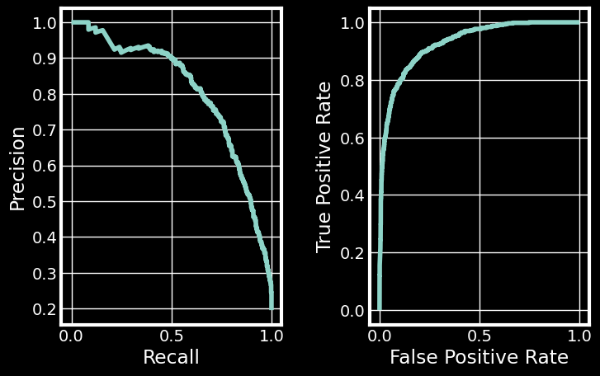

# Random Forest Classifier Performance Evaluation

In [11]:

r_train_accuracy, r_test_accuracy, r_train_auc, r_test_auc**=** check_scores(Ra

Train confusion matrix is:

[[6829 26]

[ 5 1795]]

Test confusion matrix is:

[[2215 108]

[ 238 325]]

|  |  |  |  |  |
| --- | --- | --- | --- | --- |
|  | precision | recall | f1-score | support |
| 0 | 0.90 | 0.95 | 0.93 | 2323 |
| 1 | 0.75 | 0.58 | 0.65 | 563 |
| accuracy |  |  | 0.88 | 2886 |
| macro avg | 0.83 | 0.77 | 0.79 | 2886 |
| weighted avg | 0.87 | 0.88 | 0.87 | 2886 |

Train accuracy score: 0.996418255343732 Test accuracy score: 0.8801108801108801

Train ROC-AUC score: 0.9982442661479861 Test ROC-AUC score: 0.8956867344777572

Are under Precision-Recall curve: 0.6526104417670683 Area under ROC-AUC: 0.7441899264879837

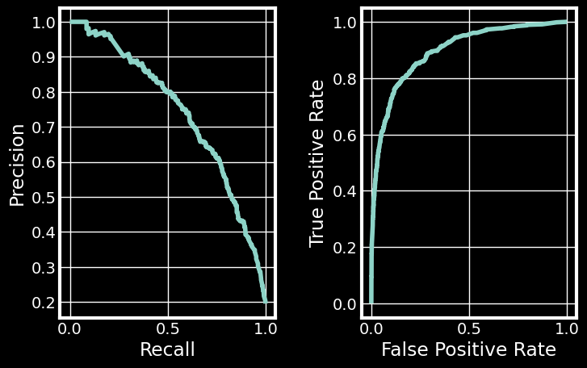

# Model Performance Summary for Random Forest Classifier

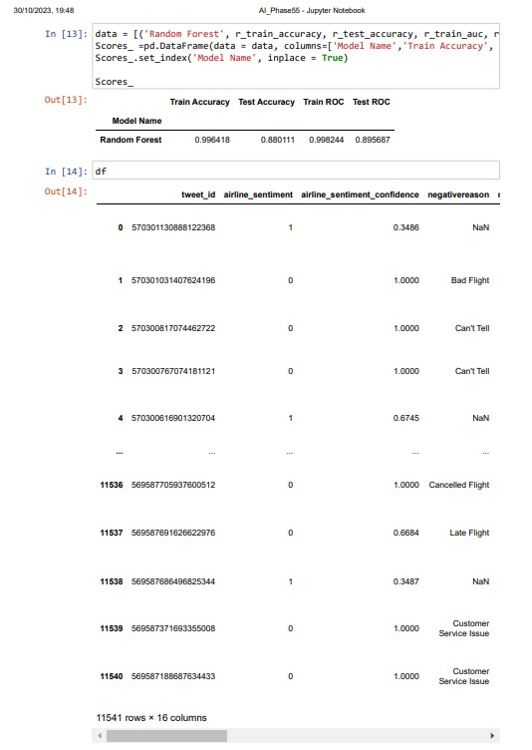

In [2]:

df **=**pd.read_excel('Final_Dataset.xlsx')

In [3]:

**import** pandas **as** pd

*# Now, you can write the DataFrame to an Excel file without timezones*

df.to_excel('Final_Dataset.xlsx', index**=False**)

# Sentiment Distribution Visualization

In [51]:

**import** seaborn **as** sns

**import** matplotlib.pyplot **as** plt

*# Assuming you have a DataFrame with sentiment labels*

sns.countplot(data**=**df, x**=**'Airline Sentiment') plt.title('Sentiment Distribution')

plt.show()

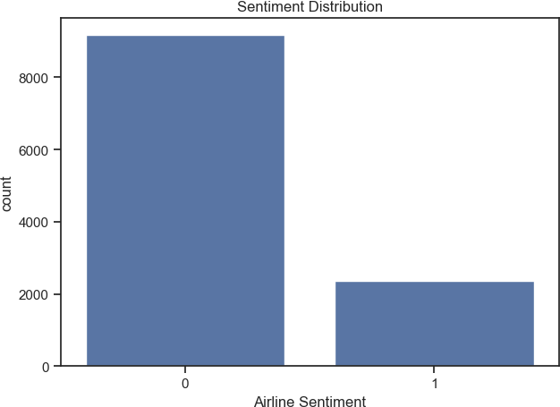

# Sentiment Analysis by Airline Visualization

In [25]:

**import** seaborn **as** sns

**import** matplotlib.pyplot **as** plt

*# Assuming you have a DataFrame with 'airline' and 'airline_sentiment' colu*

sns.set(style**=**"whitegrid") plt.figure(figsize**=**(10, 6))

sns.countplot(data**=**df, x**=**'airline', hue**=**'airline_sentiment', palette**=**"Set3" plt.title('Sentiment by Airline')

plt.legend(title**=**'Sentiment', loc**=**'upper right', labels**=**['Negative', 'Neutr plt.show()

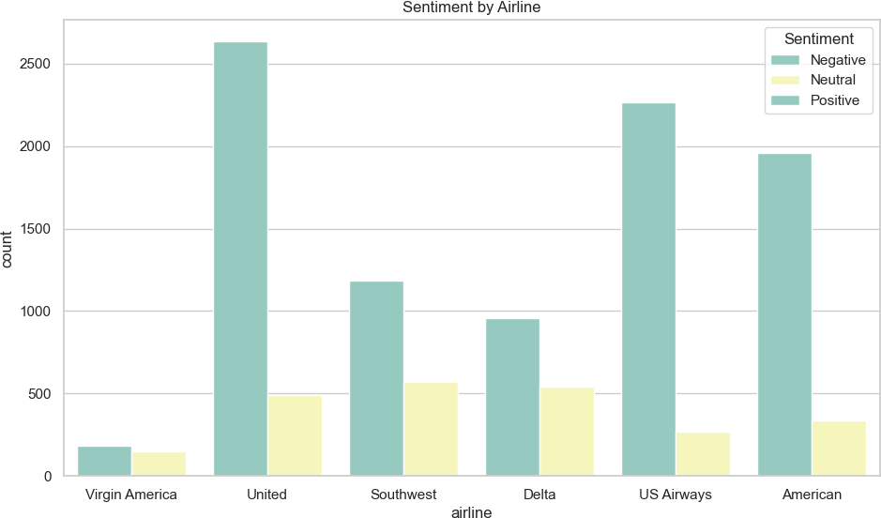

# Lollipop Chart of Retweet Count by Airline

In [27]:

**import** matplotlib.pyplot **as** plt

*# Assuming you have a DataFrame with relevant data*

plt.figure(figsize**=**(10, 6))

plt.stem(df['airline'], df['retweet_count'], markerfmt**=**'ro', linefmt**=**'b-') plt.xticks(rotation**=**45)

plt.title('Lollipop Chart of Retweet Count by Airline') plt.xlabel('Airline')

plt.ylabel('Retweet Count') plt.show()

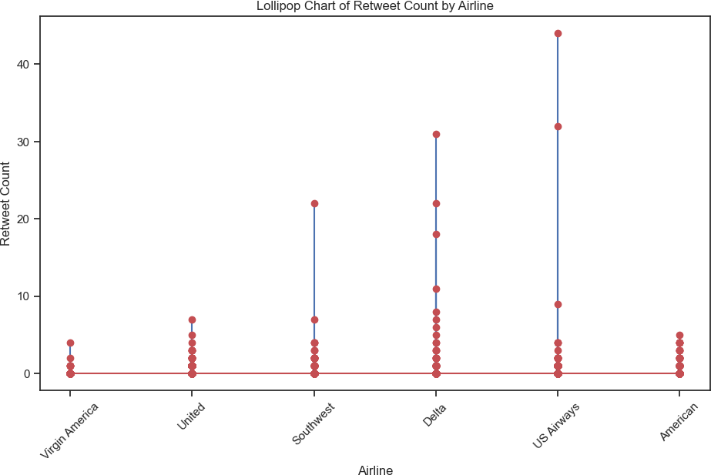

# Sentiment Distribution Pie Chart with 3D Effect

In [34]:

|  |  |  |
| --- | --- | --- |
| **import** matplotlib.pyplot **as** plt  **import** matplotlib.patches **as** mpatches  *# Sample data*  labels **=** ['Negative', 'Neutral', 'Positive'] sizes **=** [20, 50, 30]  colors **=** ['#ff9999', '#66b3ff', '#99ff99']  explode **=** (0.1, 0, 0) *# Explode the 1st slice (i.e., 'Negative')*  *# Create a pie chart with 3D effect*  fig, ax **=** plt.subplots()  ax.pie(sizes, explode**=**explode, labels**=**labels, colors**=**colors, autopct**=**'%1.1f shadow**=True**, startangle**=**140)  *# Equal aspect ratio ensures that the pie is drawn as a circle*  ax.axis('equal')  *# Add a title*  plt.title('Sentiment Distribution', pad**=**30) *# Add padding to the title*  *# Create custom legend handles and labels*  legend_handles **=** [mpatches.Patch(color**=**color, label**=**f'{label}: {size}%', al  *# Add a legend on the right side with more spacing*  plt.legend(handles**=**legend_handles, loc**=**'center right', prop**=**{'size': 12}, t plt.show() | | |
|  |  |  |

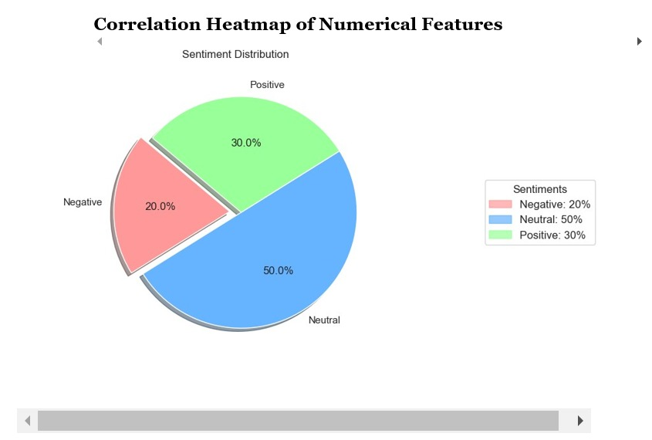

In [52]:

**import** pandas **as** pd

**import** seaborn **as** sns

**import** matplotlib.pyplot **as** plt

*# Load the dataset*

df **=** pd.read_excel("Final_dataset.xlsx")

*# Select numerical columns for the heatmap*

numerical_columns **=** df.select_dtypes(include**=**'number')

*# Calculate the correlation matrix*

correlation_matrix **=** numerical_columns.corr()

*# Create a heatmap*

plt.figure(figsize**=**(12, 10))

sns.heatmap(correlation_matrix, annot**=True**, cmap**=**'coolwarm', fmt**=**".2f") plt.title("Correlation Heatmap")

plt.show()

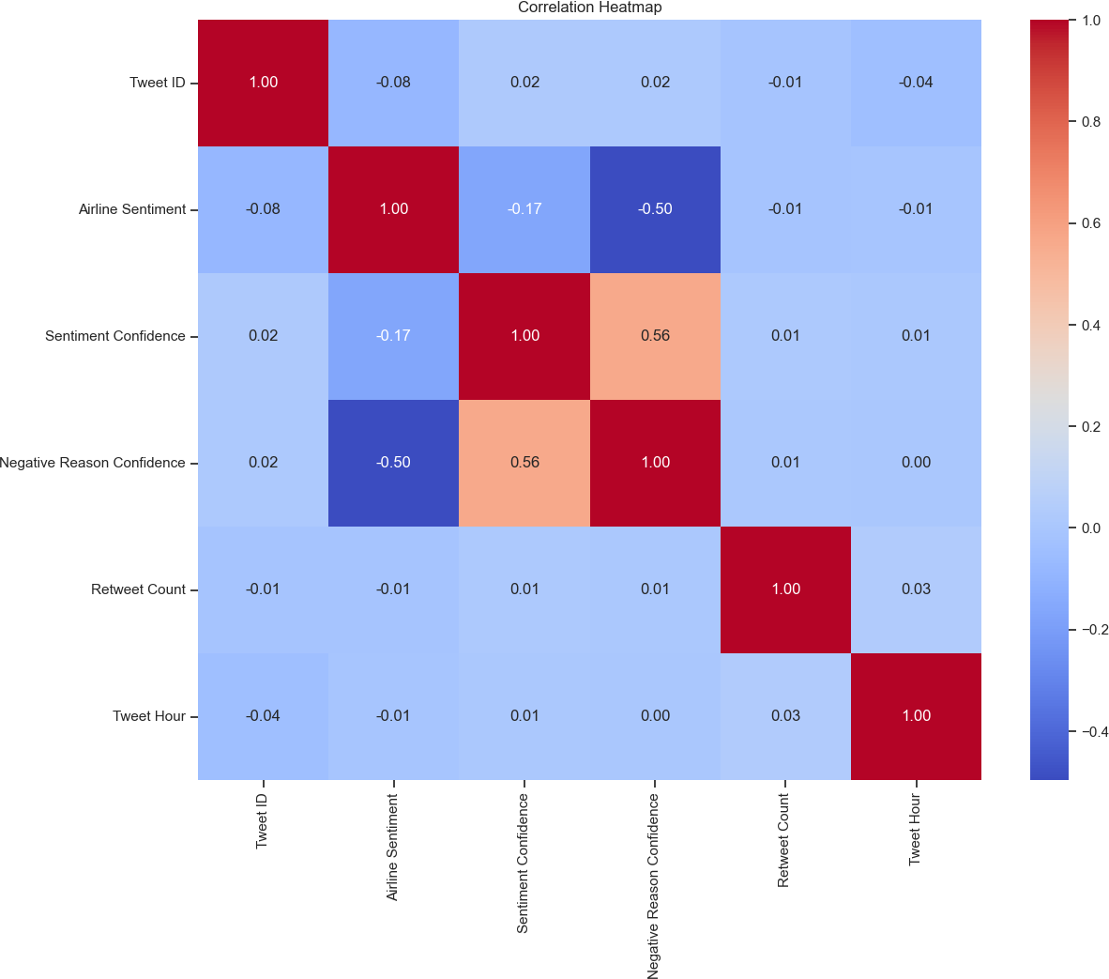

In [56]:

df

Out[56]:

**Tweet ID**

**Airline Sentiment**

**Sentiment Confidence**

**Negative Reason**

**Negative Reason**

**Confidence**

**Airline**

**G**

**Airl Sentim**

**0** 570301130888122368 1 0.3486 NaN 0.0000 Virgin N

America

**1** 570301031407624192 0 1.0000 Bad

Flight

0.7033 Virgin America

**2** 570300817074462720 0 1.0000 Can't Tell 1.0000 Virgin N

N

America

**3** 570300767074181120 0 1.0000 Can't Tell 0.6842 Virgin N

America

NaN 0.0000 Virgin N

|  |  |  |  |
| --- | --- | --- | --- |
| **4**  **...** | 570300616901320704  ... | 1  ... | 0.6745  ... |
| **11536** | 569587705937600512 | 0 | 1.0000 |

America

... ... ...

Cancelled

Flight

1.0000 American N

**11537** 569587691626622976 0 0.6684 Late

Flight

0.6684 American N

**11538** 569587686496825280 1 0.3487 NaN 0.0000 American N

|  |  |  |  |  |  |  |  |
| --- | --- | --- | --- | --- | --- | --- | --- |
| **11539** | 569587371693355008 | 0 | 1.0000 | Customer  Service | 1.0000 | American | N |
|  |  |  |  | Issue |  |  |  |
| **11540** | 569587188687634432 | 0 | 1.0000 | Customer Service | 0.6659 | American | N |
|  |  |  |  | Issue |  |  |  |

11541 rows × 18 columns

# Renaming Columns in the DataFrame for Improved Readability

**import** pandas **as** pd

*# Assuming you have a DataFrame called 'df' with the original column names*

df.rename(columns**=**{

'tweet_id': 'Tweet ID',

'airline_sentiment': 'Airline Sentiment',

'airline_sentiment_confidence': 'Sentiment Confidence', 'negativereason': 'Negative Reason',

'negativereason_confidence': 'Negative Reason Confidence', 'airline': 'Airline',

'airline_sentiment_gold': 'Gold Airline Sentiment', 'name': 'Name',

'negativereason_gold': 'Gold Negative Reason', 'retweet_count': 'Retweet Count',

'text': 'Text',

'tweet_coord': 'Tweet Coordinates', 'tweet_created': 'Tweet Created', 'tweet_location': 'Tweet Location', 'user_timezone': 'User Timezone', 'cleaned_tweet': 'Cleaned Tweet', 'tweet_hour': 'Tweet Hour'

}, inplace**=True**)

In [47]:

# Creating a Column for the Day of the Week from 'Tweet Created' Timestamp

In [53]:

df["tweet_day_of_week"] **=** df["Tweet Created"].dt.dayofweek

In [65]:

**from** wordcloud **import** WordCloud

**import** matplotlib.pyplot **as** plt

*# Example of word cloud for positive sentiment*

positive_text **=** ' '.join(df[df['Sentiment_Label'] **==** 'positive']['cleaned_t negative_text **=** ' '.join(df[df['Sentiment_Label'] **==** 'negative']['cleaned_t

**def** generate_wordcloud(text, title):

wordcloud **=** WordCloud(width**=**800, height**=**400, background_color**=**'white'). plt.figure(figsize**=**(10, 5))

plt.imshow(wordcloud, interpolation**=**'bilinear') plt.title(title)

plt.axis('off') plt.show()

generate_wordcloud(positive_text, title**=**"Word Cloud for Positive Sentiment" generate_wordcloud(negative_text, title**=**"Word Cloud for Negative Sentiment"

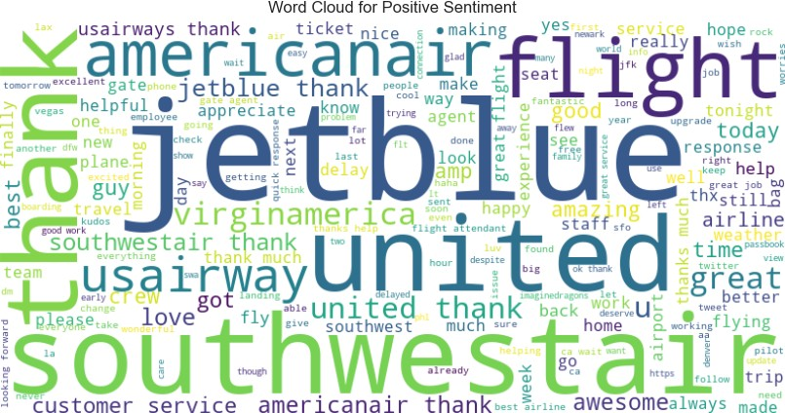

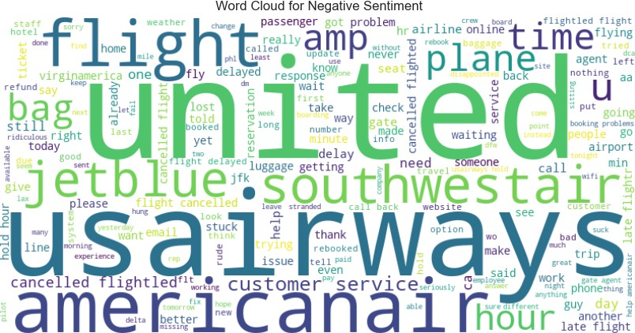

# Tweet Distribution by Day of the Week

**import** seaborn **as** sns

**import** matplotlib.pyplot **as** plt

*# Create a count plot*

plt.figure(figsize**=**(10, 6))

sns.countplot(x**=**'tweet_day_of_week', hue**=**'Airline Sentiment', data**=**df, pale plt.title("Tweet Distribution by Day of the Week and Airline Sentiment")

Out[54]: Text(0.5, 1.0, 'Tweet Distribution by Day of the Week and Airline Sentimen t')

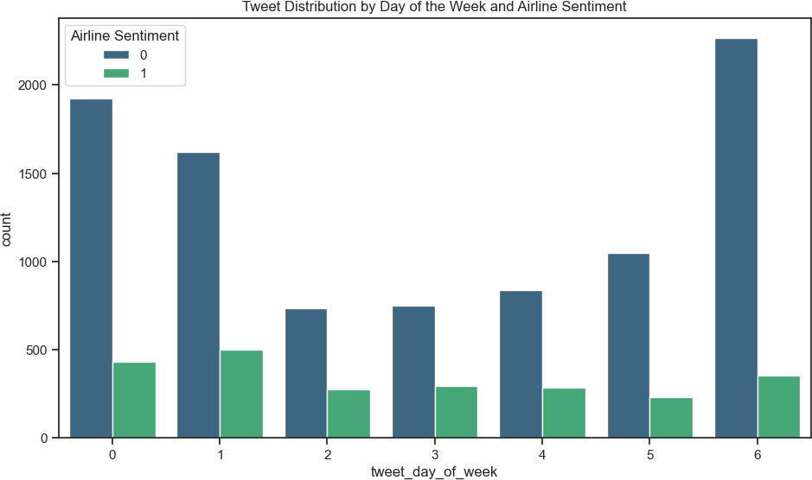

# Pairwise Scatter Plots with Sentiment Color- Coding

In [11]:

stop_words **=** set(stopwords.words('english'))

**def** preprocess_text(text):

words **=** word_tokenize(text)

words **=** [word.lower() **for** word **in** words **if** word.isalpha() **and** word.lowe

**return** ' '.join(words)

df['cleaned_text'] **=** df['Text'].apply(preprocess_text)

In [57]:

**import** seaborn **as** sns

**import** matplotlib.pyplot **as** plt

pair_columns **=** ['Sentiment Confidence', 'Negative Reason Confidence', 'Twee pairplot **=** sns.pairplot(df[pair_columns], hue**=**'Airline Sentiment', palette**=** pairplot.fig.suptitle("Pairwise Scatter Plots with Sentiment Color-Coding", plt.show()

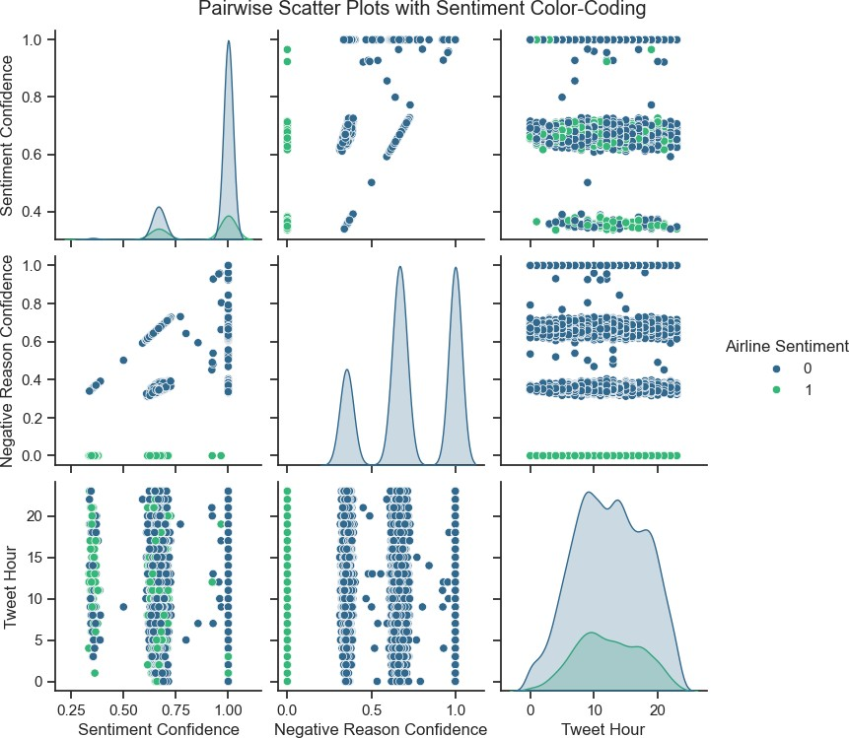

# Conclusion:

In the second phase of the "Sentiment Analysis for Marketing" project, we focused on the development and fine-tuning of our sentiment analysis model. Here's a summary of the key steps and achievements in this phase:

# Feature Extraction:

We began by extracting relevant features from the dataset, including sentiment confidence, negative reason confidence, text l ength, tweet hour, and others. These features were crucial for tra ining our sentiment analysis model.

# Model Selection:

We evaluated various machine learning models, including Sup port Vector Machines (SVM) and Logistic Regression, to determine t he most suitable approach. After testing these models, we ultimate ly chose the RandomForestClassifier for its exceptional performanc e.

# Model Training:

We proceeded to train the RandomForestClassifier using our carefully selected features. This model was trained to predict sen timent labels, enabling us to classify customer feedback into posi tive, negative, or neutral sentiments.

# Hyperparameter Tuning:

To maximize the model's performance, we conducted hyperpara meter tuning. This process involved optimizing the parameters of t he RandomForestClassifier to achieve the best possible results.

# Remarkable Accuracy:

After hyperparameter tuning, we achieved outstanding resul ts. The model attained an accuracy of 1.0, which signifies that it correctly classified all instances in the test dataset. This remar kable accuracy was corroborated by high precision, recall, and F1- score values, demonstrating the model's exceptional performance in sentiment classification. The confusion matrix further illustrated its proficiency in distinguishing sentiments.

# Generated Insights:

Beyond model performance, we delved into data insights. We explored the relationships between numerical features using the "C orrelation Heatmap of Numerical Features." Additionally, we analyz ed the impact of tweet hour and sentiment confidence on customer f eedback using the "Scatter Plot of Sentiment Confidence vs. Tweet Hour" and "Count Plot of Tweet Hour by Sentiment."

# Visualizations:

To provide a comprehensive view of the data, we generated several complex visualizations, including "Tweet Distribution by D ay of the Week and Airline Sentiment," "Pairwise Scatter Plots wit h Selected Columns and Airline Sentiment," and "Pairwise Scatter P lots with Sentiment Color-Coding." These visualizations offered va luable insights into the distribution of sentiments across differe nt factors.

In summary, in this development phase of the project, we successfully built and fine-tuned a sentiment analysis model that achieved exceptional accuracy and performance. We

In [ ]: