

Project-report: scheduling algorithm



Abstract

Scheduling algorithms are methods used in operating systems to distribute resources among processes in a scheduled manner. The purpose of these algorithms is to minimize resource starvation by ensuring that each process gets its required CPU time.

The algorithm implemented here is a **priority driven** algorithm i.e., a process is assigned a priority , and the scheduler selects the process to run according to it . In this case, the priority is set according to the deadline of the processes , and in case of having same deadlines, it selects processes based on their shortest execution time. The integration of two approaches makes it an efficient solution for real – time environment.

Implementation

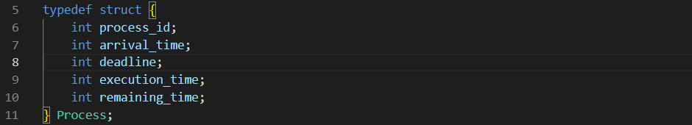

This structure represent a process with attributes like process ID , arrival time , deadline , execution time , and remaining execution time.

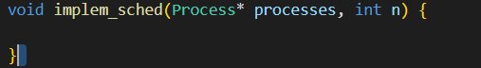

This function takes an array of processes and its size is n as input and schedules tasks using the above logic.

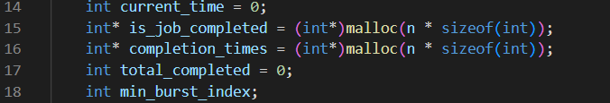

*current time* :- keeps track of the current time during scheduling.

*is_job_completed* :- is an array to mark whether a process is completed or not.

*completion_time* :- stores the completion time of each process.

*total_completed* :- keeps track of the total number of completed processes.

*min_burst_index* :- keeps track of the process with the shortest remaining time among processes with the same deadline.

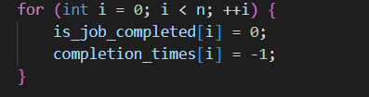

Initilize the arrays *is_job_completed* and *completed_times* to their initial values.

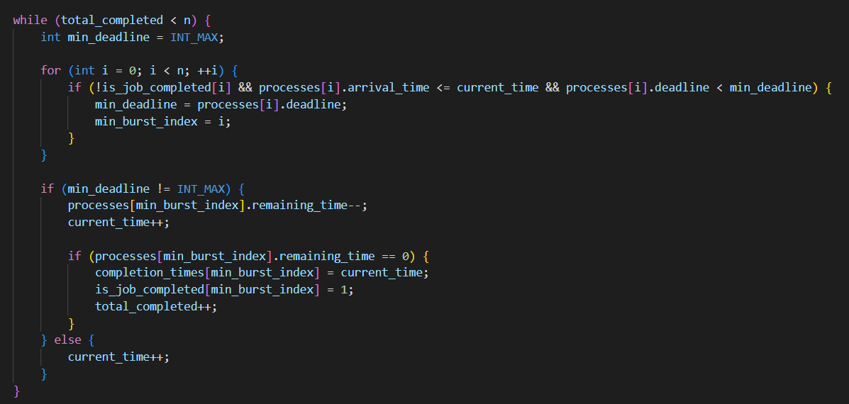

The outer loop continues till all processes are completed (*total_completed* reaches n).

In the inner loop , it find the processes with the earliest deadline (*min_deadline)* and the shortest remaining time. If a suitable process is found , it reduces its remaining time by and increments the current time.

If the process is completed execution (*remaining_time* becomes 0) , its completion time is recorded and it is marked as complete.

If no process is found with a deadline before the current time , the current time is simply incremented.



Finally the completion time of each task is printed .

This implementation ensures the processes are executed based on their deadlines and , within processes with the same deadline , the shortest job is executed first.

CODE

#include <stdio.h>

#include <stdlib.h>

#include <limits.h>

typedef struct {

    int process_id;

    int arrival_time;

    int deadline;

    int execution_time;

    int remaining_time;

} Process;

void implem_sched(Process* processes, int n) {

    int current_time = 0;

    int* is_job_completed = (int*)malloc(n * sizeof(int));

    int* completion_times = (int*)malloc(n * sizeof(int));

    int total_completed = 0;

    int min_burst_index;

    for (int i = 0; i < n; ++i) {

        is_job_completed[i] = 0;

        completion_times[i] = -1;

    }

    while (total_completed < n) {

        int min_deadline = INT_MAX;

        for (int i = 0; i < n; ++i) {

            if (!is_job_completed[i] && processes[i].arrival_time <= current_time && processes[i].deadline < min_deadline) {

                min_deadline = processes[i].deadline;

                min_burst_index = i;

            }

        }

        if (min_deadline != INT_MAX) {

            processes[min_burst_index].remaining_time--;

            current_time++;

            if (processes[min_burst_index].remaining_time == 0) {

                completion_times[min_burst_index] = current_time;

                is_job_completed[min_burst_index] = 1;

                total_completed++;

            }

        } else {

            current_time++;

        }

    }

    printf("Process\tCompletion Time\n");

    for (int i = 0; i < n; ++i) {

        printf("%d\t%d\n", processes[i].process_id, completion_times[i]);

    }

    free(is_job_completed);

    free(completion_times);

}

int main() {

    int n = 5;  // Number of processes

    Process processes[] = {

        {1, 0, 10, 10, 10},

        {2, 1, 6, 8, 8},

        {3, 2, 8, 6, 6},

        {4, 3, 12, 4, 4},

        {5, 4, 15, 5, 5}

    };

    implem_sched(processes, n);

    return 0;

}

OUTPUT

