1. In a cricket match, a batswoman hits a boundary 6 times out of 30 balls she plays. Find the probability that she did not hit a boundary.

2. 1500 families with 2 children were selected randomly, and the following data were recorded:

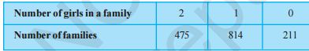

Compute the probability of a family, chosen at random, having (i) 2 girls (ii) 1 girl (iii) No girl

Also check whether the sum of these probabilities is 1.

3. An organisation selected 2400 families at random and surveyed them to determine a relationship between income level and the number of vehicles in a family. The information gathered is listed in the table below:

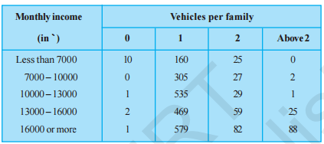

Suppose a family is chosen. Find the probability that the family chosen is

(i) earning ` 10000 – 13000 per month and owning exactly 2 vehicles.

(ii) earning ` 16000 or more per month and owning exactly 1 vehicle.

(iii) earning less than ` 7000 per month and does not own any vehicle.

(iv) earning ` 13000 – 16000 per month and owning more than 2 vehicles.

(v) owning not more than 1 vehicle

4. To know the opinion of the students about the subject statistics, a survey of 200 students was conducted. The data is recorded in the following table.

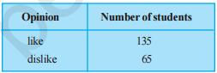

Find the probability that a student chosen at random

(i) likes statistics, (ii) does not like it

5. Eleven bags of wheat flour, each marked 5 kg, actually contained the following weights of flour (in kg):

4.97 5.05 5.08 5.03 5.00 5.06 5.08 4.98 5.04 5.07 5.00

Find the probability that any of these bags chosen at random contains more than 5 kg of flour.

6. frequency distribution table which gives the weights of 38 students of a class:

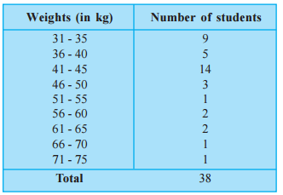

If we select random from class

a) Probability that student weight will be in 56-60 weight range

b) Probability weight will be greater than 40Kg.

c)probability weight will be less than 51 kg.

7. A study was conducted to find out the concentration of sulphur dioxide in the air in parts per million (ppm) of a certain city. The data obtained for 30 days is as follows: (In Air.csv)

(i) Make a grouped frequency distribution table for this data with class intervals as 0.00 - 0.04, 0.04 - 0.08, and so on.

(ii) For how many days, was the concentration of sulphur dioxide more than 0.11 parts per million?

(iii) find the probability of the concentration of sulphur dioxide in the interval 0.12 - 0.16 on any of these days.

8. Suppose 10,000 tickets are sold in a lottery each for Re 1. First prize is of Rs 3000 and the second prize is of Rs. 2000. There are three third prizes of Rs. 500 each. If you buy one ticket, what is your expectation.

8. A shopkeeper sells three types of flower seeds A1 , A2 and A3 . They are sold as a mixture where the proportions are 4:4:2 respectively. The germination rates of the three types of seeds are 45%, 60% and 35%. Calculate the probability

(i) of a randomly chosen seed to germinate

(ii) that it will not germinate given that the seed is of type A3 ,

(iii) that it is of the type A2 given that a randomly chosen seed does not germinate.

9. By examining the chest X ray, the probability that TB is detected when a person is actually suffering is 0.99. The probability of an healthy person diagnosed to have TB is 0.001. In a certain city, 1 in 1000 people suffers from TB. A person is selected at random and is diagnosed to have TB. What is the probability that he actually has TB?

10. An item is manufactured by three machines A, B and C. Out of the total number of items manufactured during a specified period, 50% are manufactured on A, 30% on B and 20% on C. 2% of the items produced on A and 2% of items produced on B are defective, and 3% of these produced on C are defective. All the items are stored at one godown. One item is drawn at random and is found to be defective. What is the probability that it was manufactured on machine A?

11. Suppose that 6% of the people with blood group O are left handed and 10% of those with other blood groups are left handed 30% of the people have blood group O. If a left handed person is selected at random, what is the probability that he/she will have blood group O?