Guideline

for

Heropa- Self paced labs

|  |  |  |  |
| --- | --- | --- | --- |
|  | Prepared By / Last Updated By | Reviewed By | Approved By |
| Name | Jayashree Mohan-288218 | M,Kandaswamy-155213 | M,Kandaswamy-155213 |
| Role | Senior Analyst | Project Manager | Project Manager |
| Signature |  |  |  |
| Date | 10-10-2023 | 10-10-2023 | 10-10-2023 |

|  |
| --- |
| ##ESIGN_PLACEHOLDER## |
| (please do not remove/edit this page/content) |

Table of Contents

1.0 Introduction 4

2.0 Accessing Heropa Lab 4

Introduction

This document helps to access the self paced labs of Heropa.

Accessing Heropa Lab

Click on the link provided to access the lab. For first time users the registration page will be displayed as given below.

Register using your Cognizant email ID. Password need not be necessarily Cognizant network password.

Once registered then login to your account. Your home page will be displayed as shown below. Click on start button to prepare your environment.

If it prompts to enroll, please enroll to the lab during login.

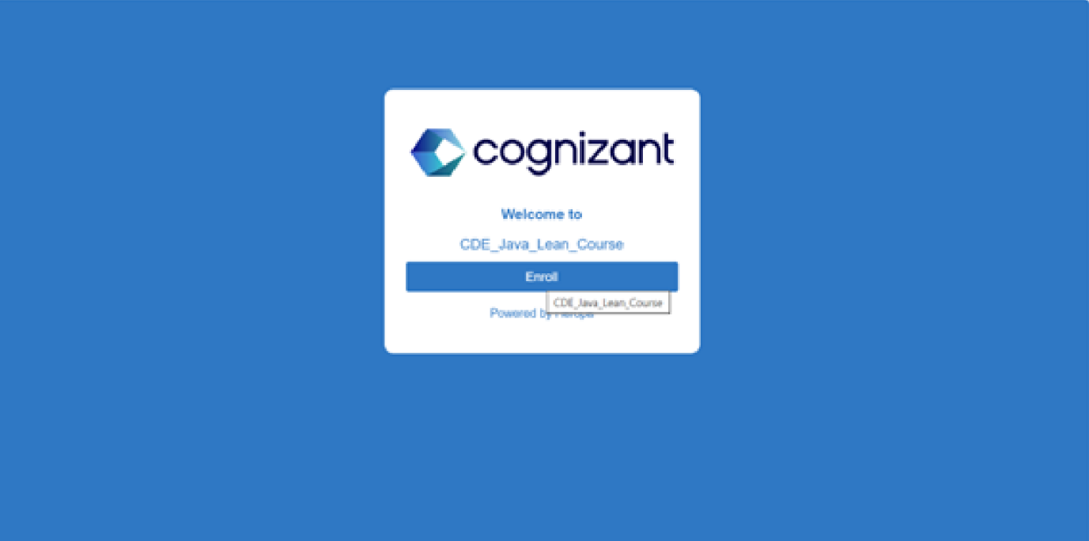

Click on view workspace button to start working in lab.

You are into the lab now! You can see the time left on the top right corner.

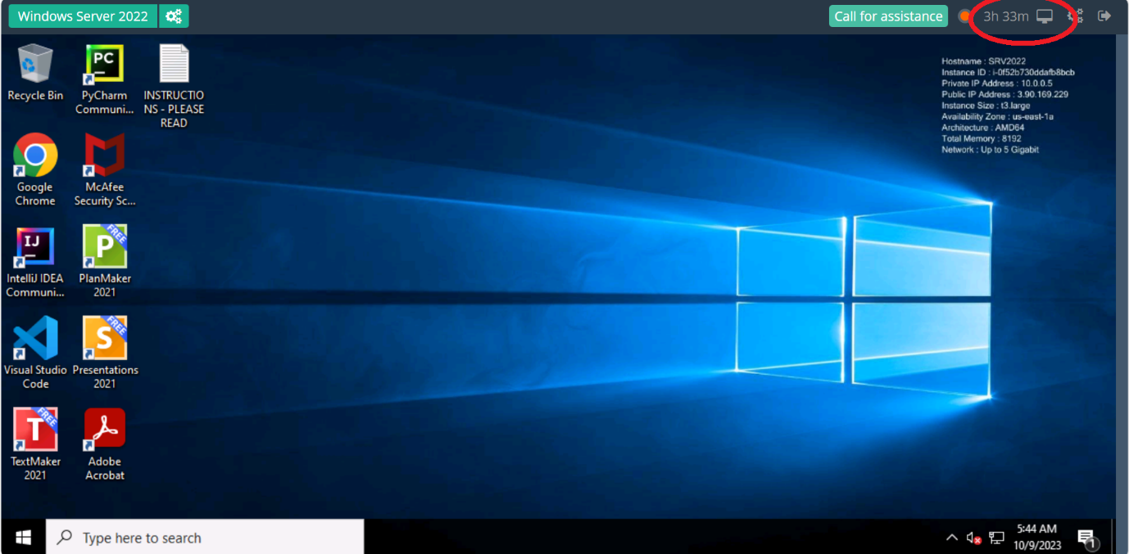

Look for Read the INSTRUCTION – PLEASE READ /Read me document for lab instructions.

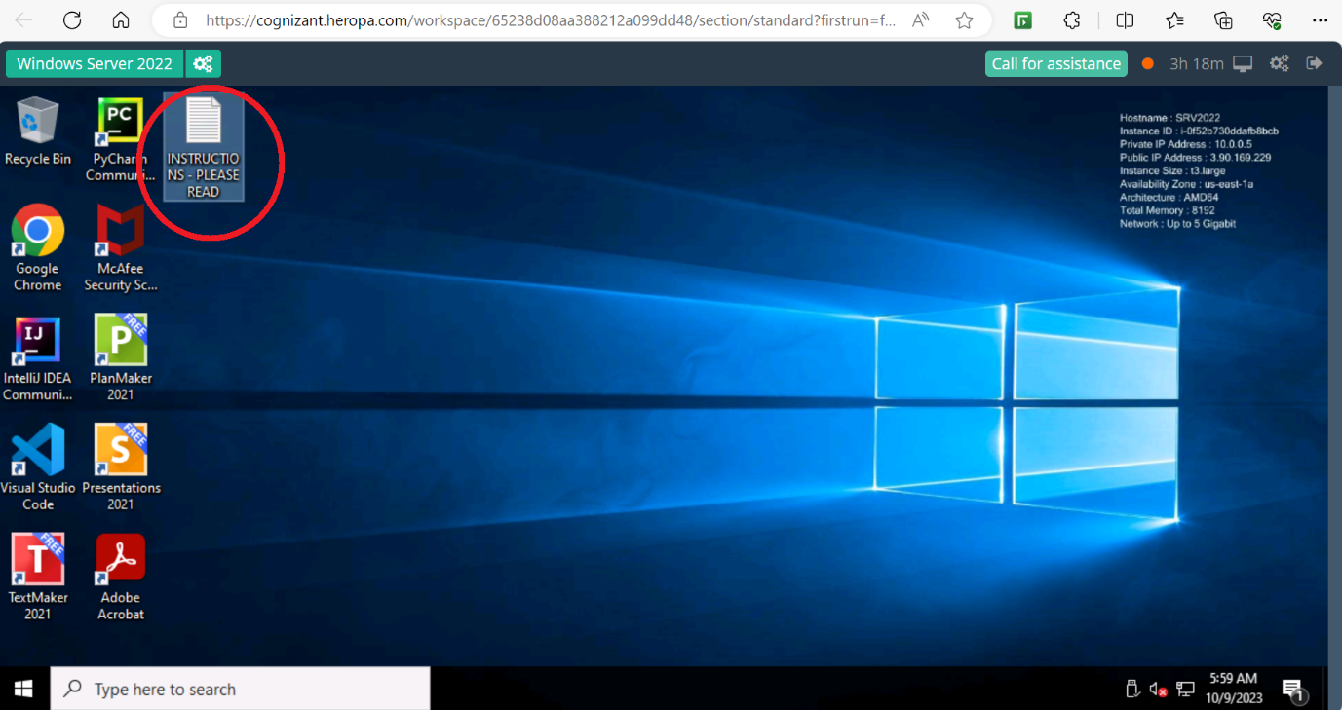

Support:

Troubleshooting issues after connecting to VDI Once you connect to the VDI if you face any performance issue or unable to launch any application please raise a GSD under Academy in OneCognizant (URL)

Text to be used while raising GSD:

|  |  |
| --- | --- |
| **Issue** | **Keyword to be used in GSD** |
| VDI performance issues | Academy VDI Performance Issue |
| Unable to access an URL inside VDI | Academy VDI URL Issue |
| Unable to access/find folder inside VDI | Academy VDI access Issue |
| Unable to access application inside VDI | Academy VDI application Issue |