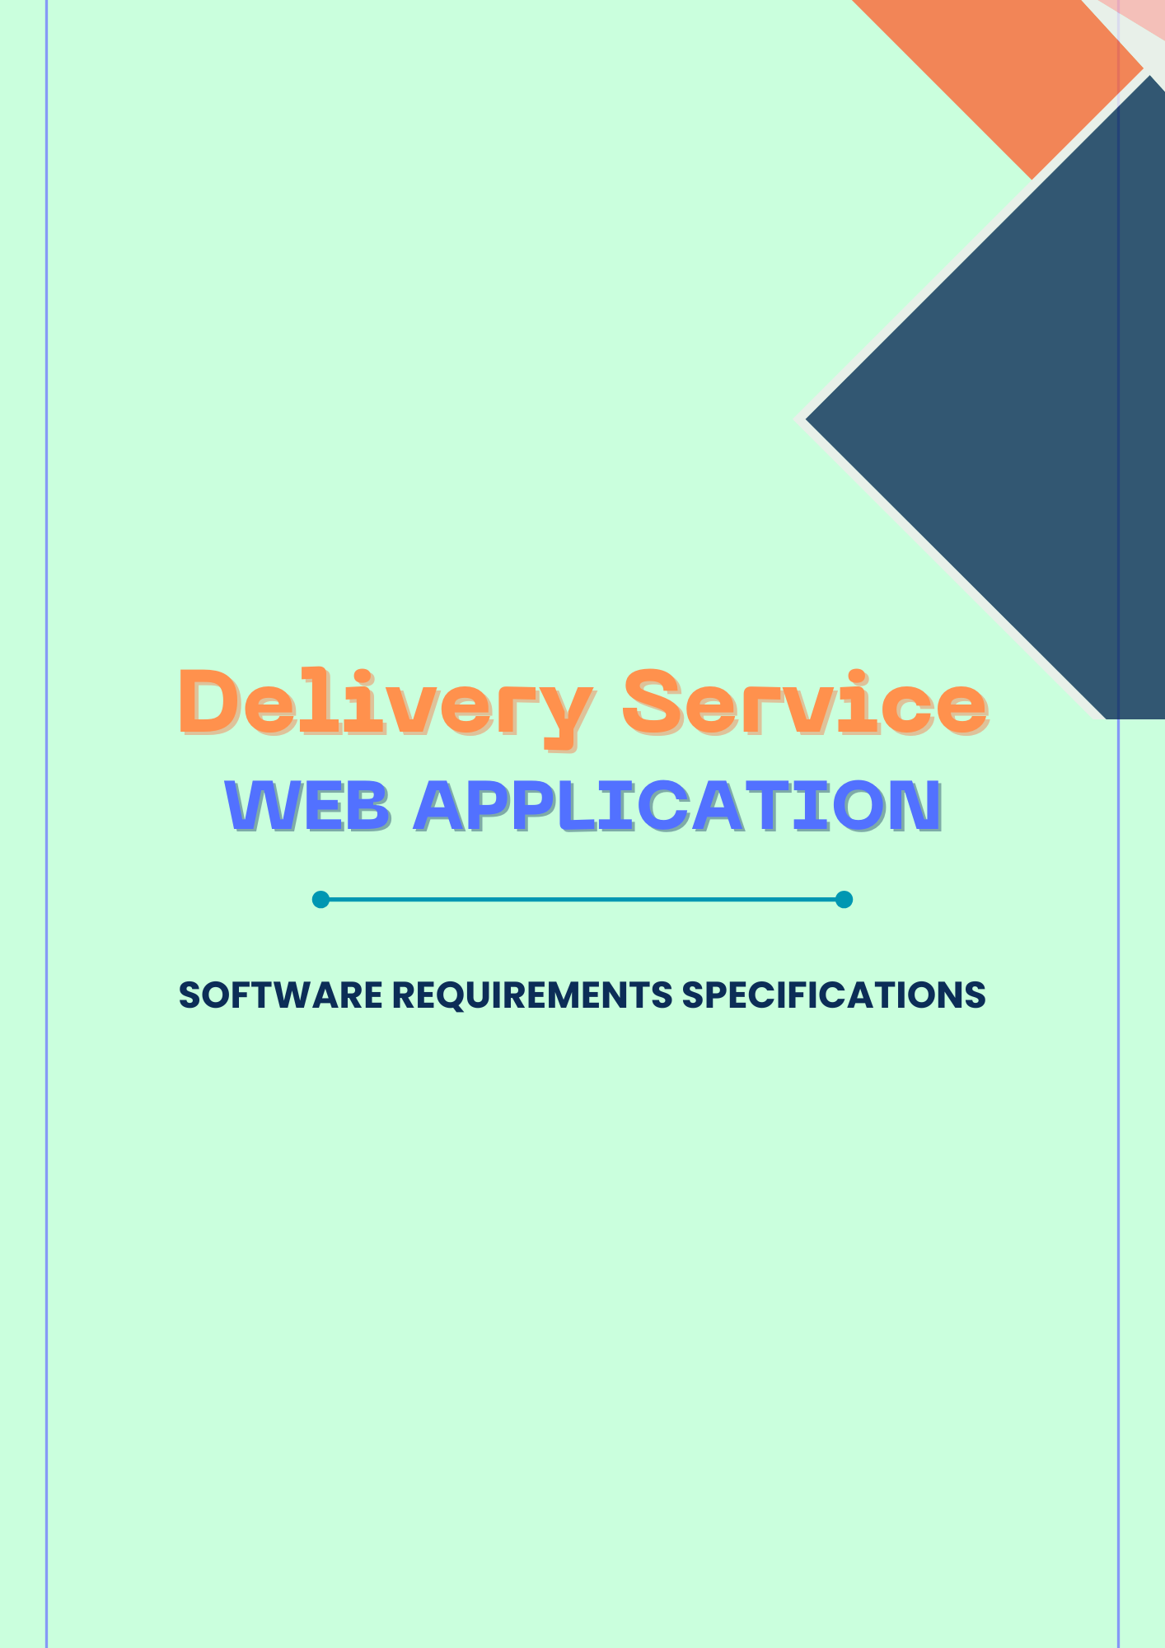

Contents

**1.** **Introduction** 3

1.1 **Purpose** 3

1.2 **Scope** 3

1.3 **Definitions, Acronyms, and Abbreviations** 4

1.4 **Overview** 4

**2.** **The Overall Description** 5

2.1 **Product Perspective** 5

2.1.1 **Hardware Interfaces** 5

2.1.2 **Software Interfaces** 5

2.2 **Product Functions** 5

2.3 **User Characteristics** 6

2.4 **Apportioning of Requirements** 6

2.4 **Assumptions and Dependencies** 6

**2.** **Specific Requirements** 8

3.1 **External Interfaces** 8

3.1.1 **User Interfaces** 8

3.1.2 **Software Interfaces** 9

3.1.3 **Hardware Interfaces** 9

3.1.4 **Communication Interfaces** 9

3.2 **Functional Requirements** 9

3.3 **Non-Functional Requirements** 10

3.3.1 **Performance Requirements** 11

3.3.2 **Logical Database Requirements** 11

3.3.3 **Design Constraints** 11

3.3.4 **Standards Compliance** 11

3.3.5 **Reliability** 11

3.3.6 **Availability** 11

3.3.7 **Security** 11

3.3.8 **Maintainability** 11

3.3.9 **Portability** 11

3.3.10 **Accessibility** 12

3.3.11 **Compatibility** 12

3.3.12 **Usability** 12

**4.** **Change Management Process** 13

**5.** **Document Approvals** 14

5.1 **Team One Approval** 14

5.2 **Team Two Approval** 14

**6.** **Supporting Information** 15

6.1 **System Context Diagram** 15

6.2 **Use cases of DSWA** 15

6.3 **Use case diagram** 15

# **Introduction**

The following subsections of the Software Requirements Specifications (SRS) document provide an overview of the entire SRS.

## 1.1 **Purpose**

The Software Requirements Specification (SRS) will provide a detailed description of the requirements for the Delivery Service Web Application (DSWA). This SRS will allow for a complete understanding of what is to be expected of the DSWA to be constructed. The clear understanding of the DSWA and its functionality will allow for the correct software to be developed for the end user and will be used for the development of the future stages of the project. This SRS will provide the foundation for the project. From this SRS, the DSWA can be designed, constructed, and finally tested.

This SRS will be used by the software engineers constructing the DSWA and the delivery service end users. The software engineers will use the SRS to fully understand the expectations of this DSWA to construct the appropriate software. The delivery service end users will be able to use this SRS as a “test” to see if the software engineers will be constructing the system to their expectations. If it is not to their expectations the end users can specify how it is not to their liking and the software engineers will change the SRS to fit the end users’ needs.

## 1.2 **Scope**

The delivery service web application streamline the process of tracking parcels and requesting delivery requests. The first subsystem is User Registration and Authentication, allowing customers, drivers, and administrators to create accounts with secure login functionality. It includes email verification and password recovery features to ensure account security. The second subsystem is Delivery Request, allowing customers to create a delivery request. The third subsystem is Parcel Tracking, allowing customers, and drivers to track the parcels. The forth subsystem is Profile management, enabling customers, drivers, and administrators to view and update their personal details and professional details respectively. The fifth subsystem is Feedback, enabling customers to give feedbacks. The sixth subsystem is Admin Dashboard, allowing administrators to manage customer accounts, driver accounts, and delivery requests. The seventh subsystem is Driver Dashboard, allowing drivers to update delivery requests.

The delivery service web application is to provide system to manage delivery requests and track parcels efficiently. Without automation, managing delivery requests has become an overwhelming task. The end user’s day-to-day jobs of managing delivery requests will be significantly simplified through the automated system. The system will handle various services to ensure quick and efficient management of delivery requests and user information. It should be user-appropriate, easy to use, provide easy recovery from errors, and offer high overall end user satisfaction. Additional features include an administrator dashboard for managing customers, drivers, and delivery requests, a feedback system for customers to give feedbacks about the service.

## 1.3 **Definitions, Acronyms, and Abbreviations**

SRS – Software Requirements Specifications

DSWA – Delivery Service Web Application

Subjective satisfaction – The overall satisfaction of the system

End Users – The people who will be using the system

## 1.4 **Overview**

The SRS is organized into two main sections. The first is The Overall Description and the second is the Specific Requirements. The Overall Description will describe the requirements of the DSWA from a general high-level perspective. The Specific Requirements section will describe in detail the requirements of the system.

# **The Overall Description**

## 2.1 **Product Perspective**

The Delivery Service Web Application (DSWA) as a separate independent system. It is fully self-contained.

### 2.1.1 **Hardware Interfaces**

The DSWA will be hosted on regular servers and can be accessed via common web browsers from devices such as desktops, laptops or tablets/ smartphones. The system will interface to simple hardware like keyboards and mice monitors.

### 2.1.2 **Software Interfaces**

Need to mention

## 2.2 **Product Functions**

**User Registration, and Authentication**

* Customers can create accounts
* Secure login functionality for all users
* Email verification and password recovery features

**Delivery Request**

* Customers can create delivery requests

**Track parcel**

* Customers, Drivers can track parcels

**Profile Management**

* Customers, Drivers, and Administrators can view and update their personal information

**Feedback**

* Customers can give feedbacks

**Admin Dashboard**

* Administrators can manage customer accounts, driver accounts, and delivery requests

**Driver Dashboard**

* Drivers can update delivery requests

## **User Characteristics**

* Educational Level: Low. But user should be capable of handling web applications
* Experience: No special training is needed for the basic operations, but some training may be required for the administrative tasks.
* Technical Expertise: Low; this is because the system is developed in a manner that can easily be understood and used by any lay person.

## 2.4 **Apportioning of Requirements**

Audio and video, other options can be considered as insignificant right now and thus are likely to be implemented later along with improvements.

## **Assumptions and Dependencies**

**Assumptions**

* User Connectivity: Assumes customers and drivers have reliable internet access for using the web application.
* Device Compatibility: Assumes compatibility across various devices (e.g., smartphones, tablets, desktops) for seamless user experience.

* Data Security: Assumes implementation of robust security measures (e.g., HTTPS, encryption) to protect user data and maintain privacy.
* User Competence: Assumes users (customers, drivers, and administrators) are competent in using basic digital tools required for registration, delivery requests, and accessing features.
* Delivery Service Provider Availability: Assumes delivery service providers maintain accurate availability information for parcel tracking.

**Dependencies**

* Email Services: Dependency on reliable email services for account verification and password recovery functionalities.
* Internet Service Providers: Dependency on ISPs for stable internet connectivity for both users and administrators.
* Database Management: Dependency on efficient database management systems for storing and retrieving user information, delivery request details, and feedback.

# **Specific Requirements**

This section contains all the software requirements at a level of detail, that when combined with the system context diagram, use cases, and use case descriptions, is sufficient to enable designers to design a system to satisfy those requirements, and testers to test that the system satisfies those requirements.

## 3.1 **External Interfaces**

The E-Channeling Web Application will use standard input/output devices typically available on personal computers and mobile devices. This includes the following:

* Keyboard
* Mouse
* Monitor
* Touchscreen (for mobile devices)

### 3.1.1 **User Interfaces**

The User Interface Screens are described in table 1.

**Table 1. Delivery Service Web Application User Interfaces Screens**

|  |  |
| --- | --- |
| Screen Name | Description |
| Login | Log into the system as a customer, driver, admin, and super admin |
| User Registration | Create new account as a customer, driver, admin, and super admin |
| Password Recovery | Recover or reset account password |
| Delivery Request | Request a parcel delivery |
| Track Parcel | Track parcels |
| Feedback | Give feedbacks |
| User Profile Management | View and update personal information |
| Driver Dashboard | Manage delivery request updates |
| Admin Dashboard | Manage customers, drivers, delivery requests |

### 3.1.2 **Software Interfaces**

The system shall interface with a MySQL database for storing user information, appointment details, and schedules.

### 3.1.3 **Hardware Interfaces**

The system shall run on various platforms, including personal computers and mobile devices, and be accessible through modern web browsers such as Google Chrome, Mozilla Firefox, Safari, and Microsoft Edge.

### 3.1.4 **Communication Interfaces**

The system shall support internet-based communication for functionalities like email verification, password recovery, etc. It will use standard protocols such as HTTP/HTTPS for data transmission

## 3.2 **Functional Requirements**

Functional requirements define the fundamental actions that a system must perform. The functional requirements for the system are divided into three main categories, Customers, Drivers, and Management/System Admin. For further details, refer to the use cases.

1. **Customer**
   1. User Registration and Authentication
      1. The system shall allow customers to create an account.
      2. The system shall implement secure login functionality for customers.
      3. The system shall include email verification features.
      4. The system shall include password recovery features.
   2. Create Delivery request
      1. The system shall enable customers to create delivery requests.
   3. Make a payment
      1. The system shall enable customers to make payments for delivery requests through the web application.
   4. Track Parcel
      1. The system shall allow customers to track their parcels.
   5. Profile Management
      1. The system shall allow customers to update their personal information.
   6. View Delivery Request
      1. The system shall enable customers to view past delivery requests.
   7. Feedback
      1. The system shall allow customers to give feedbacks about the service.
   8. Send Message
      1. The system shall enable customers to send messages.
2. **Driver**
   1. User Registration and Authentication
      1. The system shall implement secure login functionality for customers.
      2. The system shall include email verification features.
      3. The system shall include password recovery features.
   2. Profile Management
      1. The system shall allow drivers to update their personal information.
   3. Delivery Request Management
      1. The system shall allow drivers to mark delivered requests as delivered.
      2. The system shall enable drivers to view active delivery requests.
3. **Management / System Administration**
   1. User Management
      1. The system shall allow administrators to block customers, and drivers.
      2. The system shall allow administrators to add new drivers into the system.
   2. Delivery Request Management
      1. The system shall allow administrators to view active delivery requests.
      2. The system shall allow administrators to block active delivery requests.

## 3.3 **Non-Functional Requirements**

Non-Functional requirements define the needs in terms of performance, logical database requirements, design constraints, standards compliance, reliability, availability, security, maintainability, and portability.

### 3.3.1 **Performance Requirements**

Ensure the application responds quickly to user interactions and handles requests efficiently.

### 3.3.2 **Logical Database Requirements**

The logical database requirements include the retention of the following data elements. This list is not a complete list and is designed as a starting point for development.

Need to mention

### 3.3.3 **Design Constraints**

The Delivery Service Web Application shall be a stand-alone system running in a Windows environment. The system shall be developed using Java and a MySQL database.

### 3.3.4 **Standards Compliance**

There shall be consistency in variable names within the system. The graphical user interface shall have a consistent look and feel.

### 3.3.5 **Reliability**

Specify the factors required to establish the required reliability of the software system at time of delivery.

### 3.3.6 **Availability**

The system shall be available during 24 hours.

### 3.3.7 **Security**

Need to mention

### 3.3.8 **Maintainability**

The Delivery Service Web Application is being developed in PHP (Laravel). PHP is an object-oriented programming language and shall be easy to maintain.

### 3.3.9 **Portability**

Need to mention

### 3.3.10 **Accessibility**

Ensure the application is accessible to users with disabilities, complying with relevant accessibility standards.

### 3.3.11 **Compatibility**

Ensure the application works seamlessly across different devices, browsers, and operating systems.

### 3.3.12 **Usability**

Provide an intuitive and user-friendly interface that simplifies the requesting and tracking process for all users.

# **Change Management Process**

Changes to this document require approval from the project manager and the client.

# **Document Approvals**

## 5.1 **Team One Approval**

_______________ _______________

Client Date

## 5.2 **Team Two Approval**

_______________ _______________

Backend Developer Date

_______________ _______________

Frontend Developer Date

# **Supporting Information**

A system context diagram as well as use cases and use case descriptions that have been developed is as follows.

## 6.1 **System Context Diagram**

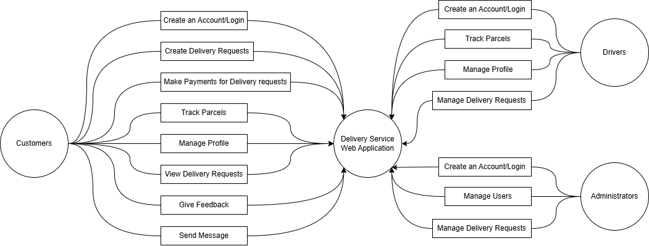Below shows the system context diagram created for the DSWA

## 6.2 **Use cases of DSWA**

## 6.3 **Use case diagram**