**Exercise 1**

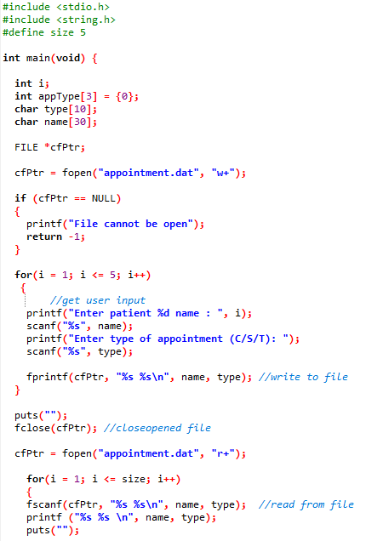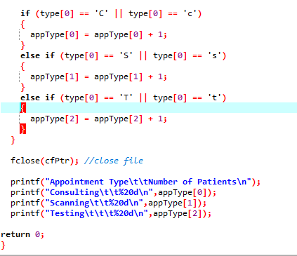

**Exercise 2**