Content

1. Data
2. Preprocessing
3. Proposed Architecture (CNN 1 gana kiyanna ona)
4. Generalization and training
   1. Data augmentation
   2. GPU use kala name ka gana wisthara
   3. Python libraries monawada hoda result 1k dunna

**********In this chapter, a fully automated two-stage procedure to detection of hard exudates from digital fundus image is presented. The procedure is initiated using a preprocess method for fundus image. Then the preprocessed image is used to eliminate the optic disc for exudates detection. The next step of the algorithm explains process of exudates detection. Finally, the exudates are classified as hard exudates using fuzzy logic. ***********

In this chapter, a cnn model to detect hand gestures for a Sinhala letter is presented. This procedure is initiated using a preprocess method for hand gesture images. Then the preprocessed images are used in the feature extraction process in CNN model. To do that the preprocessed image is going through some processing steps inside the CNN model. Finally, the model will predict the sinhala letter for corresponding hand gesture by using a desktop application which is connected to the server

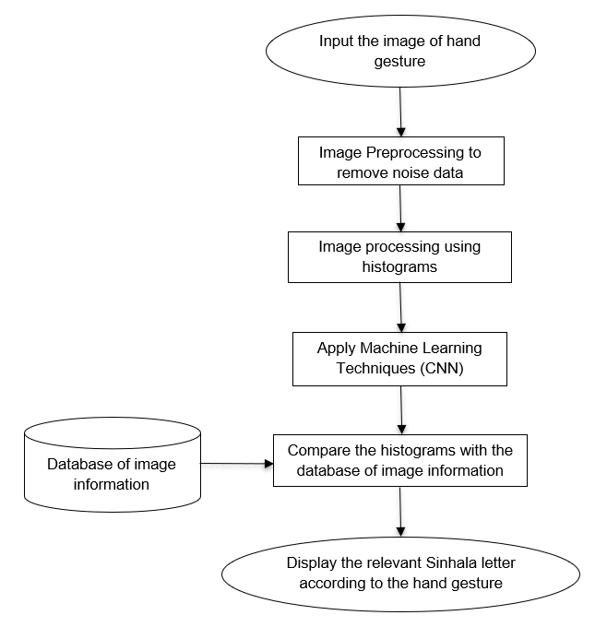

**Image Processing (What is image processing)**

An image is nothing more than a two dimensional signal. It is defined by the mathematical function f(x,y) where x and y are the two co-ordinates horizontally and vertically. The value of f(x,y) at any point is gives the pixel value at that point of an image.

Image processing is a method to perform some operations on an image, in order to get an enhanced image or to extract some useful information from it. It is a type of signal processing in which input is an image and output may be image or characteristics/features associated with that image. Nowadays, image processing is among rapidly growing technologies. Image processing has extensive applications in many areas, including astronomy, medicine, industrial [robotics](https://www.britannica.com/technology/robotics), and remote sensing by satellites.

There are two types of methods used for image processing namely, analogue and digital image processing. Analogue image processing can be used for the hard copies like printouts and photographs. Image analysts use various fundamentals of interpretation while using these visual techniques. Digital image processing techniques help in manipulation of the digital images by using computers. It spans a wide variety of topics such as digitization, histogram manipulation, warping, filtering, segmentation, restoration and compression

Some of the image processing techniques are pre-processing, enhancement, morpho

The three general phases that all types of data have to undergo while using digital technique are pre-processing, enhancement, and display, information extraction.

Here we are using digital image processing in this research

**Dataset**

**(image dataset per class kiyala graph 1k add karanna puluwan)**

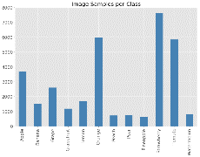

First, we need to collect our data and put it in a form the network can train on. This involves collecting images and correctly labeling them. This dataset is originally obtained and produced for purpose of this research. In this research as a limit we only detecting static hand gestures by using our model.

In Sinhala alphabet, there are 60 letters. Among those, 26 letters have static hand gestures while other letters have dynamic hand gestures. So we are only consider those 26 sinhala letters which are having static hand gestures. So there are 26 categories of letters we have to recognize by the CNN model. Also we are only taking the right hand of the people for take images. Because by the rotation function which we have in the model we are implementing this application, the image will give the mirror images. Then it will become the images of the left hand.

**We use color images for the dataset in this research. They are close-ups of hands that span the majority of the image surface.** (meka research paper 1ka wakyak). We used a green color for the background of the image which the hand held against a green color background. Because the furthest color from the skin color is green. Some of the images have a considerable difference with other images while some hand gestures of images have slightly difference with other hand gesture images

How dataset separate?

The dataset is divided into two categories. One is training set which are we going to use to train our model. The other category is test set which we are going to test our model and take decisions (e results matha). As further describe of the training set and test set of our dataset, there are 10 images have in one category. So there are total number of 260 images in the dataset. And there are 3 images in one category in our dataset. So there are total number of 78 images in our test set. As a result of that, the whole dataset contains 338 images. If this describe with persentages, there are 75% of training images have in our dataset. And there are 25% of test set images have from the whole dataset. This partitioning ratio is an important aspect. if number of points in the whole data set is large then any division may work fine but this data set is limited, division ratio may play a crucial role. So in this research we use the same split ratio used as in the sklearn package

**Preprocessing**

Preprocessing is used to prepare our dataset before fed it into the CNN model to train. **Preprocessing** refers to all the transformations on the raw data before it is fed to the machine learning or deep learning algorithm. For instance, training a convolutional neural network on raw images will probably lead to bad classification performances ([Pal & Sudeep, 2016](https://ieeexplore.ieee.org/document/7808140/)). The preprocessing is also important to speed up training (for instance, centering and scaling techniques, see [Lecun et al., 2012; see 4.3](http://yann.lecun.com/exdb/publis/pdf/lecun-98b.pdf)). - <https://www.freecodecamp.org/news/https-medium-com-hadrienj-preprocessing-for-deep-learning-9e2b9c75165c/>

In this research we are using the convolutional neural network to categorize the images into 26 hand gesture categories. For a CNN model, it needs a very little preprocessing. Also data do not get truly *pre*-processed in Keras, Instead the image preprocessing is doing by the model itself when the images are training. So we don’t need to worry about to apply image preprocessing techniques like *(****mean normalization****,****standardization****, and****whitening)***------------------- for the image dataset.

We wouldn’t be able to say what type of preprocessing of image is needed before feeding it into the Deep Network for feature learning. the suitable preprocessing depends on our problem domain.

So if we consider our research problem domain, all the images are taken under same parameters like background color, same side of the hand in this research. So we don’t need to apply lots of images preprocessing techniques. Therefore we have applied only two suitable image preprocessing techniques.

We have rescale our images. All images are same rectangular size shaped. it’s time to scale each image appropriately. We’ve decided to have images with width and height of 255 pixels. We’ll need to scale the width and height of each image by a factor of 1./255. There are a wide variety of up-scaling and down-scaling techniques and we usually use a library function to do this for us.

Also we did resizing. The original image is 2448 * 3264. We have resized it into 128 * 128. **we do resize our image during the pre-processing phase because** some images captured by a camera and fed to our CNN model vary in size, therefore, we should establish a base size for all images fed into our CNN model

**Proposed Architecture**

Uses Convolutional Neural Networks (CNN) in real time to translate a video of a user’s SSL signs into the letter. This is done by 3 steps

1. Obtaining video of the user signing (input)

2. Classifying each frame in the video to a letter

3. Reconstructing and displaying the most likely letter from classification scores (output)

CNN

Image processing can be done

With the dawn of a new era of A.I., machine learning, and robotics, its time for the machines to perform tasks characteristic of human intelligence. Machines use their own senses to do things like planning, pattern recognizing, understanding natural language, learning and solving problems. And Image Recognition is one of its senses!!!

From Automated self-driven cars to Boosting augmented reality applications and gaming, from Image and Face Recognition on Social Networks to Its application in various Medical fields, Image Recognition has emerged as a powerful tool and has become a vital for many upcoming inventions.

Nowadays we can create our own Image Recognition Classifier with a few lines of code, thanks to the modern day machine learning libraries.

Used for image classification and recognition

Network learns to extract features automatically while training

Advantages

Easy to train

Have fewer parameters than fully connected networks with the same number of hidden neurons

The Keras library in Python makes it pretty simple to build a CNN.

Convolutional 2D

Max Pooling

Activation layer

Fully Connected Layer

**Data Augmentation**

* **Increase the amount of training data using our original training data**
* **Prevent the classifier from overfitting[1][3]**
* **Augmentation methods**
  + **Shear shifting**
  + **Zoom shifting**

**Evaluation Metric**

**Implementation**

Final Product