**Overview**

The Guide is prepared to help with understanding the playground library and different concepts. The library provides basic functionalities to create sites, load kids into the system, execute kid’s enrollment to the sites in a multithreaded way with background analytical process in place to generate report for site utilization, duration spent at site by each kid, real time screen to view active and waiting kids on the system and total visitor count.

**Application packaging and class structure**

Technologies used to build this app is Java 8, Spring boot and Maven.

The application contains the below package structure, tried to provide a meaningful naming convention wherever possible for easy understanding of the code.

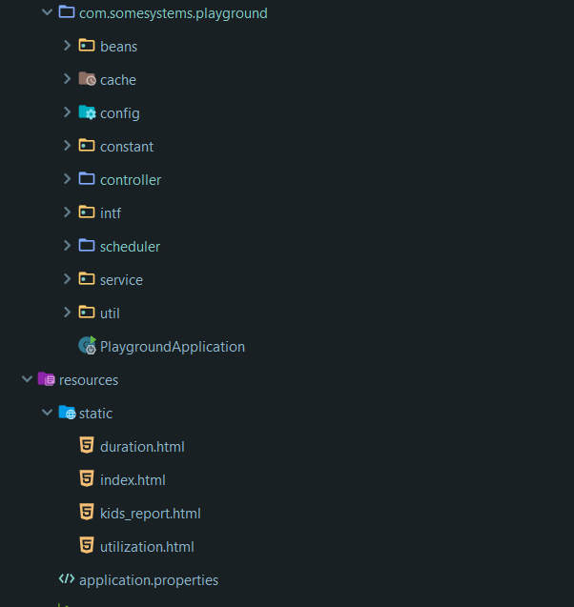

As the application is built using spring boot 2, there is a very minimal configuration required to run the app. The only configuration which possibly you want to modify is application.properties for the rate of utilization scheduler. The application uses in memory cache for most of its functionalities.

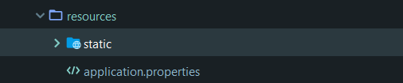

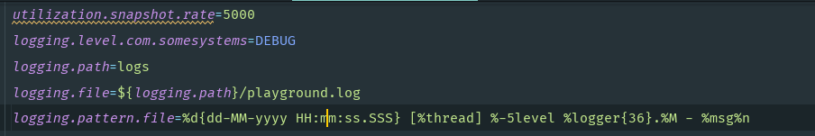

The endpoint of the application are located under controller package, to understand the endpoint please go through the README.md file. Most of the endpoint can be accessed through the UI

<http://localhost:8080/index.html> or <http://localhost:8080/swagger-ui.html>

Since this is a library and you may want to use this library as a dependency in other project, you can very well inject/auto wire PlaygroundService class and access the relevant functionalities.

**Running the application**

Make sure you are able to compile and build the application post cloning from github or downloading the archive into your IDE and once you have an error free workspace.

Run the below command to run the application as a spring boot application.

*$ mvn clean install spring-boot:run*

Alternatively if you are using IDE you can even run PlaygroundApplication.java as a standalone java program. This will start the application at 8080 port.

Once you are able to run the application, please access the UI at <http://localhost:8080/index.html>

You should be able to view the front end page as below:

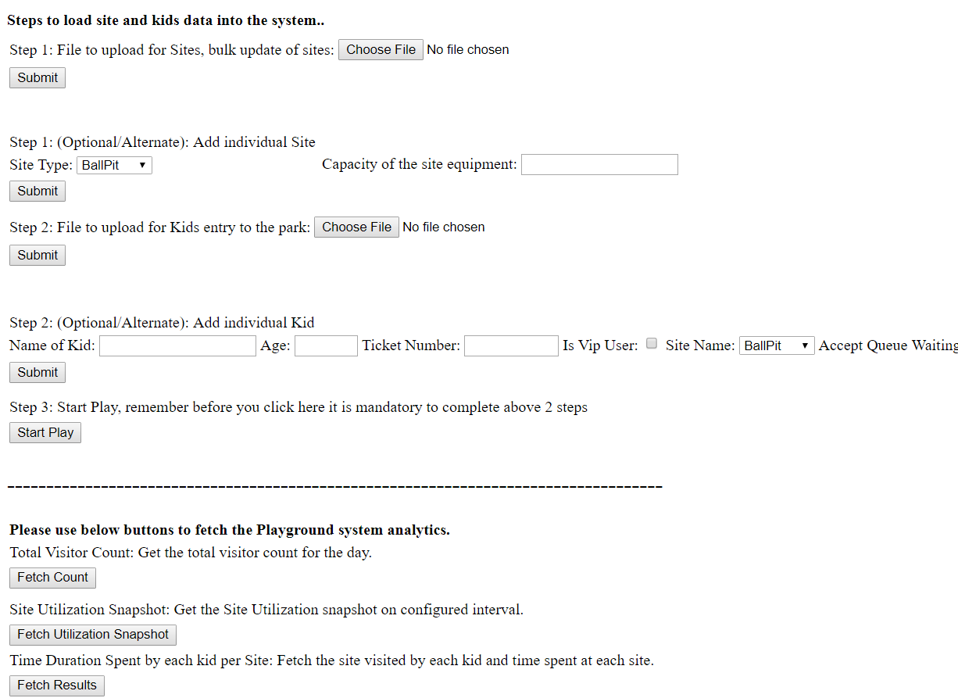

Kindly follow the Steps as directed on the page. Step 1 , Step 2 etc for proper functioning of the system.

For Step 1 and Step 2, if you wish to load data in bulk, there is sample csv under ROOT/csv folder. Feel free to modify the csv before you upload into the system. By default the csv is populated with enough data to carry on the functioning. I have provided screenshot below for your reference

**Step 1**: Load Site Data. (Bulk)

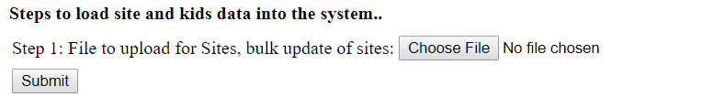

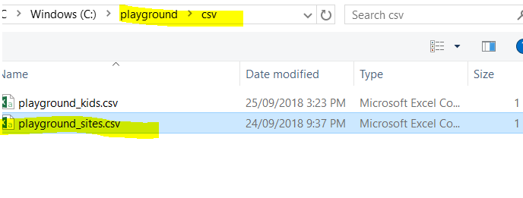

**Step 2**: Load Kid Data(Bulk)



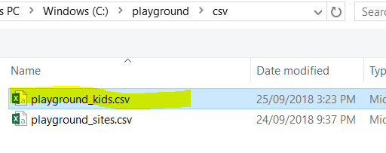

**Optional Step (for 1 and 2):** You may even want to load individual site and kid’s data. The UI has links to those below the step 1 and 2 respectively. Fill the required information and click on submit to load site/kid data into the system.

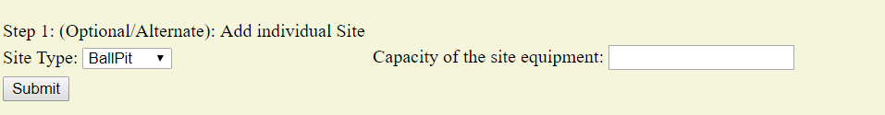

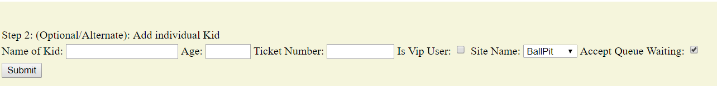

**Step 3:** Click Start the play, which is nothing but enrolling the kids to the sites and executing the actual play (swing, slide etc) for specified duration.

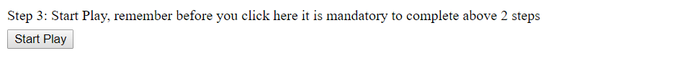

On Click on start play you can see the message like :

Play Started, Monitor logs. Or access <http://localhost:8080/kids_report.html>

As well you will be redirected to above mentioned link automatically to view the active kids playing at each kids and kids waiting in queue, the page refresh every 5 s to bring the new data(like queued kids moved to active status and so on)

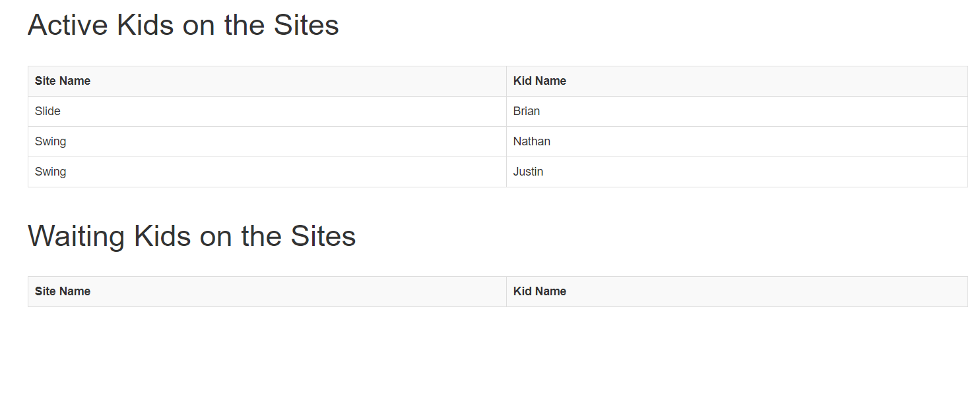

You can also monitor log files or console logs on the system. The logs are located under ROOT/log folder.

The logs also display all the necessary information related to active and waiting kids on the sites.

**Analytics :**

The same UI link can be used to access analytics like site utilization etc.

**Visitor Count: Display total visitors on the given day, returned as plain text.**

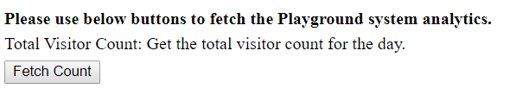

Result



**Site Utilization snapshot (Each site utilization in % calculated on an interval of specified time period)**



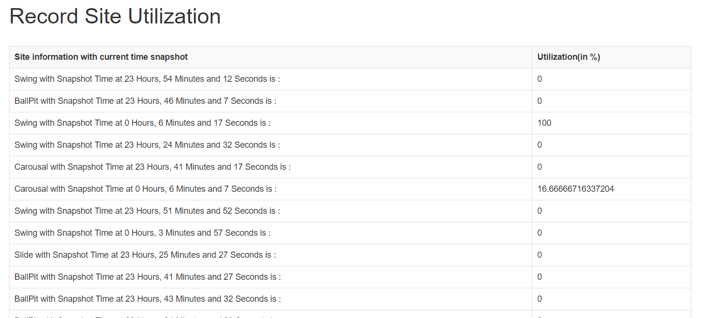

**Duration spent by the kid at each Site**



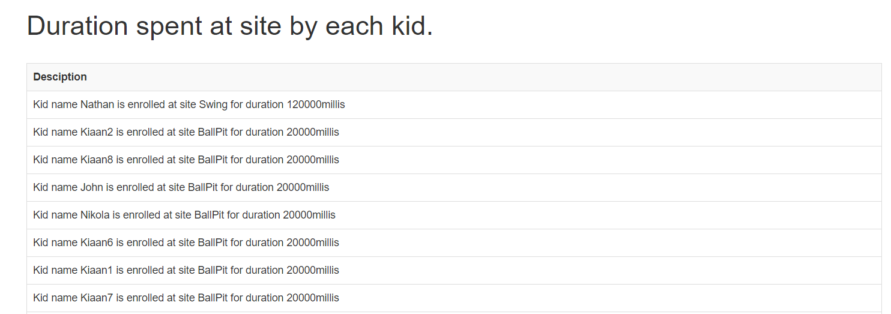

**Summary:**

The application is designed to best suit the need of the requirements and time frame in which in need to be developed and hence certainly there are assumptions made while designing this library. There are definitely areas of improvements and I look forward to the feedback.

Please pardon me if you feel the UI is bit clumsy, I mainly created this UI only for demo purpose and it can certainly be a lot better. Otherwise without a UI screen it would be very hard to justify the functionality of the application.