CA3 – AGENTIC AI

Course / Subject: Agentic AI
Course Title:
Course Duration (minimum 45 hours):
Faculty:
Division:

Introduction to Agentic AI
Objective
Key Concepts Understood

Understanding of Agentic AI
What is an AI Agent?
An AI agent is a software program that uses the information available to it to choose actions towards a goal. It does not need a person to decide every small step. It can use tools, check the result of an action, and use that feedback to plan its next step.
An agent needs a goal, information to observe, a way to make decisions, and tools to carry out tasks. A language model can help it understand and generate text, while the workflow connects its decisions to actions and keeps track of earlier steps.
In StudyBuddy, the goal is to help a student revise difficult topics. The agent reviews the notes, answers, and scores, then chooses an explanation, a worked example, simpler teaching, or more practice. LangGraph manages the flow between these steps. The tutor follows the app's limits, and the student chooses whether to take another quiz.

Courses Completed (multiple courses as applicable)

Course Details
  - Course Title:
Platform / Provider:
Course Duration (minimum 45 hours):
Completion Evidence:
  - Course Title:
Platform / Provider:
Course Duration (minimum 45 hours):
Completion Evidence:

Problem Statement

Problem Statement
Students often read their notes several times but still find it difficult to identify which topics they have not understood. Making practice questions and checking answers also takes time. A score alone does not explain why an answer is wrong. StudyBuddy helps with this problem by creating quizzes from study notes, checking answers, and explaining the concepts a student needs to revise.

Proposed Solution

Project Title
StudyBuddy - Adaptive AI Learning Assistant Using LangGraph

Project Description
StudyBuddy is a web application that helps students revise their notes through quizzes and explanations. The student pastes notes, chooses the number of questions and difficulty, and starts a study session. The AI tutor prepares a quiz and reviews the answers. For a wrong answer, it explains the concept in simple words, gives an example, and adds useful information beyond the notes. It can then suggest another quiz to practise the weaker topics. If the notes are unclear, it can ask the student for more information.

Agent Workflow and Roles
The project uses one AI tutor with six possible actions: create a quiz, explain a concept, give a worked example, simplify an explanation, ask for clarification, or finish the session. The tutor chooses an action based on the notes, answers, scores, and feedback from earlier steps. For another quiz, it can choose the topics, difficulty, and whether to ask basic recall questions or questions that apply a concept.
LangGraph connects these steps and keeps track of the study session. Its state stores details such as the notes, questions, answers, and scores. Conditional edges send the session to the step selected by the tutor. The workflow pauses when the student needs to answer and continues after a response. Python checks the quiz format and calculates the score. This makes the project agentic because the tutor uses the result of each step to decide what to do next. The student still chooses whether to take another quiz.

Implementation

Technologies Used
Programming Language: Python 3.12
LLM / AI Model: GPT-OSS 20B hosted by Groq; model ID: openai/gpt-oss-20b.
Agent Framework: LangGraph 1.2.16 with StateGraph, shared state, conditional edges, interrupts, and checkpointing.
Tools / APIs: Groq OpenAI-compatible HTTP API; Requests 2.34.2 for HTTP calls; Pydantic 2.14.1 for schema validation; JSON Schema for structured model output.
Database / Storage: LangGraph InMemorySaver checkpoints and Streamlit session state. Markdown study-summary downloads and JSON evidence exports; no persistent database.
Frontend: Streamlit 1.66.0 with custom CSS for layout and styling.
Backend: Python modules in backend/studybuddy for agent decisions, graph execution, model requests, source retrieval, validation, scoring, and exports. Runs within the Streamlit application process.
Hosting: Streamlit Community Cloud for the web app and Groq Free plan for inference. The API key is stored server-side in Streamlit Secrets.
Implementation Steps
1. Organise the project into separate folders for the interface, backend, tests, and documentation.
2. Add a notes input box and options for the number of questions, difficulty, and score goal. Check that the notes contain enough text.
3. Connect the app to GPT-OSS 20B through Groq so it can generate questions, explanations, and examples.
4. Build the study workflow using LangGraph. Keep the session details between steps and pause when the student needs to respond.
5. Generate three to five multiple-choice questions from the notes. Check the question format and compare the answers with the answer key to calculate a score.
6. Send the results to the AI tutor. Let it choose how to explain the missed concepts and what practice to suggest next.
7. Add progress history, a downloadable summary, and a retry option that keeps submitted answers. Test the complete study flow.
8. Deploy on Streamlit Community Cloud, save the Groq API key privately, and check the public app from a new browser.

Session Limits
Each session allows up to three quiz rounds. The tutor must explain missed concepts before moving on, and repeated requests are limited. If Groq's free usage limit is reached, the app waits briefly and retries. A stopped request can be tried again without losing submitted answers. The separate example mode uses fixed practice content.

Final Project Demonstration

Prototype / Application Link
https://flexi-agenticai-v5z2sxuprwkupywyvkepc9.streamlit.app/

GitHub Repository
https://github.com/shanvsrivas/Flexi-AgenticAI
Demonstration
Open the prototype link in a browser, paste study notes, choose the quiz settings, and start learning. Answer the questions and submit them to see the score. Include a wrong answer to show how the tutor explains a weak concept with an example and extra information. If another quiz is suggested, try it and check the progress tab. Finally, download the study summary. Visitors do not need to install a model or enter an API key. The screenshots below show the notes screen, quiz, feedback, answer review, progress, and downloaded summary.
The updated project passed 63 automated checks. The public app was also checked for live quiz generation, scoring, concept explanations, summary downloads, separate visitor sessions, and a phone-sized layout.

Testing and Evidence
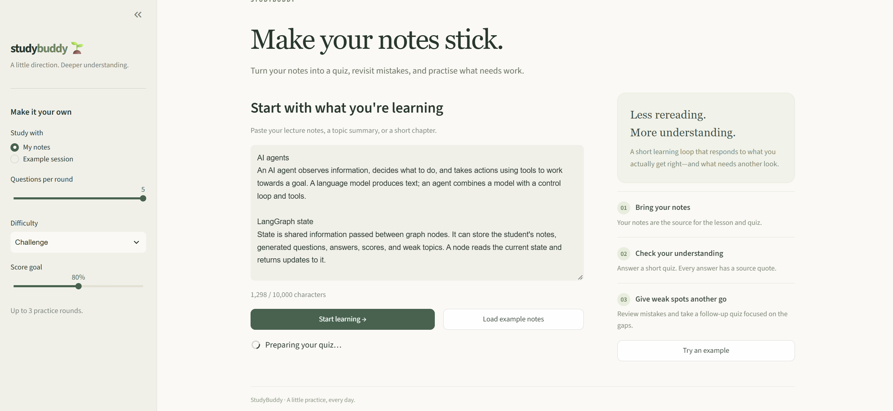
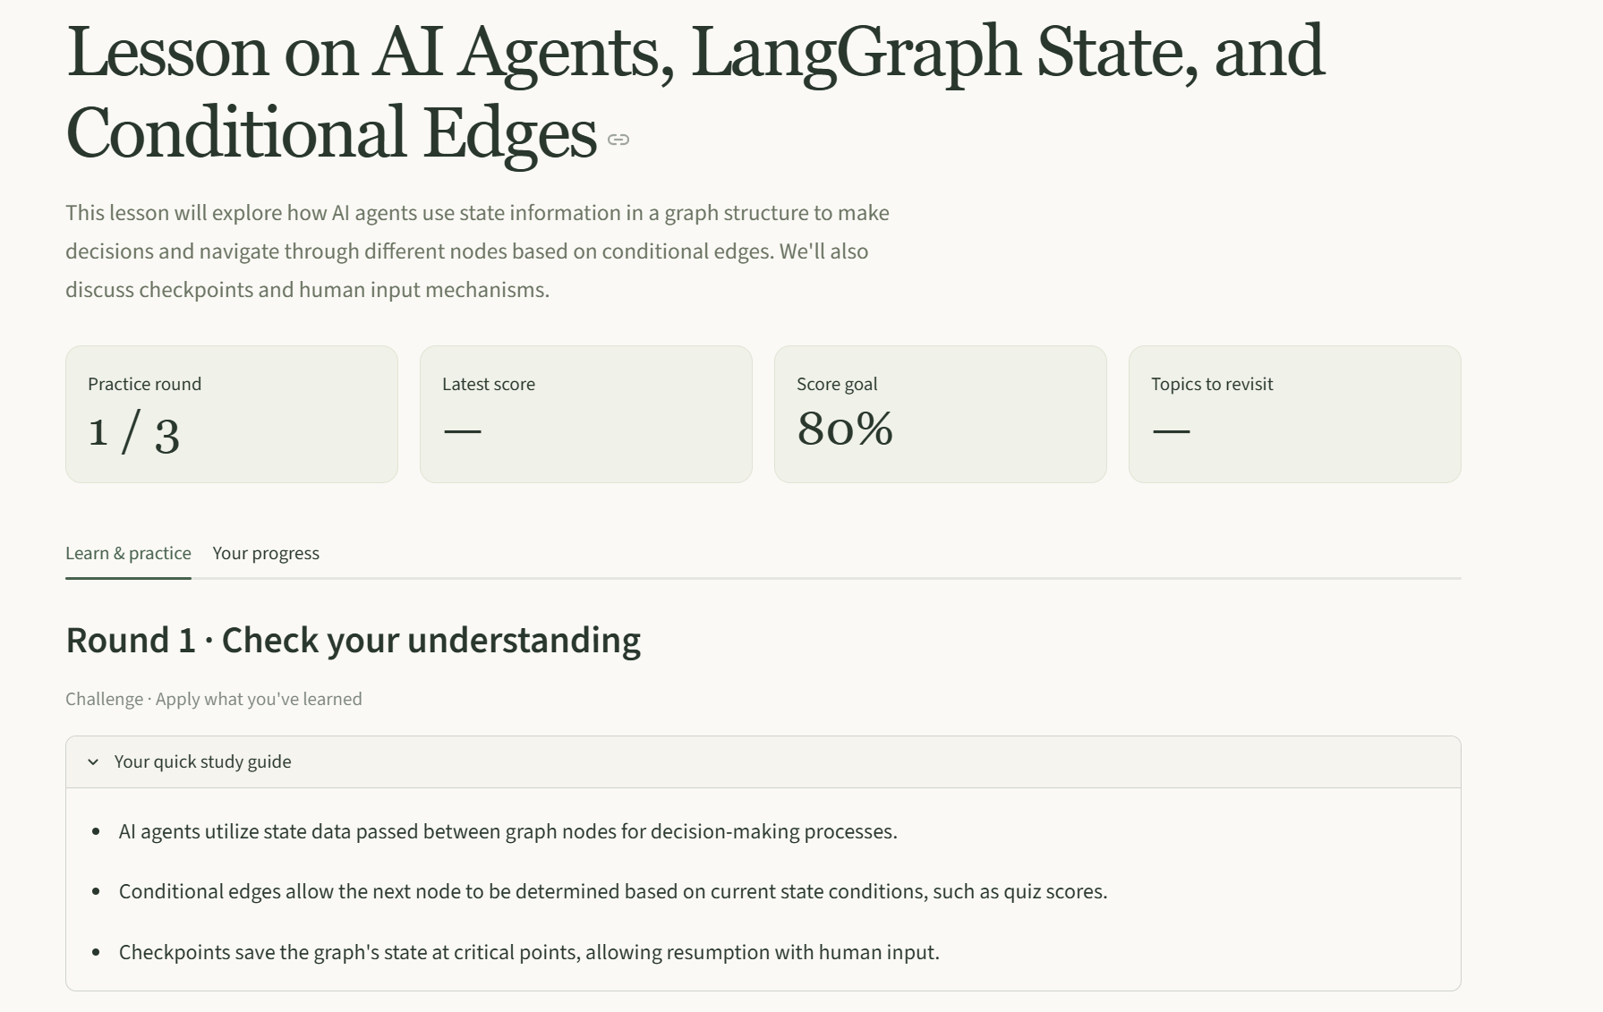
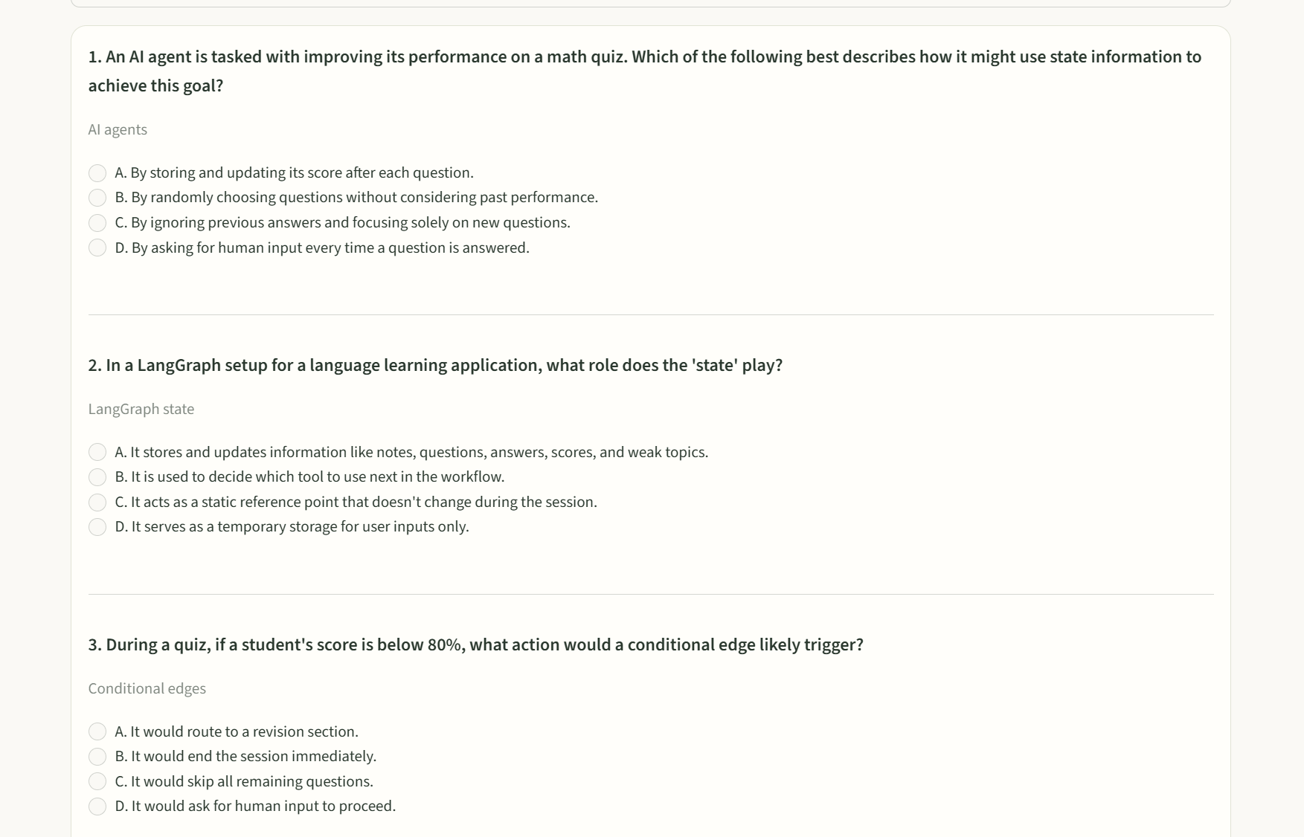
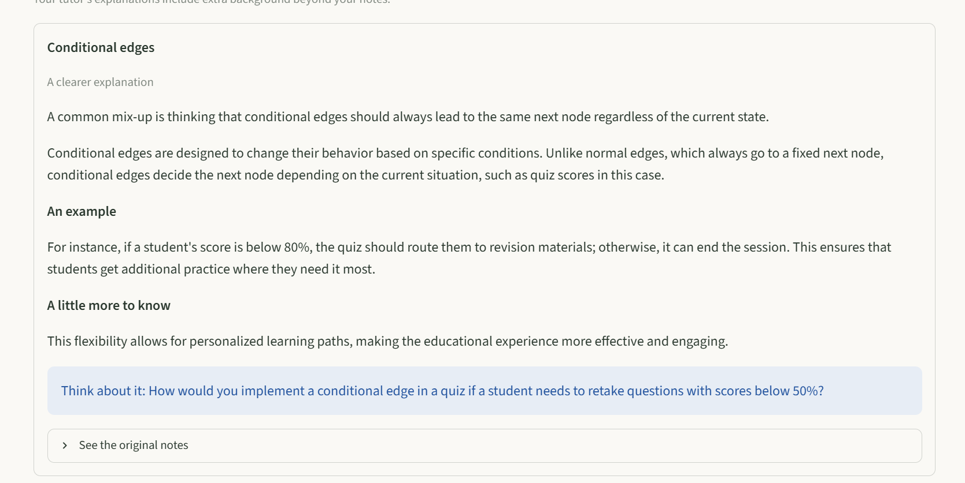
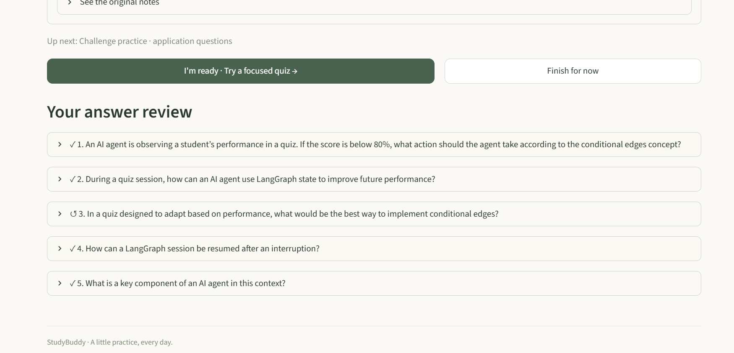
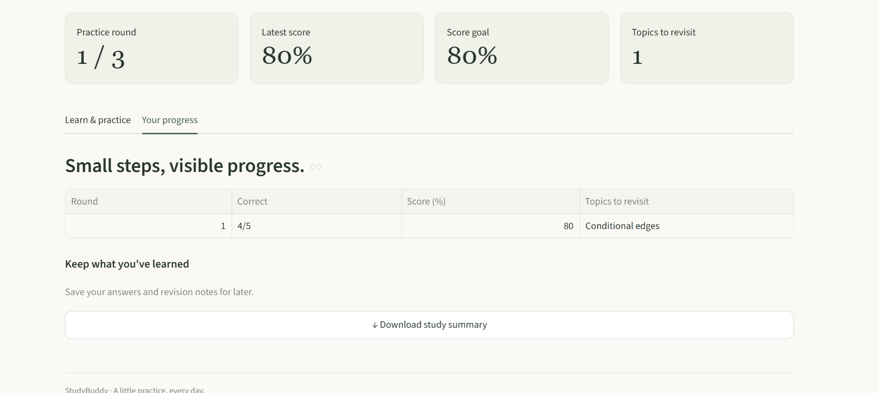
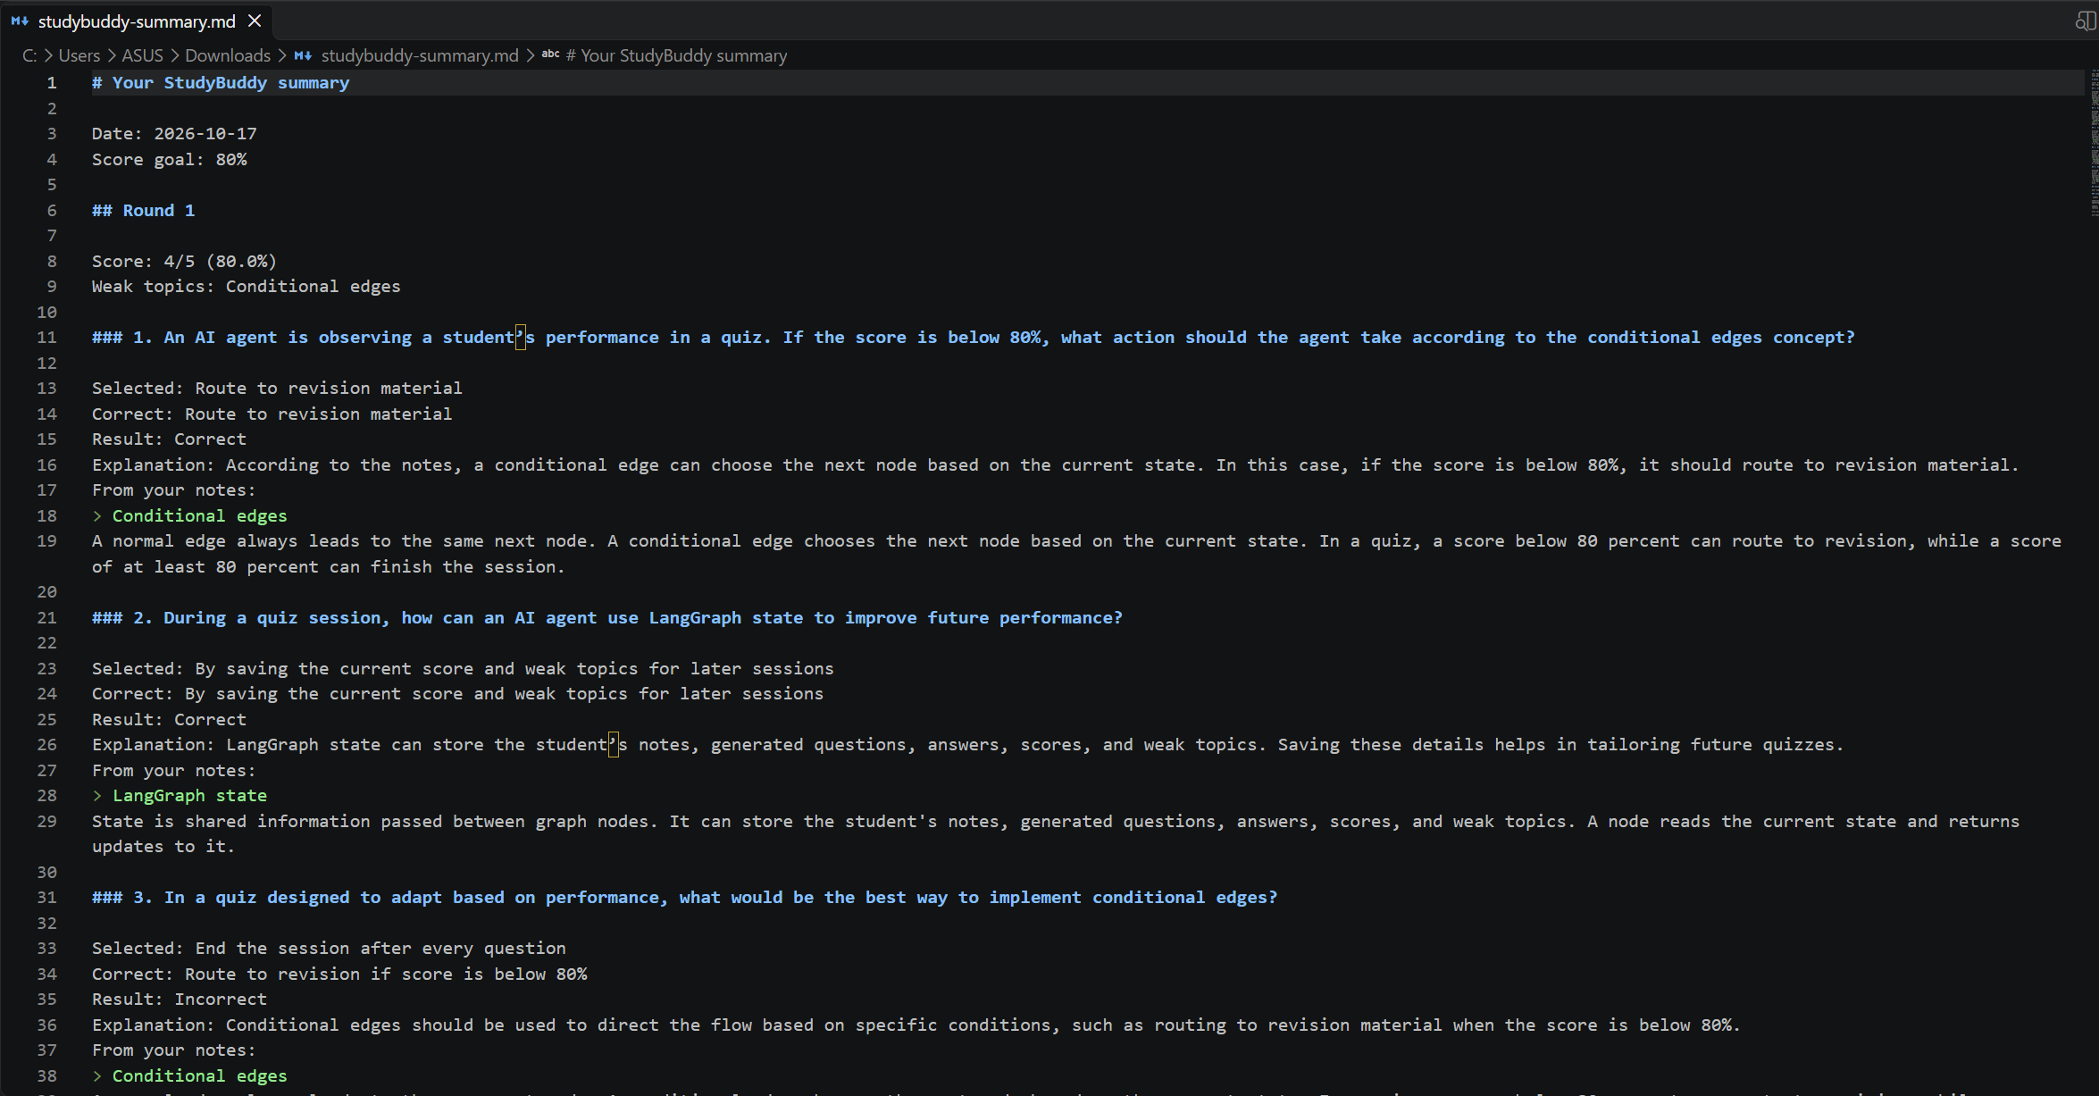

- Conclusion
StudyBuddy shows how AI agents and LangGraph can be used to build a useful study tool. It goes beyond generating questions by checking the results and choosing what help to give next. The explanations and examples help students revisit topics they answered incorrectly.
The project combines AI decisions with simple Python checks. The AI chooses the teaching approach, while Python calculates scores and keeps the session within its limits. The tutor can still make mistakes, so generated answers and extra information should be reviewed. Progress is stored only while the app is running, and the free service can sometimes require a short wait. Future improvements could include saving progress, uploading notes as files, and adding a fixed rule to lower difficulty after repeated low scores.
AI coding assistance was used during development. The project code is available in the GitHub repository.

