Bolton health and wellbeing overview - test in markdown

Table of Contents

2 Introduction 2

3 Key messages 2

4 Our people 2

4.1 Population size and structure 2

Date: 04/03/2020

.

# Introduction

Bolton has an ambitious Vision for 2030: In 2030, we want Bolton to be a vibrant place build on strong cohesive communities, successful businesses and healthy, engaged residents. It will be a welcoming place where people choose to study, work, invest and put down roots. To support the achievement of the Vision, the council and its partners will need to ensure that strategies and decision making are informed by shared and robust insight and intelligence on the existing strengths and challenges, and evidence of what will work to deliver improved outcomes for residents and the town.

Bolton’s Joint Strategic Needs Assessment (JSNA) is a set of local arrangements that create a shared picture of health and wellbeing of Bolton residents, and the local factors acting to influence health of people in the borough. JSNA activities and products support a focus on improving outcomes for everyone across the short, medium and long term. The process is distinct from performance management. This document draws together a selection of key population health indicators from a range of sources to give an overview of the health and wellbeing of Bolton residents.

# Key messages

* Bolton’s resident population is 285,400 (mid year 2018), but it has a lower GP registered population
* The resident population in Bolton has increased by an estimated **6%** in the last 10 years, this is typical for Greater Manchester but some way behind Manchester and Salford.
* The health of the people of Bolton is worse than that seen across England as a whole. This is seen in measures of life expectancy, and in death rates for common causes amongst those aged under 75.
* Bolton experiences a number of challenges in relation to health related behaviours and the social and physical environment.
* There are inequalities across Bolton with areas of affluence as well as deprivation, and similarly inequalities in health outcomes.
* Bolton also has many assets, with a thriving voluntary sector and access to greenspace which is valued by many.
* Bolton is not alone in facing these challenges and opportunities, and in many ways shows a picture typical of the North West region and Greater Manchester.

# Our people

## Population size and structure

Bolton has a resident population of 285,400 (mid year 2018), whereas the GP registered population is higher at 312,873 (2018/19). Bolton has fewer males of younger adult age (20-39) than England, more males of secondary school age (10-19), and fewer females of older retirement age (75+). Figure 1 shows Bolton’s population distribution by 5-year age bands and gender compared with England.

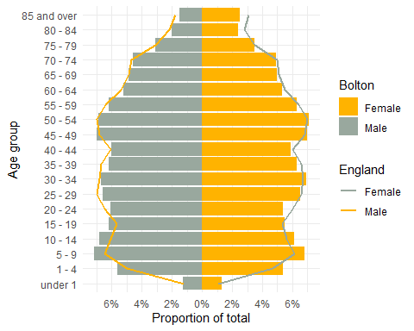

Figure 1: Bolton population compared to England