<http://www.templatemonster.com/demo/53778.html>

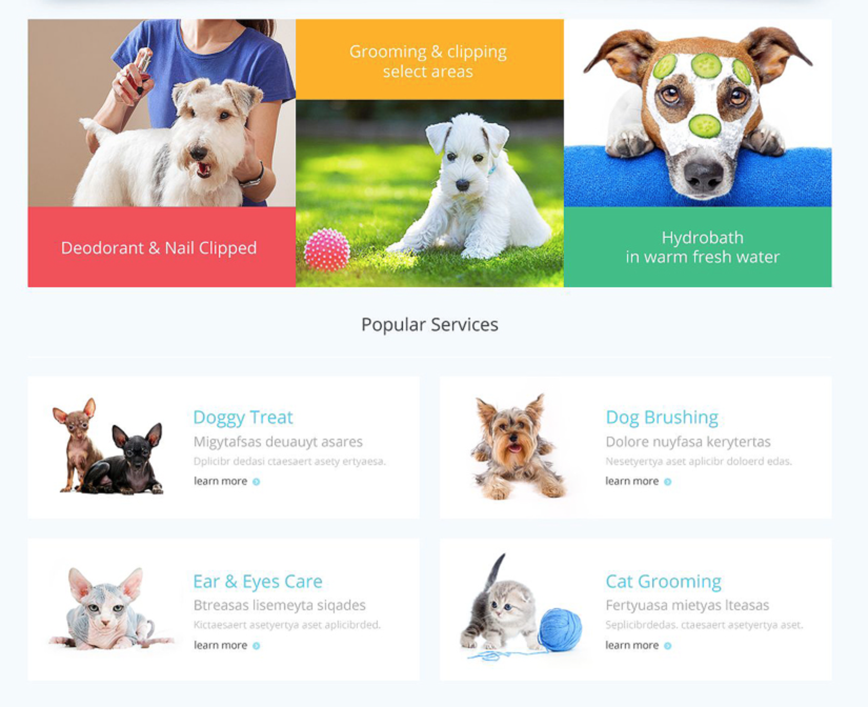

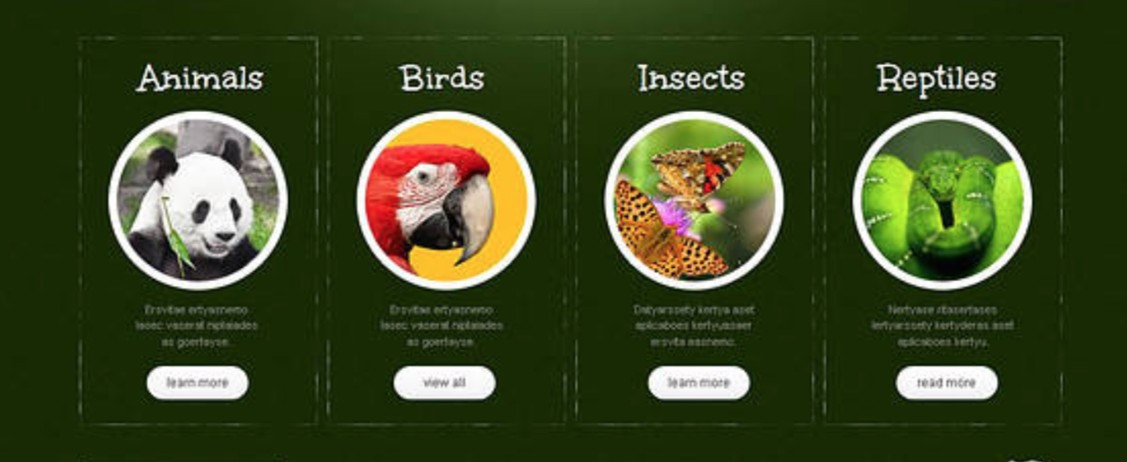

Here are two examples of features. In #1, special boxes are used to bring out the main features or specialties that bring in the most money or publicity. Below that, in a rather normal grid, are the most popular services available. By using bigger pictures and bright colors, the user is drawn to the more expensive items first. The popular items are listed also but just in regular boxes with no special fonts or colors.

In #2, a very dark background brings out the colorful images of exotic animals. These are the websites categories split into sections. A whimsical font is used for the titles and unique round image containers bring the user to this feature. A small description under each photo tells the user where this button will take them.

Both websites use a very symmetrical layout. All of the items are the same size and shape. This makes the page look very clean and sleek. The colors are bright and friendly to give the users a feel of the company behind the page.

This website is targeting animal lovers, mainly 20 – 40 years old. One is for pet owners who love to pamper their furry friends while the other is supporting a “green” zoo. These users are hip and up-to-date with trends and have money to spend on animals whether it is donating money to the zoo or sending Fido to a day spa.