**Part A: Portfolio Optimization based on the Full Data Set**

### 1. Preparing the data

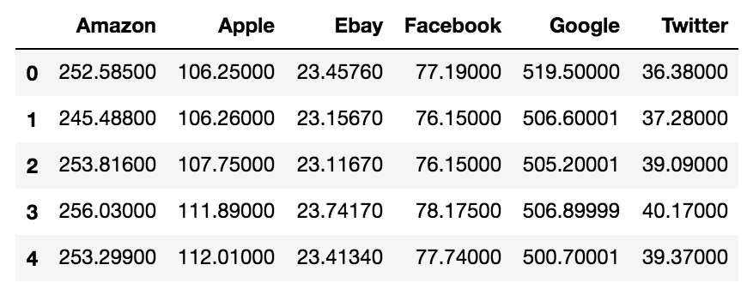

A. Based on the data set, compute the rate of returns for each stock

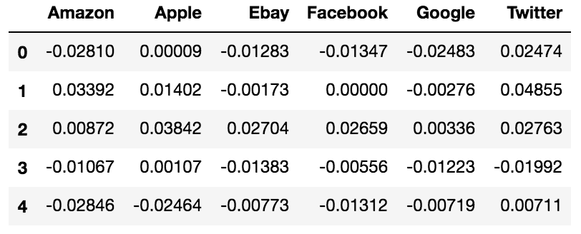

B. Based on the data set, compute the average returns that will be used for the optimization



C. Based on the data set, compute the variance-covariance matrix of the stock returns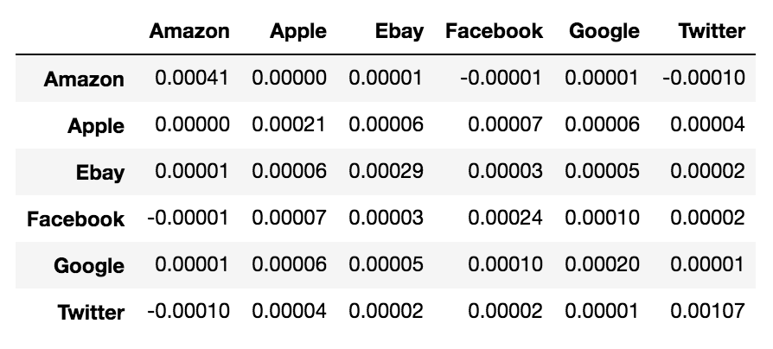

#### D. Provide the vector 𝜇 and the variance-covariance matrix 𝛴 for the 6 assets considered

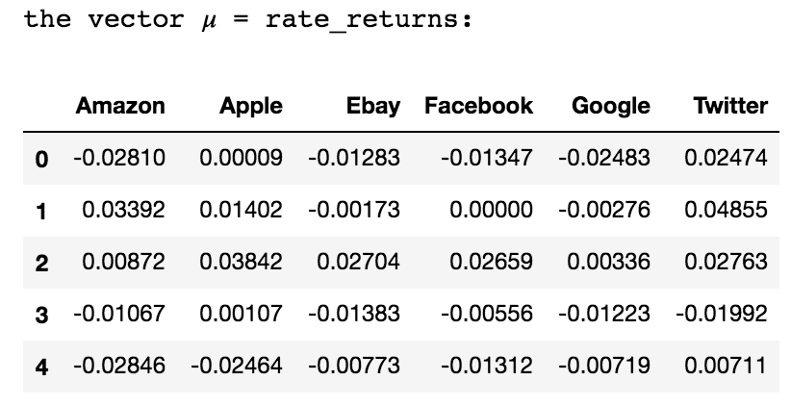

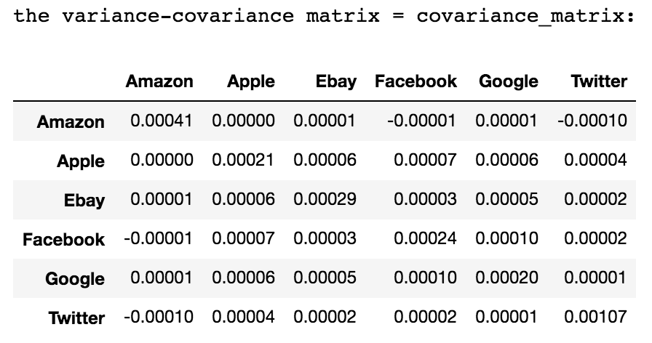

### 2. Portfolio Optimization: Minimizing Risk

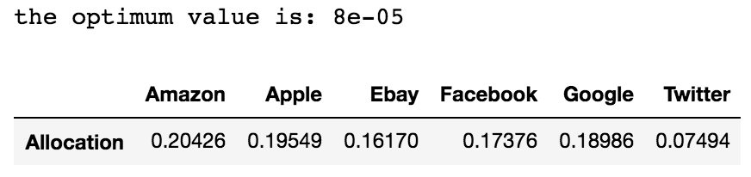

### 3. Portfolio Optimization: Maximizing Returns (or Utility)

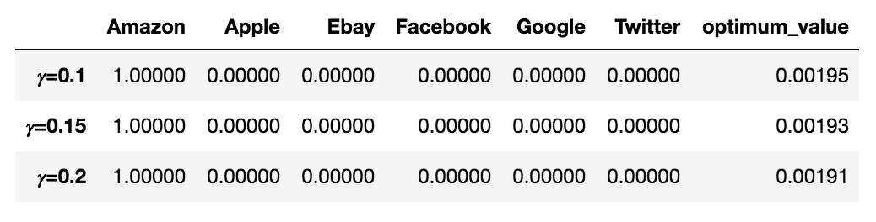

### 4. Simulations

- Portfolio Optimization: Minimizing Risk

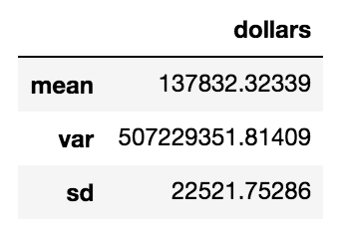

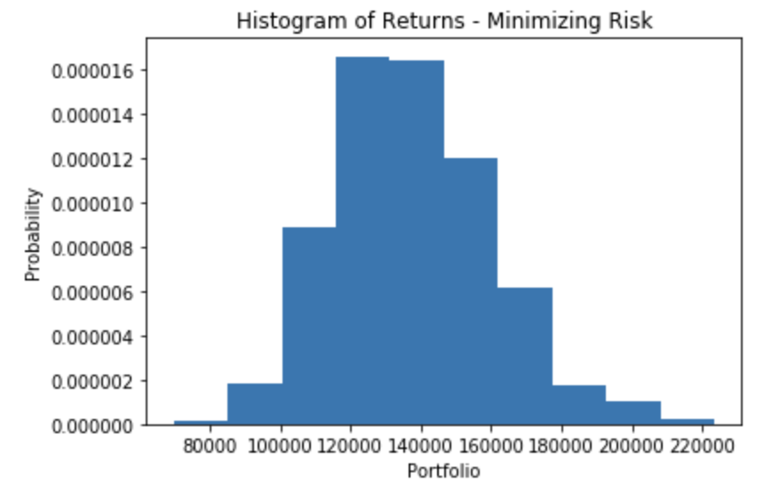

#### - Portfolio Optimization: Maximizing Returns (or Utility) for 𝛾=0.1, 𝛾=0.15 and 𝛾=0.2

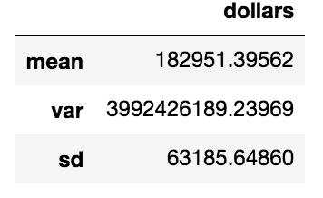

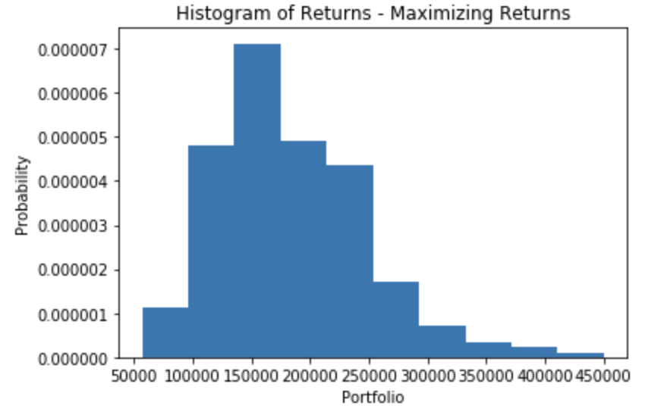

### 5. Recommendations

#### a. Explain the different allocations, i.e., why they are different

The allocations are different to different portfolio strategies:

* Minimizing risk: The goal is not to purely maximize the returns. The goal is to select the best return with the lowest risk. So, in this case, risk has higher priority than return.
* Maximizing returns: The goal is to purely maximize the returns not matter how risky the portfolio is. So, in this case, risk has lower priority than return. The risk aversion coefficient 𝛾 reflects how risky an investor can bear and generally, the more risky the stock is, the larger the fluctuation of the return is.

#### b. What should an investor with risk aversion 𝛾 = 0.1 do? What about investors with 𝛾 = 0.15 and 𝛾 = 0.2?

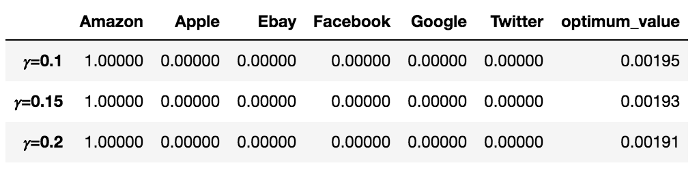

Based on the result showing above, investor with risk aversion 𝛾 from 0.1 to 0.2 should all invest Amazon only.

## Part B: Portfolio Optimization based on the last 400 trading days

### 1. Preparing the data

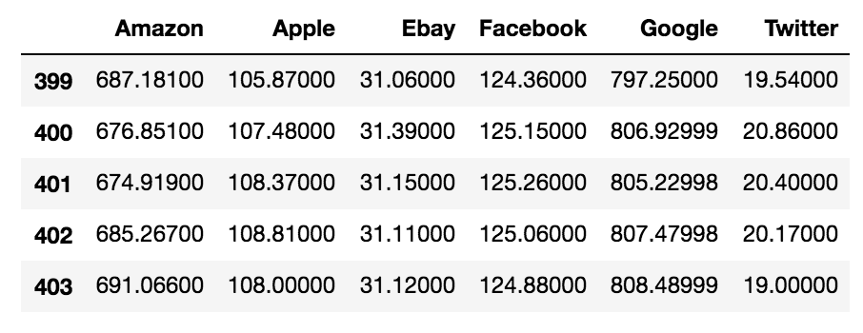

#### E. Based on the data set, compute the rate of returns for each stock

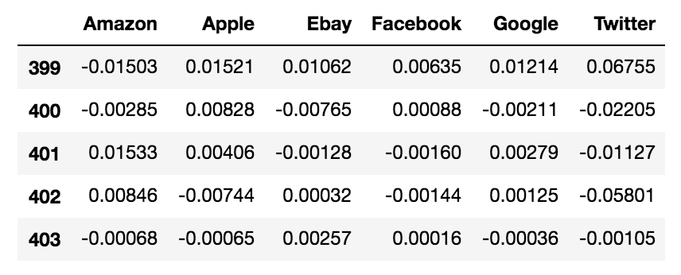

#### F. Based on the data set, compute the average returns that will be used for the optimization



#### G. Based on the data set, compute the variance-covariance matrix of the stock returns

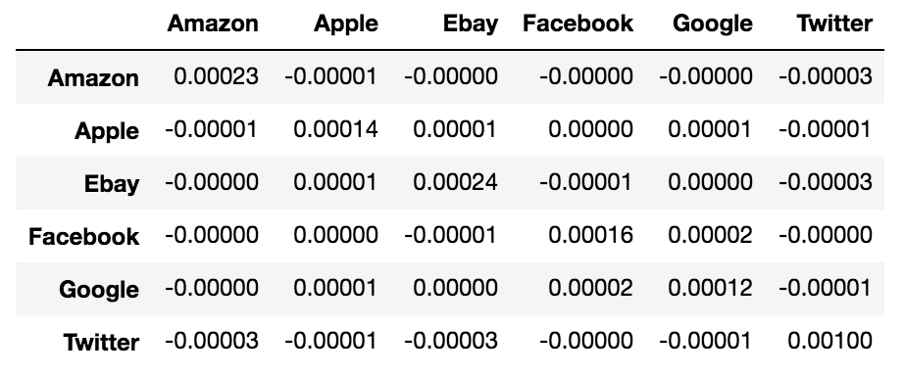

#### H. Provide the vector 𝜇 and the variance-covariance matrix 𝛴 for the 6 assets considered

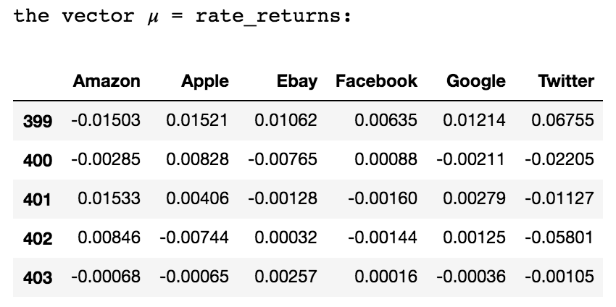

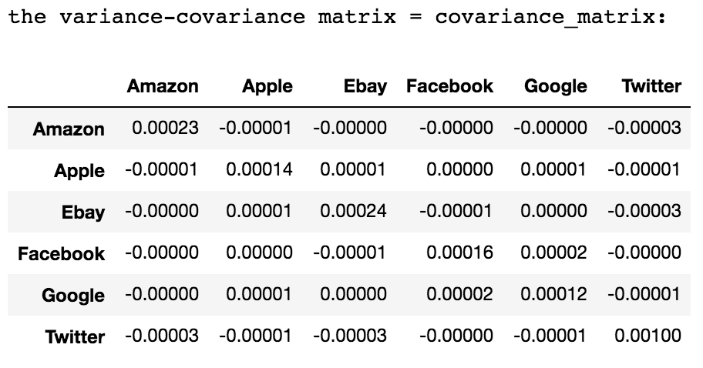

### 2. Portfolio Optimization: Minimizing Risk

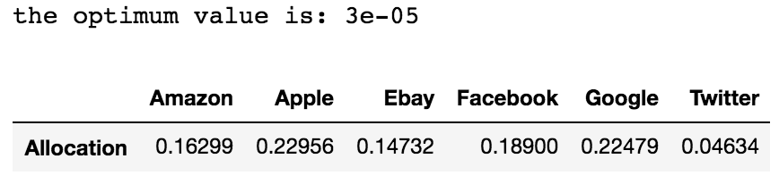

### 3. Portfolio Optimization: Maximizing Returns (or Utility)

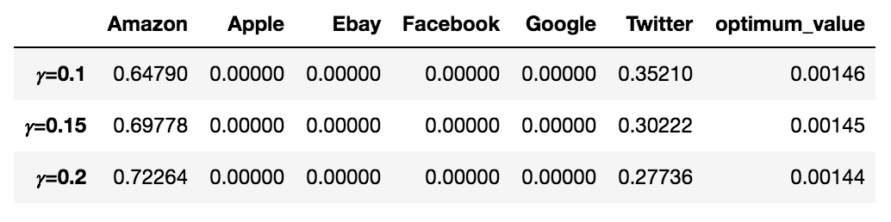

### 4. Simulations

#### - Portfolio Optimization: Minimizing Risk

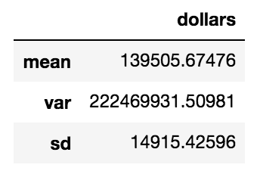

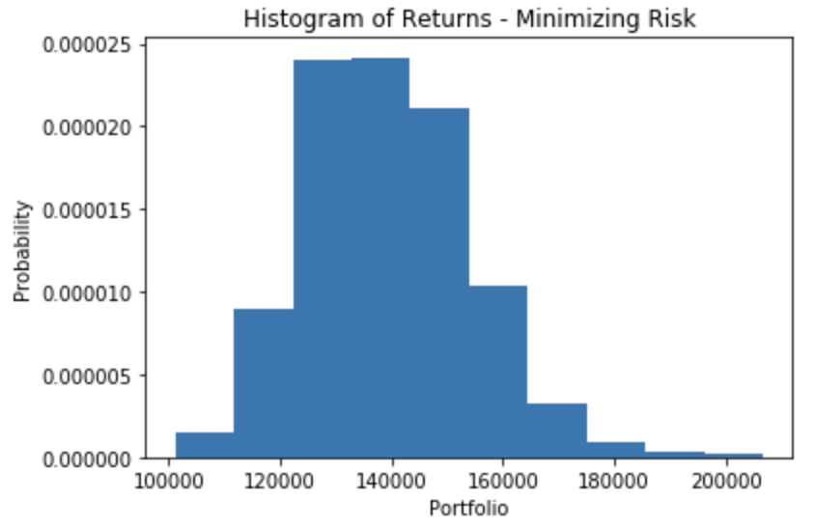

#### - Portfolio Optimization: Maximizing Returns (or Utility) for 𝛾=0.1

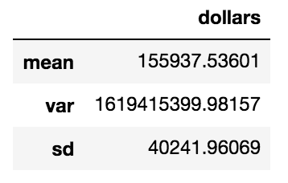

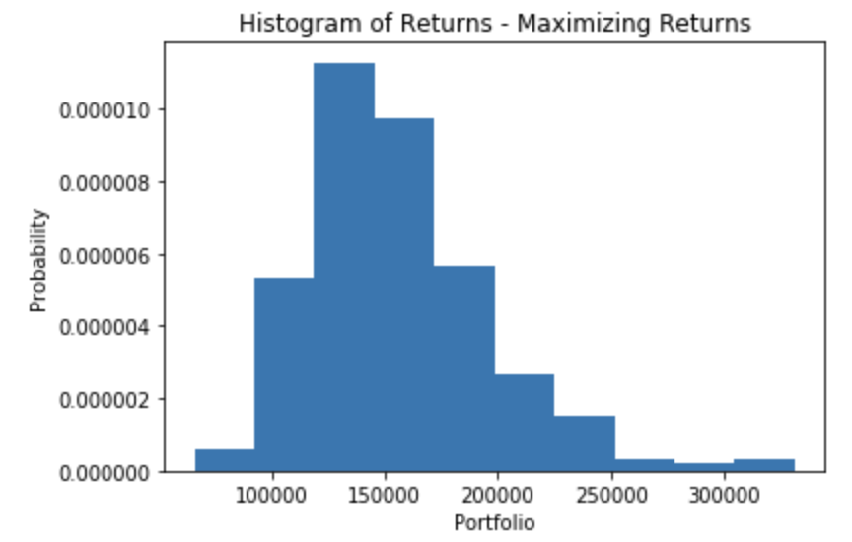

#### - Portfolio Optimization: Maximizing Returns (or Utility) for 𝛾=0.15

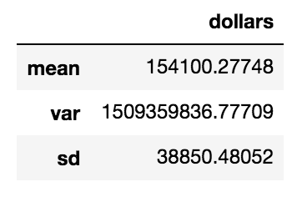

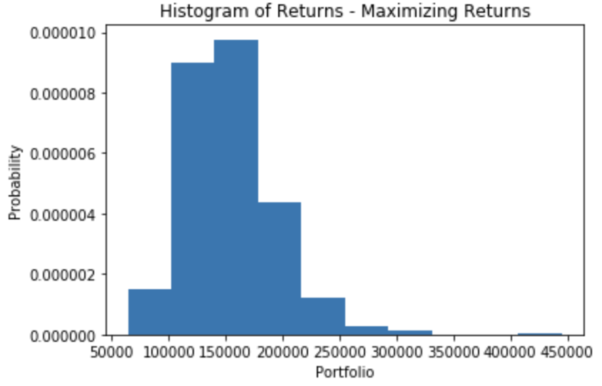

#### - Portfolio Optimization: Maximizing Returns (or Utility) for 𝛾=0.2

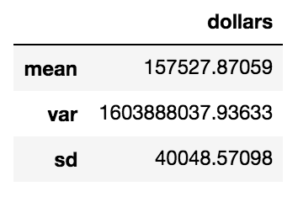

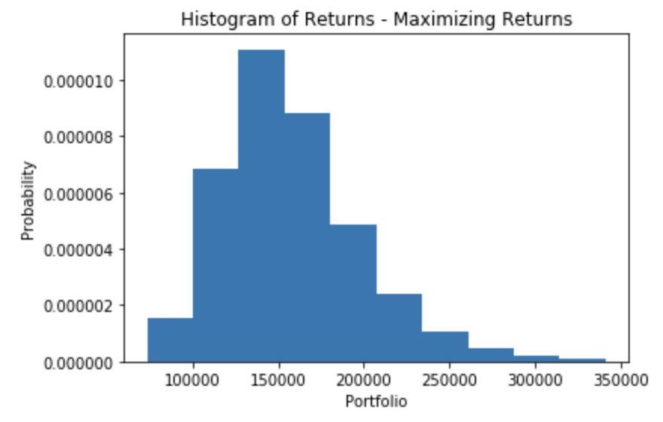

### 5. Explanations

### a. Explain the different allocations, i.e., why they are different

The allocations are different to different portfolio strategies:

* Minimizing risk: The goal is not to purely maximize the returns. The goal is to select the best return with the lowest risk. So, in this case, risk has higher priority than return.
* Maximizing returns: The goal is to purely maximize the returns not matter how risky the portfolio is. So, in this case, risk has lower priority than return. The risk aversion coefficient 𝛾 reflects how risky an investor can bear and generally, the riskier the stock is, the larger the fluctuation of the return is.

### b. What should an investor with risk aversion 𝛾 = 0.1 do? What about investors with 𝛾 = 0.15 and 𝛾 = 0.2?

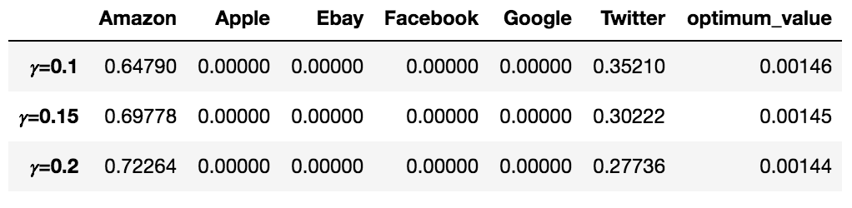

Based on the result showing above, investors who have different risk aversion should have different allocation plan. The detailed allocation plan is demonstrated in the table above.

### c. Why are the allocations different?

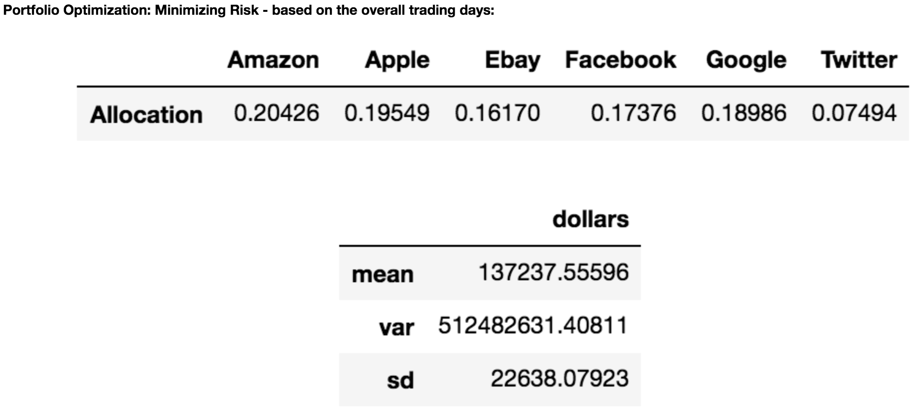

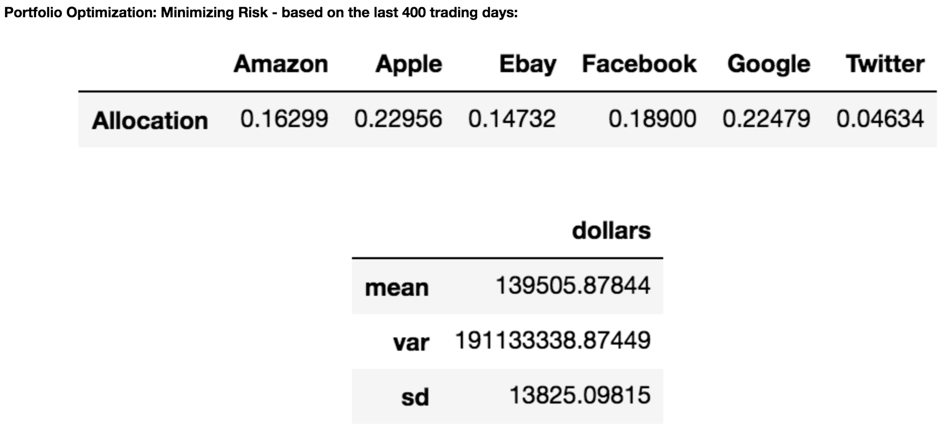

As you can see from the above comparison, in the strategy of minimizing risk, the return for the last 400 trading days is generally higher than the entire trading days while the risk for the last 400 trading days is overall lower than the overall trading days.  
  
This means the stock in the last 400 days performed better than the overall trading days although the specific circumstances of each stock had different changes. And this is the reason why the allocation changed.

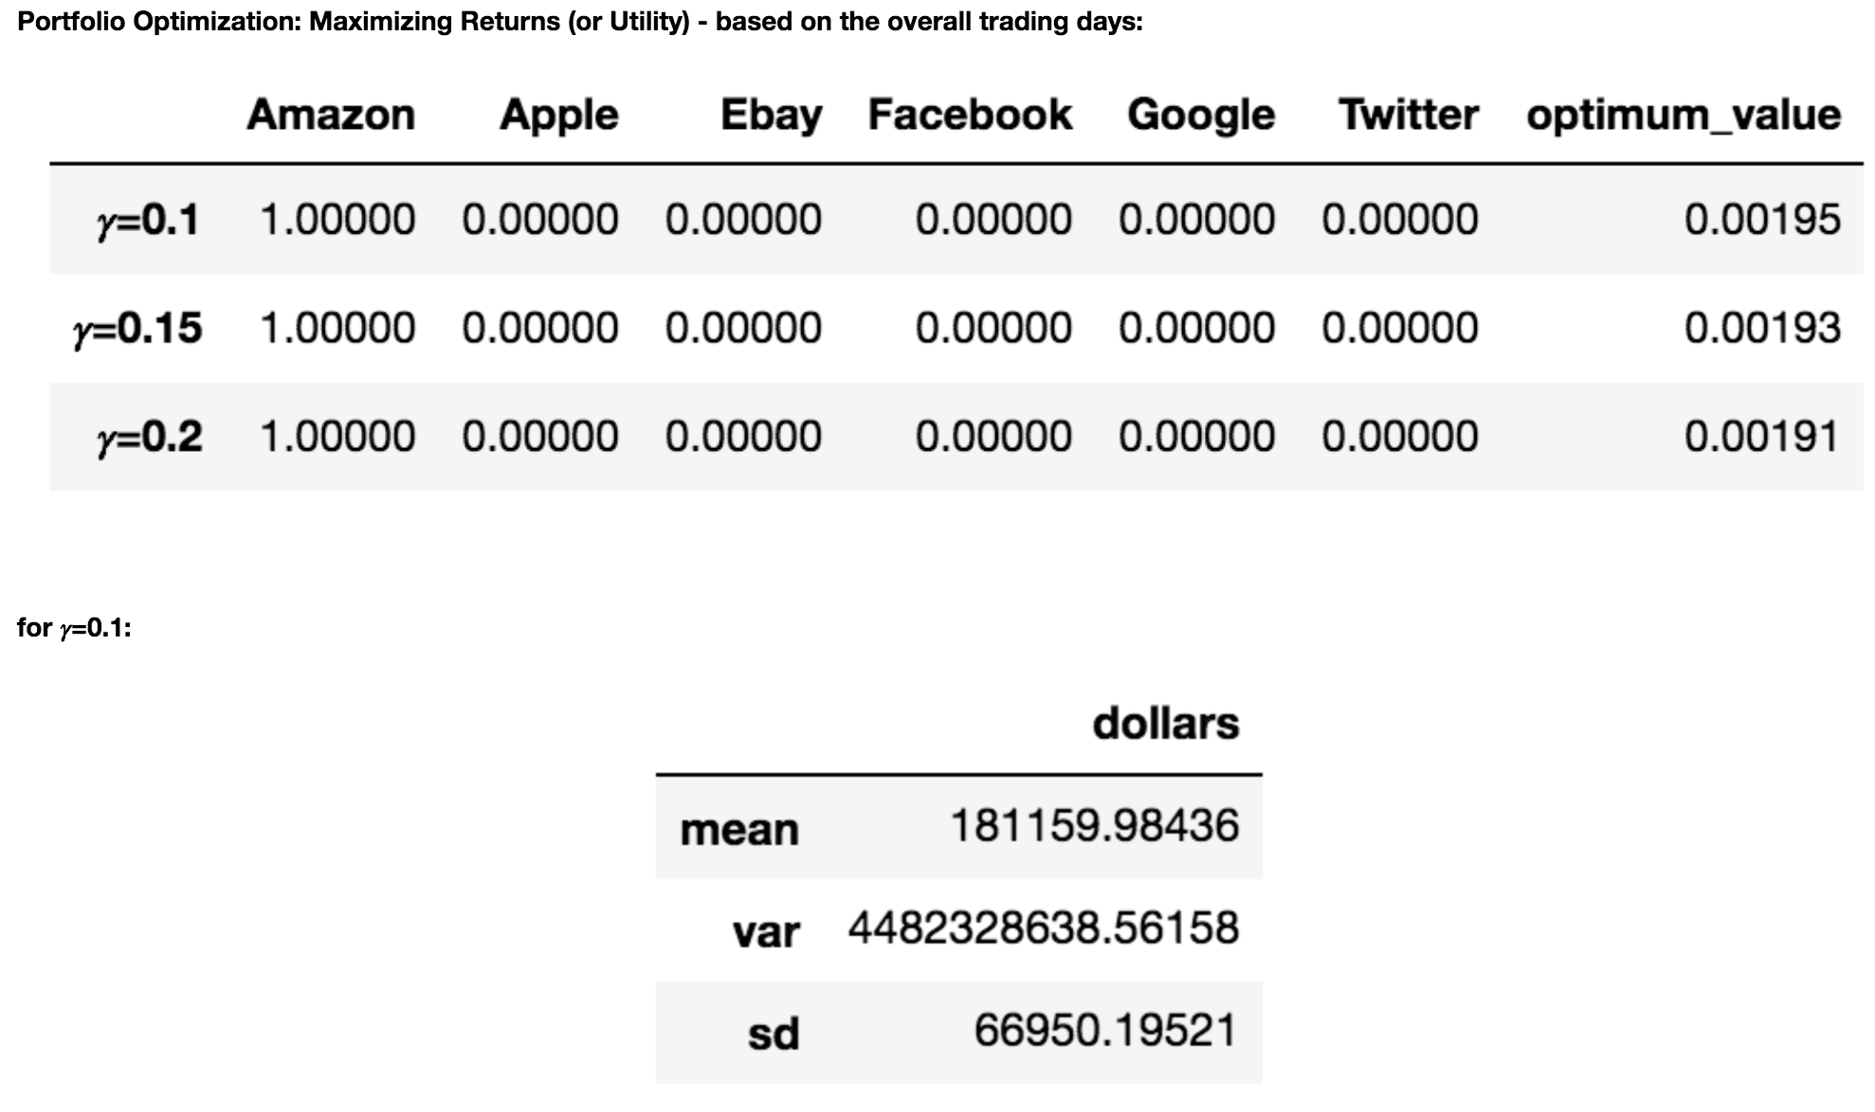

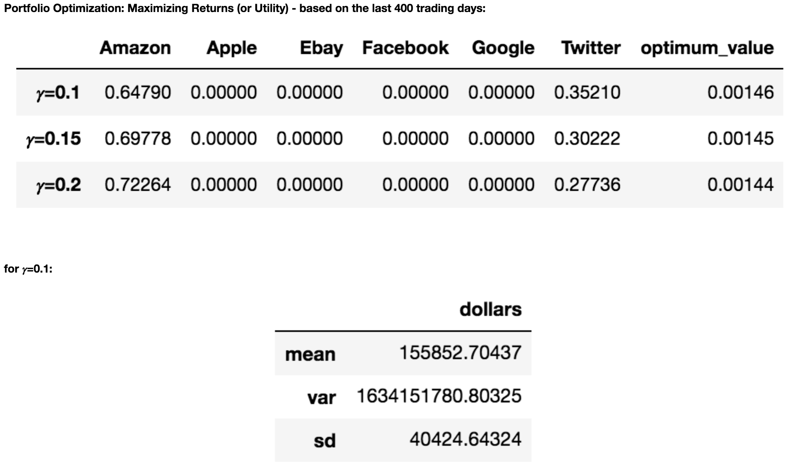

Both the return and risk for the last 400 trading days are less than the overall trading days. This means the stock market of the 6 companies performed more stable in the last 400 trading days. These stocks are overall performed less risky but also less profitable.  
  
For the analysis on the overall trading days, the suggested allocation is to invest Amazon only with the risk aversion range from 0.1 to 0.2. But for the analysis on the last 400 trading days, the suggested allocation is to invest Amazon and Twitter and the weight for each are different in different risk aversion levels. This change is caused by the companies' stock market change. These stocks are overall performed less risky but also less profitable.