

National Textile University
Department of Computer Science
Subject:
Operating System

Submitted to:

Sir Nasir

Submitted by:

Shanza Batool

Reg. number:

23-NTU-CS-FL-1209

Semester:
5th- A

Docker LAB_3

Task_01: Create networks to facilitate communication between frontend, backend and database.
Code:
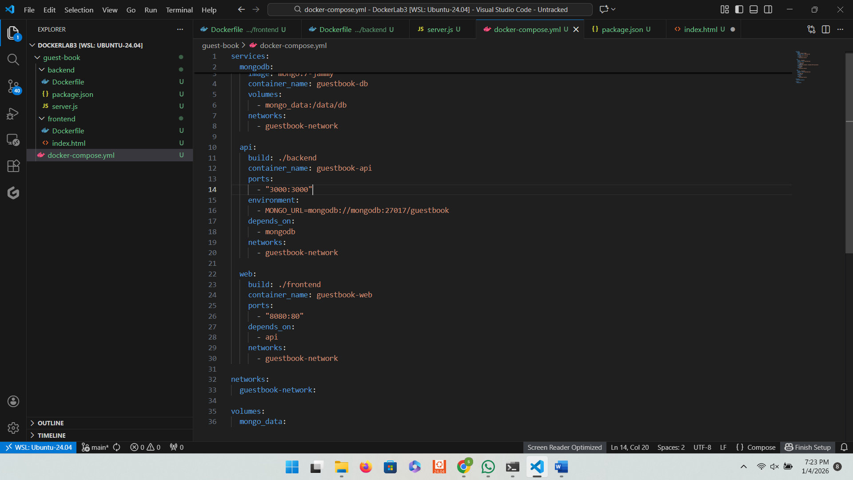

Task_02: Running of “docker compose up –build”
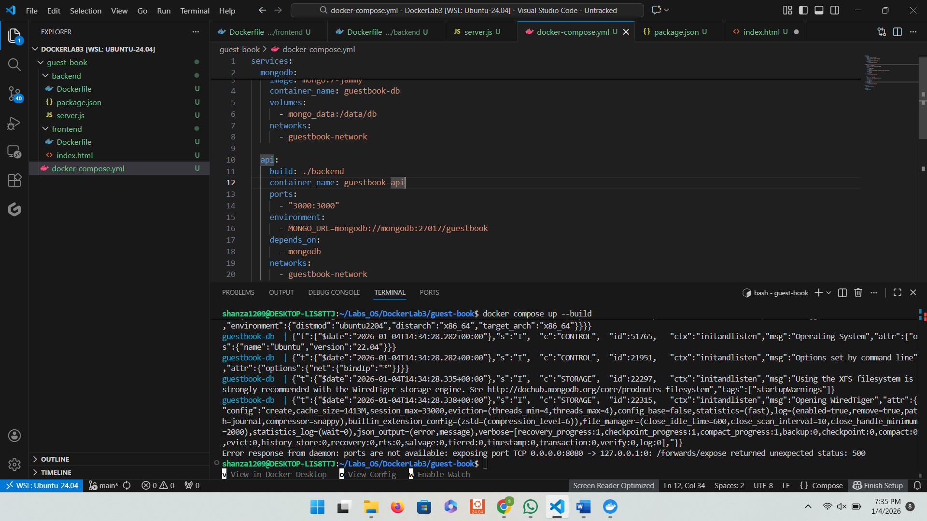

Task_03: Don't forget to create named volume with the same name you've used in dockercompose.yml
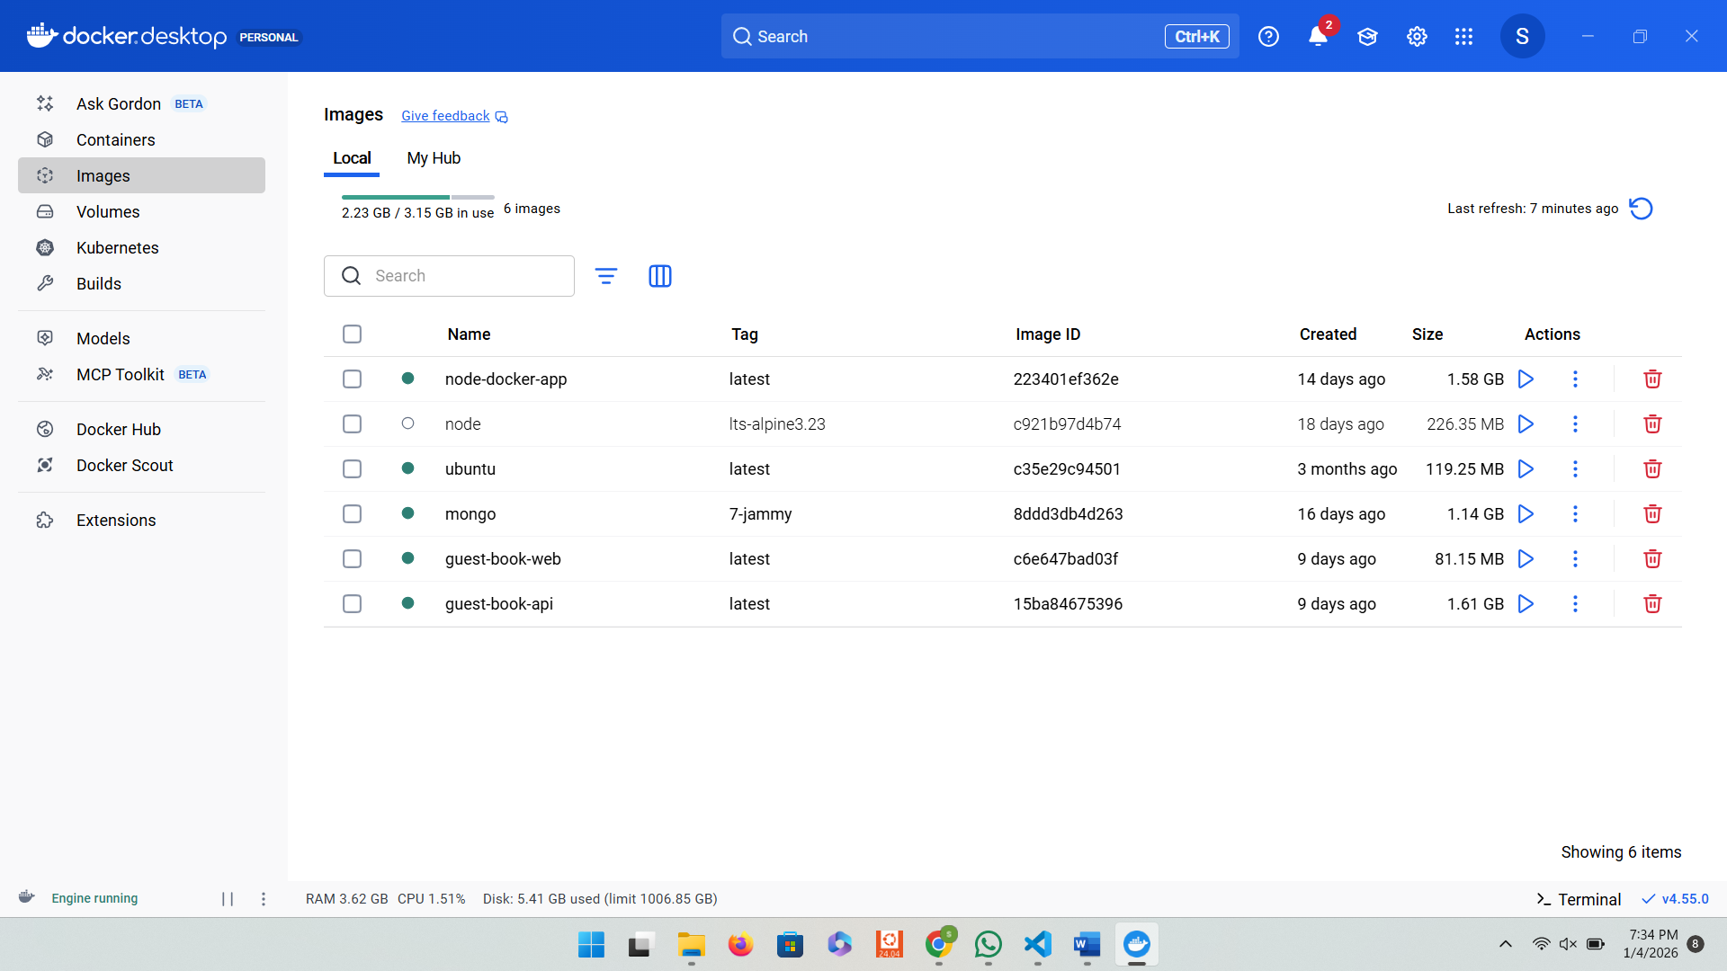

Task_04: Screenshot of whole project file
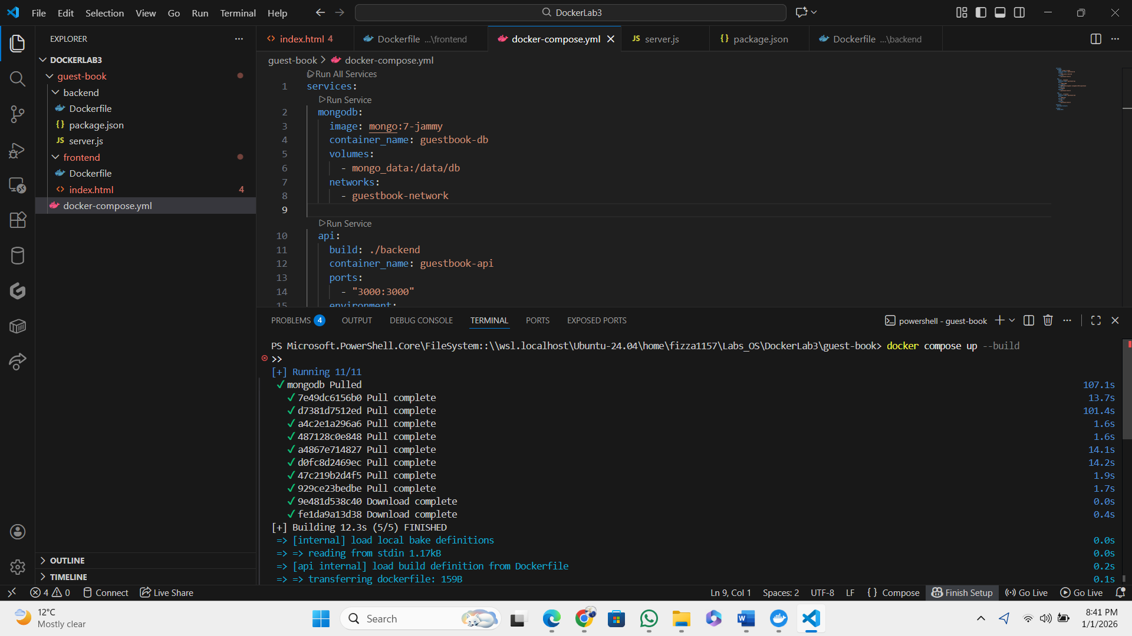

Task_05: Output of both image building commands e.g "docker build -t frontend."
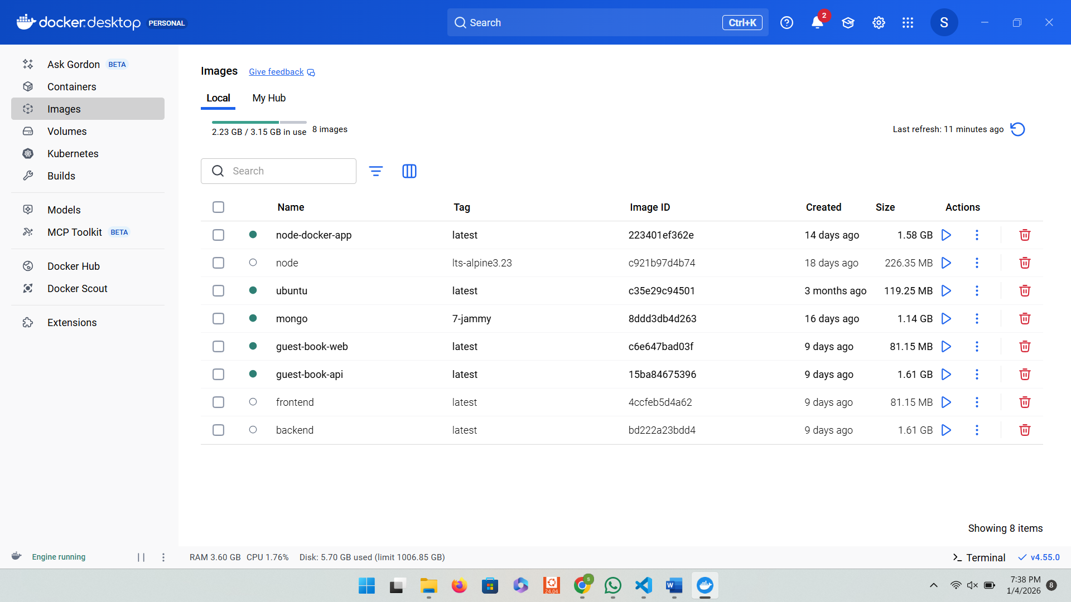

Task_06: Copy contents of docker-compose and both Docker files in the pdf.
Code of docker- compose file:

Code of docker file of backend:
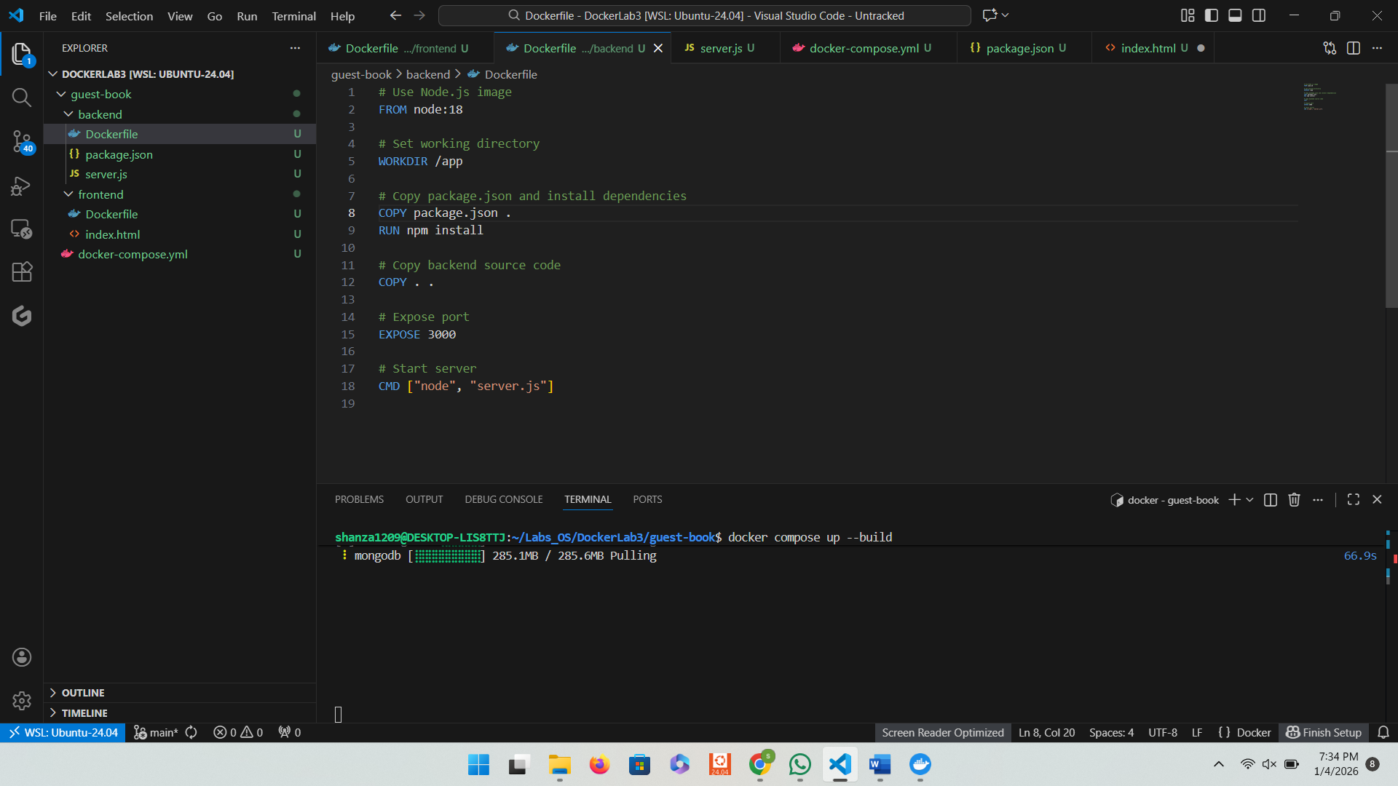

Code of docker file of frontend:
