

National Textile University
Department of Computer Science
Subject:
Operating Systems

Submitted to:
Sir Nasir Mehmood

Submitted by:
Shanza Batool

Reg number:
23-NTU-CS-1209

Lab no. :
9

Semester:
5th

Task1:
When Semaphore initialized to 1:
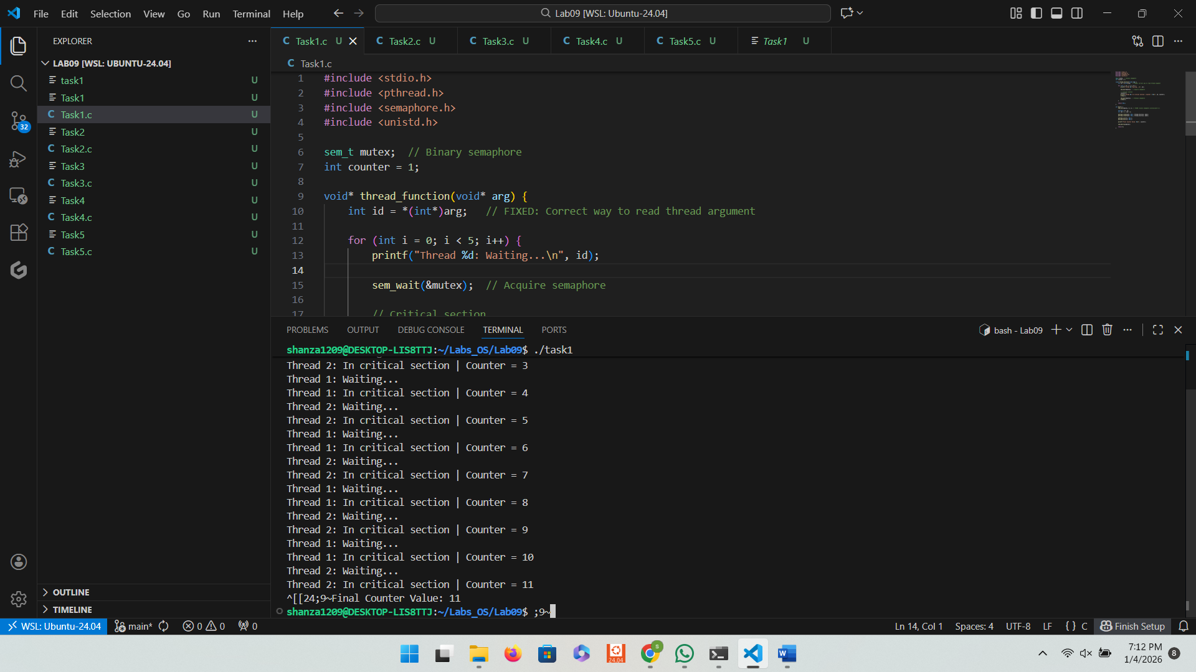

Task2:
When semaphore initialized to 0:
Code:
#include <stdio.h>
#include <pthread.h>
#include <semaphore.h>
#include <unistd.h>
sem_t mutex; // Binary semaphore
int counter = 1;
void* thread_function(void* arg) {
int id = *(int*)arg;
for (int i = 0; i < 5; i++) {
printf("Thread %d: Waiting...\n", id);
sem_wait(&mutex); // Acquire
// Critical section
counter++;
printf("Thread %d: In critical section | Counter = %d\n", id,
counter);
sleep(1);
sem_post(&mutex); // Release
sleep(1);
}
return NULL;
}
int main() {
sem_init(&mutex, 1, 0); // Binary semaphore initialized to 1
pthread_t t1, t2;
int id1 = 1, id2 = 2;
pthread_create(&t1, NULL, thread_function, &id1);
pthread_create(&t2, NULL, thread_function, &id2);
pthread_join(t1, NULL);
pthread_join(t2, NULL);
printf("Final Counter Value: %d\n", counter);
sem_destroy(&mutex);
return 0;
}

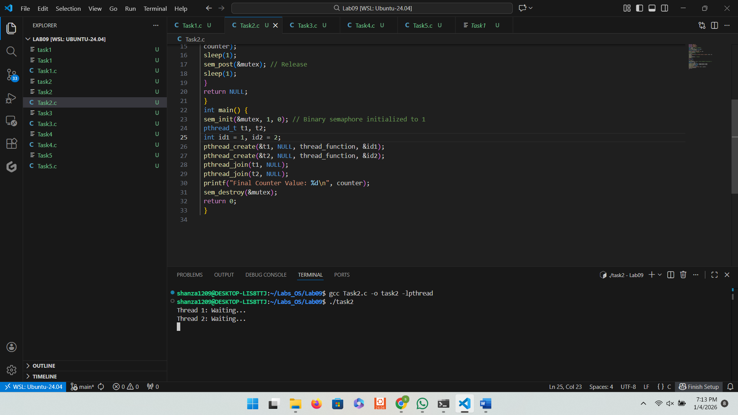

Task3:
Comment Post function:
Code:
#include <stdio.h>
#include <pthread.h>
#include <semaphore.h>
#include <unistd.h>
sem_t mutex; // Binary semaphore
int counter = 1;
void* thread_function(void* arg) {
int id = *(int*)arg;
for (int i = 0; i < 5; i++) {
printf("Thread %d: Waiting...\n", id);
sem_wait(&mutex); // Acquire
// Critical section
counter++;
printf("Thread %d: In critical section | Counter = %d\n", id,
counter);
sleep(1);
sem_post(&mutex); // Release
sleep(1);
}
return NULL;
}
int main() {
sem_init(&mutex, 0, 1); // Binary semaphore initialized to 1
pthread_t t1, t2;
int id1 = 1, id2 = 2;
pthread_create(&t1, NULL, thread_function, &id1);
pthread_create(&t2, NULL, thread_function, &id2);
pthread_join(t1, NULL);
pthread_join(t2, NULL);
printf("Final Counter Value: %d\n", counter);
sem_destroy(&mutex);
return 0;
}

Output:
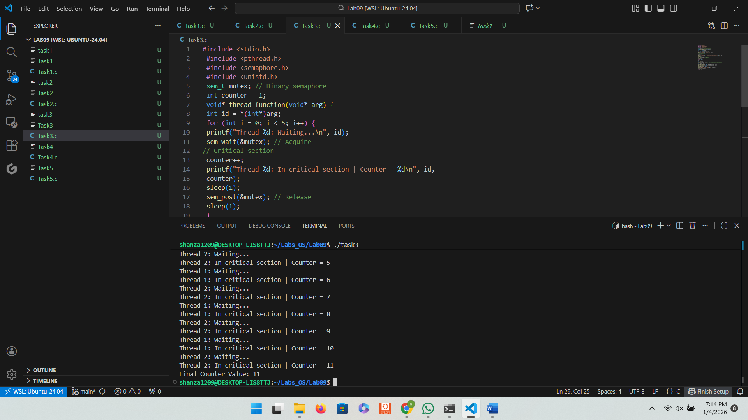

Task4:
When comment wait function:
Code:
#include <stdio.h>
#include <pthread.h>
#include <semaphore.h>
#include <unistd.h>
sem_t mutex; // Binary semaphore
int counter = 0;
void* thread_function(void* arg) {
int id = *(int*)arg; // FIXED
for (int i = 0; i < 5; i++) {
printf("Thread %d: Waiting...\n", id);
sem_wait(&mutex); // Acquire

// Critical section
counter++;
printf("Thread %d: In critical section | Counter = %d\n", id, counter);
sleep(1);
sem_post(&mutex); // Release
sleep(1);
}
return NULL;
}
int main() {
sem_init(&mutex, 0, 1); // Binary semaphore initialized to 1
pthread_t t1, t2;
int id1 = 1, id2 = 2;
pthread_create(&t1, NULL, thread_function, &id1);
pthread_create(&t2, NULL, thread_function, &id2);
pthread_join(t1, NULL);
pthread_join(t2, NULL);
printf("Final Counter Value: %d\n", counter);
sem_destroy(&mutex);
return 0;
}

Output:
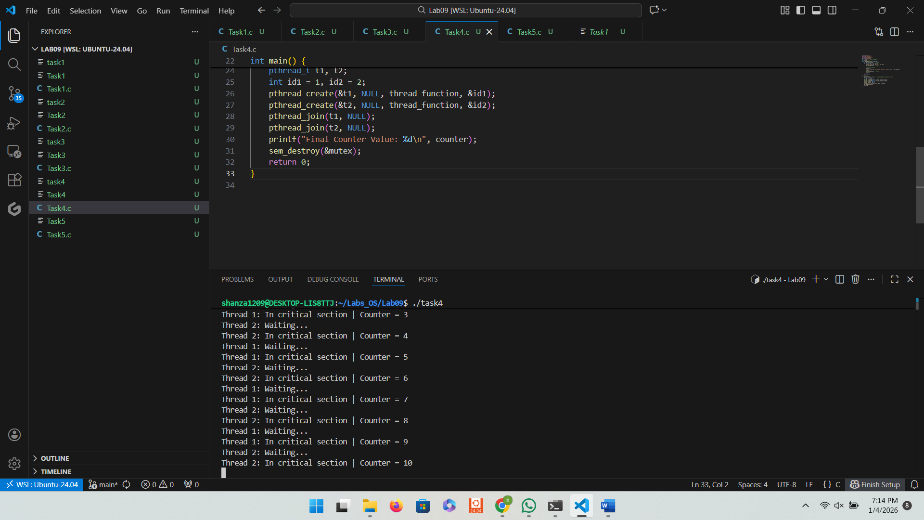

Task5:
Code:
#include <stdio.h>
#include <pthread.h>
#include <semaphore.h>
#include <unistd.h>

sem_t mutex; // Binary semaphore
int counter = 1;

// Thread function to increment counter
void* increment_thread(void* arg) {
int id = *(int*)arg;

for (int i = 0; i < 5; i++) {
printf("Increment Thread %d: Waiting...\n", id);
sem_wait(&mutex); // Acquire
// Critical Section
counter++;
printf("Increment Thread %d: Counter = %d\n", id, counter);
sleep(1);
sem_post(&mutex); // Release
sleep(1);
}
return NULL;
}
// Thread function to decrement counter
void* decrement_thread(void* arg) {
int id = *(int*)arg;
for (int i = 0; i < 5; i++) {
printf("Decrement Thread %d: Waiting...\n", id);
sem_wait(&mutex); // Acquire
// Critical Section
counter--;
printf("Decrement Thread %d: Counter = %d\n", id, counter);
sleep(1);
sem_post(&mutex); // Release
sleep(1);
}
return NULL;
}
int main() {
sem_init(&mutex, 0, 1); // Binary semaphore initialized to 1

pthread_t t1, t2;
int id1 = 1, id2 = 2;
// Create increment and decrement threads
pthread_create(&t1, NULL, increment_thread, &id1);
pthread_create(&t2, NULL, decrement_thread, &id2);
// Wait for both threads to finish
pthread_join(t1, NULL);
pthread_join(t2, NULL);
printf("Final Counter Value: %d\n", counter);
sem_destroy(&mutex);
return 0;
}
Output:
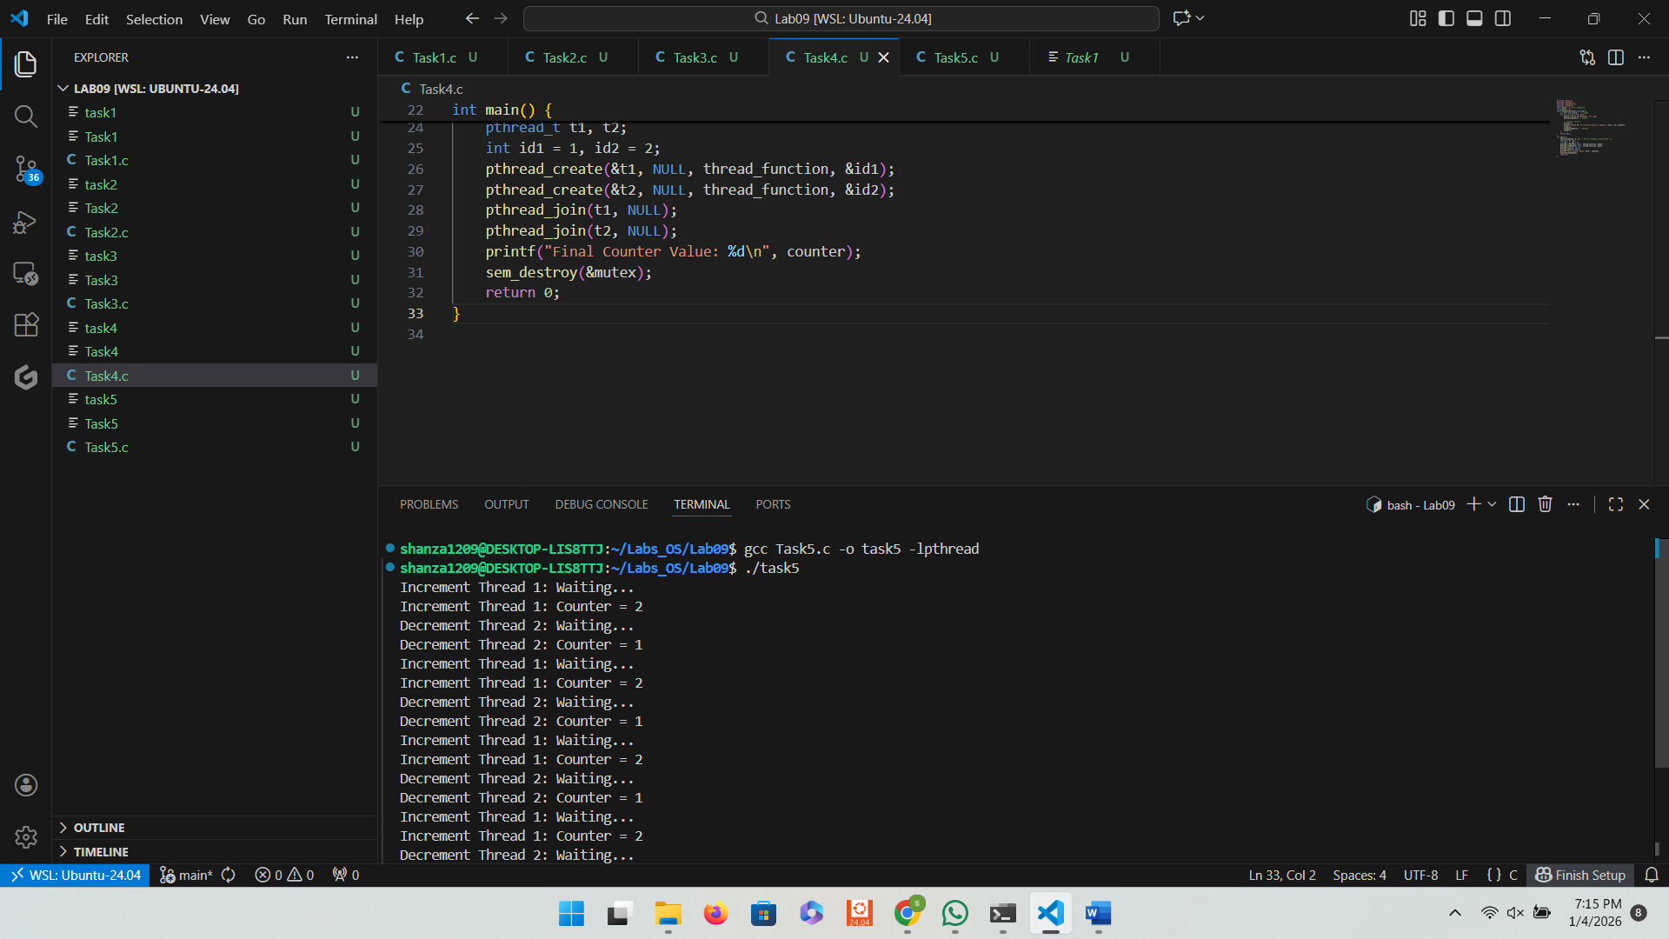

Task6:
Comparison between mutex and semaphore:
- A mutex is a mutual exclusion lock that only one thread can own at a time and the same thread that locks the mutex is the only one that is able to unlock it.Mutex is used only for mutual exclusion-for protecting critical threads.
- In mutex, owned by the thread that locks it; only that thread can unlock.
- Initialization :
- pthread_mutex_t
- pthread_mutex_init(&mutex, NULL);
- A binary semaphore has two functions wait() and signal().Semaphore is used for mutual exclusion and signaling between threads.
- In semaphore, not owned by any thread; any thread can post (signal).
- Initialization:
- sem_t sem;
- sem_init(&sem, 0, 1);
Similarities:
- Both are synchronization mechanisms.
- Both can control access to shared resources.
- Both can use lock(wait) and unlock(signal) to manage resources.
- Both help ensure mutual exclusion.

