Receipt Module :

1. Special character validation. If ,’;”: are entered in input boxes the bellow errors are shown. Note the department forwarding no.

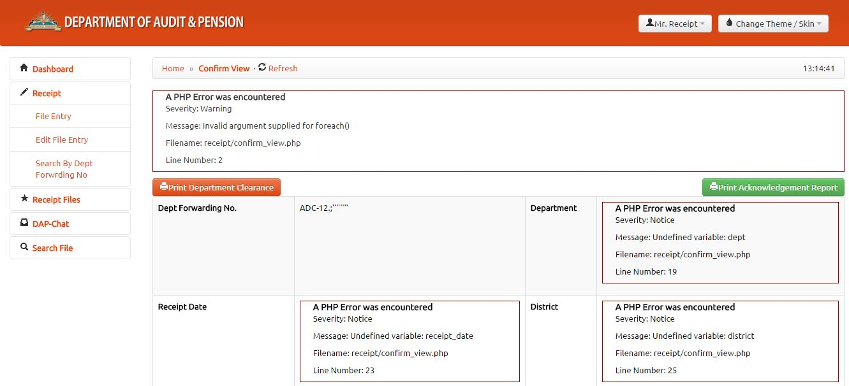

At this point if “Print Acknowledgement Report” is clicked report with the error messages is generated.

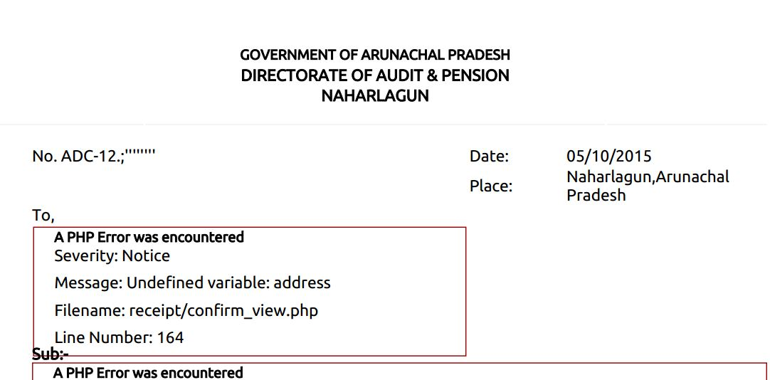

** In the same form I got the following error. Again related to input validation.

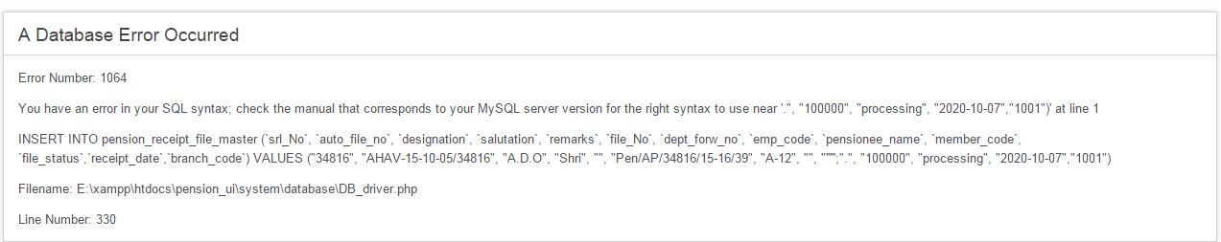

1. Receipt Date field is read only but one can paste copied data.
2. In the search by department forwarding number it will be more user friendly if we provide a list of the forwarding number with the last entered number appearing first. ***Otherwise the user will have to memorise the number or look into some hard copy to search. If the user clicks the number in the list no need to type the number again.***

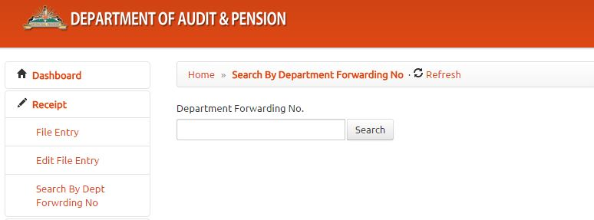

1. For all errors use pop up error message rather than exposing the database structure to the user.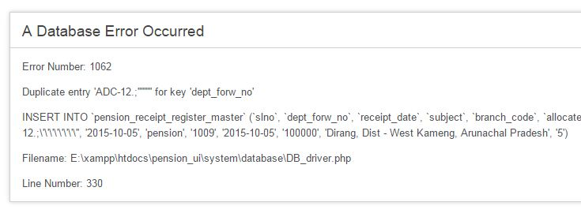
2. In Add receipt multiple files can be attached under one single department forwarding number. But if the user forgets to add any one person details there is no way to add that member again. So in the Edit receipt this facility must be integrated.

** Edit Receipt Register is not working at all at this time

1. Look at the following screenshot.

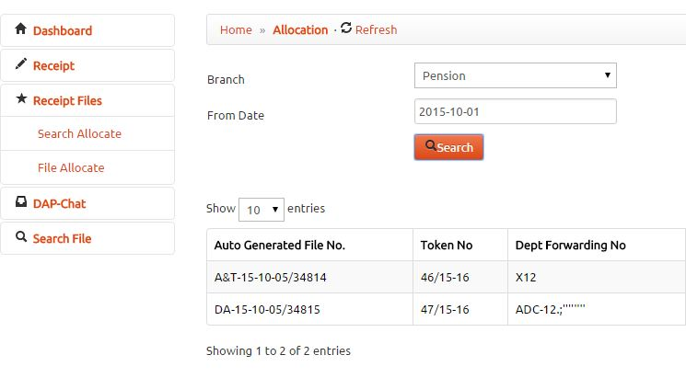

Now if I copy the department forwarding No ADC-12,;’’’’’’’ and try to search it shows no record found.

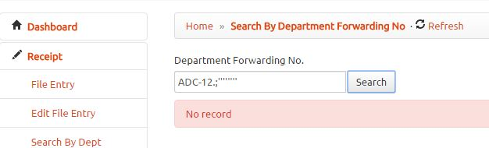

** So validate every character that is not supported in the Mysql version Where clause. We must not store anything that is not returned by select statement.

1. As a good practice and user friendly feature all search page should have a list displaying the entries in proper order.
2. In Search File there is only one submenu and yet to go to search menu user need to click twice. Either we can remove the submenu or move the search option to the Receipt menu where there is already one search submenu . Also in the Type filter dropdown menu no option is populated except for “all”

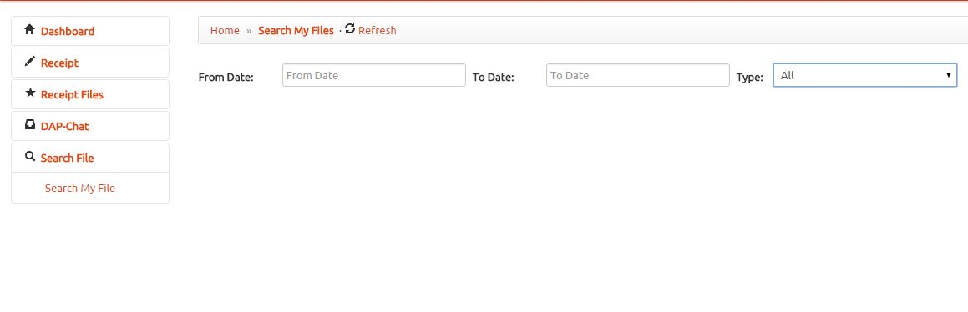

1. The change theme/skin is showing 404 not found error in my system.
2. All input box must have the same length as the database table field.

Reversal process for Pension file forwarded by mistake:

1. If a file is registered and user can reverse the decision he can directly do it provided the higher authority to whom the file was forwarded has not taken any action on the file. Otherwise the user can only raise an alarm stating the reason for requesting decision reversal.
2. Once the request alarm is raised Admin can reverse the error. Until then no further processing of the file will be possible.
3. All respective authorised user will be able to view the notification.
4. When reversal is done data will not be deleted from database. And instead the entry will be flagged using some variable.

Controller/administrator/receipt.php

Controller/administrator/home.php

Views/administrator/receipt/search.php

Views/administrator/receipt/edit_register.php

Views/administrator/receipt/search_report.php

Views/administrator/receipt/add.php

Models/administrator/model_receipt.php