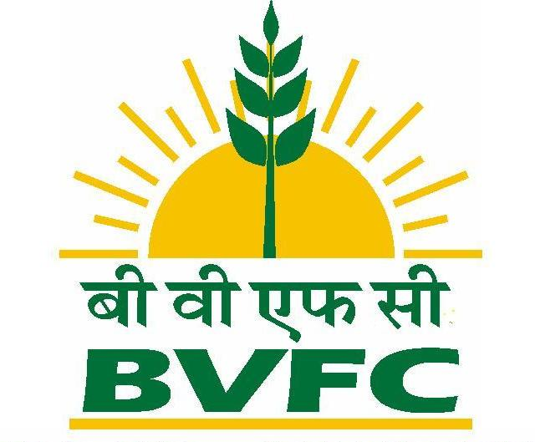
BRAHMAPUTRA VALLEY FERTILIZER CORPORATION LIMITED, N A M R U P
(A Govt. of India Undertaking)
P.O: Parbatpur-786623, Dist: Dibrugarh (Assam)

AMMONIA – III (Mechanical Deptt.) NOTICE INVITING TENDER

Tender Notice No: N-III/Mech-5/Cont-1334A/041 Date:29-04-2022

Sealed tenders are hereby invited on item rate / lump sum basis from experienced & approved contractors for the following work(s) in Brahmaputra Valley Fertilizer Corporation Ltd., Namrup,

Sl.No | Name of work: | Earnest  Money:  (Rs.) | Completion time days / months | Tender paper cost (Rs.)
01. | Provision of pipeline for improvement of turbine washing of SGC and PAC in AMM-III plant. | 500 | 04 days | 118/-
Earnest Money Deposit – MSME bidders are exempted from paying EMD & tender paper cost upon submission of valid documentary evidence with bid security declaration form as per attached herein.
Tender papers / documents can be obtained during working hours on application to the undersigned and on the payment of the tender paper cost as mentioned above in cash. Tender papers also available in BVFCL website & Govt. Website. Tender paper cost & Earnest Money shall be submitted in the form of SBI Bank challan which shall be obtained from BVFCL website in “Download link”. The copy of the Bank challan shall be submitted along with bid document. Tenders received without EMD are likely to be rejected.
1) OFFICE OF THE CE (M), AG& CPP (BVFCL, Namrup)
2) Closing date of sale of Tender papers On 05-05-2022 at 4.00 p.m.
3) Last date of submission of tender papers On 06-05-2022 at 3.00 p.m.
4) Opening date of tender papers On 06-05-2022 at 3.30 p.m.

The tenders will be opened on the above scheduled date and time in presence of the tenderers or their authorized representative who may like to be present BVFCL will neither be responsible nor consider the late submission tenders. The undersigned reserve the right to accept or reject any or all tenders without assigning any reason thereof.

DOCUMENTARY EVIDENCES
Tenderer must submit copies of the following documents along with their tenders:
1. Income Tax PAN Card.
2. Experience of having successfully completed similar works during last 7 (Seven) years ending last day of month previous to the one in which applications are invited should be either of the following:
a) Three similar works costing not less than the amount equal to Rs. 31638.00.
b) Two similar completed works costing not less than the amount equal to Rs. 39548.00.
c) One similar work costing not less than the amount equal to Rs. 63277.00.
------Rates are excluding taxes-----------
3. Copy of GST Registration Certificate.
For & on behalf of BVFC Limited, Namrup

(G.C. Gowala)
P.E. (M), A-III
Encls. Annexure-I, II & III

