You can create a Wi-Fi network between two or more devices without using a Wi-Fi router. These networks are often referred to as ad-hoc networks. All you need is a computer with Wi-Fi running Windows 8. Windows 8 comes with the ICS (Internet Connection Sharing) feature to allow devices to connect to the internet connection of your PC.

1. Press the shortcut **Windows Key + Q** to open the app search in Windows 8.
2. Enter **cmd** in the search box on the right, the search result will be displayed on the left.
3. Right click on the **cmd** app in the search results

1. Click on **Run as administrator**
2. Enter the following command to configure an ad-hoc Wi-Fi connection: **netsh wlan set hostednetwork mode=allow ssid=photosyncnet key=12345678**
3. Press the **Enter** key and you should receive the following output: The hosted network node has been set to allow...
4. Now enter the following command: **netsh wlan start hostednetwork**
5. Press the **Enter** key and you should receive the following output: The hosted network started.
6. Now enable the Internet Connection Sharing (ICS): Go to Network & Sharing Center, open the properties for the current internet connection, and enable ICS. Don't forget to select the ad-hoc network connection under Home networking connection.
7. Now your iOS devices can join the network you've created by selecting its name in the Wi-Fi section of the device settings

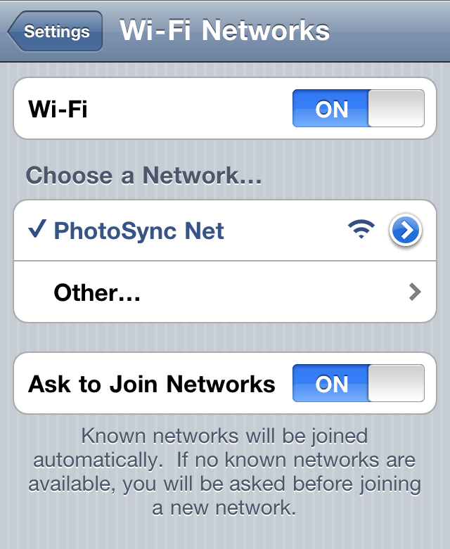

1. After connecting your iOS device with the ad-hoc network give your computer some time to assign a valid internet address to your iOS device. This may take a few seconds.