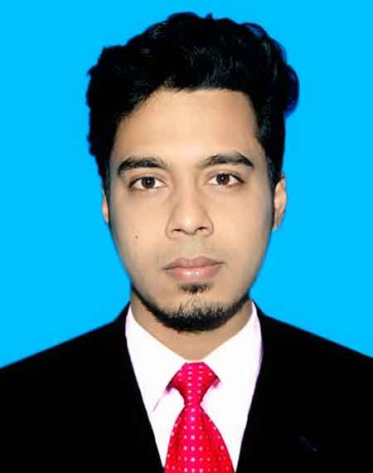**Sourov Das Tomal**

Junior Software Engineer (PHP-Track).

**Address:** Joar Sahara, Jomoj road, Dhaka, Bangladesh

**Contact:** 01631327584, 01731072730

**E-mail:** [sourovtomaldas@gmail.com](mailto:sourovtomaldas@gmail.com)

[2018200000034@seu.edu.bd](mailto:2018200000034@seu.edu.bd)

**GitHub:** [github.com/Sourov02](https://github.com/Sourov02)

**Facebook:** [Sourov Das Tomal](https://www.facebook.com/profile.php?id=100009372703695&mibextid=ZbWKwL)

**LinkedIn:** [linkedin.com/in/sourov-das-tomal-2219b0237](https://www.linkedin.com/in/sourov-das-tomal-2219b0237/)

**Career Objective:**

To obtain such a position where I would be able to exert my academic knowledge, experience and potentiality to develop my career and establish myself as a dexterous one in the related field and thereby contribute to the welfare & enhancement of organization, country & the world.

**Some of My Project:**

**Project Url:** <https://github.com/Sourov02/my-commerce.git>

**Front End:** HTML5, CSS3, JQuery with Bootstrap Framework.

**Server Side**: PHP Laravel Framework.

**Project Url:** <https://github.com/Sourov02/blog-site.git>

**Front End:** HTML5, CSS3, JQuery with Bootstrap Framework.

**Server Side**: PHP Laravel Framework.

**Project Url:** <https://github.com/Sourov02/ecommerce-app.git>

**Front End:** HTML5, CSS3, JQuery with Bootstrap Framework.

**Server Side**: PHP Laravel Framework.

**Project Url:** <https://github.com/Sourov02/management-system.git>

**Front End:** HTML5, CSS3, JQuery with Bootstrap Framework.

**Server Side**: PHP Laravel Framework.

**My Skills:**

* Object Oriented Programming
* MVC
* Php-8
* Laravel Framework
* HTML5
* CSS3
* JavaScript (ECMA-6), JQuery
* Bootstrap
* My SQL

**Academic Qualification:**

|  |  |  |  |  |  |
| --- | --- | --- | --- | --- | --- |
| **Exam Title** | **Concentration/Major** | **Institute** | **Result** | **Passing Year** | **Duration** |
| BSc in Computer Science & Engineering | Computer Science & Engineering | Southeast University | CGPA: 3.33 out of 4 | 2023 | 4 |
| Higher Secondary School Certificate. | Science | Milestone College | GPA: 4.00 out of 5 | 2018 | - |
| Secondary School Certificate | Science | Central Coronation High School | GPA: 4.56 out of 5 | 2016 | - |

**Language Proficiency:**

|  |  |  |  |
| --- | --- | --- | --- |
| **Language** | **Reading** | **Writing** | **Speaking** |
| Bangla | High | Medium | High |
| English | High | High | High |
| Hindi | Low | Low | Medium |

**Personal Details:**

Father’s Name : Samar Das

Mother’s Name : Swapna Rani Paul

Date of Birth : 10 December, 2000

Gender : Male

Marital Status : Unmarried

Nationality : Bangladeshi – By Born.

National Id No. : 151 008 8220

Religion : Sanatan

Permanent Address : Panchgaon, Araihazar, Narayanganj.

Current Location : Joar Sahara, Jomoj road, Dhaka, Bangladesh

**References:**

Habibur Rahman

Trainer at BITM

+880 1711-805110

**Email:** habib2498922@gmail.com