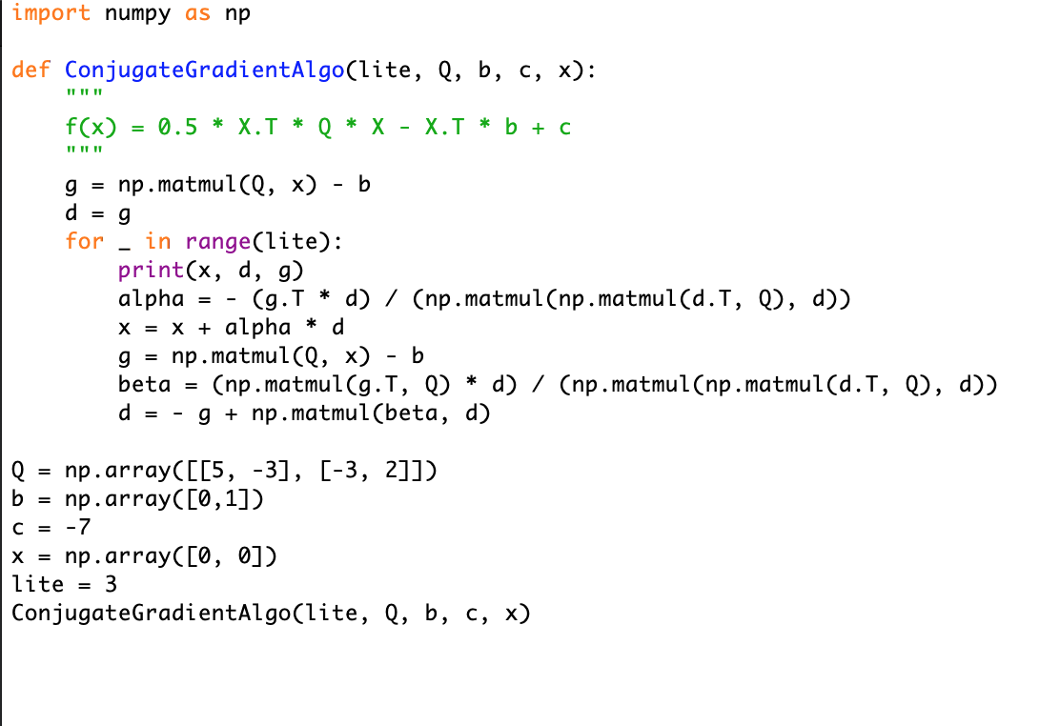

python3 10_9.py

[0 0] [ 0 -1] [ 0 -1]

[0. 0.5] [3.75 2.25] [-1.5 0. ]

[0.70754717 0.5 ] [4.01299395 8.17337131] [ 2.03773585 -2.12264151]