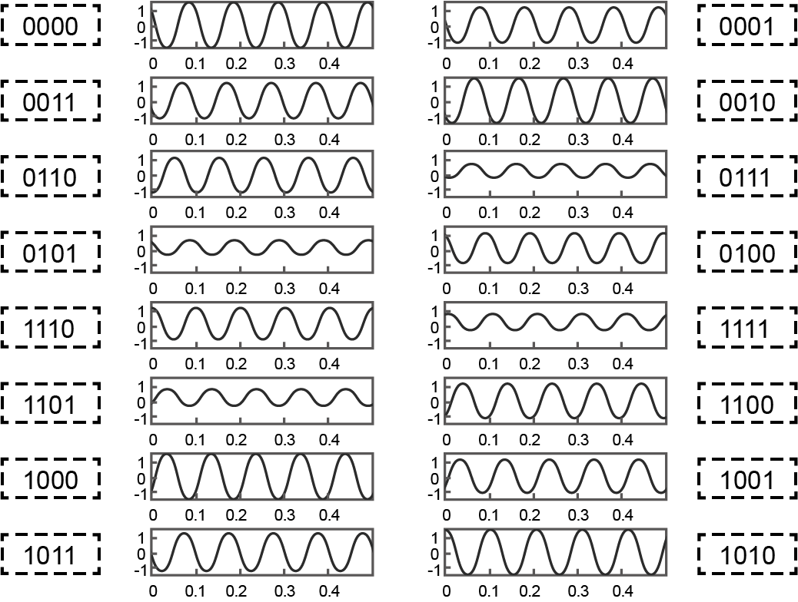

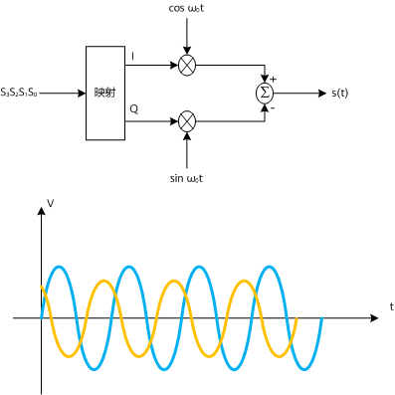

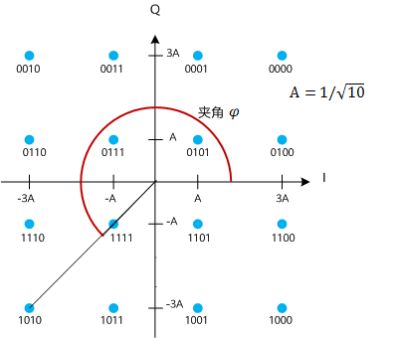

I/Q Channel

尤拉公式：𝑒!"=cos𝑥+jsin𝑥

線性調變：原始基頻訊號為𝑚𝑡，調變至頻率𝑓#射頻訊號𝑠𝑡:-𝑠(𝑡)=𝐴𝑡)cos2𝜋𝑓"𝑡+𝜙!(𝑡)=Re𝐴!(𝑡)𝑒#$%&!'()"(')=Re𝐴!(𝑡)𝑒#)"(')𝑒#$%&!'=Re𝐴!(𝑡)(𝑐𝑜𝑠𝜙!(𝑡)+𝑗𝑠𝑖𝑛𝜙!(𝑡))𝑒#$%&!'

對應的cos 稱作I-channel(in-phase carrier)、sin稱作Q-channel (quadrature-phase carrier) ，相當於訊號經歷了兩個正交的通道

$$s\left(t\right)=A_{m}\left(t\right)\cos\left(2πf_{c}t+∅_{m}\left(t\right)\right)=Re\left\{A_{m}\left(t\right)e^{j\left(2πf_{c}t+∅_{m}\left(t\right)\right)}\right\}$$

$$=Re\left\{A_{m}\left(t\right)e^{j\left(∅_{m}\left(t\right)\right)}e^{j\left(2πf_{c}t\right)}\right\}=Re\left\{A_{m}\left(t\right)(cos∅_{m}\left(t\right)+jsin∅_{m}\left(t\right))e^{j\left(2πf_{c}t\right)}\right\}$$

基頻訊號: $A_{m}\left(t\right)(cos∅_{m}\left(t\right)+jsin∅_{m}\left(t\right)=I\left(t\right)+jQ(t)$

射頻訊號: $Re\left\{\left(I\left(t\right)+jQ\left(t\right)\right)e^{j\left(2πf_{c}t\right)}\right\}=I\left(t\right)cos{2πf}_{c}t-jQ\left(t\right)sin{2πf}_{c}t$

IEEE802.11A

藉由QAM 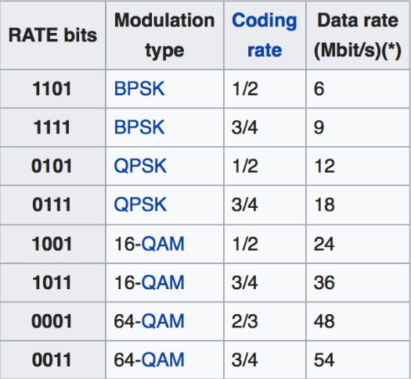調變技術提升Data Rate

BPSK

Data Rate = 12 (Msymbol/s) x 1/2 (bit/coded bit)x 1(coded bit/symbol) = 6 (Mbit/s)-QPSK:

Data Rate = 12 (Msymbol/s) x 3/4 (bit/coded bit)x 2(coded bit/symbol) = 18(Mbit/s)-

64-QAM:

Data rate ¾:üData Rate = 12 x 3/4 x 6 = 54 (Mbit/s)