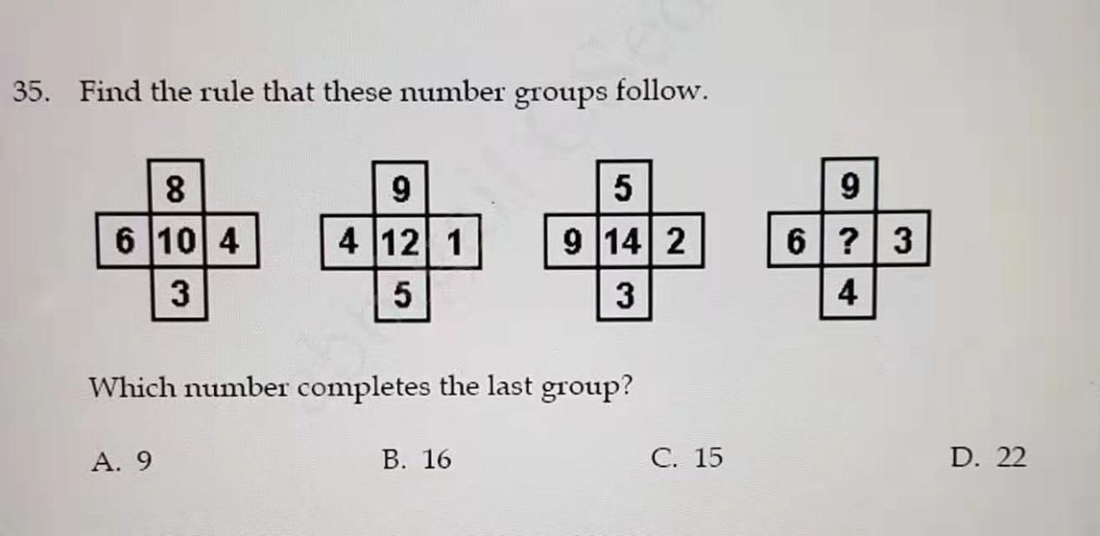

（6-3）\*（9-4）=15

12-5 \* 5-3 = 14

8-5 \* 7-2 = 15

120 -110 \* 110 -100 = 100