- The ones to remain
输入文件名为:problem1.in 输出:标准输出
Problem description
There are N soldiers standing in one line. They are marked from 1 to N, from right to left. And they are given a number m. Then the soldiers numbered off, straight from the right-hand man. The one who reported a number that is the multiple of m was kept in the line. Others have to leave the line. They continue doing this till the number of people in the line is less than m. For example, if there are 10 soldiers, and m = 3. For the first time the soldiers who are marked 3, 6, 9 remain in the line. For the second time the soldier who is marked 9 remains in the line. Because the number of soldiers in the line is less than m, so the soldier marked 9 was the only one to remain in the line.
Now we want to know who will be the ones to remain, can you tell us ?
Input
There are several test cases in the input. Each test cases is only one line, contains two integers n and m.(3 <= n <= 10⁹, 2 <= m <= n). The input ends when n = 0 and m = 0.
Output
For each test case, output two lines. The first line contains one integer x, the number of soldiers to remain. The second line contains x integers, the numbers marked on the soldiers who remain in the line. You should output them in increasing order.
Sample Input
10 3
8 3
0 0
Sample Output
1
9
2
3 6
Problem Source
YiYi

- Base 64 Encoding
输入文件名为:problem2.in 输出:标准输出
Problem description
The Base 64 encoding is designed to represent arbitrary sequences of octets in a form that requires case sensitivity but need not be humanly readable.
65-character subset of US-ASCII is used, enabling 6 bits to be represented per printable character. (The extra 65th character, "=", is used to signify a special processing function.).
The encoding process represents 24-bit groups of input bits as output strings of 4 encoded characters. Proceeding from left to right, a 24-bit input group is formed by concatenating 3 8-bit input groups. These 24 bits are then treated as 4 concatenated 6-bit groups, each of which is translated into a single digit in the base 64 alphabet(Table 1).
Each 6-bit group is used as an index into an array of 64 printable characters. The character referenced by the index is placed in the output string.
Table 1: The Base 64 Alphabet

Value Encoding Value Encoding Value Encoding Value Encoding
0 A 17 R 34 i 51 z
1 B 18 S 35 j 52 0
2 C 19 T 36 k 53 1
3 D 20 U 37 l 54 2
4 E 21 V 38 m 55 3
5 F 22 W 39 n 56 4
6 G 23 X 40 o 57 5
7 H 24 Y 41 p 58 6
8 I 25 Z 42 q 59 7
9 J 26 a 43 r 60 8
10 K 27 b 44 s 61 9
11 L 28 c 45 t 62 +
12 M 29 d 46 u 63 /
13 N 30 e 47 v
14 O 31 f 48 w (pad) =
15 P 32 g 49 x
16 Q 33 h 50 y
Special processing is performed if fewer than 24 bits are available at the end of the data being encoded. A full encoding quantum is always completed at the end of a quantity. When fewer than 24 input bits are available in an input group, zero bits are added (on the right) to form an integral number of 6-bit groups. Padding at the end of the data is performed using the '=' character. Since all base 64 input is an integral number of octets, only the following cases can arise:
- the final quantum of encoding input is an integral multiple of 24 bits; here, the final unit of encoded output will be an integral multiple of 4 characters with no "=" padding,
- the final quantum of encoding input is exactly 8 bits; here, the final unit of encoded output will be two characters followed by two "=" padding characters, or
- the final quantum of encoding input is exactly 16 bits; here, the final unit of encoded output will be three characters followed by one "=" padding character.
Input
The first line of the input contains a single integer T (1 <= T <= 100), the number of test cases. Then T cases followed. Each case is a string(no empty string) in one line to be encoded.
Output
For each test case, the encoding result of the string will be output.
Sample Input
4
What is your name
i
you
yes
Sample Output
V2hhdCBpcyB5b3VyIG5hbWU=
aQ==
eW91
eWVz
Problem Source
Hekui

- Chinese Chess
输入文件名为:problem3.in 输出:标准输出
Problem description
Both Xnby and Hekui like playing Chinese Chess. There are two sides: black and red in Chinese Chess. Each side take moves in turns. One day, they made a composition(Now, it's red's turn):
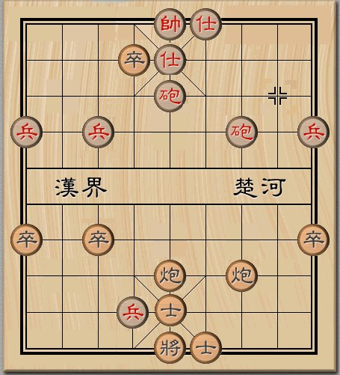
By the way, each side can only move the "Cannon"and the "Pawn".. The cannon can move in straight lines at any distance (from one cross to another) if no other chess pieces block its way. And the pawn can only move forward, one unit per turn. (For the red, top-bottom is forward, and for the black, bottom-top).
After the discussion,they all agree that only when one side, for example, the black cannon is forced to take a horizonal move which makes the red cannon can get to the hemline of the black, then the red wins (See the following figure).
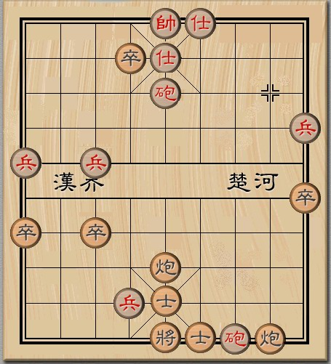
So, they make a few rules:
- 1.The cannon can only move forward. If one side has to move the "cannon" to left or right, he loses. Notice that it doesn't change situation if a cannon moves backward, because the opposite side can move its cannon forward for the same distance.
- 2.Only the pawns which haven't crossed the river can move and the pawn can only move forward. The distance between each pair of pawns (one red, one black) can not be less than 1.
- 3.The winner only depends on the distance m and n(between the pair of cannons in the same vertical line counting from the left side), S₁,S₂,S₃ (between the pair of pawns' which not cross the river in the same vertical line counting from the left side).
(See the following figure)
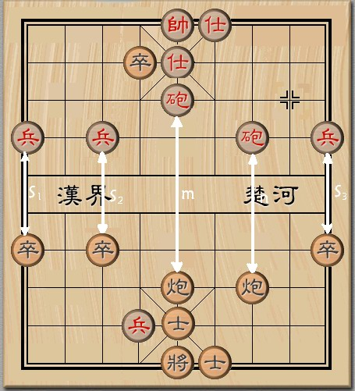
Xnby and Hekui want to know: which side is the winner when each of them moves in the best strategy. To make it more interesting, m,n, S₁,S₂,S₃ are not limited by Chinese Chessboard, in other words, Chessboard of this game is large enough.
Input
There are several test cases, each case in a single line which contains 5 integers separated by a blank: m, n,S₁,S₂,S₃ , 0≤m,n≤1000000,1≤ S₁,S₂,S₃ ≤1000. The input terminates when one line contains a single negative integer, which needn't to be processed.
Output
For each test case, output the winner(Red or Black)
Sample Input
4 1 2 2 1
0 0 1 1 1
-1
Sample Output
Red
Black
Problem Source
Dr Wu

- Counting
输入文件名为:problem4.in 输出:标准输出
Problem description
In a directed connected graph G, there are N nodes and M edges. Among the M edges, for arbitrary given node k (we named the N nodes 1, 2, . . . , N), if there are s edges point to it, we call the node k with a in-degree s, if there are t edges leads from it, we call the node k with a out-degree t. For the given graph G, we define the spanning tree as follows:
- The tree contains N nodes and N-1 edges in G;
- The N nodes are connected.
For the above definition of the spanning tree, if there is a node v meets that, the in-degree of node v is 0, and the in-degree of all the remaining nodes is 1, we call this kind of tree as outward tree roots with v. Now the given task is following:
In arbitrary given connected graph G with N nodes and M edges, can you tell me how many different kinds of trees there are in G meet the following condition?
- Maybe the tree is a outward tree roots with v, and also maybe it's only a spanning tree;
- The tree must contains the given h edges, you should assume the h edged belong to G;
You may assume that there is no same direction edge between any two nodes.
Input
In the first line, there is a single integer T, which indicates the test case. For each test case, the first line contains three integers N (2 <= N <= 100), M (N-1 <= M < 10000), R (0 <= R <= N), which N is the number of node, M is the number of directed edge, R is the root of the outward tree you should count, if R = 0, you task is counting the number of the spanning tree. In the next M lines, each line contains two integer numbers x and y, which is one edge that node x points to node y. After that, a integer h is given, which indicates the edges that the trees you are counting must contain, then next h lines is following, each line contains two integers x and y, indicates one edge which leads from x to y.
Output
For each test case, the first line you should output is "Case #:", where the '#' is the id of the test case, and then you should output one integer in the second line, which is the number of the outward tree roots witch R or the spanning tree (if R = 0) you have figured out, of course the tree must contains the given h edges. If the result is not less then 10007, please output the result mod 10007.
Sample Input
2
4 5 0
1 2
1 4
4 2
4 3
3 2
0
4 6 1
1 2
1 4
1 3
2 4
4 3
2 3
1
4 3
Sample Output
Case 1:
8
Case 2:
2
Problem Source
huicpc305

- Chinese Segment
输入文件名为:problem5.in 输出:标准输出
Problem description
Few weeks ago, ZJS was busy with his Graduation Design (GD), after weeks of efforts he finally get it. His GD is on the Chinese Word Segment.
As we know western language is used to write the word separated by a space between words. Chinese does not write words continuously, and because word is the basic unit of any language, so the Word Segment (Separates the word with the word by a space or other markings) has become the necessary first working procedure in Chinese auto analysis.
There is a “the biggest probability algorithm” in ZJS' GD. The algorithm described as follows: Before the Word Segment there has been a dictionary with the word frequency and the dictionary is believable. In the dictionary, each word takes a line, behind each word is its frequency, and these words are stored in the dictionary by lexicographic. At the time of segmenting word we find out all the words according to the dictionary, then find out all the possible cut paths(the word strings),and choose a best (that is, the biggest probability) path as the output, the key of this approach is to find out the best path efficiently. For simplicity, we transform the biggest probability into the minimum cost and to find the best path with which the cost is the smallest.
fee ( word ) = - log ( ( fre ( word ) + 1) / MaxFre ), which fee ( word ) is the cost of the word, fre ( word ) is the frequency of the word which can be found in the dictionary.And we suppose MaxFre = 5196588.If we can not find the word in the dictionary, its frequency is 0.
For example, a part of the dictionary is like this:
成 2871
成分 160
合 276
合成 21
分 1986
分子 373
结 247
结合 2208
时 8076
子 127
Transform the expense into the frequency, the result is as follows:
成 7.50075 成分 10.3821 合 9.8395
合成 12.3725 分 7.86913 分子 9.53926
结 9.95008 结合 7.76322 时 6.46674
子 10.6115
“结合成分子时” can be segmented in to “结/合/成/分/子/时/”, “结合/成/分/子/时/”, “结合/成分/子/时/”, “结合/成/分子/时/”, and so on.
Obviously, the best path of “结合成分子时” is “结合/成/分子/时”.Its cost is 31.26997 which is smallest among all the paths. And now your task is to segment Chinese sentences, then output the best path, use “ / ” as separation mark. For simplicity, in the input does not have the punctuation mark and the western languages character.
Input
A integer m first line which is the number of the words in the dictionary, then a dictionary with m lines as described above, and every word contains four Chinese characters at most , then an integer n. Each of the following n lines contains a Chinese sentences, no punctuation, only composed of Chinese characters.
Output
N sentences with separation marks after segmenting. Each sentence a line.
Sample Input
10
成 2871
成分 160
合 276
合成 21
分 1986
分子 373
结 247
结合 2208
时 8076
子 127
1
结合成分子时
Sample Output
结合/成/分子/时/
Problem Source
jinhui

- QQ Game About LianLian Kan
输入文件名为:problem6.in 输出:标准输出
Problem description
As we all know, lfq198502 likes to play the LianLian Kan game very much.
During the LianLian Kan game, so long as the same color of the two cards can be linked together with no more than three straight lines,they will be eliminated,the rules simple and easy to use.
Operations: The first use of mouse clicks a pawn in the chessboard, the pawn is "checked" at this moment with a special display;the mouse clicking another pawn again, if the pawn of pattern is the same as the "checked" pawn,and the two pawns can be linked together with no more than three straight lines, this pair of pawns will be eliminated;otherwise the first pawn was not "checked", and the second one was "checked".

Here,we can imagine the LianLian Kan’s interface into a plane with 10 × 10 blocks, each block is a type of pictorial or empty.The sake of simplicity, we use different characters representing different patterns, a space means that there is no pattern. Given the initial interface of game and the records that lfq198502’s mouse clicked the coordinates in the course of the game,your task is to judge whether he can eliminate all the patterns or not after these actions.
Input
The first line of the input contains an integer T(1 <= T <= 50). T refers to the number of the test cases followed.
Each test case contains two parts:
The first part: ten lines of strings and each line contains ten characters (a space character indicates that there is no pattern at this block and each other character stands for one pattern),indicating the initial interface.
The second part: an integer n on the first line,indicating how many times that lfq198502’s mouse clicked; then n lines followed,each line with two integers x,y(1≤x≤10, 1≤y≤10), indicating the row and column postion of a mouse click.
Output
For each test case output one line.If lfq198502 can eliminate all the patterns,output “Yes,all patterns are eliminated!”;otherwise,output “No,m pattern(s) are left!”.Show the exact format as bellow.
Sample Input
2
abccba x
bax
ab 8
8

@ (

( @
18
1 3
1 4
1 2
1 5
1 1
1 6
1 10
2 3
2 2
3 2
3 3
2 1
3 7
4 10
8 1
10 7
10 3
8 10
ab 8
ba

8

@

@
8
1 1
2 2
1 2
2 1
1 10
4 10
8 1
10 7
Sample Output
Yes,all patterns are eliminated!
No,4 pattern(s) are left!
Problem Source
lfq198502

- Getting the same color
输入文件名为:problem7.in 输出:标准输出
Problem description
There are n students standing in a line, each of them is wearing clothes of one certain color. There is total m different colors, so each color can be represented by a single number from 0 to m-1.Teacher Wu wants to let his students wear clothes of the same color, so he need some operations. As we all know teacher Wu is an erratic person, if one student is wearing clothes of i-th color and teacher Wu wants to change this student’s color, he only asks this student to wear ((i+1)%m)-th color in one operation. What’s more, in one operation, teacher Wu always let the t consecutive students change their colors. Now here comes the problem, give you the number n,m,t,（n < 2000, m < 150, t < n）and all students’ clothes color, you are required to calculate the least operations through which all the students can wear clothes of the same color.
Input
In the first of the input, there is a number k<=30, indicating the number of test cases.
For every test case, there is one line containing three positive integers n, m, t, followed by some lines containing n numbers a_{i}(0<=a_{i}<=m-1) indicating the color of the i-th student’s clothes.
Output
For each test case, you are to output two integers in one line, the minimal operations and the color these students wear at last. If there are two colors which can be achieved by the same number of operations, you need to output the small one. It’s guaranteed that you can find some operations getting the same color for all of the input.
Sample Input
1
7 2 3
0 0 1 0 1 0 0
Sample Output
3 1
Judge Tips
Output details You need three operations to let all the students wear the same color (the color 1):

0 1 1 1
0 1 1 1
1 0 1 1
0 0 1 1
1 1 0 1
0 0 0 1
0 0 0 1

Problem Source
huicpc302

- Orienteering
输入文件名为:problem8.in 输出:标准输出
Problem description
Cross-Country Orienteering, one of more and more important and well-known sports games in Hunan University, has made the University more and more impressive in the National competitions. Each year,after the military training there will be a Cross-Country Orienteering for the freshmen.
The form of the orienteering is Score Orienteering,Many controls are placed throughout the area, each having a point value determined by its distance from the start/finish or its technical difficulty. Participants have a set time to find as many controls as they can and earn as large a point value as possible. There is a large point penalty for being over-time. Highest score wins!
To win the game,you should find all the controls.If you can compute the best route by compute programing, you will have great advantages.Now give you the map,the map contains the start location,end location,all the controls location,and the obstruction,obviously you can’t cross the obstruction.To simple the problem,you can assume that the obstruction is a polygon which has not got self-intersections or self-contacts. And all the control and start,end point are outside the obstruction.Can you find the minimum length way from start point to end point and cross all the controls.Why not try?!
Input
The first line in the input is one integer T, indicates the number of test cases. Each test case begin with two integers n(n<=100) the number of vertices of the polygon, m(m<=10) the number of the controls,the second line is four integers(x₁,y₁,x₂,y₂),these integers represent the start and end point .then followed n lines,each line is the vertices coordinate,in counterclockwise order. and the next is m lines,each line is the coordinate of the control.All the coordinates are integers and the value less than 100000.
Output
The output consists of one line containing the length of a shortest way, with the accuracy 0.01.
Sample Input
1
4 1
0 0 3 3
1 1
1 2
2 2
2 1
0 3
Sample Output
6.00
Problem Source
xnby

