**Storm启动流程分析**

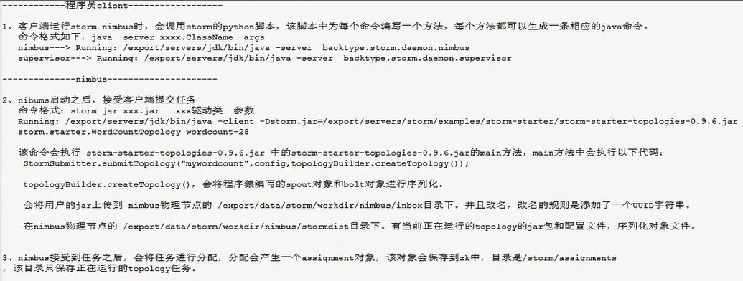

------------------------supervisor-----------------------------------------------------------------------------------------

