*The TI SmartAmp software is loaded into program ram(PRAM) through writes to mapped memory registers.*

*The encrypted binary software is downloaded and decoded on chip. Therefore read-back of the PRAM is disabled.*

*a 8 bit CRC checksum is provided to the customer to verify the code was correctly written to PRAM*

*error-free.*

**Initialization Set Up：**

1. **Bring-up the power supplies**

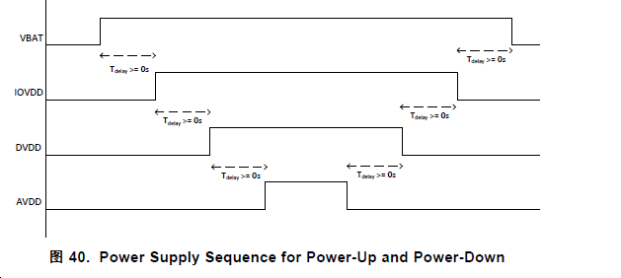

电源稳定后，可以将/ RESET端子设置为高电平以操作设备。 另外/ RESET引脚可以连接到IOVDD，内部DVDD POR将执行器件复位。 之后硬件或软件复位设备的附加命令应延迟100uS以允许OTP

加载。

1. **Set the /RESET terminal to HIGH.**
2. **Software sequence**

#Book-0

#Software reset

# wait 100us time for OTP-One Time Programmable memory values to be transferred to device

# use default coefficients and operate DSP in rom mode 2

################### CHANNEL POWER UP ####################################################

# Power up Analog Blocks

# Power up DSP and clock dividers

# Unmute Analog Blocks

# Soft stepped unmute of audio playback

# DSP filter coefficient update if required

# Soft stepped mute of audio playback

# wait for DSP to mute classD after soft step down of audio

# Mute Analog Blocks

# Power down DSP and clock dividers (except Ndivider)

# Power down Analog Blocks

I2C_probe->tas2555_parse_dt{读取dts reset_gpio,左右声道信息}//devm_regmap_init_i2c{初始化regmap}//复位芯片//然后实现读写等函数//tas2555_set_config{配置设置：上面那一套}//register_codec{codecdriver(wiget\damp\controls\routes、然后一些probe 读写函数) and dai driver（ops函数集）}//tas2555_register_misc(pTAS2555);// tiload_driver_init(pTAS2555);