K & r Results

index leaks errors ops secs Kops file

1 0 0 12 0.000030 400 short1-bal.rep

2 0 0 12 0.000019 631 short2-bal.rep

3 0 0 5694 0.007792 730 traces/trace0.rep

4 0 0 5848 0.007502 779 traces/trace1.rep

5 0 0 5380 0.008059 667 traces/trace3.rep

6 0 0 14400 0.014692 980 traces/trace4.rep

7 0 0 4800 0.010852 442 traces/trace5.rep

8 0 0 4800 0.010668 449 traces/trace6.rep

9 0 0 12000 0.044859 267 traces/trace7.rep

10 0 0 24000 0.087243 275 traces/trace8.rep

11 0 0 14401 0.143064 100 traces/trace9.rep

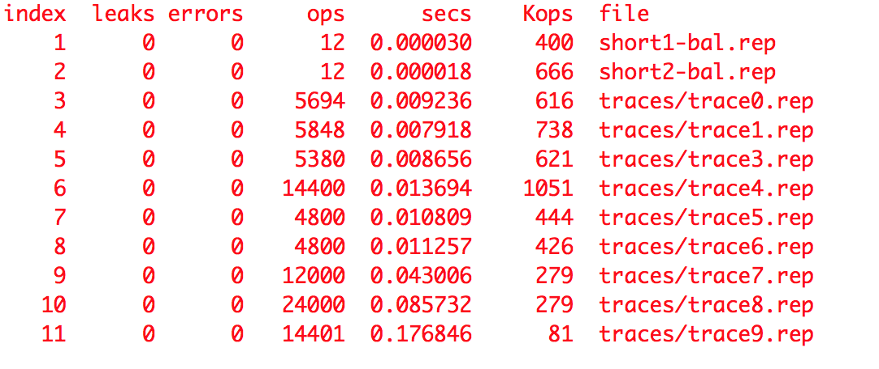

malloc Results

index leaks errors ops secs Kops file

1 0 0 12 0.000028 428 short1-bal.rep

2 0 0 12 0.000019 631 short2-bal.rep

3 0 0 5694 0.006989 814 traces/trace0.rep

4 0 0 5848 0.007487 781 traces/trace1.rep

5 0 0 5380 0.006561 819 traces/trace3.rep

6 0 0 14400 0.015440 932 traces/trace4.rep

7 0 0 4800 0.005363 895 traces/trace5.rep

8 0 0 4800 0.006556 732 traces/trace6.rep

9 0 0 12000 0.011350 1057 traces/trace7.rep

10 0 0 24000 0.021709 1105 traces/trace8.rep

11 0 0 14401 0.025876 556 traces/trace9.rep

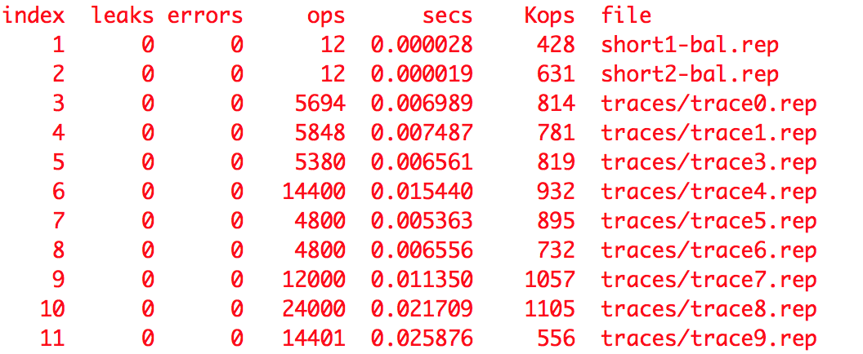

simple Results

index leaks errors ops secs Kops file

1 0 0 12 0.000011 1090 short1-bal.rep

2 0 0 12 0.000015 800 short2-bal.rep

3 0 0 5694 0.005288 1076 traces/trace0.rep

4 0 0 5848 0.005033 1161 traces/trace1.rep

5 0 0 5380 0.004893 1099 traces/trace3.rep

6 0 1 14400 0.011029 1305 traces/trace4.rep

7 0 1 4800 0.003168 1515 traces/trace5.rep

8 0 1 4800 0.003092 1552 traces/trace6.rep

9 0 0 12000 0.011426 1050 traces/trace7.rep

10 0 0 24000 0.018701 1283 traces/trace8.rep

11 0 1 14401 0.010761 1338 traces/trace9.rep

