# Manual of HM-Simulator

# Version 0.1

Geosoft @ Peking University

HM-Simulator is a software tool for simulating human motions developed in Java. It can generate synthetic trajectories with particular constrains, and analyze the patterns. It implements a number of well-known human mobility models including the Levy flight model. The functions of HM-Simulator are demonstrated in Fig. 1.

Fig. 1 Major functions of HM-Simulator

We will provide a tutorial to demonstrate the use of HM-Simulator using the sample data set, which including:

1. city.shp, a vector data representing administrative units of a city;
2. Boundary.shp, city boundary;
3. road.shp;
4. population.txt, a raster file for the population distribution of the city.

The main window of the software tool contains the following child windows: map window, analysis window, and message windows. (Fig. 2)

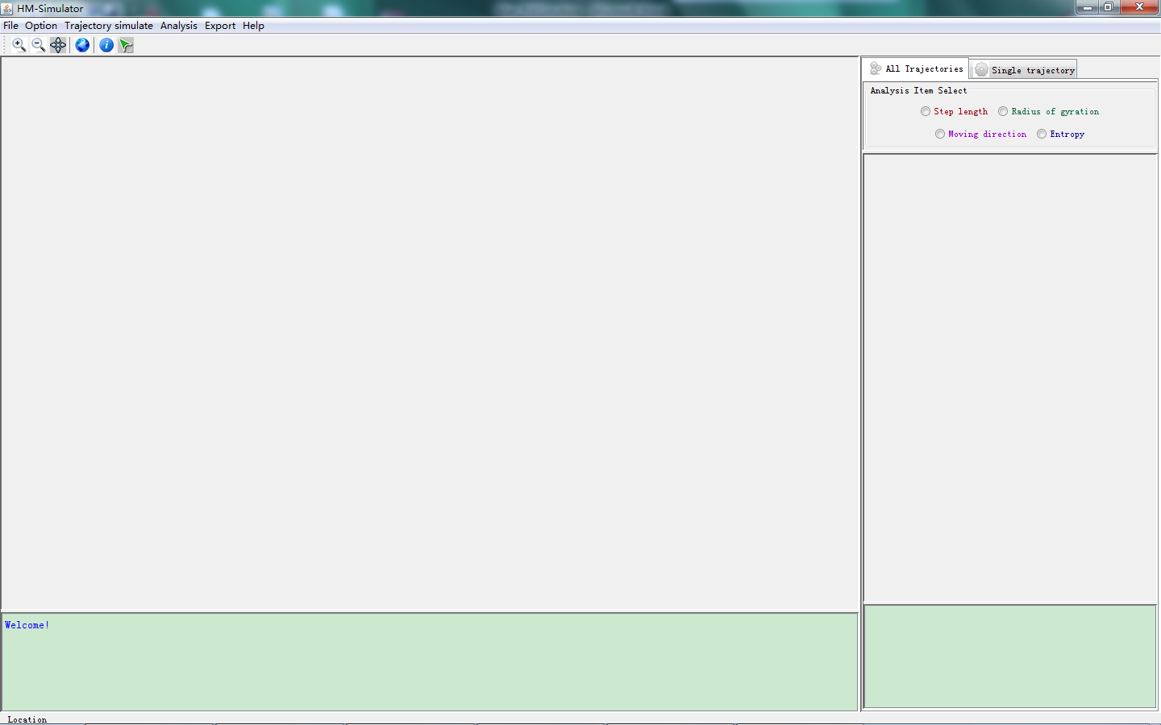

Fig. 2 UI of HM-Simulator

**First**, we can click the menu item “File🡪Import Polygon” to open a polygon data (boundary.shp) as a geographical constraint. Then other geographical data (road.shp, population.txt) can be loaded as references. The displace mode of each layer can be set using the menu “Option🡪Set Layer Style”. Fig. 3 displays a map including three layers.

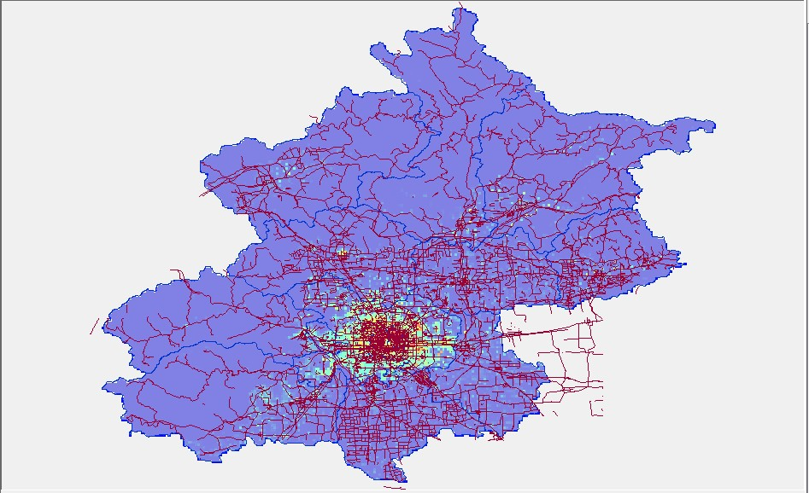

Fig. 3 Geographical data in HM-Simulator

**Second**, we can generate synthetic trajectories using existing data. Click the menu item “File->Generate Trajectories-> Power Law”, can we get a dialog box shown as Fig. 4.

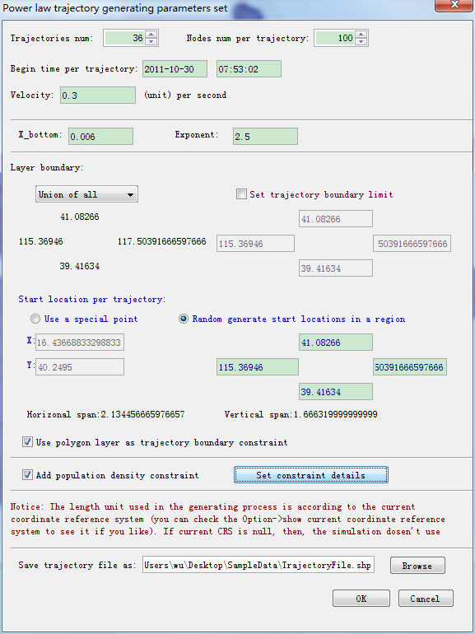

Fig. 4 Dialog box for inputting parameters in generating trajectories.

We can set the number of trajectories, number of stops in trajectories, velocity of trajectories, and pre-defined distribution of displacements. For example, if we use the power law distribution

$$p\left(x\right)=Cx^{-α}$$

we should set the minimum length (x_bottom) and the exponent $α$. Generally, x_bottom should be consistent with the range of the background geographical data. During the trajectory simulation, we can use a vector boundary data and a raster data as the geographical factors to contain the spatial distribution trajectory stops. Fig. 5 displays detailed necessary parameters when use a raster layer as the constraint.

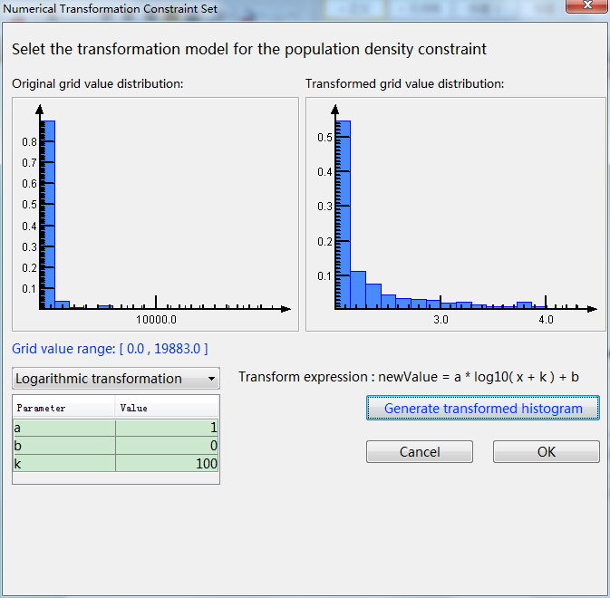

Fig. 5 parameters when use a raster layer as the constraint

The tool also support exponential models Gaussian models, in which the displacement distributions follow $p\left(x\right)=ae^{-bx}$ and $p\left(x\right)=\frac{1}{\sqrt{2π}σ}e^{-\frac{{(x-μ)}^{2}}{2δ^{2}}}$, respectively.

The generated trajectories are shown in Fig. 6.

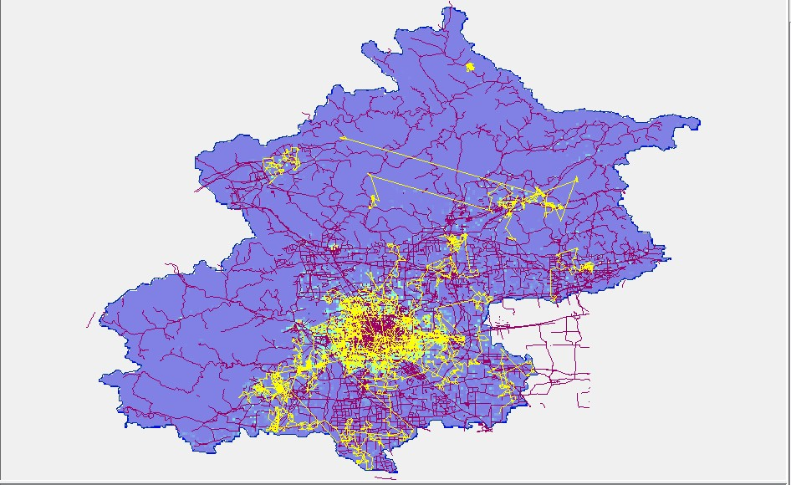

Fig. 6 Generated trajectories using the LF model with geographical constraints

Finally, we can analyze the patterns for all trajectories or a single trajectory. Click “macro analysis”, we can compute the distribution of the displacements, ROGs, and entropies of all trajectories. Several statistics are provided below the plots. (Fig. 7)

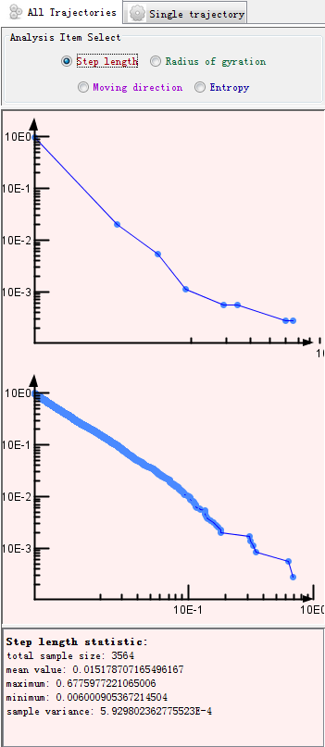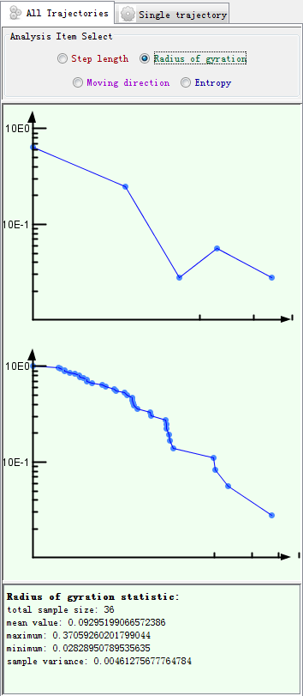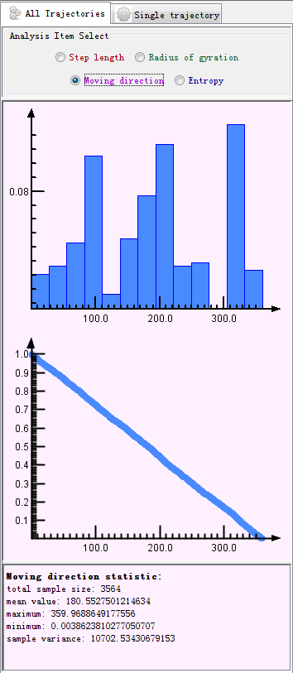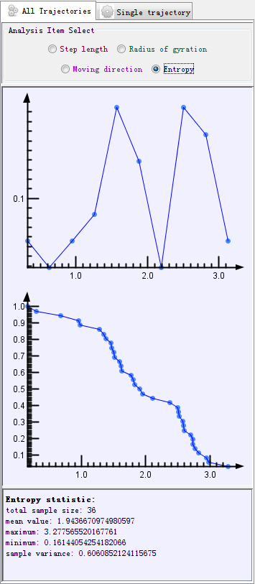

Fig. 7 Plots and statistics of the generated trajectories.

By clicking the right button, we can set different display modes of the plots. For example, we can get a log-log plot of a cumulative distribution function. (Fig. 8)

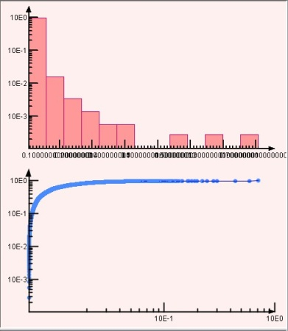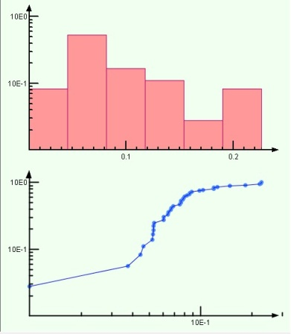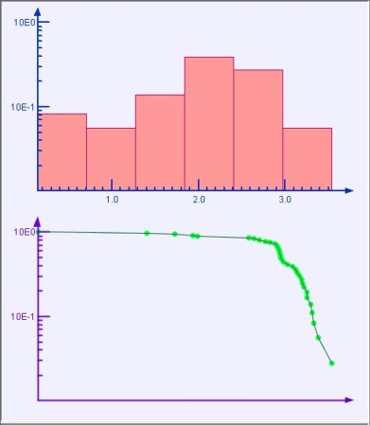

Fig. 8 Different display models of the plots

The single trajectory analysis function is shown in Fig. 9. Click a trajectory with “Ctrl”, the trajectory will be highlighted and the plot and statistics will be outputted in the analysis window.

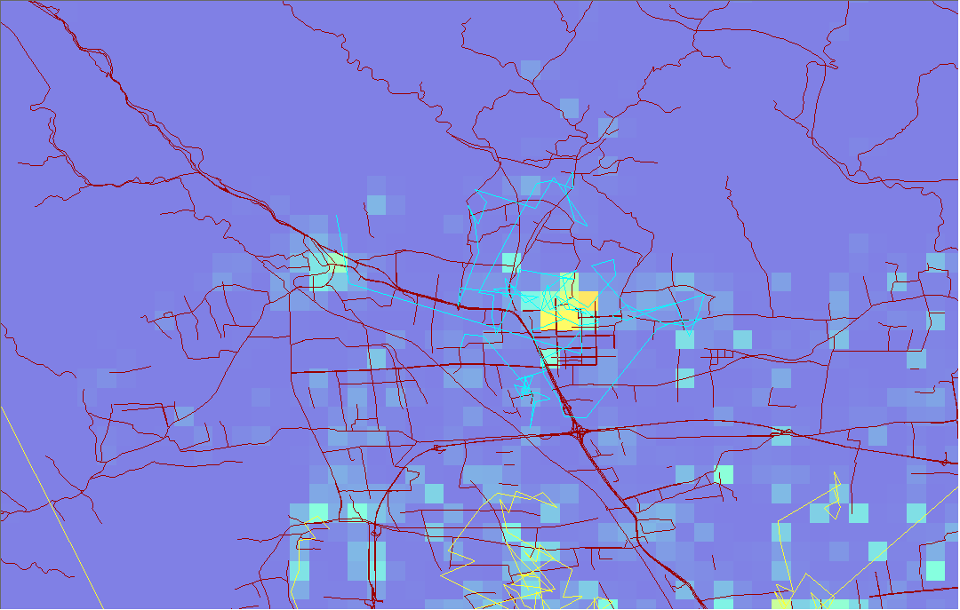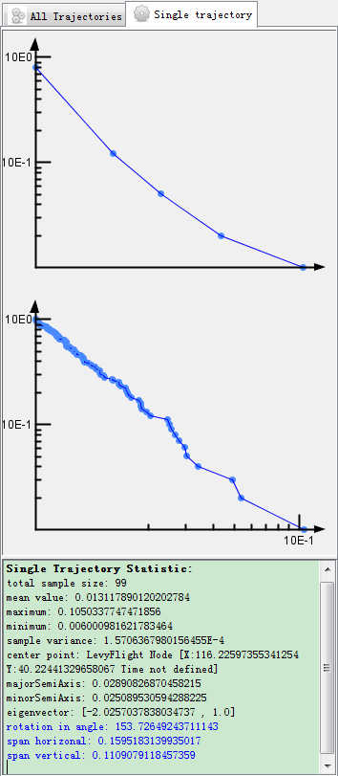

Fig. 9 Displacement distribution of a trajectory