Analysis methods
Twelve periodontitis-derived 7–9-aa micropeptides were docked with AutoDock Vina (exhaustiveness = 32; three independent successful runs) into human AChE (PDB 4EY6). The grid was centered on the peripheral anionic site (PAS: Tyr72, Asp74, Thr75, Trp286, His287, Tyr341) and included the gorge neck and catalytic triad (Ser203, His447, Glu334). Best-run affinity, three-run mean ± SD, hydrogen bonds, and PAS contacts were taken from the local summary and each ligand’s single best pose. PDBQT files are not archived.
Four GROMACS systems (apo AChE and the ALLLHRC, FLLHTTR, and YLSLLQR complexes) were simulated for 100 ns with Amber99SB-ILDN, TIP3P water, 0.15 M NaCl, LINCS, and Particle Mesh Ewald electrostatics at 300 K and 1.0 bar. Metrics in Figures 4–6 are backbone RMSD, per-residue RMSF, SASA, radius of gyration (Rg), DSSP occupancy, and intermolecular hydrogen bonds. Reported values are mean ± SD over the last 20 ns.

Results

Docking
Best-run scores ranged from -8.25 to -9.60 kcal/mol and three-run means from -8.07 ± 0.16 to -9.44 ± 0.09 kcal/mol (Table 1, Figure 1). Residue contacts at the Peripheral Anionic Site (PAS) are taken from each best pose. FLLHTTR had the strongest best pose (-9.60 kcal/mol) but the largest SD (-8.77 ± 1.41 kcal/mol). YLSLLQR had the strongest mean (-9.44 ± 0.09 kcal/mol); ALLLHRC was second by mean (-9.18 ± 0.11 kcal/mol) despite a catalytic-pocket rather than outer-PAS pose. Best poses formed 3–10 hydrogen bonds (Figures 2 and 3; Figure S1).
Table 1. Local three-run AutoDock Vina scores against human AChE (PDB 4EY6).
No. | Peptide | HBonds | Best (kcal/mol) | Mean ± SD, n=3 (kcal/mol) | PAS in best pose
1 | ALLLHRC | 3 | -9.29 | -9.18 ± 0.11 | No (Ser203 gorge neck)
2 | FCLHLQLR | 7 | -9.27 | -8.96 ± 0.48 | Yes (Thr75, Tyr341)
3 | FLLHTTR | 8 | -9.60 | -8.77 ± 1.41 | Yes (Asp74, Tyr72, His287)
4 | HLLTLKKHV | 6 | -8.88 | -8.69 ± 0.20 | Yes (Tyr72, Phe346)
5 | HLPLLHRCC | 4 | -8.35 | -8.28 ± 0.07 | No
6 | HVLLLRQCA | 4 | -8.25 | -8.07 ± 0.16 | Yes (Thr75)
7 | LLHLPKRTT | 3 | -9.01 | -8.89 ± 0.16 | Adjacent (Val340)
8 | LLHPLRC | 4 | -8.91 | -8.78 ± 0.11 | No
9 | LLHPLRL | 10 | -8.94 | -8.91 ± 0.05 | Yes (Trp286/Tyr341 to His447)
10 | WLLVHLKK | 4 | -8.94 | -8.64 ± 0.26 | No
11 | YHHLLCRR | 7 | -9.03 | -8.62 ± 0.43 | No (Trp86 pocket)
12 | YLSLLQR | 7 | -9.49 | -9.44 ± 0.09 | Yes (Tyr72, Thr75, Ser203)

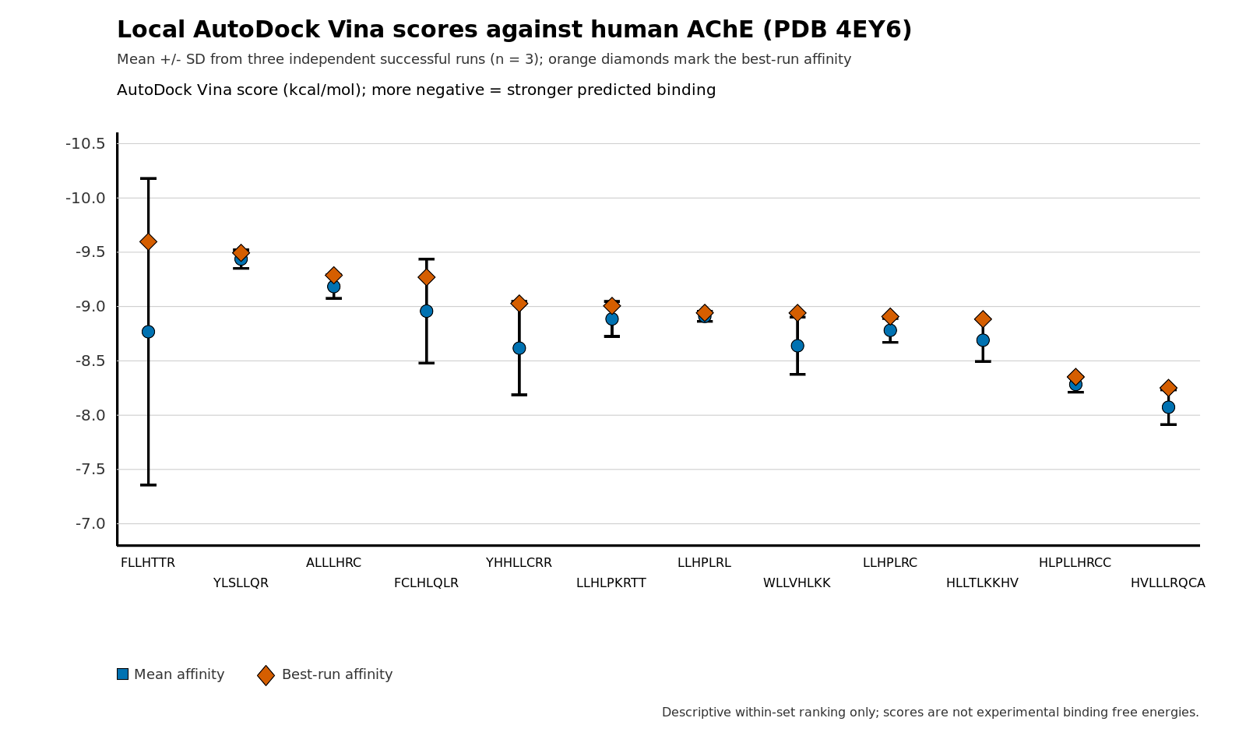
Figure 1. Local AutoDock Vina scores against human AChE (PDB 4EY6). Blue circles: three-run mean; whiskers: SD; orange diamonds: best-run affinity. Horizontal order is best-run ranking.
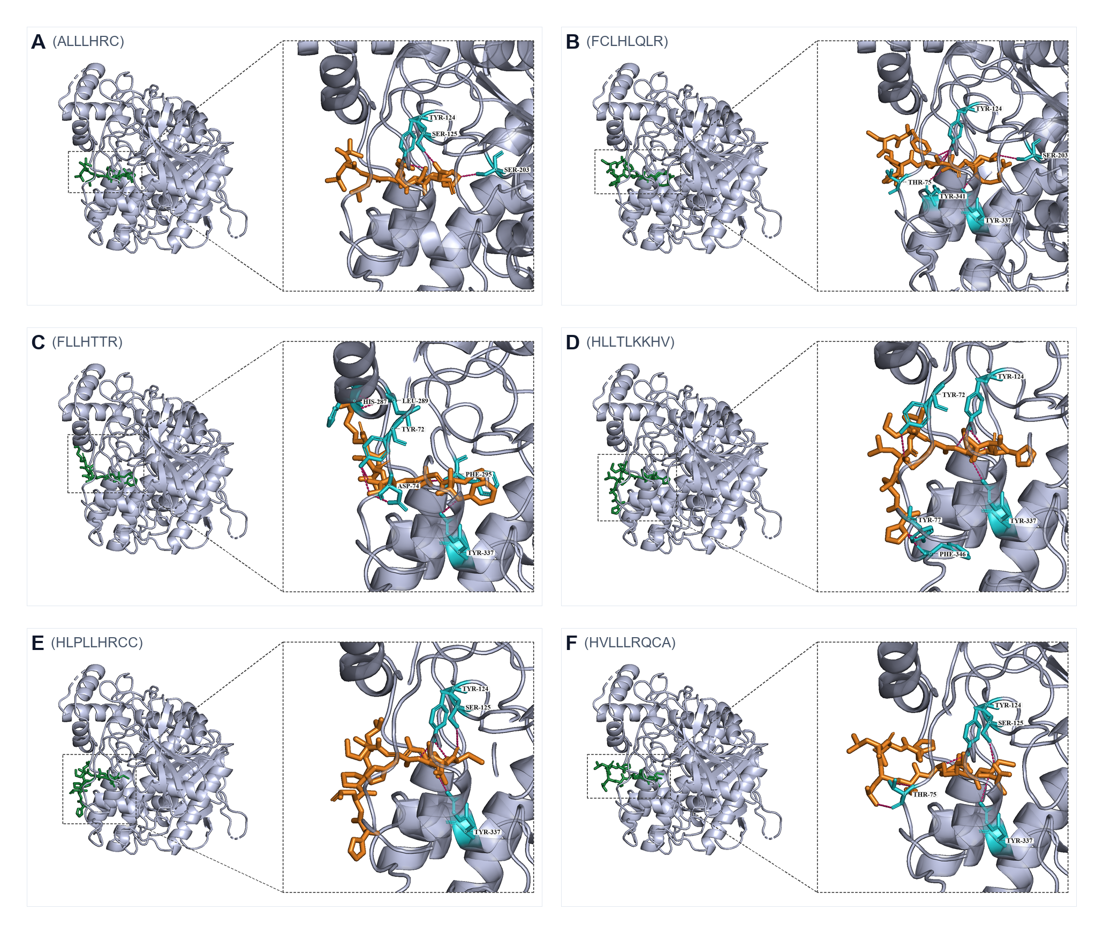
Figure 2. Best poses A–F (ALLLHRC to HVLLLRQCA). FLLHTTR (panel C) is the densest PAS pose.
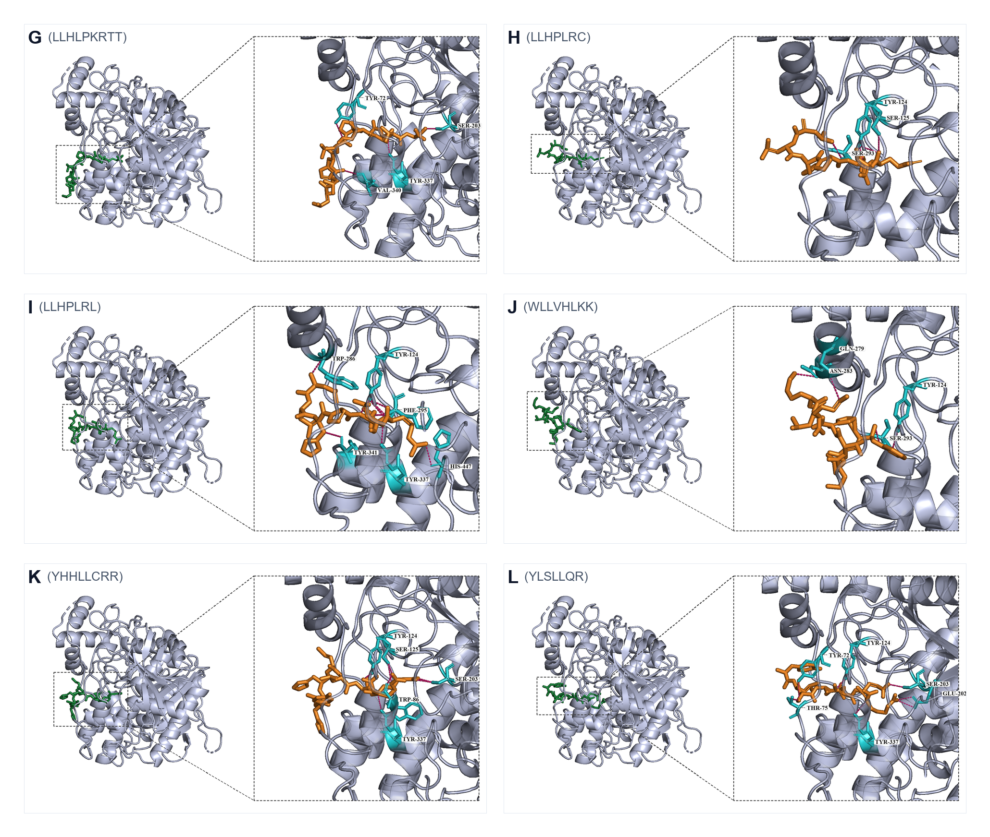
Figure 3. Best poses G–L. LLHPLRL (panel I) spans PAS to His447; YLSLLQR (panel L) bridges PAS and the catalytic entrance.
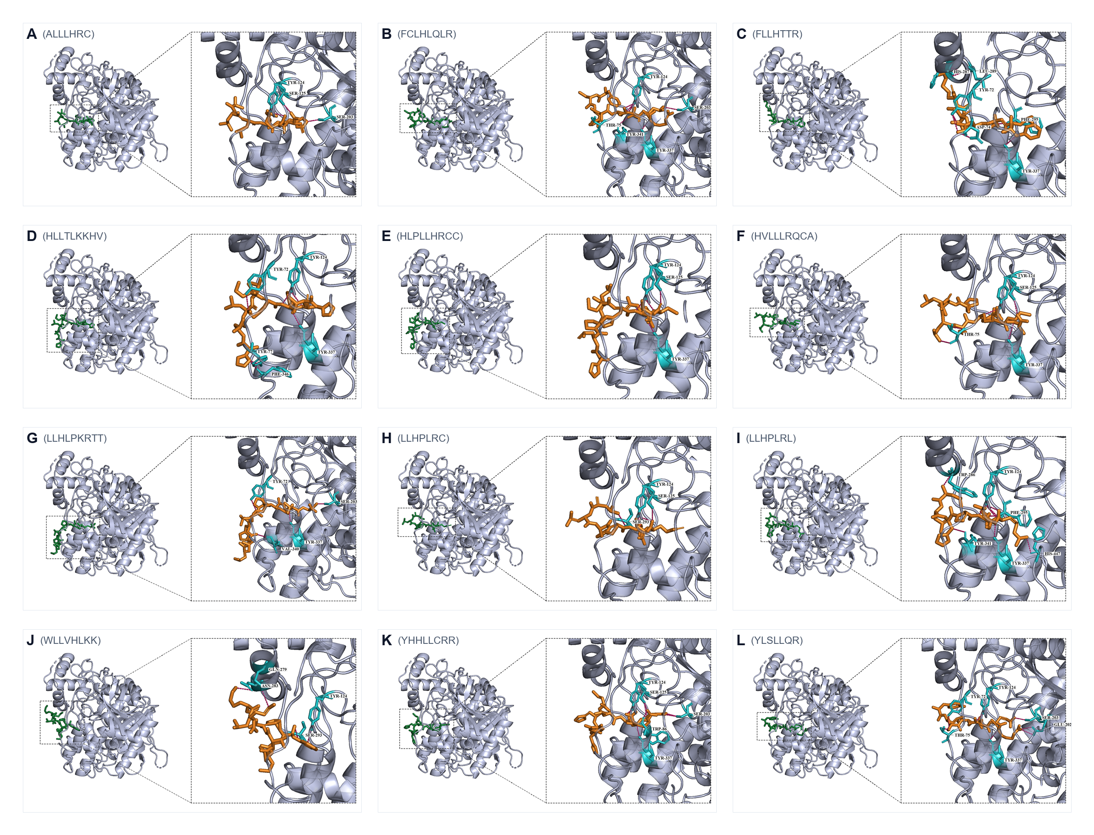
Figure S1. Combined overview of panels A–L.

100-ns molecular dynamics
Apo AChE and the three complexes remained globular over 100 ns (Table 2, Figures 4–6). Each figure uses the same six-panel layout as the source fig_compare.png files: RMSD (A), RMSF (B), SASA (C), Rg (D), DSSP last 20 ns (E), and intermolecular hydrogen bonds (F).

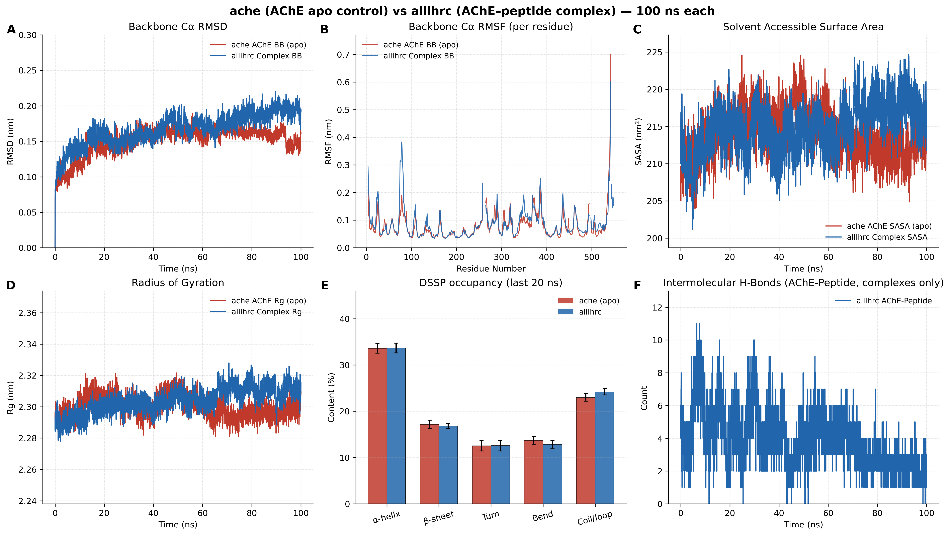
Figure 4. Apo AChE versus AChE–ALLLHRC. Complex RMSD (A) plateaus near 0.19 nm; hydrogen bonds (F) persist.
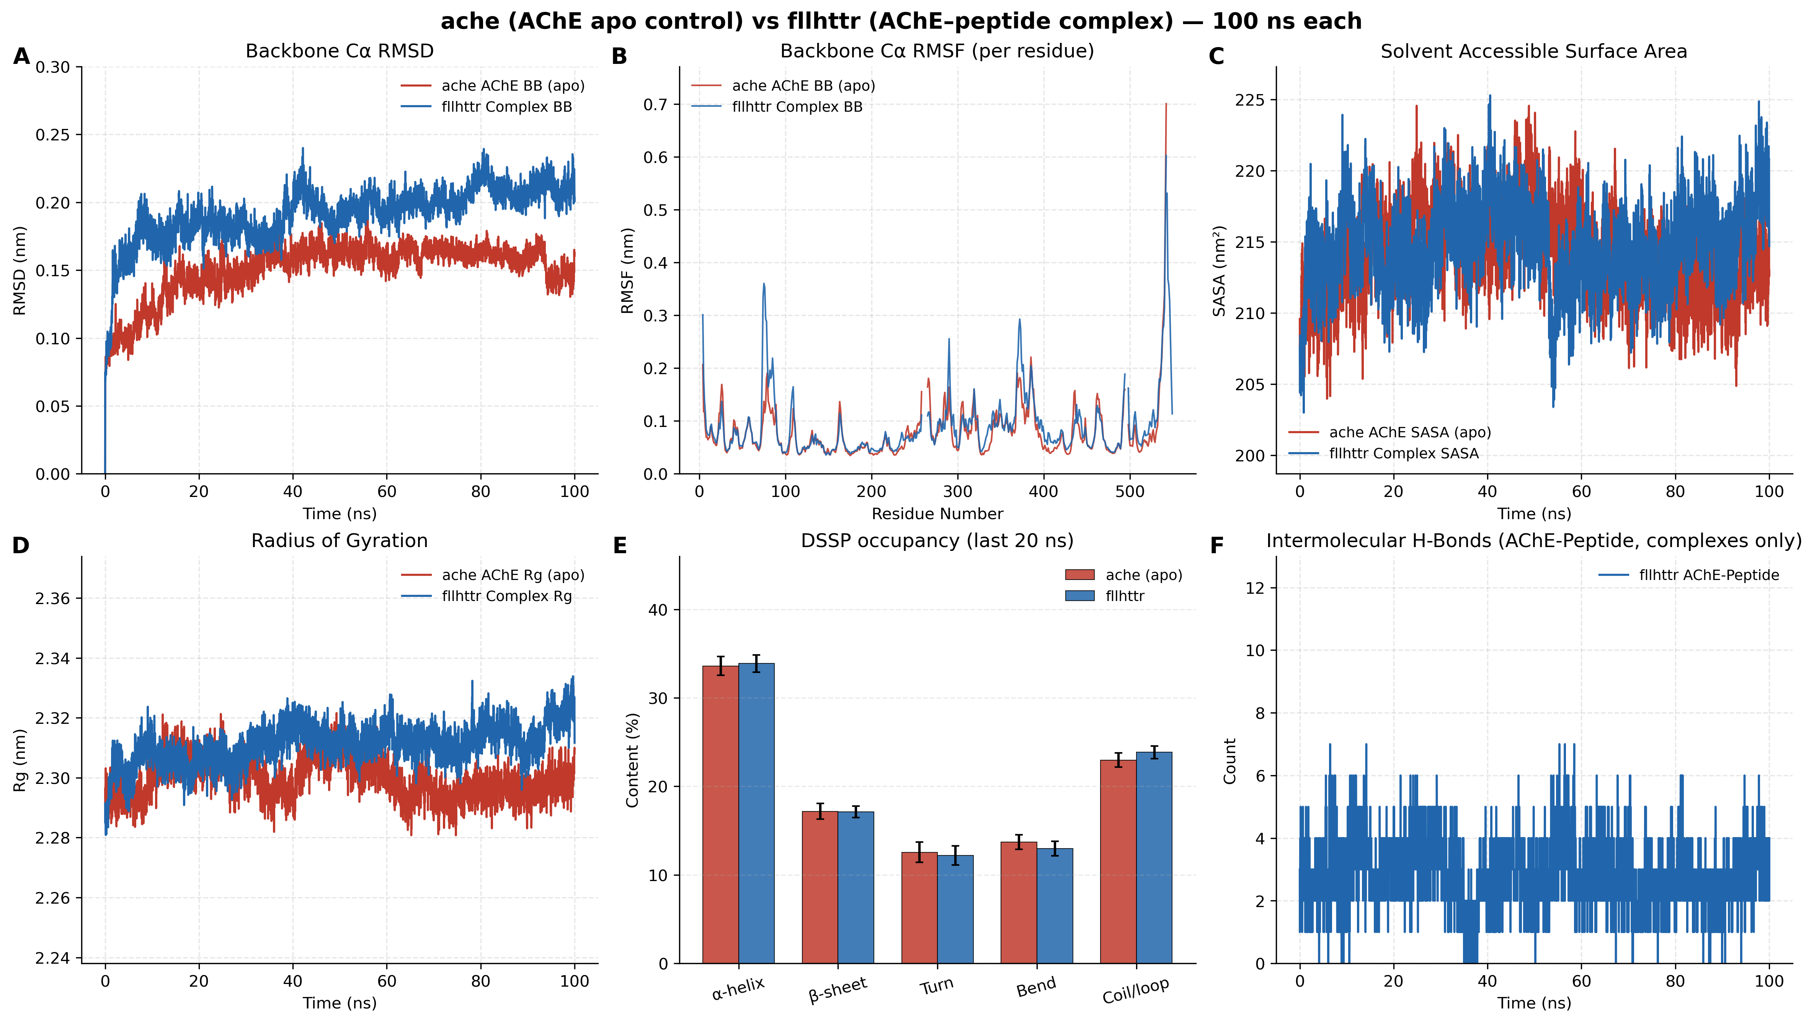
Figure 5. Apo AChE versus AChE–FLLHTTR. Largest RMSD (A) and Rg (D) elevations among the three peptides.
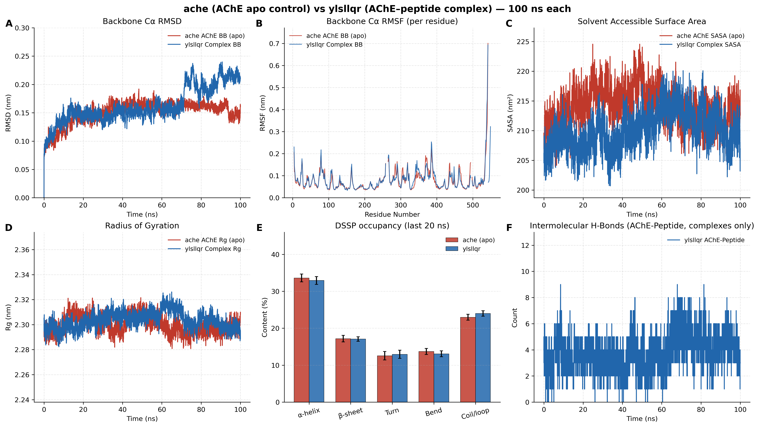
Figure 6. Apo AChE versus AChE–YLSLLQR. SASA (C) falls below apo; hydrogen-bond counts (F) are densest.
Table 2. Last-20-ns metrics matching Figure 4–6 panels (mean ± SD).
Metric | apo AChE | ALLLHRC | FLLHTTR | YLSLLQR | Figure panel
Backbone RMSD (nm) | 0.1562 ± 0.0093 | 0.1916 ± 0.0092 | 0.2102 ± 0.0087 | 0.2064 ± 0.0136 | A
RMSF mean (nm) | 0.0783 ± 0.0524 | 0.0876 ± 0.0581 | 0.0901 ± 0.0644 | 0.0813 ± 0.0574 | B
SASA (nm²) | 212.41 ± 2.36 | 217.47 ± 2.49 | 216.34 ± 2.55 | 210.37 ± 2.91 | C
Rg (nm) | 2.2967 ± 0.0043 | 2.3107 ± 0.0052 | 2.3163 ± 0.0059 | 2.3004 ± 0.0051 | D
DSSP α-helix / β-sheet (%) | 33.59 / 17.18 | 33.66 / 16.76 | 33.87 / 17.11 | 32.92 / 17.08 | E
Intermolecular H-bonds | N/A | 2.19 ± 0.80 | 2.80 ± 0.99 | 4.23 ± 1.24 | F

Complex RMSD stays below 0.22 nm. YLSLLQR is the only complex whose SASA contracts versus apo, matching Figure 6C, and it forms the densest hydrogen-bond network (4.23 ± 1.24). Helix (~33–34%) and sheet (~17%) contents overlay the apo bars in every panel E. Each complex retains seven persistent contact pairs.

Evidence boundary
Table 3. What the figures and tables do and do not support.
No. | Supported | Not supported
1 | Best poses of FLLHTTR, YLSLLQR, and LLHPLRL contact PAS residues | Vina scores are not experimental Kd or Ki
2 | 100-ns complexes remain folded (RMSD < 0.22 nm; conserved DSSP) | Mild RMSD increase is not unfolding
3 | Last-20-ns H-bonds 2.19–4.23 persist in panels F | Single 100-ns trajectories are not irreversible binding
4 | FLLHTTR best-run -9.60 kcal/mol versus mean -8.77 ± 1.41 kcal/mol | A best pose is not a converged affinity

Discussion
Candidate micropeptides can occupy the AChE PAS after hypothesized blood–brain barrier leakage in periodontitis. Best-pose docking and 100-ns residence at that surface provide a structural hypothesis for gorge occlusion (cholinergic deficit) and for PAS-centered pathological chaperone activity toward Aβ, following Atanasova et al., Inestrosa et al., Silman and Sussman, and the P. gingivalis brain findings of Dominy et al. These remain computational hypotheses. Each system is a single 100-ns trajectory; planned checks include isothermal titration calorimetry, surface plasmon resonance, and Ellman inhibition.

References
1. Atanasova, M., Dimitrov, I., & Ivanov, S. (2020). Molecular dynamics simulations of acetylcholinesterase – beta-amyloid peptide complex. Cybernetics and Information Technologies, 20(6), 140–154. https://doi.org/10.2478/cait-2020-0068
2. Dominy, S. S., Lynch, C., Ermini, F., Benedyk, M., Marczyk, A., Forbes, A., Haditsch, M., et al. (2019). Porphyromonas gingivalis in Alzheimer's disease brains: Evidence for disease causation and treatment with small-molecule inhibitors. Science Advances, 5(1), eaau3333. https://doi.org/10.1126/sciadv.aau3333
3. Silman, I., & Sussman, J. L. (2005). Acetylcholinesterase: ‘classical’ and ‘non-classical’ functions and pharmacology. Current Opinion in Pharmacology, 5(3), 293–302. https://doi.org/10.1016/j.coph.2005.01.014
4. Inestrosa, N. C., Alvarez, A., Pérez, C. A., Moreno, R. D., Vicente, M., Link, C. A., Dayoub, O. I., et al. (1996). Acetylcholinesterase accelerates assembly of amyloid-β-peptides into Alzheimer's fibrils: possible role of the peripheral site of the enzyme. Neuron, 16(4), 881–891. https://doi.org/10.1016/S0896-6273(00)80108-7
5. Inestrosa, N. C., Dinamarca, M. C., & Alvarez, A. (2008). Amyloid-cholinesterase interactions. Implications for Alzheimer's disease. Molecular Neurobiology, 38(3), 262–273. https://doi.org/10.1007/s12035-008-8043-6
6. Hampel, H., Mesulam, M. M., Cuello, A. C., Farlow, M. R., Giacobini, E., Grossberg, G. T., Khachaturian, A. S., et al. (2018). The cholinergic system in the pathophysiology and treatment of Alzheimer's disease. Brain, 141(7), 1917–1933. https://doi.org/10.1093/brain/awy132
7. Bartus, R. T., Dean, R. L., Beer, B., & Lippa, A. S. (1982). The cholinergic hypothesis of geriatric memory dysfunction. Science, 217(4558), 408–414. https://doi.org/10.1126/science.7046051

