Meta-TMP users’ manual
Release date: Aug/3/2016
Introduction
Parallel-META is a software toolkit which can perform rapid data mining among
massive microbial community data for comparative taxonomical and functional
analysis.
Based on parallel algorithms, Parallel-META can achieve a very high speed
compare to traditional metagenomic analysis pipelines.
Parallel-META now supports 16S rRNA based taxonomical analysis and KEGG
based predictive functional analysis for microbial community samples,
phylogenetic and functional comparison and feature selection.
We strongly recommend that read this manually carefully before use
Parallel-META.
Download
The latest release is available at:
http://www.microbioinformatics.org/software/meta-tmp.html
Packages
Executive binary package:
Now the Parallel-META 3 executive binary package integrated with all tools is
available for Linux (32 bit & 64 bit), which is easy to install.
Rscript environment:
For statistical analysis and pdf format output, Parallel-META 3 requires cran R
(http://cran.r-project.org/) 3.0 or higher for the execution of “.R” scripts.
Source code package:
Parallel-META source code package is also available for building and installation
for other Unix/Linux based operating systems.
Installation
Extract the package:
1

tar –xzvf parallel-meta-3.tar.gz
Configure the environment variables
export ParallelMETA=Path to Parallel-META
export PATH=”$PATH:$ParallelMETA/bin”
Rscript parallel-meta/Rscript/PM_Config.R
Compile the source code* (only required by the source code package):
cd parallel-meta
make
Package Dependency* (only required by source code package)
The following packages have been integrated in the executive binary package, but
are still required by the source code package.
GCC 4.2 or higher;
Bowtie2 (2.1.0 or higher)
http://sourceforge.net/projects/bowtie-bio/files/bowtie2/
and put the “bowtie-align-s”to $ParallelMETA/Aligner/bin/
HMMER 3 :
http://hmmer.janelia.org/software/
and put the “hmmsearch” to $ParallelMETA/HMMER/bin/
Tools in toolkit
format-seq
For input sequence file(s) format check and reformat into Parallel-META
required format of FASTA or FASTQ (See Sequence format). We strongly
recommend that check the sequence file(s) format before analysis steps.
The format-seq accepts single input sequence file in FASTA or FASTQ
format, or multiple input sequences in sample list format (See Sample list format).
If the sequence passed the format check, format-seq keeps the input with no
modification; otherwise the format-seq reformats the input sequence file(s) with
making a backup.
Usage:
format-seq [Options] Value
[Options]
-i Input sequence file in FASTA or FASTQ format [Conflict with -l]
-l Input sample list [Conflict with -i] (See Sample list format)
-p List file path prefix for '-l' [Optional]
-h help
2

Example:
format-seq –i sample.fasta
format-seq –l list.txt
pipeline
The pipeline is an integrated process for multiple samples with most of the
following analysis steps.
Usage:
pipeline [Options] Value
[Option] :
Input options:
-i Sequence list file, pair-ended sequences are supported [Conflict with '-l']
(See Sequence format and sequence list)
-m Meta data file [Required] (See Meta-data format)
-l Taxonomic analysis results list [Conflict with ‘-i’] (See Sample list
format)
-p List file path prefix for '-i' and '-l' [Optional]
Output options:
-o Output path, default is "default_out"
Profiling parameters:
-M Sequence type, T (Shotgun) or F (16S rRNA), default is F
-e Alignment mode, 0: very fast, 1: fast, 2: sensitive, 3: very-sensitive,
default is 3
-P Pair-end sequence orientation, 0: Fwd & Rev, 1: Fwd & Fwd, 2: Rev
& Fwd, default is 0
-r rRNA length threshold of rRNA extraction. 0 is disabled, default is 0
-k Sequence format check, T(rue) or F(alse), default is T
-f Functional analysis, T(rue) or F(alse), default is T
Statistic parameters:
-L Taxonomical levels (1-6: Phylum - Species). Multiple levels are
accepted
-F Functional levels (Level 1, 2, 3 or 4 (KO number)). Multiple levels are
accepted
-s Sequence number normalization depth, 0 is disabled, default is disable.
-b Bootstrap for sequence number normalization, default is 200,
maximum is 1000
-R Rarefaction curve, T(rue) or F(alse), default is F
-E If the samples are paired, T(rue) or F(alse), default is F
3

-c Cluster number, default is 2
-T Network analysis edge threshold, default is 0.7
Other options:
-t cpu core number, default is auto
-h help
Notice:
1. Pair-ended sequences are supported for 16S rRNA sequences (See Sequence
format and sequence list).
2. Samples (pairs) should be in the same order in all lists and meta-data.
3. In Meta data file, sample IDs should not be started with number, and should
not contain space symbol (‘ ‘) and table symbol (‘\t’) (See Meta-data format).
4.Rarefaction curve is disabled in default setting, use “–R T” to enable (might be
slow).
5. Sequence number normalization is disabled in default setting, use “-s” to
enable and set the normalization depth (might drop samples with sequence
number less than the setting depth).
parallel-meta
The parallel-meta accepts single shotgun sequences or 16S/18S rRNA
sequences in FASTA or FASTQ format for taxonomical and predictive functional
profiling.
Usage:
parallel-meta [Options ] Value
[Options]
-m Input single sequence file (Shotgun)
A single input sequence file [Conflict with -r and -R]
-r Input single sequence file (rRNA targeted)
A single input sequence file [Conflict with -m]
-R Input paired sequence file for -r [Conflict with -m]
-o Output path
To appoint the result output path, default is "Result"
-e Alignment mode
0: very fast, 1: fast, 2: sensitive, 3: very-sensitive, default is 3
-P Pair-end sequence orientation for -R
0: Fwd & Rev, 1: Fwd & Fwd, 2: Rev & Fwd, default is 0
-k Sequence format check
T(rue) or F(alse), default is F
-L Integer value
To assign the rRNA length threshold of rRNA extraction. 0 is disabled,
default is 0 [Conflict with -r]
4

-t Integer value
To assign the core number of CPU Parallel-META can use. Default is
auto.
-f Functional analysis, T(rue) or F(alse), default is T
-h Help
Example:
parallel-meta –m examples/meta.fasta –o metaresults –e 1e-20 –l 150
extract-rna
The extract-rna can extract 16S & 18S rRNA fragments from shotgun
sequences. This function has already been included in “parallel-meta” with
parameter “-m” for shotgun sequences.
Usage:
extract-rna [Options] Value
[Options]
-m Input single sequence file (Shotgun)
To analysis a metagenomic shotgun file
-o Output Path
To appoint the result output path, default is "Extract_RNA"
-l integer value
To assign the 16S rRNA length threshold of RNA extraction, conflict
with -r. 0 is disabled, default is 0.
-h Help.
Example:
extract-rna –m examples/meta.fasta –o metaresults –e 1e-20 –l 150
class-tax
For taxonomical analysis results integration of multiple samples. The
class-taxa has already been integrated in program parallel-meta.
The class-tax accepts the taxonomical analysis results in “classification.txt”
(see Results-Single sample).
Usage:
class-tax [Options] Value
[Options]
-i input filename [Conflict with –l]
-l Input filename list [Conflict with -i] (see Sample list format)
-p List file path prefix for '-l' [Optional]
-o output path, default is “./Result_Plot”.
-h Help
5

Example:
class-tax –l list.txt –o result_plot
in which “list.txt” is the path of N samples’ taxonomical analysis results, and
each sample in one line (see Sample list format).
class-func
For functional analysis of multiple samples. The class-func has already been
integrated in program parallel-meta.
The class-func accepts the taxonomical analysis results in “classification.txt”
(see Results-Single sample).
Usage:
class-func [Options] Value
[Options]
-i input filename [Conflict with –l]
-l Input filename list [Conflict with -i] (see Sample list format)
-p List file path prefix for '-l' [Optional]
-o output path, default is “./Result_Func”.
-t Cpu core number, default is auto
-h Help
Example:
class-func –l list.txt –o result_func
in which “list.txt” is the path of N samples’ taxonomical analysis results, and
each sample in one line (see Sample list format).
class-func-nsti
For NSTI (Nearest Sequenced Taxon Index) value calculation of functional
analysis. The class-func-nsti has already been integrated in program
parallel-meta.
The class-func-nsti accepts the taxonomical analysis results in
“classification.txt” (see Results-Single sample).
Usage:
class-func-nsti [Options] Value
[Options]
-i Input single filename [Conflict with -l and -T]
-l Input filename list [Conflict with -i and -T] (See Sample list format)
-p List file path prefix for '-l' [Optional]
-T Input OTU table format (*.Abd) [Conflict with -i and -T]
-o Output file, default is "NSTI.out"
-t Cpu core number, default is auto
6

-h Help
Example:
class-func-nsti –l list.txt –o result_func
in which “list.txt” is the path of N samples’ taxonomical analysis results, and
each sample in one line (see Sample list format).
taxa-sel
For multi-sample feature selection (with a specified taxonomical level) based
on the taxonomical profiling results.
The taxa-sel accepts the taxonomical analysis results in “classification.txt”
(see Results-Single sample), and generate both the relative abundance table
(*.Abd) and the absolute count table (*.Count).
Usage:
taxa-sel [Options] Value
[Options]
-l Input sample list [Required] (See Sample list format)
-p List file path prefix for '-l' [Optional]
-o Output file name, default is "taxaonomy_selection.txt"
-M Correlation matrix T or F, default is T
-L Taxonomical level (1-6: Phylum – Species, 7: OTU), default is 5
-r 16s rRNA copy number correction, T(rue) or F(alse), default is T
-p Print distribution barchart, T(rue) or F(alse), default is F
-q Minimum sequence count threshold, default is 2
-m Maximum abundance threshold, default is 0.001 (0.1%)
-n Minimum abundance threshold, default is 0.0 (0%)
-z Minimum No-Zero abundance threshold, default is 0.1 (10%)
-v Minimum average abundance threshold, default is 0.001 (0.1%)
-h help
Example:
taxa-sel –l list.txt –o taxa.txt –L 6
func-sel
For multi-sample feature selection (with a specified KEGG pathway level
and relative abundance) based on the functional profiling results .
The func-sel accepts the functional analysis results in “functions.txt” (see
Results-Single sample), and generate both the relative abundance table and the
absolute count table.
Usage:
7

func-sel [Options] Value
[Options]
-l Input sample list [Required] (See Sample list format)
-p List file path prefix for '-l' [Optional]
-o Output file name, default is "taxaonomy_selection.txt"
-L KEGG Pathway level
Level 1, 2, 3 or 4 (4 is KO number) [Required]
-p Print distribution barchart, T(rue) or F(alse), default is F
-h Help
Example:
func-sel –l list.txt –o func.txt –L 2
comp-sam
For multi-sample comparison & similarity (distance) calculation based on the
taxonomical profiling results.
The comp-sam accepts the taxonomical profiling results in “classification.txt”
(see Results-Single sample).
Now from version 3.1 the comp-sam also accepts the relative abundance
table (OTU level only) generated by taxa-sel. (see Results-Multiple Samples
-Abundance_Tables)
Usage:
comp-sam [Options] Value
[Options]
-i Two samples path for single sample comparison [Conflict with –l and
-T]
-l Sample name list table for multi-sample comparison [Confilct with – i
and -T] (See Sample list format)
-p List file path prefix for '-l' [Optional]
-T Sample OTU table ((*.Abd results of taxa-sel ) multi-sample
comparison [Conflict with -i and -l]
-o Result output file, default is to output on screen
-r 16s rRNA copy number correction, T(rue) or F(alse), default is T
-d Output format, similarity (T) or distance (F), default is T
-p Print heatmap and clusters, T(rue) or F(alse), default is F
-t Cpu core number, default is 1
-h Help
Example:
Here suppose you compute the similarity of 2 samples:
comp-sam –i sample-1/classification.txt sample-2/ classification.txt –o
sim.txt
8

or you have multiple samples:
comp-sam –l list.txt –o sim_matrix.txt –t 8
in which “list.txt” is the path of N samples’ taxonomical analysis results, and
each sample in one line (see Sample list format).
comp-sam-func
For multi-sample comparison & similarity (distance) calculation based on the
functional profiling results.
The comp-sam-func accepts the functional profiling results in “functions.txt”
(see Results-Single sample).
Now from version 3.1 the comp-sam –func also accepts the relative
abundance table (KOlevel only) generated by func-sel (see Results-Multiple
Samples -Abundance_Tables)
Usage:
comp-sam-func [Options] Value
[Options]
-i Two samples path for single sample comparison [Conflict with –l and -T]
-l Sample name list table for multi-sample comparison [Confilct with –i
and -T] (See Sample list format)
-p List file path prefix for '-l' [Optional]
-T Sample KO table ((*.Abd results of func-sel ) multi-sample comparison
[Conflict with -i and -l]
-o Result output file, default is to output on screen
-d Output format, similarity (T) or distance (F), default is T
-p Print heatmap and clusters, T(rue) or F(alse), default is F
-t Cpu core number, default is 1
-h Help
Example:
Here suppose you compute the similarity of 2 samples:
comp-sam-func –i sample-1/functions.txt sample-2/ functions.txt –o
sim.txt
or you have multiple samples:
comp-sam –l list.txt –o sim_matrix.txt –t 8
in which “list.txt” is the path of N samples’ taxonomical analysis results, and
each sample in one line (see Sample list format).
9

rare-curv
For rarefaction analysis and rarefaction curve printing to pdf format. It
accepts the absolute count table (*.Count) results of taxa-sel and func-sel.
Usage:
rare-curv [Options] Value
[Options]
-i or –T Input feature table with Absolute Count (*.Abd results of taxa-sel )
[Required]
-o Output file directory, default is "result"
-p Prefix name of output, default is "out"
-l Rarefaction curve label, T is enable and F is disable, default is F
-b The bootstrap value, default is 20
-t Cpu core number, default is auto
-h Help
Example:
rare-curv –i taxa.Count –o rare-out –b 20
comp-corr
For correlation calculation of taxonomical and functional distribution and
with meta-data.
The comp-corr accepts the results of taxa-sel and func-sel.
Usage:
comp-corr [Options] Value
[Options]
-i Feature (Taxa/OTU/Function etc.) table file [Required]
-m Correlation file name
-o Output prefix, default is "corr_matrix"
-c Selected feature, separated by ","
-f S(Spearman) or P(Pearson) metrics,default is S
-N Network based co-occurrence analysis, T(rue) or F(alse), default is F
-T Netowrk analysis threshold, default is 0.7
-t Cpu core number, default is auto
-h Help
Example:
comp-corr –i taxa.txt –o taxa.network.txt
split-seq
For sequence split by barcode or group information
The split-seq accepts the input sequence in FASTA or FASTQ format.
Usage:
10

split-seq [Options] Value
[Options]
-i Input sequence file in FASTA or FASTQ format [Required]
-b Input barcode file [Conflicts with –g]
-g Input group file [Conflicts with –b]
-o Result output path, default is "Out"
-h Help
Notice: Sample IDs and sequence labels should not contain space symbol (‘ ‘)
and table symbol (‘\t’). Here are examples of barcode file format and group file
format:
The barcode file format:
ATTCGT
AGCGTC
……..
Sample1
Sample2
CGTGAC
SampleN
The group file format:
Seq_Id_1
Seq_Id_2
……
Sample1
Sample2
Seq_Id_N
SampleN
Example:
split-seq –i seq.fa –b barcode.txt –o seq.out
split-seq –i seq.fa –b seq.groups –o seq.out
split-table
For abundance table (*.Abd and *.Count) split by meta-data groups.
The split-table accepts the results of taxa-sel and func-sel.
Usage:
split-table [Options] Value
[Options]
-i Feature (Taxa/OTU/Function etc.) table file [Required]
-m Meta data file [Required] (See Meta-data format)
-c Group key [Required]
-o Output file, default is "Out"
-h Help
Example:
11

split-table –i taxa.txt –m meta.txt –g Status –o taxa.groups
split-matrix
For similarity (distance) matrix by meta-data groups.
The split-matrix accepts the results of comp-sam and comp-sam-func.
Usage:
split-matrix[Options] Value
[Options]
-i Input data matrix [Required]
-m Meta data file [Required] (See Meta-data format)
-c Group key [Required]
-o Output file, default is "Out"
-h Help
Example:
split-matrix –i matrix.txt –m meta.txt –g Status –o matrix.groups
R scripts
PM_Config.R
Install the R package dependency and check environment variable
configuration.
Usage:
Rscript PM_Config.R
PM_Distribution.R
For taxa/pathway abundance distribution barchart printing to pdf format. This
function has also been integrated in taxa-sel and func-sel by parameter “-p”
PM_Distribution.R accepst the relative abundance table (*.Abd) results of
taxa-sel and func-sel.
Usage:
Rscript PM_Distribution.R [Options] Value
[Options]
-i ABUND_FILE, --abund_file=ABUND_FILE
Input feature table with Relative Abundance [Required]
-o OUTFILE, --outfile=OUTFILE
Output distribution file [default distribution.pdf]
-v THRESHOLD, --threshold=THRESHOLD
Average value threshold [Optional, default 0.01]
-h, --help
12

Show this help message and exit
PM_Heatmap.R
For heatmap figure printing to pdf format. This function has also been
integrated in comp-sam and comp-sam-func by parameter “-p”.
PM_Heatmap.R accepts the results of comp-sam and comp-sam-func.
Usage:
Rscript PM_Heatmap.R [Options] Value
[Options]
-d DIST_FILE, --dist_file=DIST_FILE
Input distance matrix file [Required].
-o OUTFILE, --outfile=OUTFILE
Output heatmap [default heatmap.pdf]
-h --help
Show this help message and exit
PM_Hcluster.R
For hierarchical clustering and printing to pdf format. This function has also
been integrated in comp-sam and comp-sam-func by parameter “-p”.
PM_Hcluster.R accepts the results of comp-sam and comp-sam-func.
Usage:
Rscript PM_Hcluster.R [Options] Value
[Options]
-d DIST_FILE, --dist_file=DIST_FILE
Input distance matrix file [required].
-o OUTFILE, --outfile=OUTFILE
Output file [default hcluster.pdf]
-k GROUPNUM, --groupNum=GROUPNUM
Number of groups to rect [default 2]
-h --help
Show this help message and exit
PM_Pcoa.R
For PCoA (Principle Co-ordinate Analysis) based on the distance matrix and
results printing to pdf format.
PM_PCoa.R accepts the results of comp-sam and comp-sam-func.
Usage:
Rscript PM_Pcoa.R [Options] Value
[Options]
-d DIST_FILE, --dist_file=DIST_FILE
13

Input distance matrix file [Required].
-m META_DATA, --meta_data=META_DATA (See Meta-data format)
Input meta-data file [Required].
-l DRAWLABEL, --drawlabel=DRAWLABEL
If enable the sample label [Optional, default FALSE]
-o OUTFILE, --outfile=OUTFILE
Output PCoA [default pcoa.pdf]
-h --help
Show this help message and exit
PM_Pca.R
For PCA (Principle Component Analysis) based on the competent table and
results printing to pdf format.
PM_Pca.R accepts the results of taxa-sel and func-sel.
Usage:
Rscript PM_Pca.R [Options] Value
[Options]
-i ABUND_FILE, --abund_file=ABUND_FILE
Input feature table with Relative Abundance [Required].
-m META_DATA, --meta_data=META_DATA (See Meta-data format)
Input meta-data file [Required].
-l DRAWLABEL, --drawlabel=DRAWLABEL
If enable the sample label [Optional, default FALSE]
-o OUTFILE, --outfile=OUTFILE
Output PCA [default pca.pdf]
-h --help
Show this help message and exit
PM_ADiversity.R
For multivariate statistical analysis of alpha diversity based on the sequence
count table.
PM_ADiversity.R accepts the absolute count table (*.Count) results of
taxa-sel and func-sel.
Usage:
Rscript PM_Adiversity.R [Options] Value
[Options]
-i COUNT_FILE, --count_file=COUNT_FILE
Input feature table with Absolute Count [Required]
-m META_DATA, --meta_data=META_DATA (See Meta-data format)
Input meta-data file [Required]
-o OUT_DIR, --out_dir=OUT_DIR
Output file name[default Alpha_diversity]
-p PREFIX, --prefix=PREFIX
Output file prefix [Optional, default Out]
14

-h --help
Show this help message and exit
PM_Bdiversity.R
For multivariate statistical analysis of beta diversity based on the distance
matrix.
PM_BDiversity.R accepts the results of comp-sam and comp-sam-func.
Usage:
Rscript PM_Bdiversity.R [Options] Value
[Options]
-d DIST_FILE, --dist_file=DIST_FILE
Input distance matrix file [Required].
-m MAP_DATA, --map_data=META_DATA (See Meta-data format)
Input meta-data file [Required].
-o OUTDIR, --outdir=OUTDIR
Output directory [default .]
-p PREFIX, --prefix=PREFIX
Output file prefix [Optional, default Out]
-n DIST_NAME, --dist_name=DIST_NAME
The distance metrics name such as Meta-Storms, Jensen-Shannon,
Euclidean et al. [Optional, default Default]
-h --help
Show this help message and exit
PM_Marker.R
For bio-marker detection based on ram-sum test.
PM_Marker.R accepts the results of taxa-sel and func-sel.
Usage:
Rscript PM_Marker.R [Options] Value
[Options]
-i ABUND_FILE, --abund_file=ABUND_FILE
Input feature table with Relative Abundance [Required].
-m META_DATA, --meta_data=META_DATA (See Meta-data format)
Input meta-data file [required].
-o OUTFILE, --outfile=OUTFILE
Output path [default Marker]
-p PREFIX, --prefix=PREFIX
Output file prefix [default Out]
-P PAIRED, --Paired= PAIRED
If paired samples [default FALSE]
-h --help
Show this help message and exit
15

PM_RFscore.R
For bio-marker scoring using Random Forest algorithm.
PM_RFscore.R accepts the results of taxa-sel and func-sel.
Usage:
Rscript PM_RFscore.R [Options] Value
[Options]
-i TABLE_FILE, --table_file=TABLE_FILE
Input feature table with read count (*.Count) or abundance (*.Abd)
[Required]
-m META_DATA, --meta_data=META_DATA
Input meta-data file [Required]
-o OUT_DIR, --out_dir=OUT_DIR
Output file name[default RFimportance]
-p PREFIX, --prefix=PREFIX
Output file prefix [Optional, default Out]
-h, --help
Show this help message and exit
PM_Network.R
For network based co-occurrence analysis. The output is in pdf format. This
function has also been integrated in comp-corr by parameter “-N”.
PM_Network.R accepts the results of comp-corr, comp-sam and
comp-sam-func.
Usage:
Rscript PM_Network.R [Options] Value
[Options]
-i DIST_FILE, --dist_file=DIST_FILE
Input distance table [Required]
-o OUTFILE, --outfile=OUTFILE
Output Network [default network.pdf]
-p POSITIVE_EDGES, --positive_edges=POSITIVE_EDGES
If enable the positive edges [Optional, default TRUE]
-n NEGATIVE_EDGES, --negative_edges=NEGATIVE_EDGES
If enable the negative edges [Optional, default TRUE]
-t THRESHOLD, --threshold=THRESHOLD
Edge threshold [Optional, default 0.7]
-h --help
Show this help message and exit
16

Input Format
Sequence format and sequence list
Parallel-META accepts sequences in Fasta/Fastq format. For Fasta/Fastq format,
sequence labels should not contain space symbol (‘ ‘) and table symbol (‘\t’), and
each sequence is in 1 single line. For 16S rRNA sequences, Parallel-META support
pair-ended sequences (-R), and for metagenomic shotgun sequences Parallel-META
only support single-ended sequences.
For pipeline, input path of all input samples (pairs) should be contained in the
sequence list. In the sequence list:
Single-ended sequences: each sample has one single line for one Fasta/Fastaq
file, such as:
/home/data/sample1.fasta
/home/data/sample2.fasta
/home/data/sample3.fasta
Pair-ended sequences: each sample has two lines for pair-1 sequences and pair-2
sequences in Fasta/Fastq format, such as
/home/data/sample1_pair1.fasta
/home/data/sample1_pair2.fasta
/home/data/sample2_pair1.fasta
/home/data/sample2_pair2.fasta
/home/data/sample3_pair1.fasta
/home/data/sample3_pair2.fasta
/home/data/sample4_pair1.fasta
/home/data/sample4_pair2.fasta
Sample list format
The class-tax, class-func, comp-sam, comp-sam-func, taxa-sel and func-sel
accept multiple input samples in sample list format. In the sample list file, each line
ONLY contains 1 single sample’s input path.
For class-tax, comp-sam and taxa-sel, the input list contains the taxonomical
analysis results’ path (classification.txt, see Results-Single sample);
For class-func, comp-sam-func and func-sel, the input list contains the functional
analysis results’ path (functions.txt, see Results-Single sample).
Meta-data format
The pipeline, PM_Pca.R, PM_Pcoa.R, PM_ADiversity.R, PM_BDiversity.R,
PM_Marker.R and PM_RFsocre.R required the meta-data for all input samples for
supervised clustering and bio-marker discovery. Input samples should have the same
17

order in meta-data file and sample list file. In the meta-data file, each row represents
one sample and each column represents one feature. Sample IDs should not be started
with number and symbol ‘#’, and should not contain space symbol (‘ ’), backslash
symbol (‘/’) and table symbol (‘\t’).
Example:
SampleID
Sample1
Sample2
Sample3
Sample4
Habitat
Palm
Oral
Gut
Gut
Sex
M
F
M
F
Host
H1
H2
H1
H3
Visualization
Single sample view
The Single sample view shows the distributions of components on different
taxonomy level are displayed in a dynamic pie chart. Click each name at the
bottom to search corresponding name from NCBI. This figure is generated by
class-tax.
18
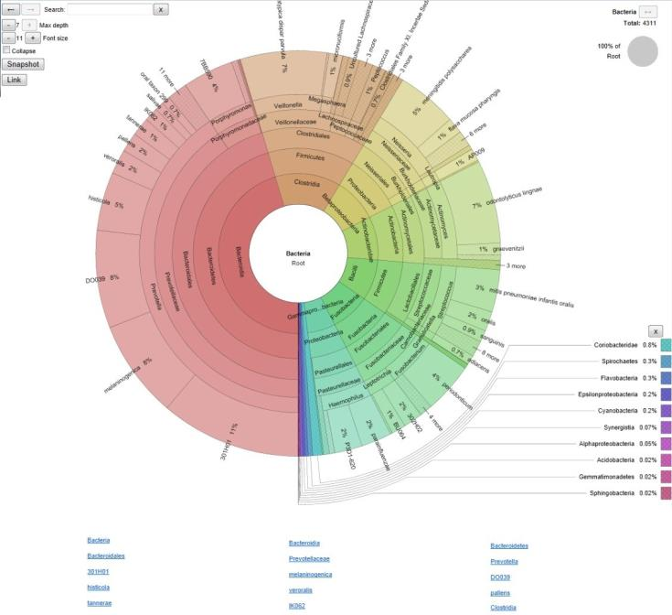

Multi-Sample View
To display the Sample View of all samples into one page.
Taxonomy & Function distribution
The distribution bar chart shows the variation of taxa & pathway abundance in
each sample. This figure is generated by PM_Distribution.R, and also integrated
in taxa-sel and func-sel.
Heatmap & Clustering
19
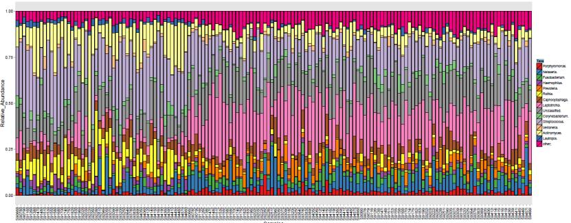
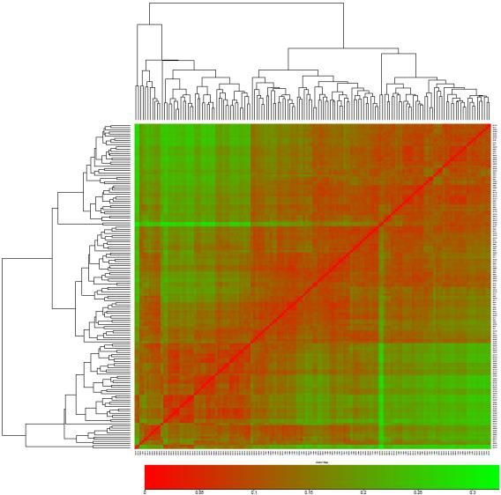

The heatmap shows the quantitative distance and unsupervised hierarchical
results of samples. The heatmap figure is generated by PM_Heatmap.R and
clustering figure is generated by PM_HClusters.R. The two functions are also
integrated in comp_sam and comp_sam_func.
PCA & PCoA
The PCA and PCoA results show the supervised clustering results of taxonomical
and functional distribution of samples. This figure is generated by PM_Pca.R
and PM_Pcoa.R.
20
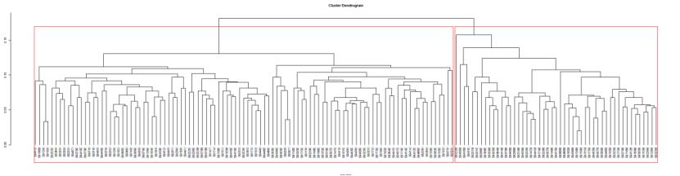
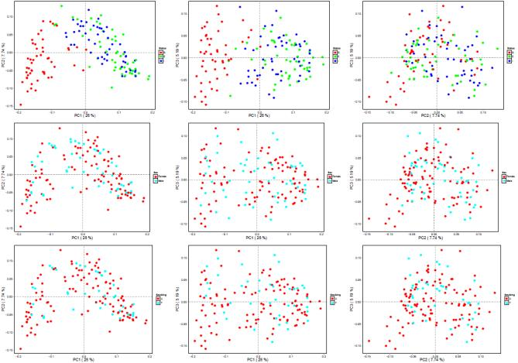

Co-occurrence network
The co-occurrence network shows the co-relationship and the network features among
sample taxa / pathway. This figure is generated by PM_Network.R, and also
integrated in comp-corr.
Results
Multiple samples
For multiple sample analysis by Parallel-META pipeline, analysis results will be
stored in the results path assigned by parameter –o. In the result folder, there will
be the following folders including:
Analysis_Report.txt
The analysis report including parameters configuration and analysis
information statistics
Single_Sample
The profiling analysis results of each single sample, which contains the
results of Single sample.
Single_Sample.Rare
The rarefied profiling analysis results of each single sample for library size
normalization.
21
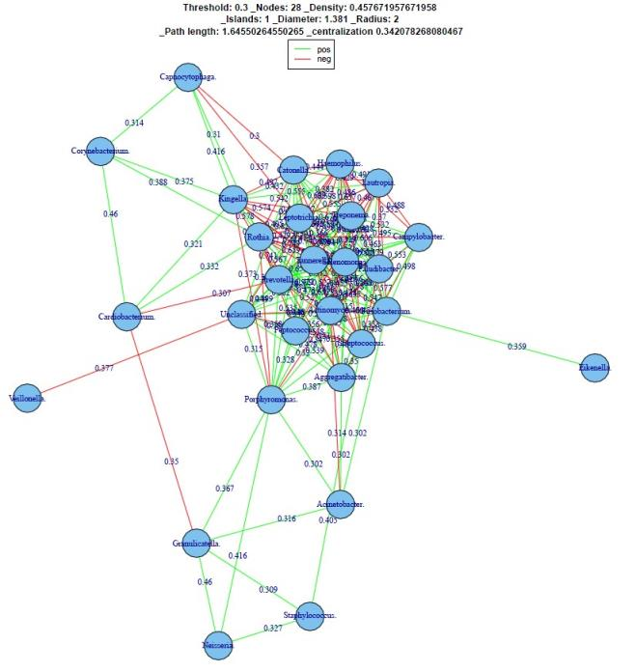

Single_Sample.List
The taxonomical and functional result lists of each single sample in Sample
list format.
Abundance_Tables
The relative abundance tables (*.Abd) and absolute count tables (*.Count) of
multiple samples on different taxonomical and functional levels.
Distance_Matrix
The distance matrix and unsupervised clustering results based on OTUs and
KO profiles of multiple samples.
Clustering
The supervised clustering results based on PCA and PCoA with different
distance metrics.
Alpha_Diversity
The rarefaction and multivariate statistical analysis results of alpha diversity.
Beta_Diversity
The multivariate statistical analysis results of beta diversity.
Markers
The Biomarker features of different groups on different taxonomical and
functional levels.
Network
The microbial interaction network based on different taxonomical and
functional levels.
scripts.sh
The detailed scripts of each analysis step.
error.log
The warning and error messages.
Single sample
For single sample analysis of Parallel-META, analysis results will be stored in
the result path assigned by parameter –o. In the result folder, there will be:
Analysis_Report.txt
The analysis report including parameters configuration and analysis
information statistics
classification.txt
The taxonomy information of the sample in text format.
taxonomy.txt
The taxonomy distribution statistic data of the sample in text format.
functions.txt
The predicted function information of the sample in text format.
meta.rna
The extracted 16S rRNA fragment, if the input is metageomic shotgun
sequences.
22

Notice
1. Please setup the environment variable for Parallel-META before use.
2. For source code package based installation, make sure the dependency
packages have been installed to the right directory.
3. The output path should not be the same path as the input file for the output
path will be cleared initially. Make sure parallel-meta has the write
permission of the output path.
4. The sample ID should not be started by number, and should not contain any
“space” or “tab”.
5. We recommend that the maximum length of input sequences should not be
longer than 2000bp.
6. Make sure the input is in fasta or fastaq format, and no “space” or “tab”
character in sequence id.
Contact
Any problem please contact
Contact: ningkang@hust.edu.cn

