实验报告

姓名 |  | 学号 |  | 班级
专业 | 计算机科学与技术 |  | 课程名称 | 《计算机组成原理课程设计》
任课老师 |  | 指导老师 |  | 机位号
实验序号 |  | 实验名称 | 实现R型指令的CPU设计实验
实验时间 |  | 实验地点 |  | 实验设备号
一、实验程序源代码
1.1 顶层文件
module shiyan8(
input rst,
input clk,
input [2:0] SW,
output reg [7:0] LED
);

wire [31:0]ALU_F;
wire ZF;
wire OF;

R_CPU rcpu(
.rst(rst),
.clk(clk),
.ALU_F(ALU_F),
.ZF(ZF),
.OF(OF)
);

always @ (*) begin
case(SW)
3'b100: LED = {ZF, 6'b00_0000, OF};
3'b011: LED = ALU_F[31:24];
2'b010: LED = ALU_F[23:16];
3'b001: LED = ALU_F[15:8];
3'b000: LED = ALU_F[7:0];
default: LED = 8'b0000_0000;
endcase
end

endmodule

1.2 译码器模块
module R_CPU(
input rst,
input clk,
output [31:0]ALU_F,
output ZF,
output OF
);

wire [31:0]Inst_code;
wire [4:0]rs;
wire [4:0]rt;
wire [4:0]rd;
wire [5:0] OP;
wire [5:0] func;

wire [31:0]A;
wire [31:0]B;

reg [2:0] ALU_OP;
reg Write_Reg;

PC pc(
.rst(rst),
.clk(clk),
.Inst_code(Inst_code)
);

assign OP = Inst_code[31:26];
assign rs = Inst_code[25:21];
assign rt = Inst_code[20:16];
assign rd = Inst_code[15:11];
assign func = Inst_code[5:0];

REG Reg(
.Write_Reg(Write_Reg),
.R_Addr_A(rs),
.R_Addr_B(rt),
.W_Addr(rd),
.W_Data(ALU_F),
.clk(clk),
.rst(rst),
.R_Data_A(A),
.R_Data_B(B)
);

ALU Alu(
.A(A),
.B(B),
.ALU_OP(ALU_OP),
.F(ALU_F),
.ZF(ZF), //结果为0
.OF(OF) //结果溢出
);

always @ (*) begin
ALU_OP = 3'b000;
Write_Reg = 1'b0;
if(OP == 6'b00_0000) begin
Write_Reg = 1'b1;
case (func)
6'b10_0000: ALU_OP = 3'b100;
6'b10_0010: ALU_OP = 3'b101;
6'b10_0100: ALU_OP = 3'b000;
6'b10_0101: ALU_OP = 3'b001;
6'b10_0110: ALU_OP = 3'b010;
6'b10_0111: ALU_OP = 3'b011;
6'b10_1011: ALU_OP = 3'b110;
6'b00_0100: ALU_OP = 3'b111;
endcase
end
end

endmodule

1.3 PC模块
module PC(
input rst,
input clk,
output [31:0]Inst_code
);

wire [31:0]PC_new;
reg [31:0]PC;

initial PC = 32'h0000_0000;

Inst_ROM IR (
.clka(clk), // input clka
.addra(PC[7:2]), // input [5 : 0] addra
.douta(Inst_code) // output [31 : 0] douta
);

assign PC_new = PC + 32'h4;

always @ (negedge clk or posedge rst) begin
if(rst) begin
PC <= 32'h0000_0000;
end
else begin
PC <= PC_new;
end
end

endmodule

1.4 寄存器堆模块
module REG(
input Write_Reg,
input [4:0] R_Addr_A,
input [4:0] R_Addr_B,
input [4:0] W_Addr,
input [31:0]W_Data,
input clk,
input rst,
output [31:0]R_Data_A,
output [31:0]R_Data_B
);

reg [31:0]REG_FILES[0:31];
integer i;

initial begin
for(i = 0; i < 32; i = i + 1) begin
REG_FILES[i] = 32'h0000_0000;
end
end

//读操作
assign R_Data_A = REG_FILES[R_Addr_A];
assign R_Data_B = REG_FILES[R_Addr_B];

//写操作
always @ (posedge clk or posedge rst) begin
if(rst) begin
for(i = 0; i < 32; i = i + 1) begin
REG_FILES[i] <= 32'h0000_0000;
end
end
else begin
if(Write_Reg) begin
REG_FILES[W_Addr] <= W_Data;
end
end
end

endmodule

1.5 ALU模块
module ALU(
input [31:0]A,
input [31:0]B,
input [2:0] ALU_OP,
output reg [31:0]F,
output reg ZF, //结果为0
output reg OF //结果溢出
);

reg CF;

always @ (*) begin
OF = 1'b0;
ZF = 1'b0;
case(ALU_OP)
3'b000: F = A & B;
3'b001: F = A | B;
3'b010: F = A ^ B;
3'b011: F = A ~^ B;
3'b100: begin
{CF, F} = A + B;
OF = CF ^ F[31] ^ A[31] ^ B[31];
end
3'b101: begin
{CF, F} = A - B;
OF = CF ^ F[31] ^ A[31] ^ B[31];
end
3'b110: F = A < B ? 32'h0000_0001: 32'h0000_0000;
3'b111: F = (B << A);
default: F = 32'h0000_0000;
endcase
ZF = (F == 32'h0000_0000) ? 1'b1 : 1'b0;
end

endmodule
二、仿真波形
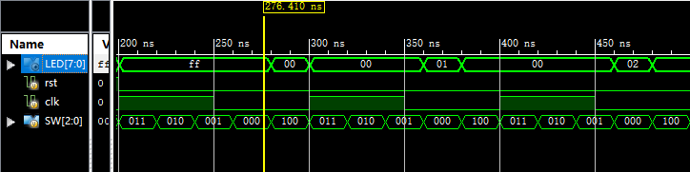
三、电路图
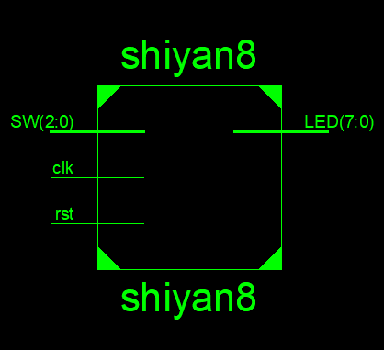

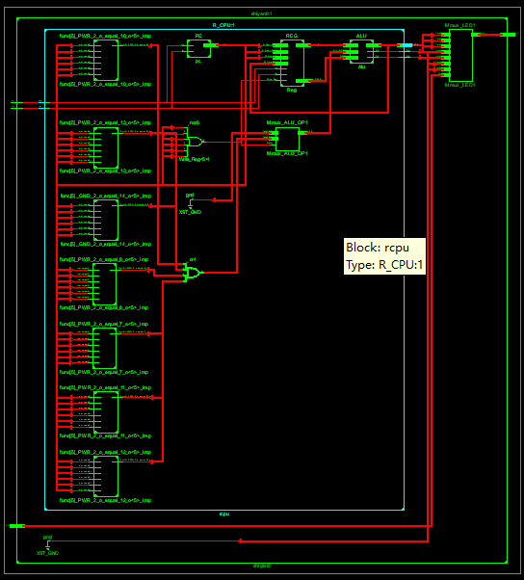

四、引脚配置（约束文件）
//复位信号
NET "rst" LOC = D9;
//时钟信号
NET"clk" LOC = C9;
//选择信号：2个逻辑开关
NET "SW[2]" LOC = V9;
NET "SW[1]" LOC = T9;
NET "SW[0]" LOC = T10;
//LED输出显示
NET "LED[7]" LOC = T11;
NET "LED[6]" LOC = R11;
NET "LED[5]" LOC = N11;
NET "LED[4]" LOC = M11;
NET "LED[3]" LOC = V15;
NET "LED[2]" LOC = U15;
NET "LED[1]" LOC = V16;
NET "LED[0]" LOC = U16;
五、思考与探索
六、意见和建议

