Task 3

Question 1:

WITH table_1 AS

(SELECT

EXTRACT (YEAR FROM rental_date) AS year,

EXTRACT (MONTH FROM rental_date) AS month,

EXTRACT (DAY FROM rental_date) AS DAY,

rental_id

FROM rental_fact)

SELECT

COUNT(table_1.rental_id),

table_1.day,

table_1.month,

table_1.year

FROM table_1

GROUP BY ROLLUP (day,month,year)

ORDER BY day;

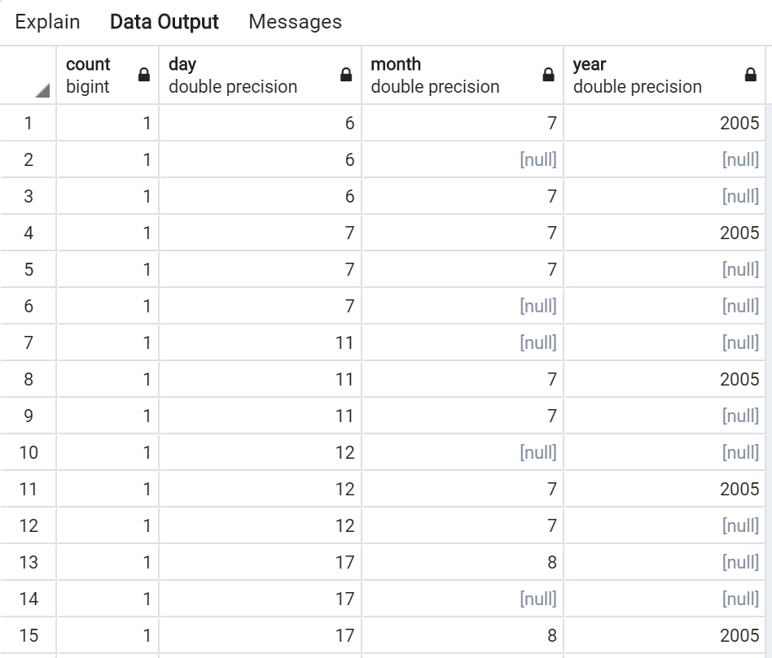

Question 2

WITH table_2 AS(

SELECT

EXTRACT (MONTH FROM rental_date) AS month,

rental_fact.payment_amount,

rental_fact.customer_id AS customer_id,

dim_customer.city AS city,

store_id

FROM rental_fact

INNER JOIN dim_customer ON dim_customer.customer_id = rental_fact.customer_id)

SELECT

SUM(table_2.payment_amount) AS sales,

store_id,

city,

month

FROM table_2

GROUP BY CUBE(store_id,city,month)

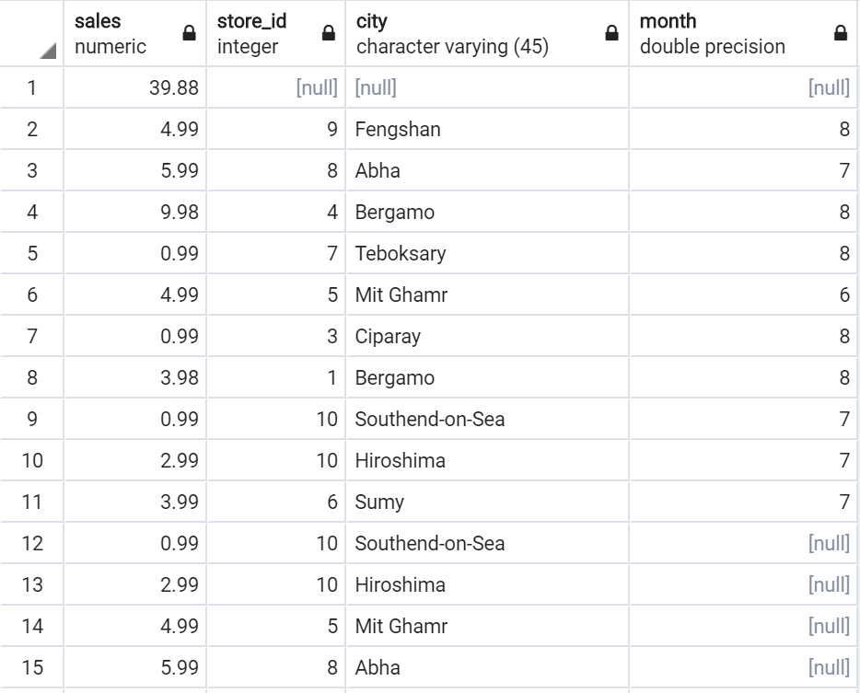

Question 3

WITH table_3 AS(

SELECT

rental_id,

dim_inventory.title,

dim_inventory.category_name AS category,

EXTRACT (MONTH FROM rental_date) AS month

FROM rental_fact

INNER JOIN dim_inventory ON dim_inventory.inventory_id = rental_fact.inventory_id)

SELECT

COUNT(rental_id),

title,

category,

month

FROM table_3

GROUP BY CUBE(2,3,4);

