**Veteran's Life History and Psychological Health**

Shuai Shao[1], Xinyue Li[2], Shuyuan Shi[3]

Department of Psychology

University of California San Diego

Final Project

**Introduction**

Mental health problems have been increasingly prevalent nowadays, especially within the military services (Eaton et al., 2008; Spelman, Hunt, Seal, & Burgo-Black, 2012). Impaired mental health can greatly incapacitate self-care which leads to weakened physical health and debilitated functionality (Kozel et al., 2016; Ohrnberger, Fichera, & Sutton, 2017). Past studies found many risk factors and protective factors for patients with mental health problems, among which social support and socio-economic status (SES) contribute significantly to mental health well-being and stability (Burnett-Zeigler et al., 2011; Jakupcak et al., 2009; Ren, Skinner, Lee, & Kazis, 1999; Smith-Osborne, 2009).

Social support is a strong predictor for mental well-being (Jakupcak et al., 2009). Previous studies found that perceived social support is associated with positive enhancement of both mental health and physical health (Jakupcak et al., 2010; Reblin & Uchino, 2008; Ren et al., 1999; Thoits, 2011). Some suggested that social support act as a direct buffer for mental disorders (Ciarleglio et al., 2018), others considered social support as a mediator that boosts patients’ willingness to seek therapeutic help (Graziano & Elbogen, 2017). Nonetheless, large scale analyses on the relationship between social support and mental health symptoms in the veteran population are lacking. Turner, Frankel and Levin (1983) suggested that social support resources and social support are two different concepts: social support resources are defined by social intimacy and social networks, whereas social support is an individual’s perception of being supported by others.

While studies suggested that higher socioeconomic status (SES) is positively correlated with better mental health outcomes, evidence for the relationship between SES and mental health conditions are limited among veteran population (Meyer, Castro-Schilo, & Aguilar-Gaxiola, 2014). Research showed that higher education benefits and income levels are associated with better mental health status among veterans (Smith-Osborne, 2009); another study presented a significant correlation between work status and mental well-being in the veteran population (Burnett-Zeigler et al., 2011). We hope to contribute to the limited empirical evidence of the association between SES and mental health symptoms among veteran population through establishing relationship among work status, education level, income level and mental health symptoms.

The Veteran Health Administration (VHA) serves over 9 million veterans in the United States each year, with increased demands by year but limited resources (Department of Veteran Affairs, 2016). Thus, it is important to understand factors that contribute to the mental well-being of the veterans despite therapeutic effort, and hopefully reduce the burden of the healthcare system. However, empirical evidences establishing associations between influential factors such as social support and SES and veterans’ mental health statuses are generally lacking. As a result, we aimed to examine the relationship between social support, SES and mental health illnesses’ severity. Our hypotheses are as follows:

1. Higher social support, indicated by relationship status and emotional support score, is positively associated with lower mental health severity (i.e. Anxiety, Depression, Alcohol Use, and Insomnia).

2. Higher SES, indicated by work status, education level and income level, is positively associated with lower mental health severity (i.e. Anxiety, Depression, Alcohol Use and Insomnia).

**Method**

*Participants*

Dataset in this study comes from a larger retrospective cross-sectional evaluation of veterans registered for healthcare at VA San Diego Healthcare System (VASDHS) between 2014 and 2018. Data were collected with the VHA eScreening program (Pittman et al., 2017), of which veterans entering various clinics in the VASDHS undergo as a standardized screening process. The veterans seeking care took the following measures in order to proceed with further treatment or referrals. Raw dataset included 14462 participants. After filtering out missing values, we had 4093 valid cases in total (*M*age = 35.85, *SD* = 9.24, 3381 males and 712 females, see Figure 1 for age distribution).

***Figure 1.*** Age distribution

Veterans’ self-reported sociodemographic background and service history are provided as follows. Among all valid participants, excluding those identify as “other”, 57.34% are Caucasian-Americans, 20.28% are African-Americans, 17.02% are Asian-Americans, 3.6% are Hispanic, and around 0.02% are Native-Americans or Pacific Islanders (See Figure 2).

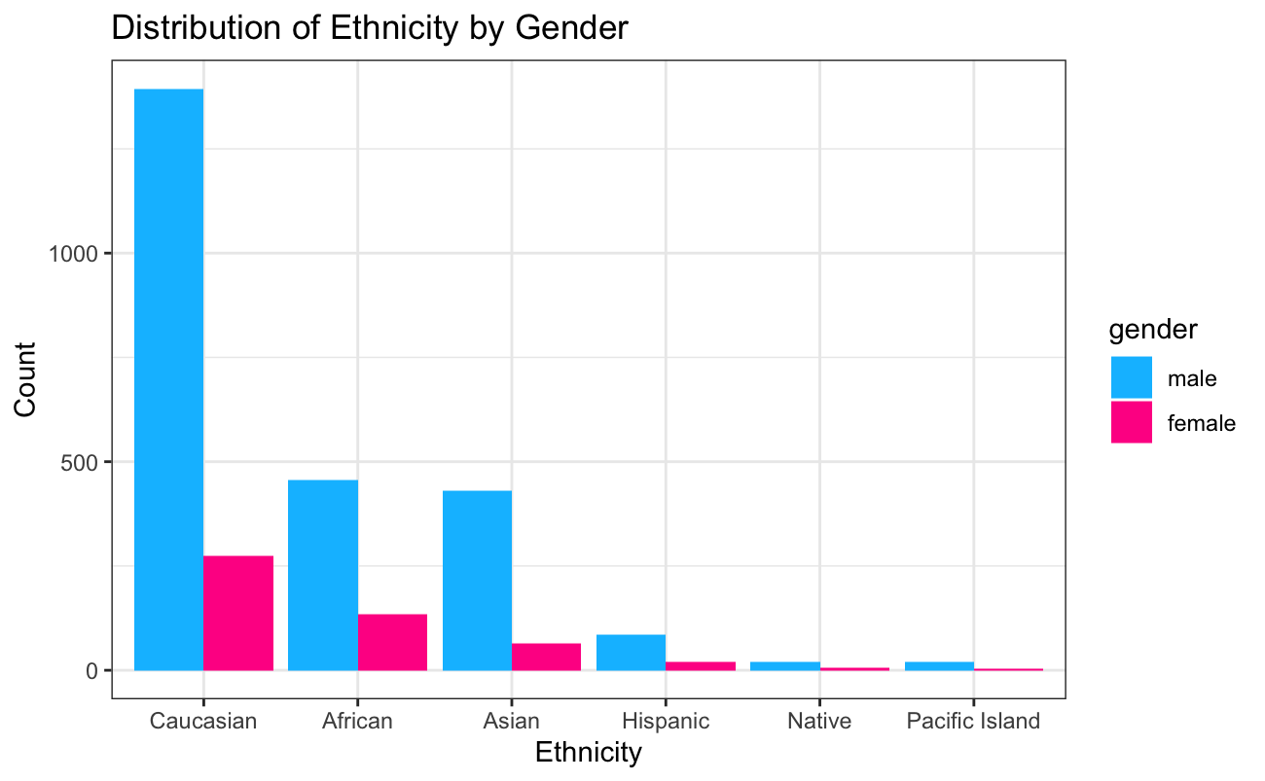

***Figure 2***. Demographic variables: distribution of ethnics by gender

Excluding missing values, 94.29% of participants are on active duty, 4.08% of participants are in reserves, and rest of them are guards. Furthermore, 51.05% participants are Navy, 30.63% are Marines, 12.75% are Army, and rest of them are Air Force, Coast Guard, or National Guard (See Figure 3). Relationship status serves as an important explanatory variable in our analyses (See Figure 4 for more details).

For socioeconomic status (SES), after filtering out missing values, majority (22.80%) of participants have relatively low annual income (15k to 30k dollars). Also, most participants (56.78%) are unemployed when accepting therapies, compared to 31.83% participants with a full-time occupation (see Figure 5). Majority of participants (42.36%) have some college-level education, 16.71% own a college degree, 13.62% have an associate degree (see Figure 6).

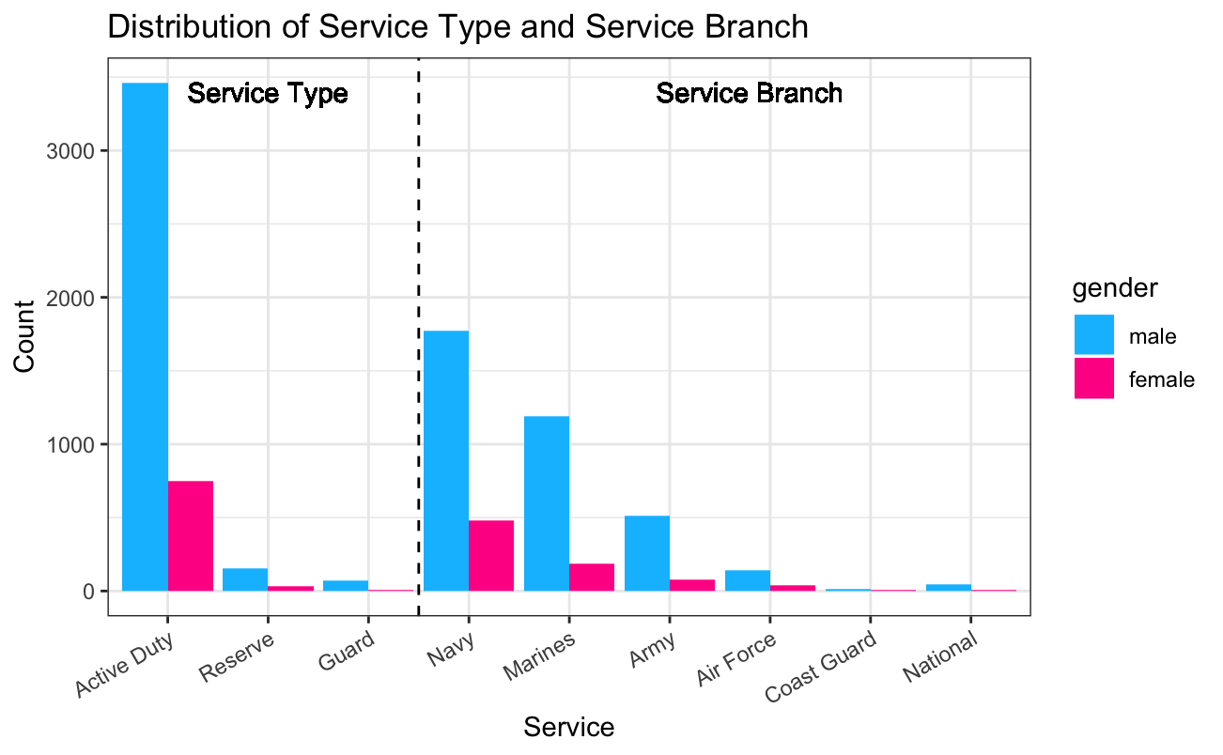

***Figure 3.*** Demographic variables: distribution of service type and service branch by gender

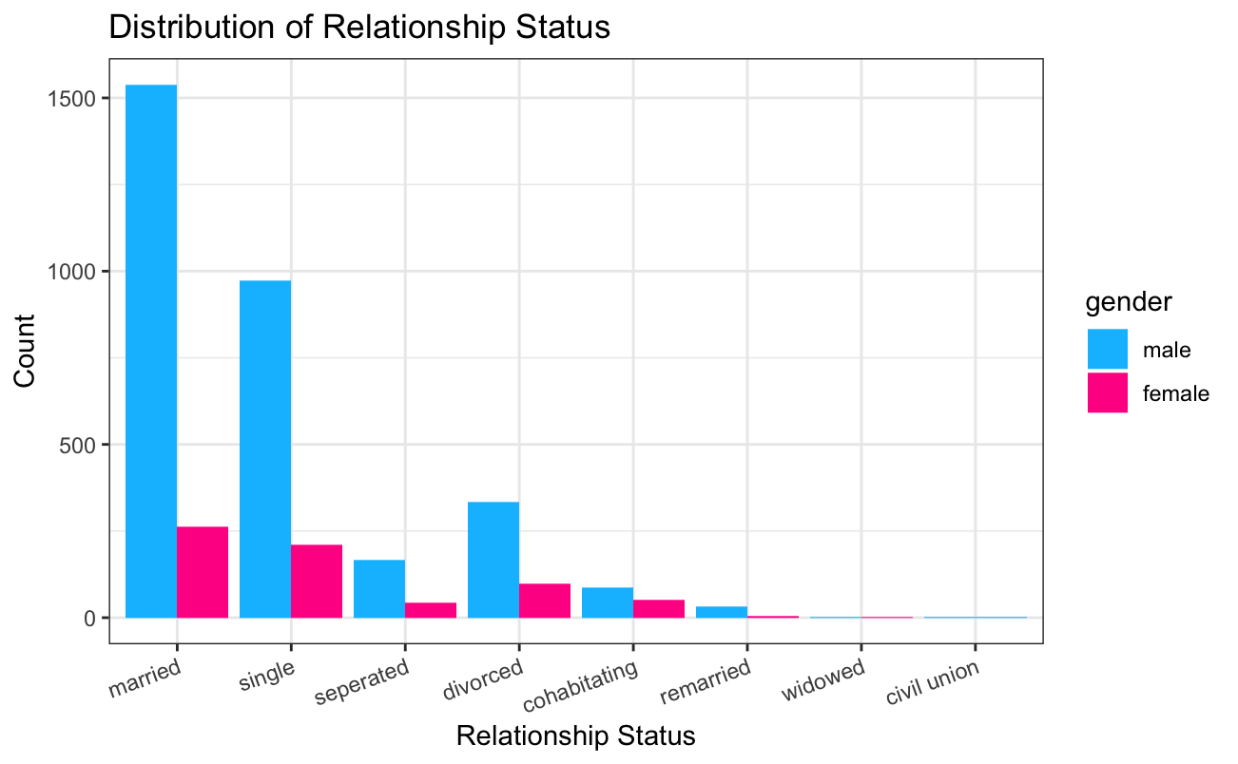

***Figure 4.*** Demographic variable: distribution of relationship status

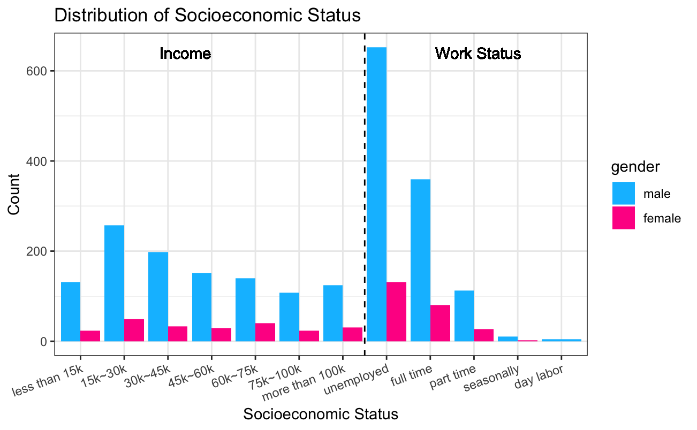

***Figure 5.*** Socioeconomic status variables: distribution of annual income and work status

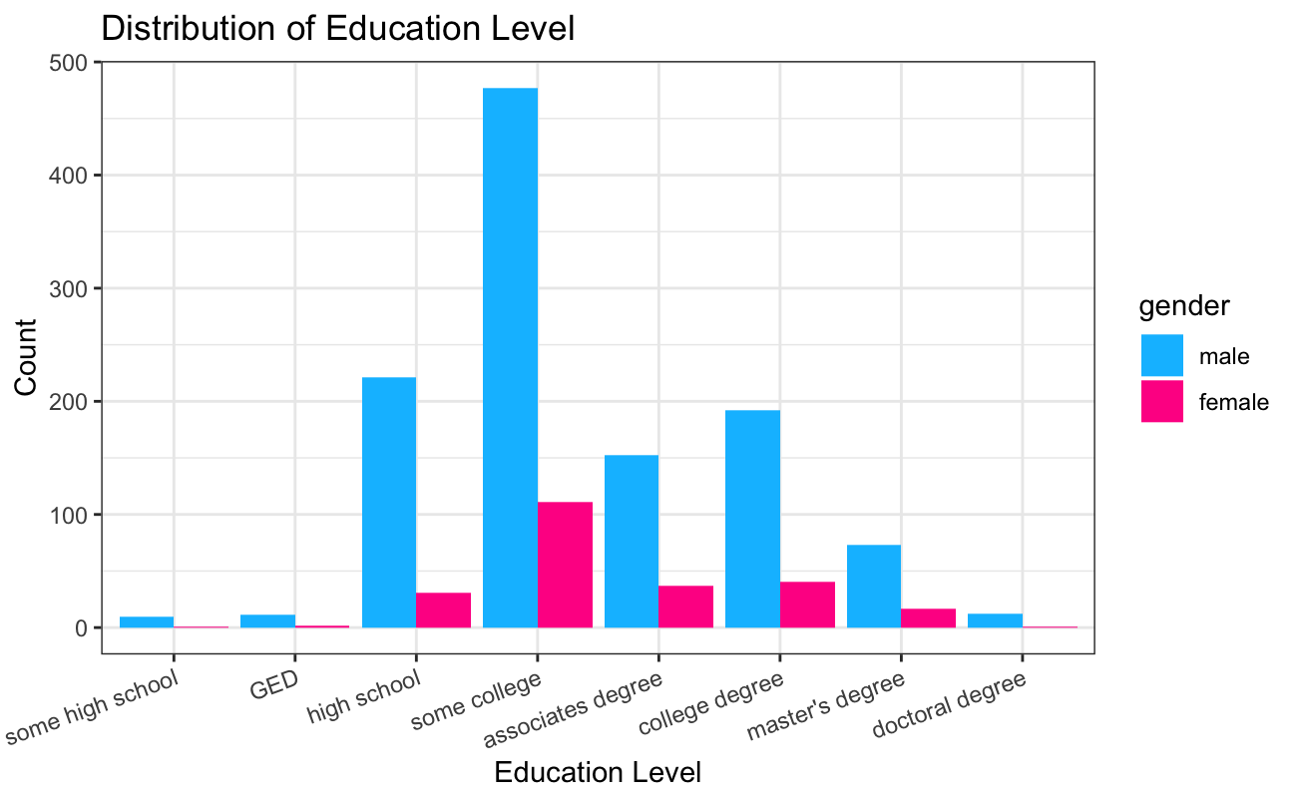

***Figure 6.*** Socioeconomic status variables: distribution of education level

*Measurements*

**Sociodemographic Background.** Demographic information including age, gender, ethnicity, highest level of education, relationship status, work status and income level were collected through an eScreening self-report questionnaire (Pittman et al., 2017).

**Service History.** Service history questions investigated self-reported information on service type (active duty, reserve, or guard), service branch (Army, Air Force, Coast Guard, Marines, National, or Navy), and number of deployments.

**Emotional Support.** Emotional Support was measured by self-reported scores on the Patient-Reported Outcomes Measurement Information System (PROMIS) Emotional Support questionnaire (Reeve et al., 2007). Higher scores indicate higher perceived emotional support.

**Anxiety symptoms.** Anxiety was measured with the Generalized Anxiety Disorder 7 scale (GAD-7), consisting of 7 items coded as three levels (low, moderate, or high) of anxiety symptoms (Spitzer, Kroenke, Williams, & Löwe, 2006). Higher scores indicate greater level of anxiety.

**Depression symptoms.** Depressionwas measured with the Patient Health Questionnaire 9-Item Depression Module (PHQ-9; Kroenke, Spitzer, & Williams, 2001). PHQ-9 is a self-reported nine-item questionnaire. Patients rate depression-related symptoms on a four-point scale from 0 to 4. Higher scores associate with greater severity.

**Insomnia.** Insomnia level was measured with the Insomnia Severity Index (ISI; Morin, Belleville, Bélanger, & Ivers, 2011) that consists of 7 items. Higher scores mean more severe symptoms of insomnia.

**Alcohol Use.** Alcohol usewas measured with the Alcohol Use Disorders Identification Test (AUDIT; Bradley et al., 1998), a ten-item five-point scale. Higher scores correlate with greater alcohol use.

**Results**

*Mental Health*

Correlation analyses indicated that in our sample size, all mental health disorders are significantly correlated to each other (all *p* < .001), suggesting that having one type of mental health disorders may increase the probability to develop other types of disorders. Specifically, emotional support is negatively correlated to all types of mental health disorders tested in the current study, indicating that the higher emotional support veterans receive or perceive, the less likely they develop depression, anxiety, sleeping disorder, or alcohol disorder (see Figure 7).

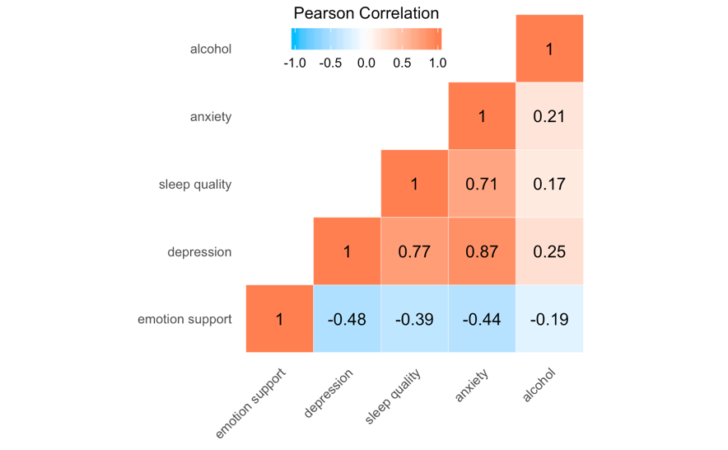

***Figure 7.*** Heatmap for Correlations between emotion support and disorders (all *p* < .001)

*Social Support*

Previous research suggested significant correlation between age and mental health disorders (Thomas et al., 2016). To better measure the effect of relationship status on mental health, four ANCOVA tests were conducted in which age served as the control variable, relationship status served as the factor, and four mental health problems (alcohol use, sleep quality, anxiety, and depression) served as outcome variables. Results showed significant main effects of relationship status on all mental disorders (all *p*<0.001), suggesting that relationship status was significantly influential for all mental health outcomes. Focusing on three major categories namely “married”, “divorced”, and “single”, further post-hoc pairwise t-tests were conducted. Results showed that married veterans were less likely to be addicted to alcohol than their single (*t*(2077) = 4.20, *p* < .001) or divorced (*t*(533) = 4.07, *p* < .001) counterparts. No significant difference in alcohol problem was revealed between single and divorced veterans (*t*(620) = 1.25, *p* = .213) (see Figure 8). Divorced veterans had higher anxiety scores than both single (*t*(700) = 5.79, *p* < .001) and married participants (*t*(617) = 3.18, *p* = .002). However, single veterans are less likely to develop anxiety disorders than married veterans ((*t*(2448) = 4.16, *p* < .001), which contradicts to the previous finding on alcohol use that marriage serves as a critical buffer to reduce potential mental health (see Figure 9). Also, divorced veterans rated higher on the Insomnia Severity Index than single ((*t*(707) = 7.20, *p* < .001) and married ((*t*(623) = 3.40, *p* = .0007) veterans, showing their worse sleep quality, whereas married participants rated their sleep quality worse than single participants ((*t*(2432) = 5.86, *p* < .001) (see Figure 10). Again, this result was against our hypothesis that marriage as a kind of significant social support can promote mental health. Similarly, divorced veterans had severer depression symptoms than single ((*t*(676) = 6.50 *p* < .001) and married ((*t*(600) = 3.66, *p* < .001) veterans (see Figure 11). Furthermore, married veterans appears to experience severer depression than their single counterparts ((*t*(2435) = 4.63, *p* < .001).

***Figure 8.*** Boxplot of Relationship Status and Alcohol Use with significant relationship status effect and gender effect

***Figure 9.*** Boxplot of Relationship Status and Anxiety with significant relationship status effect, gender effect, and relationship status and gender interaction

***Figure 10.*** Boxplot of Relationship Status and Sleep Disorder with significant relationship status effect

***Figure 11.*** Boxplot of Relationship Status and Depression with significant relationship status effect, gender effect, and relationship status and gender interaction

Emotional support is negatively correlated with mental disorder severity and all coefficients are significant (all *p*s < 0.001) across different mental health disorders (see Figure 7). Greater perceived emotional support is associated with better mental health outcomes for anxiety symptoms, depression symptoms, insomnia and alcohol use symptoms (less anxiety, alcohol addiction, depression, and sleeping disorders; see Figure 12­­–15).

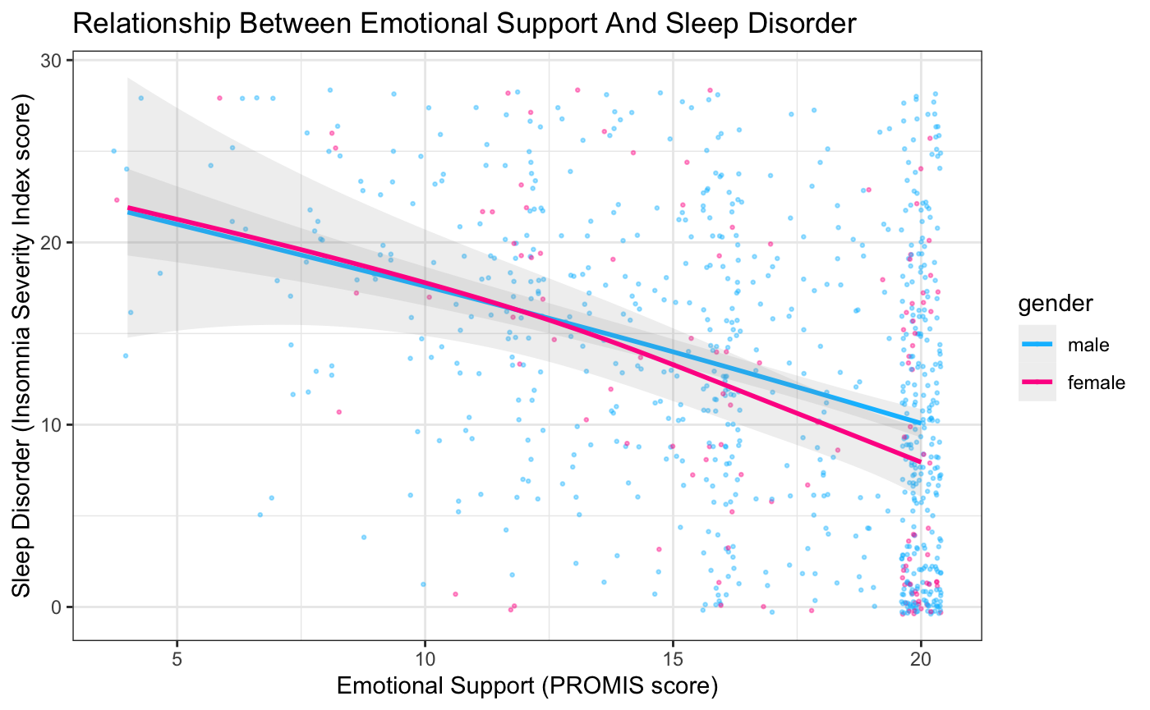

***Figure 12.*** Linear regression of emotional support and sleep disorder with significant gender effect

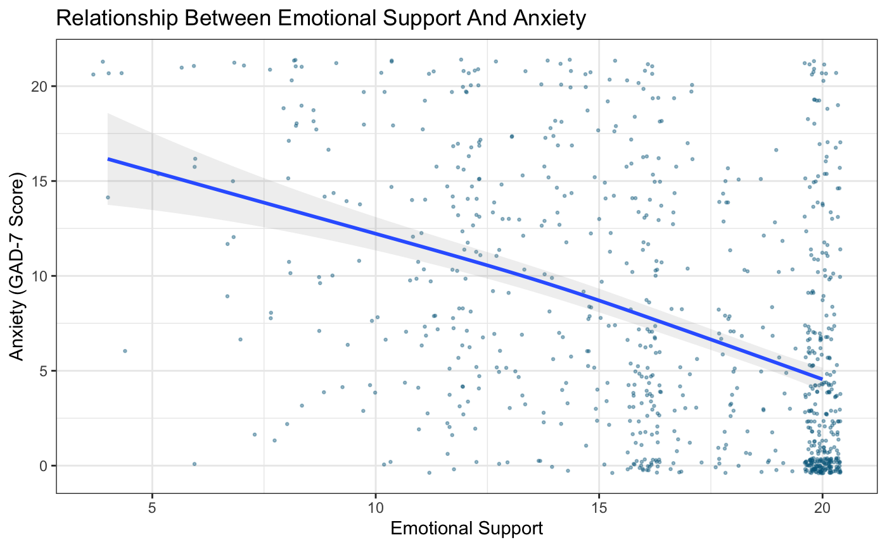

***Figure 13.*** Linear regression of emotional support and anxiety

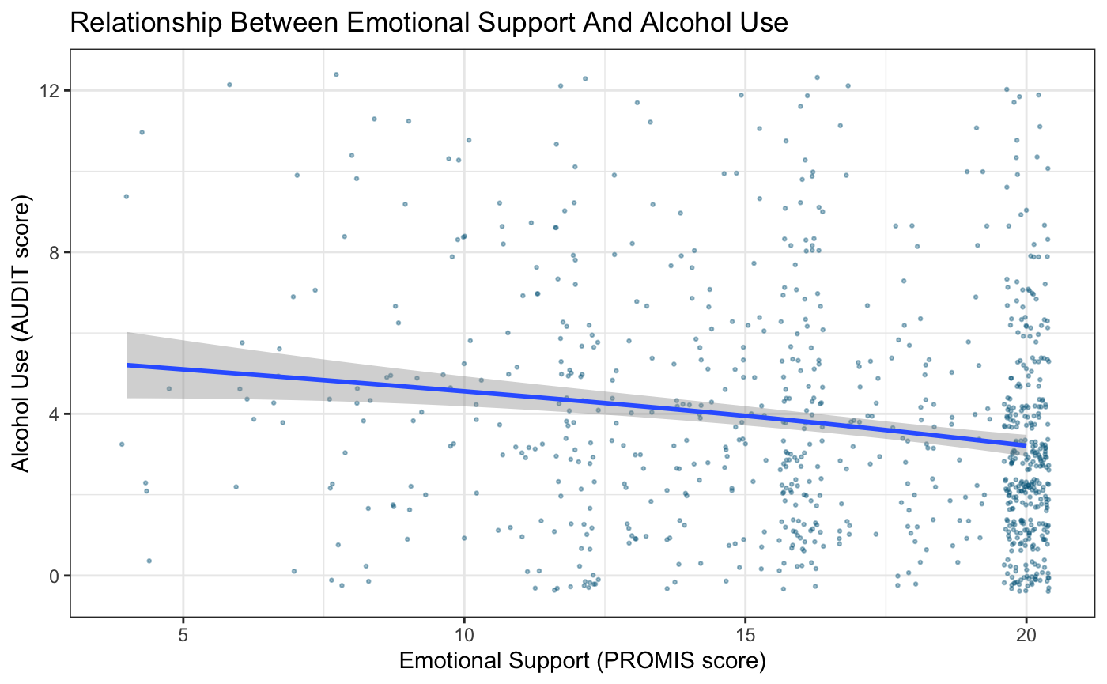

***Figure 14.*** Linear regression of emotional support and alcohol use

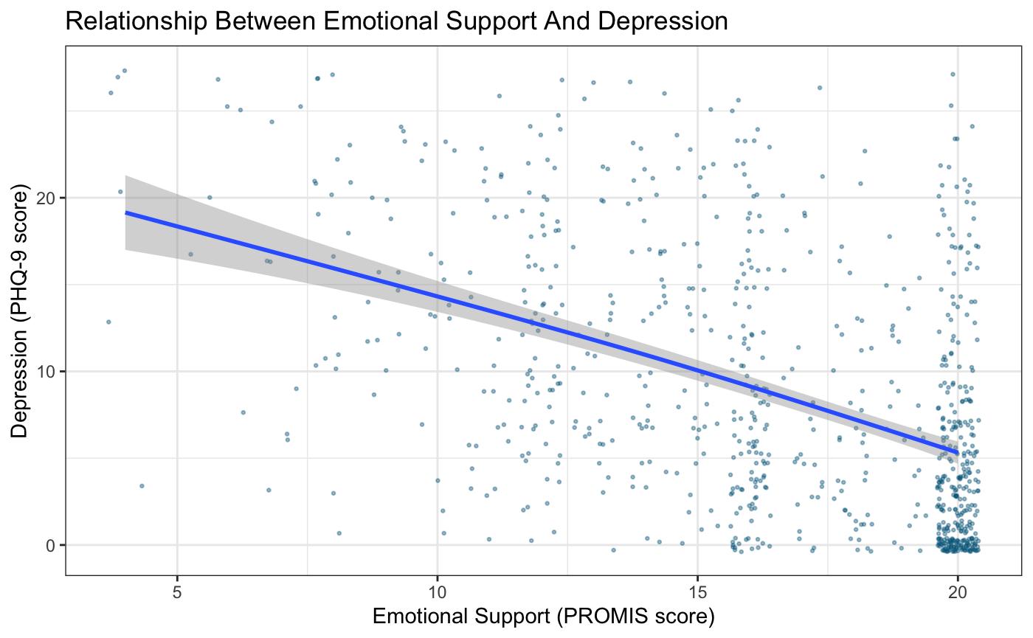

***Figure 15.*** Linear regression of emotional support and depression

*Sociodemographic Background*

Contrary to previous research which showed that higher SES relates to better mental status (Smith-Osborne, 2009), no significance was found in the relationship between SES and mental health severity in our dataset. The analysis of variance showed no significant effect on the anxiety rating for veterans for income levels (*p* = 0.201), education levels (*p* = 0.954), or work status (*p* = 0.875). There was also non-significant effect of SES on all other types of mental health issues (depression, alcohol usage, and insomnia) (see table 1).

***Table 1.*** The main effects of three socioeconomic variables on four mental health disorders

|  |  |  |  |
| --- | --- | --- | --- |
|  | Income | Education | Work Status |
| Sleep Quality | *F*(6, 1273) = 0.527  *p* = 0.788 | *F*(7, 1315) = 0.430  *p* = 0.884 | *F*(4, 1309) = 0.316  *p* = 0.867 |
| Depression | *F*(6, 1294) = 1.514  *p* = 0.170 | *F*(7, 1338) = 0.262  *p* = 0.968 | *F*(4, 1332) = 0.298  *p* = 0.879 |
| Anxiety | *F*(6, 1270) = 1.425  *p* = 0.201 | *F*(7, 1314) = 0.301  *p* = 0.954 | *F*(4, 1308) = 0.305  *p* = 0.875 |
| Alcohol Usage | *F*(6, 1151) = 1.339  *p* = 0.237 | *F*(7, 1191) = 1.626  *p* = 0.124 | *F*(4, 1186) = 0.8  *p* = 0.525 |
|  | | | |

**Discussion**

The results partially supported our hypotheses.

*Social Support*

In accordance to expectations and prior research (Dalgard, Bjork, & Tambs, 1995), we found that perceived social support is significantly correlated with mental health symptoms severity – higher self-reported emotional support successfully predicts better mental health outcomes. Interestingly, for received social support indicated by relationship status, although married veterans did report significantly better mental health outcomes comparing to divorced veterans across all conditions, they reported significantly worse mental health outcomes comparing to single veterans in all conditions but alcohol use. Our study suggests that perceived emotional support, instead of social support, is a better predictor for mental health symptoms severity. Our findings provide information for relationship-sensitive screening, monitoring and treatment efforts, such that divorced individuals might need specific attention, followed by married veterans.

Previous research suggested that many resources and patterns underlying marital status, such as social network and self-esteem, other than marital status alone, might be influential to mental well-being (Cotten, 1999). Future research should be dedicated to further explore the determinant factors or patterns underlying marital status that contribute to mental well-being or mental distress.

*Socio-economic Status*

Contrary to our hypothesis, we found no significant association between any of the SES variables and mental health symptoms in the veteran population. This topic has been controversial as some findings suggested that SES does influence mental health outcomes (Cockerham, 2016) while others find the associations between the variables are rather weak (Drentea & Reynolds, 2012). One possible explanation for this result is the large amount of missing values or refused to report in the SES questions. Nonetheless, the research on SES’s effect on mental health in the veteran population has been lacking. Our findings provide a piece of evidence for SES’s association with mental health in the veteran population and the results call on further effort to determine what part does SES play on mental health and to what extent.

Limitations of the study include the use of cross-sectional data, limited continuous variables and limited generalizability. The data was collected cross-sectionally, which make it impossible to determine causal effects between the variables. In addition, the dataset consists of largely active duty marine and navy corps veterans and does not include veterans seeking care outside of VA Hospital which narrow the generalizability of the results. Last but not the least, most of the variables are categorical which limited our choices of statistical techniques, restraining our ability to make comprehensive models of the relationship between the variables.

**References**

Bradley, K. A., McDonell, M. B., Bush, K., Kivlahan, D. R., Diehr, P., & Fihn, S. D. (1998). The AUDIT Alcohol Consumption Questions. *Alcoholism: Clinical & Experimental Research*. https://doi.org/10.1097/00000374-199811000-00034

Burnett-Zeigler, I., Valenstein, M., Ilgen, M., Blow, A. J., Gorman, L. A., & Zivin, K. (2011). Civilian Employment Among Recently Returning Afghanistan and Iraq National Guard Veterans. *Military Medicine*. https://doi.org/10.7205/milmed-d-10-00450

Ciarleglio, M. M., Aslan, M., Proctor, S. P., Concato, J., Ko, J., Kaiser, A. P., & Vasterling, J. J. (2018). Associations of Stress Exposures and Social Support With Long-Term Mental Health Outcomes Among U.S. Iraq War Veterans. *Behavior Therapy*. https://doi.org/10.1016/j.beth.2018.01.002

Cockerham, W. C. (2016). Sociology of Mental Disorder. In *Sociology of Mental Disorder*. https://doi.org/10.4324/9781315618654

Cotten, S. R. (1999). Marital Status and Mental Health Revisited: Examining the Importance of Risk Factors and Resources. *Family Relations*. https://doi.org/10.2307/585631

Dalgard, O. S., Bjork, S., & Tambs, K. (1995). Social support, negative life events and mental health. *British Journal of Psychiatry*. https://doi.org/10.1192/bjp.166.1.29

Department of Veteran Affairs. (2016). *U.S. Veterans Eligibility Trends and Statistics*.

Drentea, P., & Reynolds, J. R. (2012). Neither a borrower nor a lender be: The relative importance of debt and SES for mental health among older adults. *Journal of Aging and Health*. https://doi.org/10.1177/0898264311431304

Eaton, K. M., Hoge, C. W., Messer, S. C., Whitt, A. A., Cabrera, O. A., McGurk, D., … Castro, C. A. (2008). Prevalence of Mental Health Problems, Treatment Need, and Barriers to Care among Primary Care-Seeking Spouses of Military Service Members Involved in Iraq and Afghanistan Deployments. *Military Medicine*. https://doi.org/10.7205/milmed.173.11.1051

Graziano, R., & Elbogen, E. B. (2017). Improving mental health treatment utilization in military veterans: Examining the effects of perceived need for care and social support. *Military Psychology*. https://doi.org/10.1037/mil0000169

Jakupcak, M., Cook, J., Imel, Z., Fontana, A., Rosenheck, R., & McFall, M. (2009). Posttraumatic stress disorder as a risk factor for suicidal ideation in Iraq and Afghanistan war veterans. *Journal of Traumatic Stress*. https://doi.org/10.1002/jts.20423

Jakupcak, M., Vannoy, S., Imel, Z., Cook, J. W., Fontana, A., Rosenheck, R., & McFall, M. (2010). Does PTSD moderate the relationship between social support and suicide risk in Iraq and Afghanistan War Veterans seeking mental health treatment? *Depression and Anxiety*. https://doi.org/10.1002/da.20722

Kozel, F. A., Didehbani, N., DeLaRosa, B., Bass, C., Schraufnagel, C. D., Morgan, C. R., … Hart, J. (2016). Factors impacting functional status in veterans of recent conflicts with PTSD. *Journal of Neuropsychiatry and Clinical Neurosciences*. https://doi.org/10.1176/appi.neuropsych.15070183

Kroenke, K., Spitzer, R. L., & Williams, J. B. W. (2001). The PHQ-9. *Journal of General Internal Medicine*. https://doi.org/10.1046/j.1525-1497.2001.016009606.x

Meyer, O. L., Castro-Schilo, L., & Aguilar-Gaxiola, S. (2014). Determinants of mental health and self-rated health: A model of socioeconomic status, neighborhood safety, and physical activity. *American Journal of Public Health*. https://doi.org/10.2105/AJPH.2014.302003

Morin, C. M., Belleville, G., Bélanger, L., & Ivers, H. (2011). The insomnia severity index: Psychometric indicators to detect insomnia cases and evaluate treatment response. *Sleep*. https://doi.org/10.1093/sleep/34.5.601

Ohrnberger, J., Fichera, E., & Sutton, M. (2017). The relationship between physical and mental health: A mediation analysis. *Social Science and Medicine*. https://doi.org/10.1016/j.socscimed.2017.11.008

Pittman, J. O. E., Floto, E., Lindamer, L., Baker, D. G., Lohr, J. B., & Afari, N. (2017). VA escreening program: Technology to improve care for post-9/11 veterans. *Psychological Services*. https://doi.org/10.1037/ser0000125

Reblin, M., & Uchino, B. N. (2008). Social and emotional support and its implication for health. *Current Opinion in Psychiatry*. https://doi.org/10.1097/YCO.0b013e3282f3ad89

Reeve, B. B., Hays, R. D., Bjorner, J. B., Cook, K. F., Crane, P. K., Teresi, J. A., … Cella, D. (2007). Psychometric evaluation and calibration of health-related quality of life item banks: Plans for the Patient-Reported Outcomes Measurement Information System (PROMIS). *Medical Care*. https://doi.org/10.1097/01.mlr.0000250483.85507.04

Ren, X. S., Skinner, K., Lee, A., & Kazis, L. (1999). Social support, social selection and self-assessed health status: Results from the veterans health study in the United States. *Social Science and Medicine*. https://doi.org/10.1016/S0277-9536(99)00069-6

Smith-Osborne, A. (2009). Mental health risk and social ecological variables associated with educational attainment for gulf war veterans: Implications for veterans returning to civilian life. *American Journal of Community Psychology*. https://doi.org/10.1007/s10464-009-9278-0

Spelman, J. F., Hunt, S. C., Seal, K. H., & Burgo-Black, A. L. (2012). Post deployment care for returning combat veterans. *Journal of General Internal Medicine*. https://doi.org/10.1007/s11606-012-2061-1

Spitzer, R. L., Kroenke, K., Williams, J. B. W., & Löwe, B. (2006). A brief measure for assessing generalized anxiety disorder: The GAD-7. *Archives of Internal Medicine*. https://doi.org/10.1001/archinte.166.10.1092

Thoits, P. A. (2011). Mechanisms linking social ties and support to physical and mental health. *Journal of Health and Social Behavior*. https://doi.org/10.1177/0022146510395592

Thomas, M. L., Kaufmann, C. N., Palmer, B. W., Depp, C. A., Martin, A. S., Glorioso, D. K., … Jeste, D. V. (2016). Paradoxical trend for improvement in mental health with aging: A Community-Based study of 1,546 adults aged 21-100 years. *Journal of Clinical Psychiatry*. https://doi.org/10.4088/JCP.16m10671

1. Shuai Shao, graduate student at the Department of Psychology
2. Xinyue Li, undergraduate student at the Department of Psychology
3. Shuyuan Shi, undergraduate student at the Department of Psychology