# README

1. To compile the c file:

gcc pth-gauss1.c hrtimer_x86.c –lpthread

or: gcc pth-gauss2.c hrtimer_x86.c –lpthread

ps: pth-gauss1 is the Row Oriented Method and pth-gauss2 is the Column Oriented Method.

2. And the input data format is:

./a.out –s2048 –p32

where the number after s indicate matrix size or problem size, and number after p indicate the number of threads.

3.1 Results for Row Oriented Method

3.1.1 Cycle3

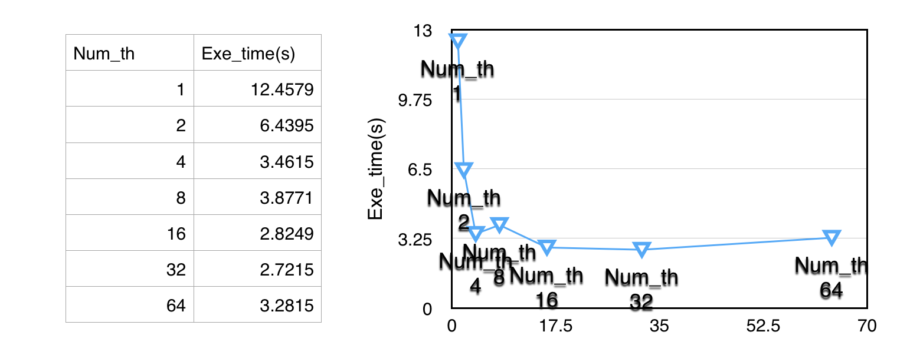a) s = 2048

b) s = 1024

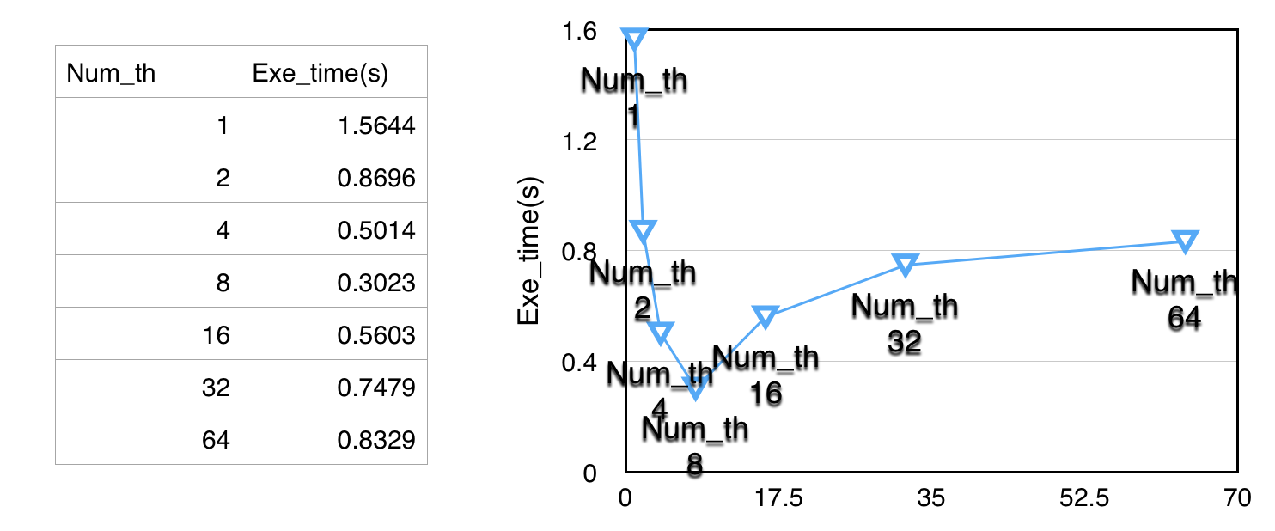

c) s = 512

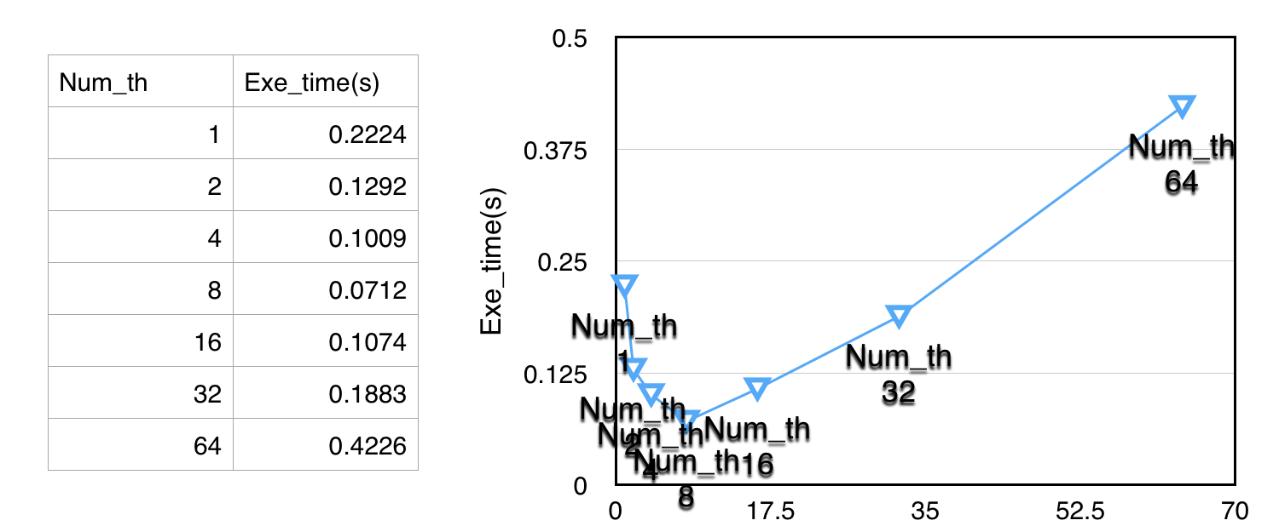

d) s = 256

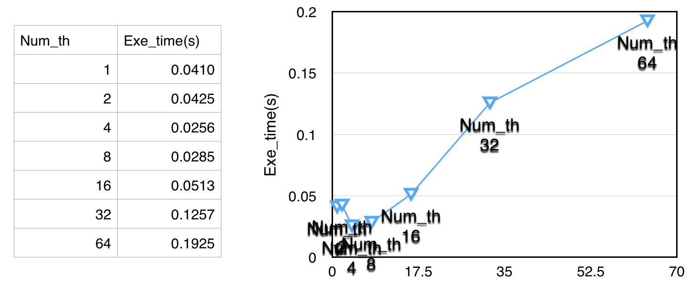

e) s = 128

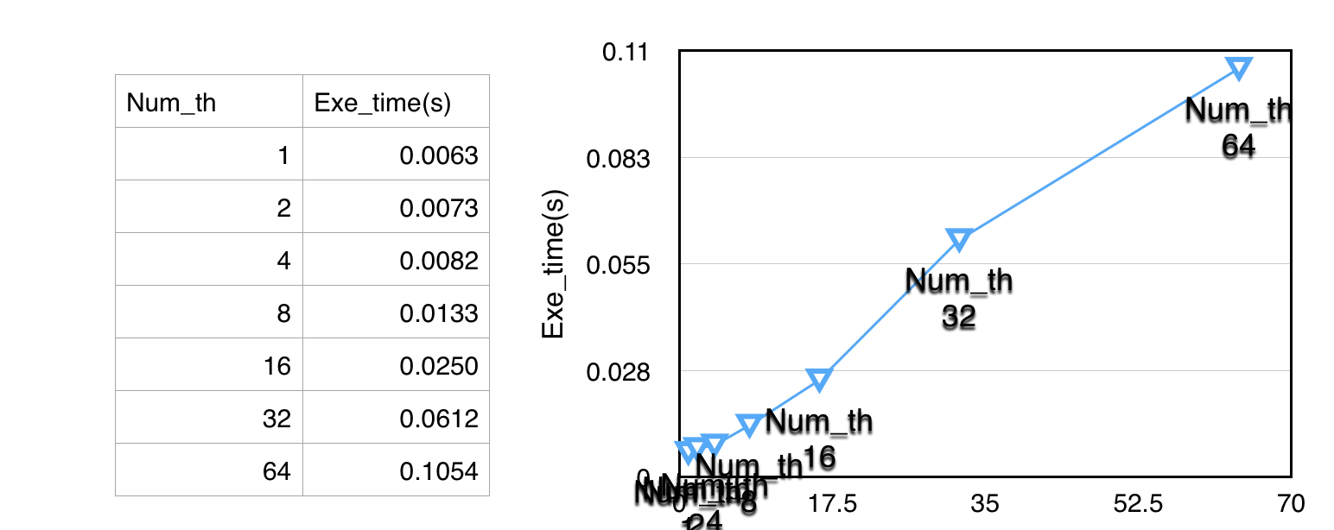

3.1.2 Cycle2

a) s = 2048

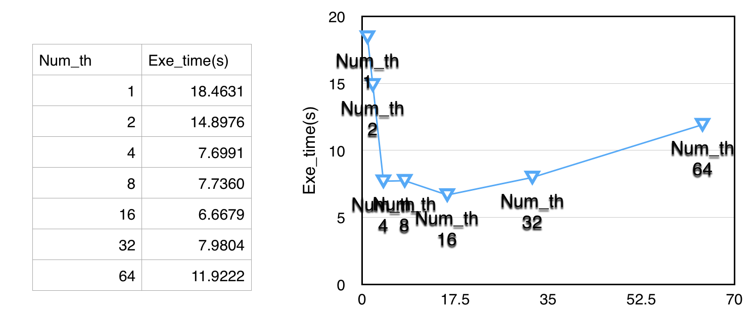

b) s = 1024

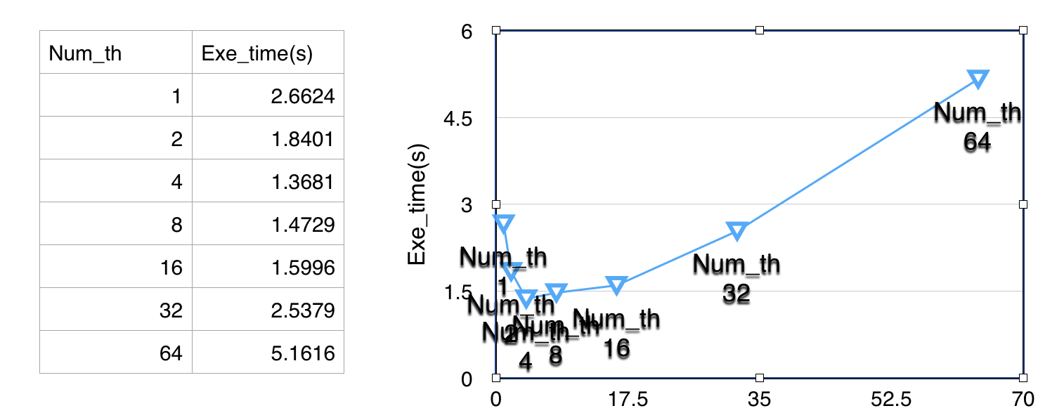

c) s = 512

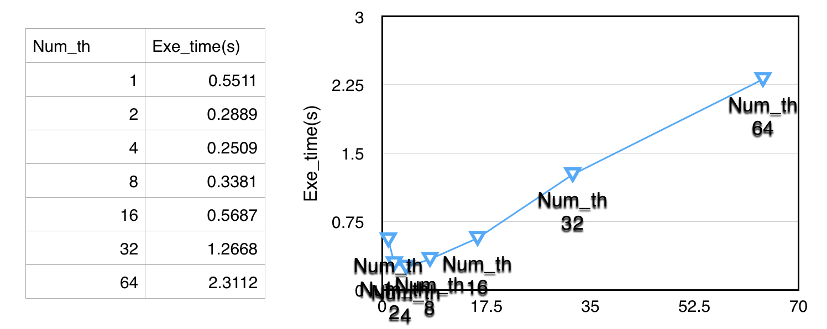

d) s = 256

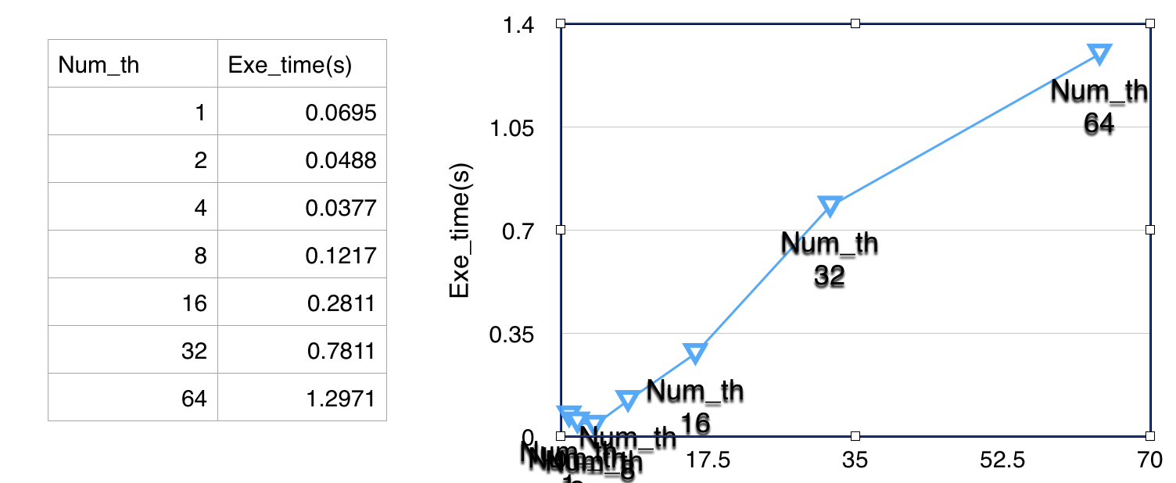

e) s = 128

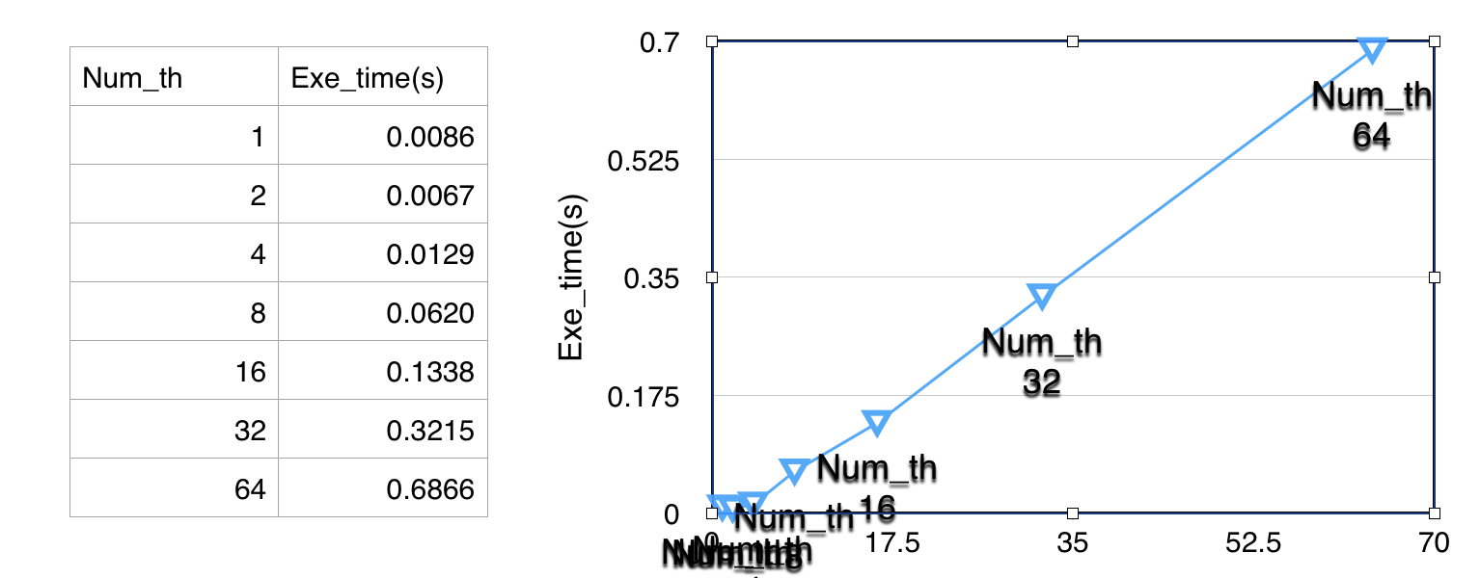

3.2 Results for Column Oriented Method

3.2.1 Cycle3

a) s = 2048

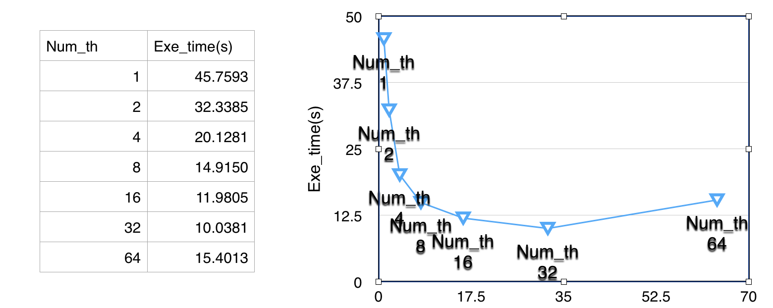

b) s = 1024

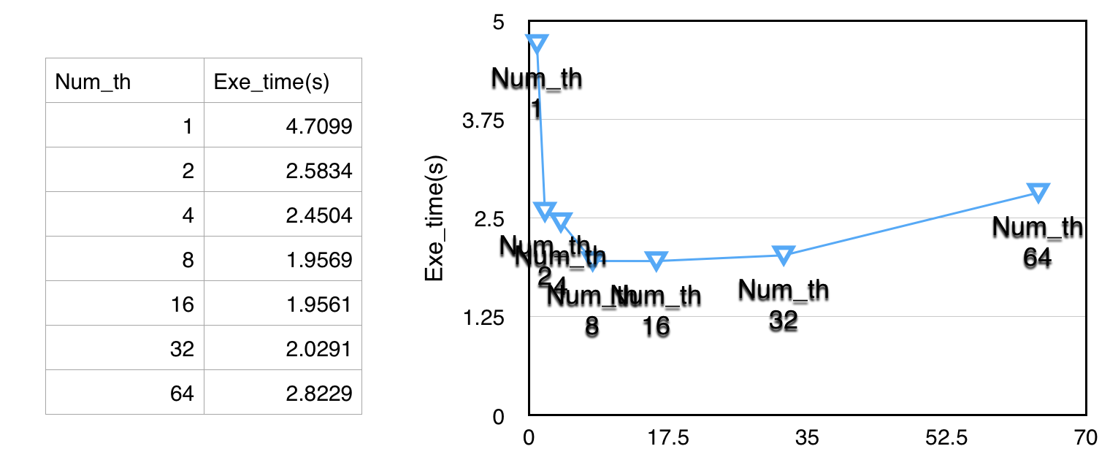

c) s = 512

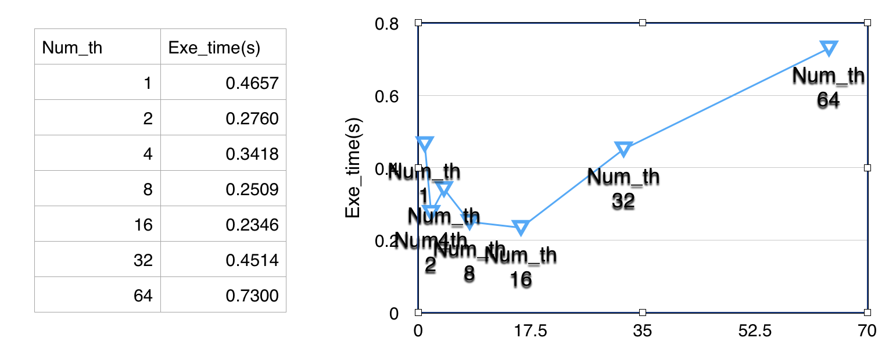

d) s = 256

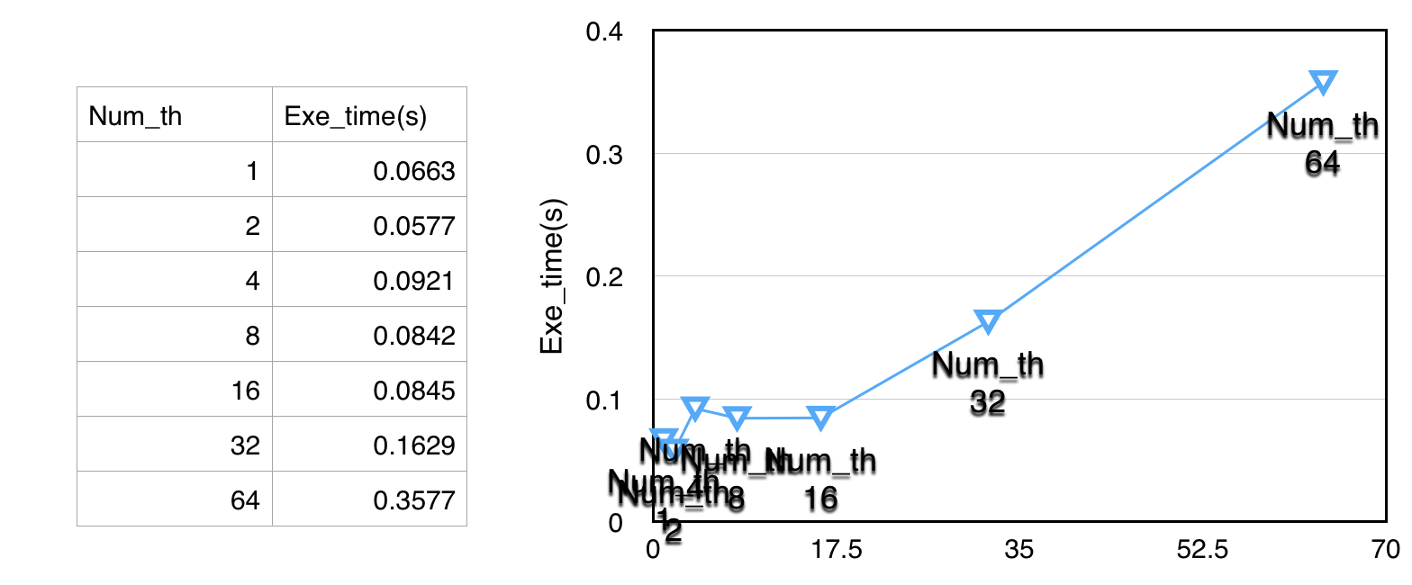

e) s = 128

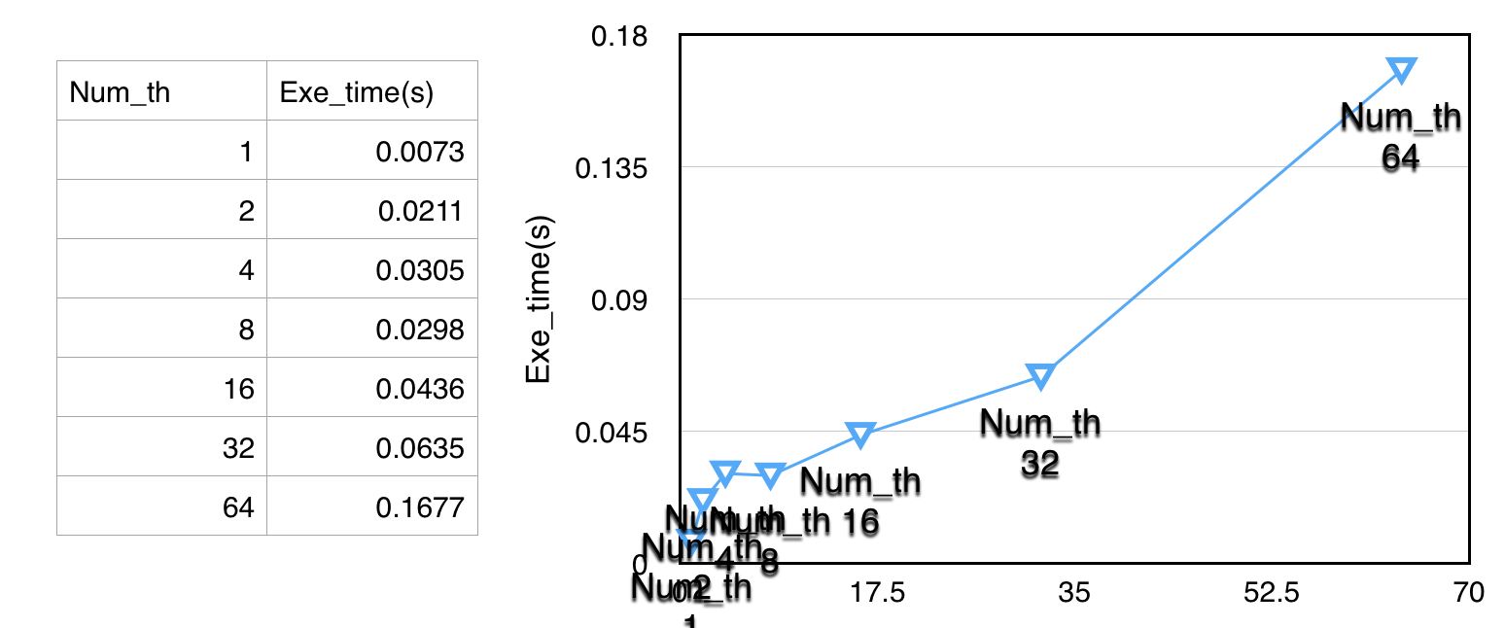

3.2.2 Cycle2

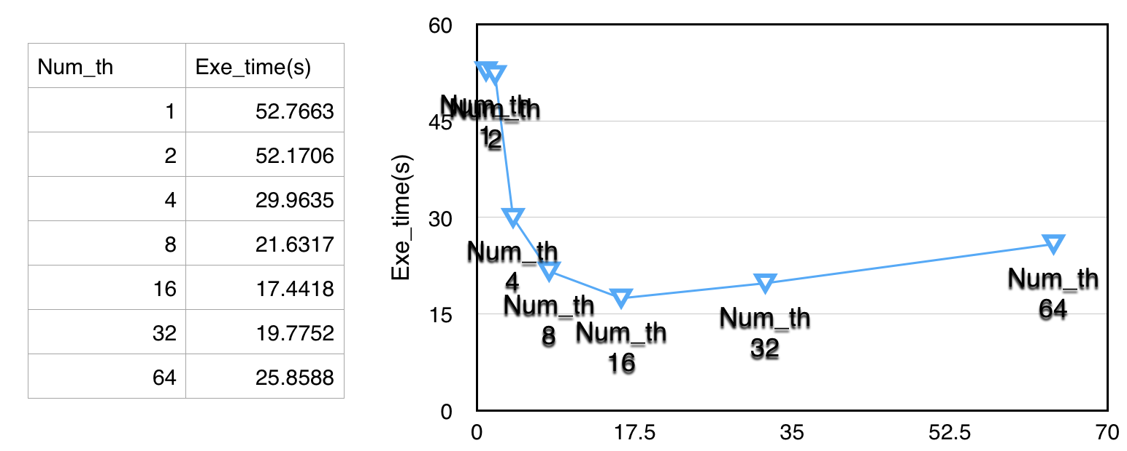a) s = 2048

b) s = 1024

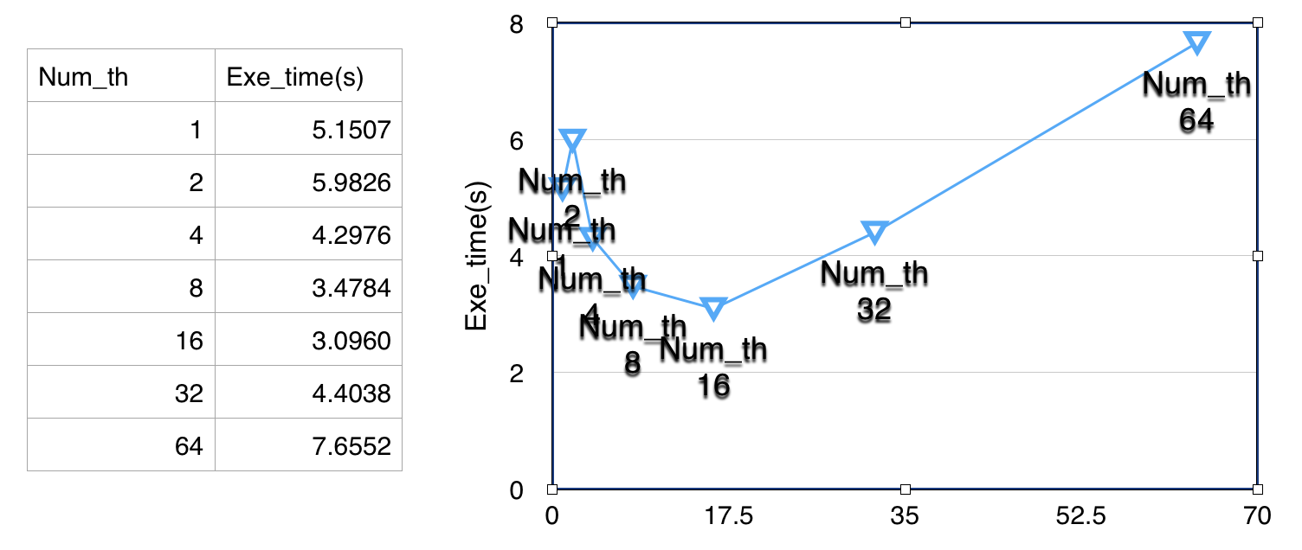

c) s = 512

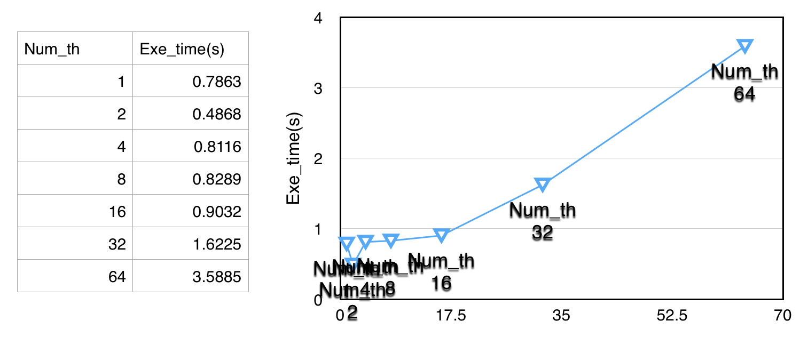

d) s =256

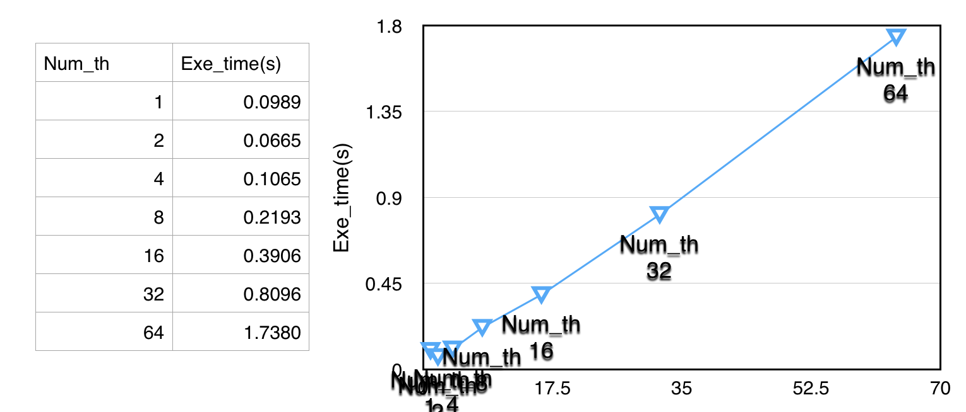

e) s = 128

