CSYE6225

Spring 2019

Web Application

Firewall Implementations

&

Penetration Testing

Yunan Shao (1818832)

Haowen Chang (1497263)

Zeyu Huang (1407537)

Andong Wang (1407537)

Selected Attack Vectors in Red

**1. Sql Injection - Implemented**

**Implementation:** Added ACL rules to block matched sql injection strings.

**Attack Vector:** ​​By inserting sql code into requests to the interpreter, an attacker can alter the intent of the requests and cause unexpected actions

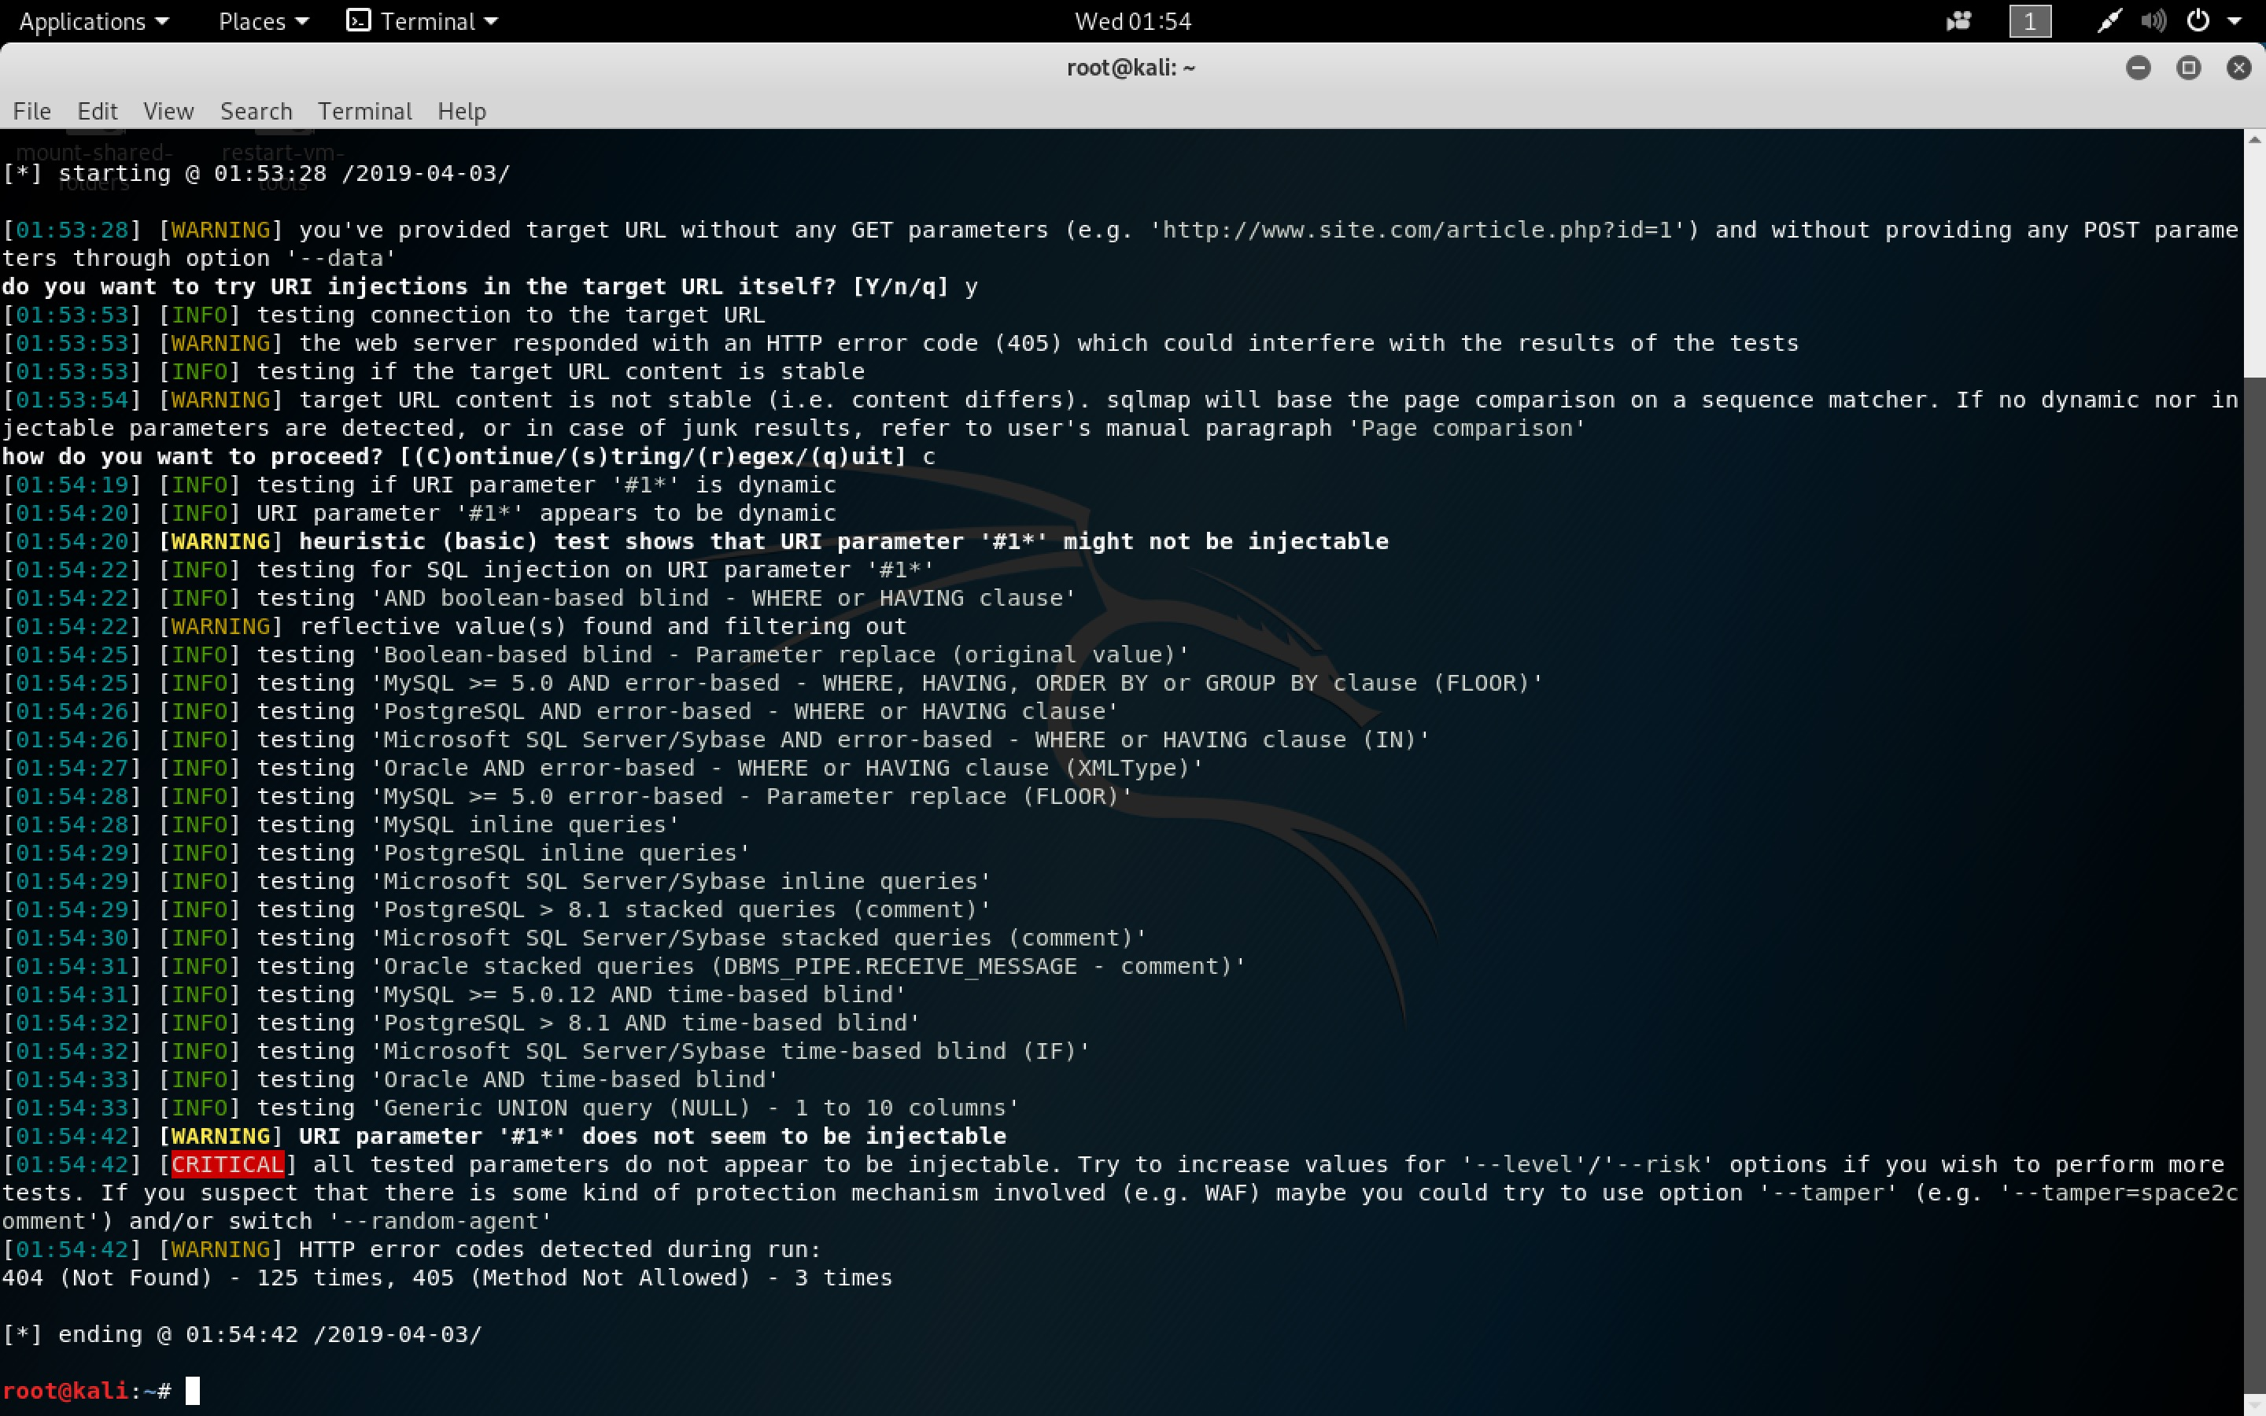

**Result:** ​​All tested parameters do not appear to be injectable at level 3 with WAF or without WAF.

**Why choose this vector:** Attackers can use any source of data as an injection vector, even without login and all types of users and these vulnerabilities are very often in SQL. Injection can result in huge data leak or even losing data in the database.

**2. Broken Authentication and Session Management – Not Implemented**

**Reason why no implement:** Our Restful API is not token or session based. If there are account credentials are exposed, we can use other methods such as asking for changing password to those exposed account.

**3. XSS - Implemented**

**Implementation:** ACL rules to block matched xss attack strings.

**4. Broken Access Control - Implemented**

**Implementation:** ACL rules to block urls that have strings related to path which can be potential path traversal attack. And our web application checks for authentication internally for reach request.

**Attack Vector:** ​​By guess direction or file and insert the location into an address, attacker can get access to file that is invisible to the users and may change or insert virus. Or guess the parameter in the url to get access to resource.

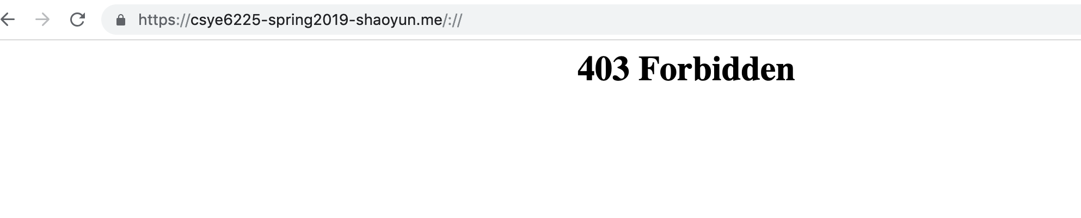

With WAF

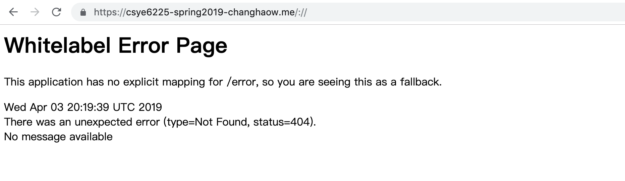

Without WAF

**Result:** ​​Although both web app didn’t show anything but web app without WAF shows that the request can get into the server and do something but with WAF all the direction string is filtered.

**Why choose this vector:** Poorly designed access control can lead to exposure of unauthorized data, manipulation of internal web application state, path traversal, and file inclusion.

**5.Security Misconfiguration – Implemented**

**Implementation:** The ports and ingress rules between security groups are designed to block potential access to our server.

**6. Sensitive Data Exposure - Implemented**

**Implementation:** Only HTTPS requests are allowed with elastic load balancer. User credentials are encrypted using Bcrypt with unique salts.

**7. Insufficient Attack Protection - Implemented**

**Implementation:** ACL rules to blocks requests that are larger than restricted file size.

**Attack Vector:** Attacker might send plenty of request that contains large file so that server need time to response then cause server slow or downtime like DDos. We added ACL rules that only accept 0.2mb size for uploading and tested with files that are larger than the restriction.

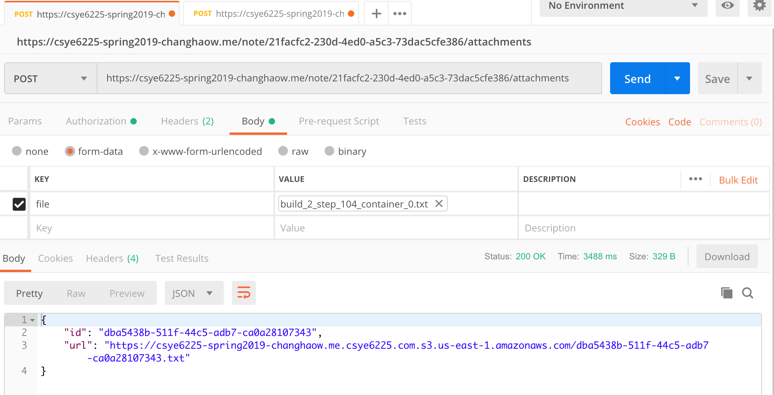

Without WAF

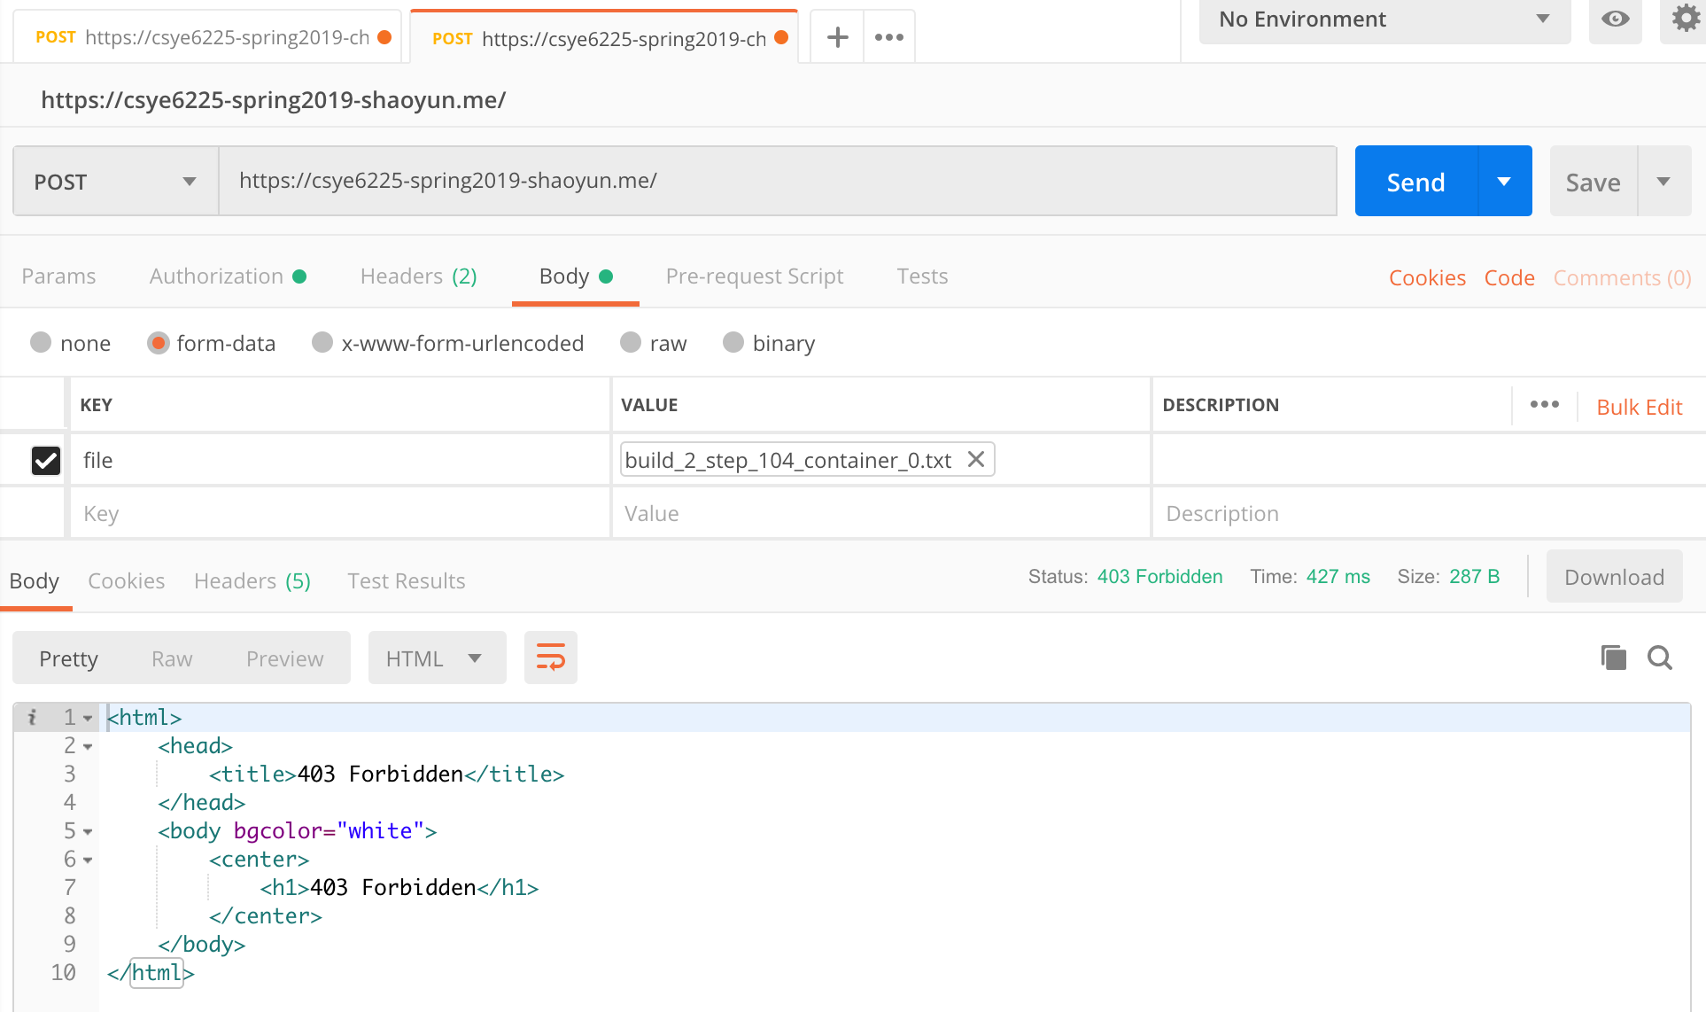

With WAF

**8. Cross-site request forgery attack – Implemented**

**Implementation:** ACL rule that blocks requests with tokens that are in certain size.

*Our application actually doesn’t use token-based authentication. We still added one rule that is explained in the AWS WAF document for explanation purpose. Without the WAF check the head, requests with tokens in any sized token will be accepted. With WAF we can allow only requests with tokens in matched size.

**9. Using Components with Known Vulnerabilities – Implemented**

**Implementation:** ACL rules that block request with certain prefix of file extensions.

**10. Under protected APIs - Implemented**

**Implementation:** Many examples are in 1-9 and we can block requests with designed ACL rules such as string match or size restrictions to protect our application.

Citations:

<https://d0.awsstatic.com/whitepapers/Security/aws-waf-owasp.pdf>