Problem-2: How many requests are made when you embed a clientLib which itself has one
dependency?

Ans: 2 requests are made to the server.

In the case of 3 clientlibs (Clientlibs-base, Clientlibs-embed and Clientlibs-dependencies), the 2 requests are made in the order – first, for Clientlibs-dependencies and second, for Clientlibs-base. All of the Clientlibs are loaded.

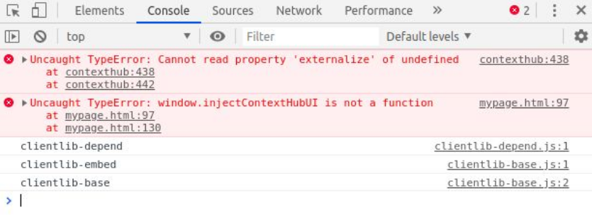
Problem-3: Create 3 clientlibs. Embed clientlib3 in clientlib2 and clientlib2 in clientlib1. State
the observation with respect to the number of calls and content of clientlib.

Ans: Only a single call is made to the server in the form of clientlib1.js . It is observed that embed is only done at one level as it is not transitive.

