- Create Database
CREATE DATABASE TTN_db;
SHOW DATABASES;
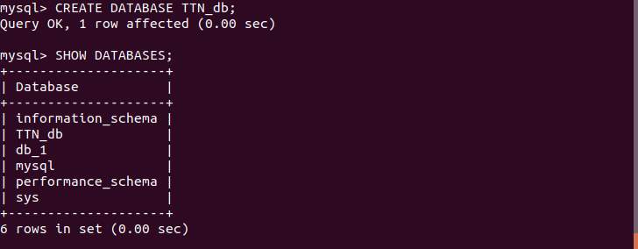
- Design Schema
Note: 3 tables (CUSTOMER, salesman and ordertable) have been created with assigned primary and foreign key.

desc CUSTOMER;
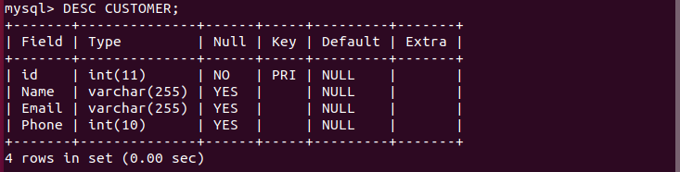
desc salesman;
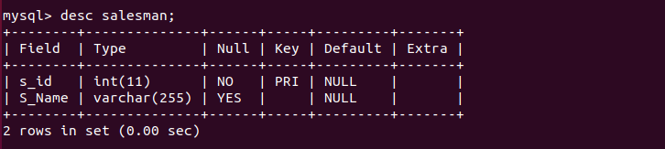
desc ordertable;
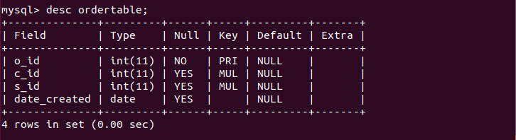
- Create tables

CREATE TABLE CUSTOMER(id int, Name varchar(255), Email varchar(255) , Phone int(10), primary key(id));

CREATE TABLE salesman(s_id int primary key, S_Name varchar(255));
CREATE TABLE ordertable(o_id int primary key, c_id int, s_id int, date_created date, foreign key (c_id) references CUSTOMER(id), foreign key (s_id) references salesman(s_id));

Note: customer and salesman ids are foreign keys that connect ordertable to CUSTOMER and salesman tables.
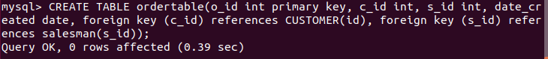
- Insert sample data
INSERT INTO CUSTOMER values (1, 'VISHODU SHAOZAE' ,'SHAOZAE@GMAIL.COM', 86977493),(2, 'MAYANK JAIN', 'MAYANKJAIN@GMAIL.COM', 98776342);
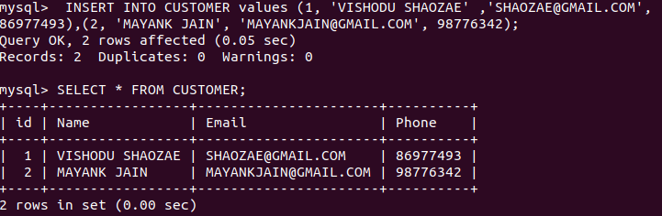
INSERT INTO ordertable values (2, 1 ,1, '2020-02-04'),(1, 2, 1, '2020-02_05');
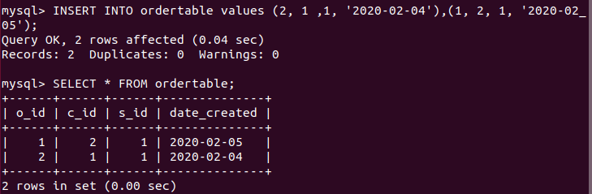
INSERT INTO salesman values(1,'AYUSH'),(2,'ROHAN');
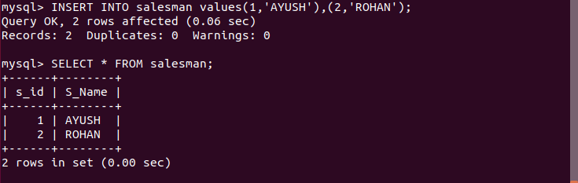
- Find the sales person have multiple orders.
select * from salesman c LEFT JOIN ordertable o on c.s_id = o.s_id ;
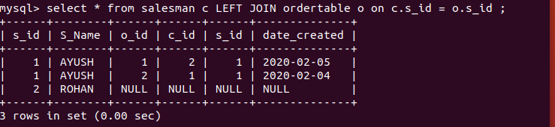
Note: AYUSH has multiple orders therefore multiple o_id (order ids).

- Find the all sales person details along with order details
select * from salesman c JOIN ordertable o ORDER BY S_Name;
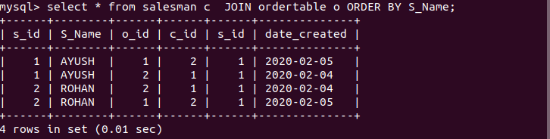
- Create index
- How to show index on a table
show index from CUSTOMER;
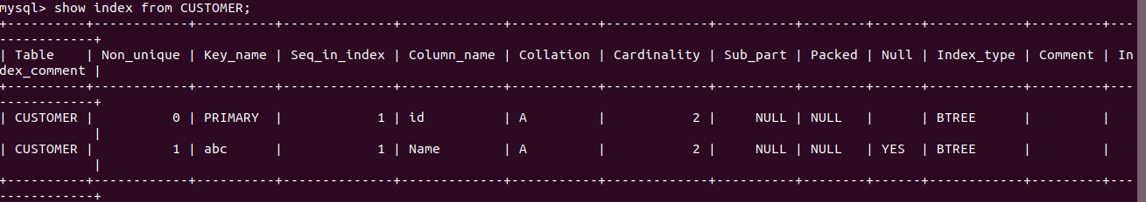
- Find the order number, sale person name, along with the customer to whom that order belongs to
Select ordertable.o_id,salesman.S_Name,CUSTOMER.Name,CUSTOMER.Email, CUSTOMER.Phone from ordertable left join salesman on salesman.s_id = ordertable.s_id left join CUSTOMER on CUSTOMER.id=ordertable.c_id;

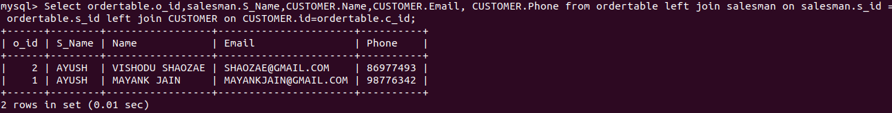
Note: Ordertable has 2 left joins. One with salesman and one with customer.

