1.How are inline and block elements different from each other?
HTML elements can be split up in two categories, namely:
Inline elements, that don’t take up any more space than required and stay in the same line they were put in. Eg: <span></span>
Block elements, that start on a new line and take up the whole width. Eg: <div></div>
2.Explain the difference between visibility:hidden and display:none
dispay:none means that the tag or the element will not appear on the page nor have any space allocated to it between tags. (It can still be interacted through the dom)
visibility:hidden means that the tag or element has space allocated to it but will not appear on the page. It is rendered but invisible.

3. Explain the clear and float properties.
Float is a property which describes the positioning of an element with respect to others. Float values are: left, right, none, and inherit.
Clear property is used as a barrier for float so as to avoid neighbouring elements from dispositioning.

4. explain difference between absolute, relative,fixed and static.
Static: The elements will be positioned in the order of appearance in the document. It is the default value.
Absolute: The elements will be positioned relative to the nearest positoned ancestor. It is positioned based on the body of the page in the absence of an ancestor.

5. Write the HTML code to create a table in which there are 4 columns( ID , Employee Name, Designation, Department) and at least 6 rows. Also do some styling to it.
<!DOCTYPE html>
<html>

<head>
<title>Q5 Table</title>
<style type="text/css">
td {
text-align: center;
}
</style>
</head>

<body>
<table border="1" style="width: 100%">
<thead>
<tr>
<th>ID</th>
<th>Employee Name</th>
<th>Designation</th>
<th>Department</th>
</tr>
</thead>
<tbody>
<tr>
<td style="color: #17202A; font-weight: bold;">001</td>
<td>vishodu</td>
<td>AMC</td>
<td>CSE</td>
</tr>

<tr>
<td style="color: #1c2833; font-weight: bold;">002</td>
<td>alok</td>
<td>Android</td>
<td>ECE</td>
</tr>
<tr>
<td style="color: #212f3d ; font-weight: bold;">003</td>
<td>mayank</td>
<td>Quality Engineering</td>
<td>CSE</td>
</tr>
<tr>
<td style="color: #273746; font-weight: bold;">004</td>
<td>Shubham</td>
<td>Quality</td>
<td>Civil</td>
</tr>
<tr>
<td style="color: #2c3e50; font-weight: bold;">005</td>
<td>Aarsh</td>
<td>Game development</td>
<td>Unity</td>
</tr>
<tr>
<td style="color: #566573; font-weight: bold;">006</td>
<td>Lakshya</td>
<td>Cyber</td>
<td>General</td>
</tr>
</tbody>
</table>
</body>

</html>
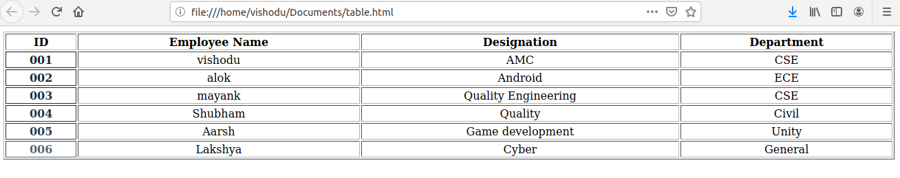
6. Why do we use meta tags?
Meta tag are important to be passed in a webpage for machine accessibility or SEO. These tags do not appear on the webpage but are used by web crawlers while scraping or searching.
The meta tags are used to specify page description, keywords, author of the document, last modified, and other metadata.
7. Explain box model.
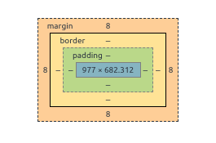

The CSS box model is basically a box that folds over each HTML component. It comprises of: margin, border, padding and content.
Content: The content that has been entered in the element
Padding: The differentiating area or the space between the content and border
Border: The border that goes around padding and content
Margin: The area outside the border. This is transparent
8. What are the different types of CSS Selectors?
- CSS Element Selector : The element selector selects the HTML element by name.
- CSS Id Selector: The id selector selects the id attribute of an HTML element to select a specific element. An id is always unique within the page so it is chosen to select a single, unique element.
- CSS Class Selector: The class selector selects HTML elements with a specific class attribute. It is used with a period character . (full stop symbol) followed by the class name.
- CSS Universal Selector: The universal selector is used as a wildcard character. It selects all the elements on the pages.
- CSS Group Selector: The grouping selector is used to select all the elements with the same style definitions.
9. Define Doctype.
Doctype is not an html language tag rather it instructs the web browser about what version of HTML will be used in the following code. This must be the very first thing that a developer must declare
Syntax: <!DOCTYPE HTML>

10. Explain 5 HTML5 semantic tags.
1- The <article> element specifies independent, self-contained content.
2- The <section> element defines a section in a document.
3- The <header> element specifies a header for a document or section.
4- The <footer> element specifies a footer for a document or section.
5- The <nav> element defines a set of navigation links.

