public class test1 {
public static void main(String[] args) {
int[] array = {9, 3, 6, 2, 1, 8, 4, 5, 7, 23};
Result result = findMaxMin(array, 0, array.length - 1);
System.out.println("最大值: " + result.max);
System.out.println("最小值: " + result.min);
}
// 定义一个类来保存最大值和最小值
static class Result {
int max;
int min;
Result(int max, int min) {
this.max = max;
this.min = min;
}
}
// 分治法寻找最大值和最小值
public static Result findMaxMin(int[] arr, int left, int right) {
// 如果数组中只有一个元素
if (left == right) {
return new Result(arr[left], arr[left]);
}
// 如果数组中有两个元素
if (right == left + 1) {
if (arr[left] < arr[right]) {
return new Result(arr[right], arr[left]);
} else {
return new Result(arr[left], arr[right]);
}
}
// 找到中间位置，将数组分成两半
int mid = (left + right) / 2;
Result leftResult = findMaxMin(arr, left, mid);
Result rightResult = findMaxMin(arr, mid + 1, right);
// 合并结果
int max = Math.max(leftResult.max, rightResult.max);
int min = Math.min(leftResult.min, rightResult.min);
return new Result(max, min);
}
}
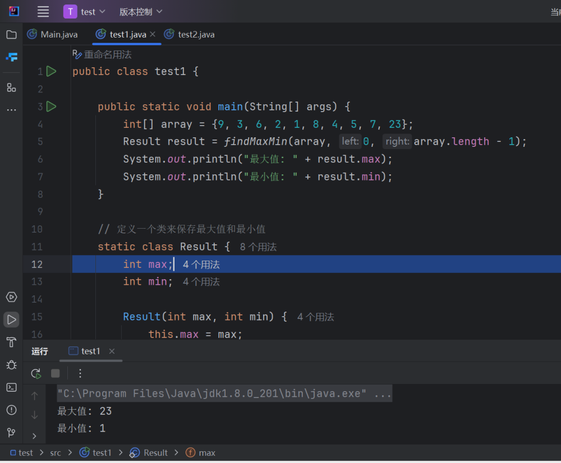
public class test2
{
public static void main(String[] args) {
int[] array = {9, 4, 6, 2, 5, 8, 4, 5, 6, 22};
quickSort(array, 0, array.length - 1);
System.out.println("排序后的数组:");
for (int num : array) {
System.out.print(num + " ");
}
}
public static void quickSort(int[] arr, int low, int high) {
if (low < high) {
int pivotIndex = partition(arr, low, high);
quickSort(arr, low, pivotIndex - 1); // 排序左子数组
quickSort(arr, pivotIndex + 1, high); // 排序右子数组
}
}
public static int partition(int[] arr, int low, int high) {
int pivot = arr[high]; // 选择最后一个元素作为基准
int i = low - 1; // 小于基准的元素的索引
for (int j = low; j < high; j++) {
if (arr[j] < pivot) {
i++;
swap(arr, i, j);
}
}
swap(arr, i + 1, high);
return i + 1;
}
public static void swap(int[] arr, int i, int j) {
int temp = arr[i];
arr[i] = arr[j];
arr[j] = temp;
}
}
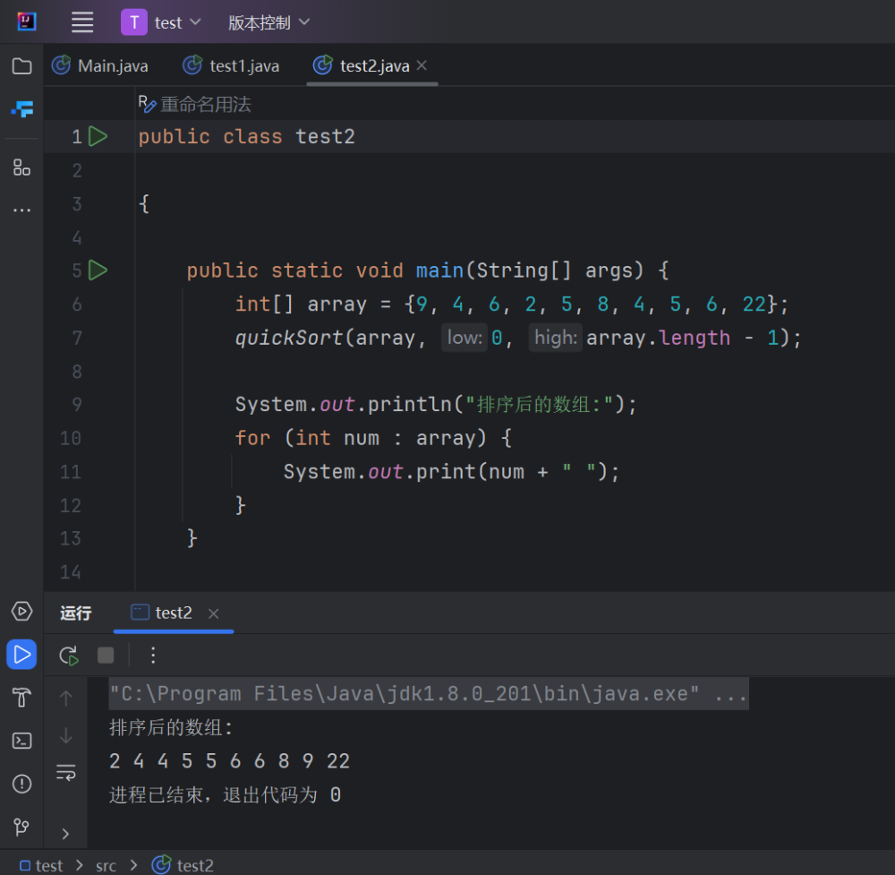
import java.util.Arrays;
import java.util.Comparator;
class Item {
int value;
int weight;
double density;
public Item(int value, int weight) {
this.value = value;
this.weight = weight;
this.density = (double) value / weight;
}
}
public class test3 {
public static void main(String[] args) {
int n = 5;
int M = 100;
int[] values = {20, 30, 66, 40, 60};
int[] weights = {10, 20, 30, 40, 50};
Item[] items = new Item[n];
for (int i = 0; i < n; i++) {
items[i] = new Item(values[i], weights[i]);
}
// 按照价值密度降序排序
Arrays.sort(items, new Comparator<Item>() {
@Override
public int compare(Item o1, Item o2) {
return Double.compare(o2.density, o1.density);
}
});
double totalValue = 0.0;
int remainingCapacity = M;
System.out.println("选择的物品：");
for (Item item : items) {
if (item.weight <= remainingCapacity) {
// 可以完全装入背包
totalValue += item.value;
remainingCapacity -= item.weight;
System.out.println("物品价值: " + item.value + ", 物品重量: " + item.weight);
} else {
// 部分装入背包
double fraction = (double) remainingCapacity / item.weight;
totalValue += item.value * fraction;
System.out.println("部分装入物品价值: " + (item.value * fraction) + ", 物品重量: " + remainingCapacity);
break;
}
}
System.out.println("最大价值: " + totalValue);
}
}
