实验二打印
int CreateGraph()
{
int point, edge;
cout << "请输入顶点和边的个数：" << endl;
cin >> point >> edge;
for (int i = 0; i < point; i++) { // 初始化边的权值
for (int j = 0; j < point; j++) {
node[i][j] = INF;
}
}
int weight;
for (int k = 0; k < edge; k++) {
int i, j;
cout << "请输入第" << k + 1 << "条边的两个顶点和权值：" << endl;
cin >> i >> j >> weight;
node[i][j] = weight;
}
return point;
}
// 求 n个顶点的多段图的最短路径
int Path(int n)
{
int i, j;
int cost[100], path[100]; // 存储路径长度和路径
for (i = 1; i < n; i++) {
cost[i] = INF; // 初始化
path[i] = -1;
}
cost[0] = 0;
path[0] = -1;
for (j = 1; j < n; j++) { // 前驱节点
for (i = j - 1; i >= 0; i--) {
if (cost[i] + node[i][j] < cost[j]) {
cost[j] = cost[i] + node[i][j]; // 更新值
path[j] = i; // 将i的值
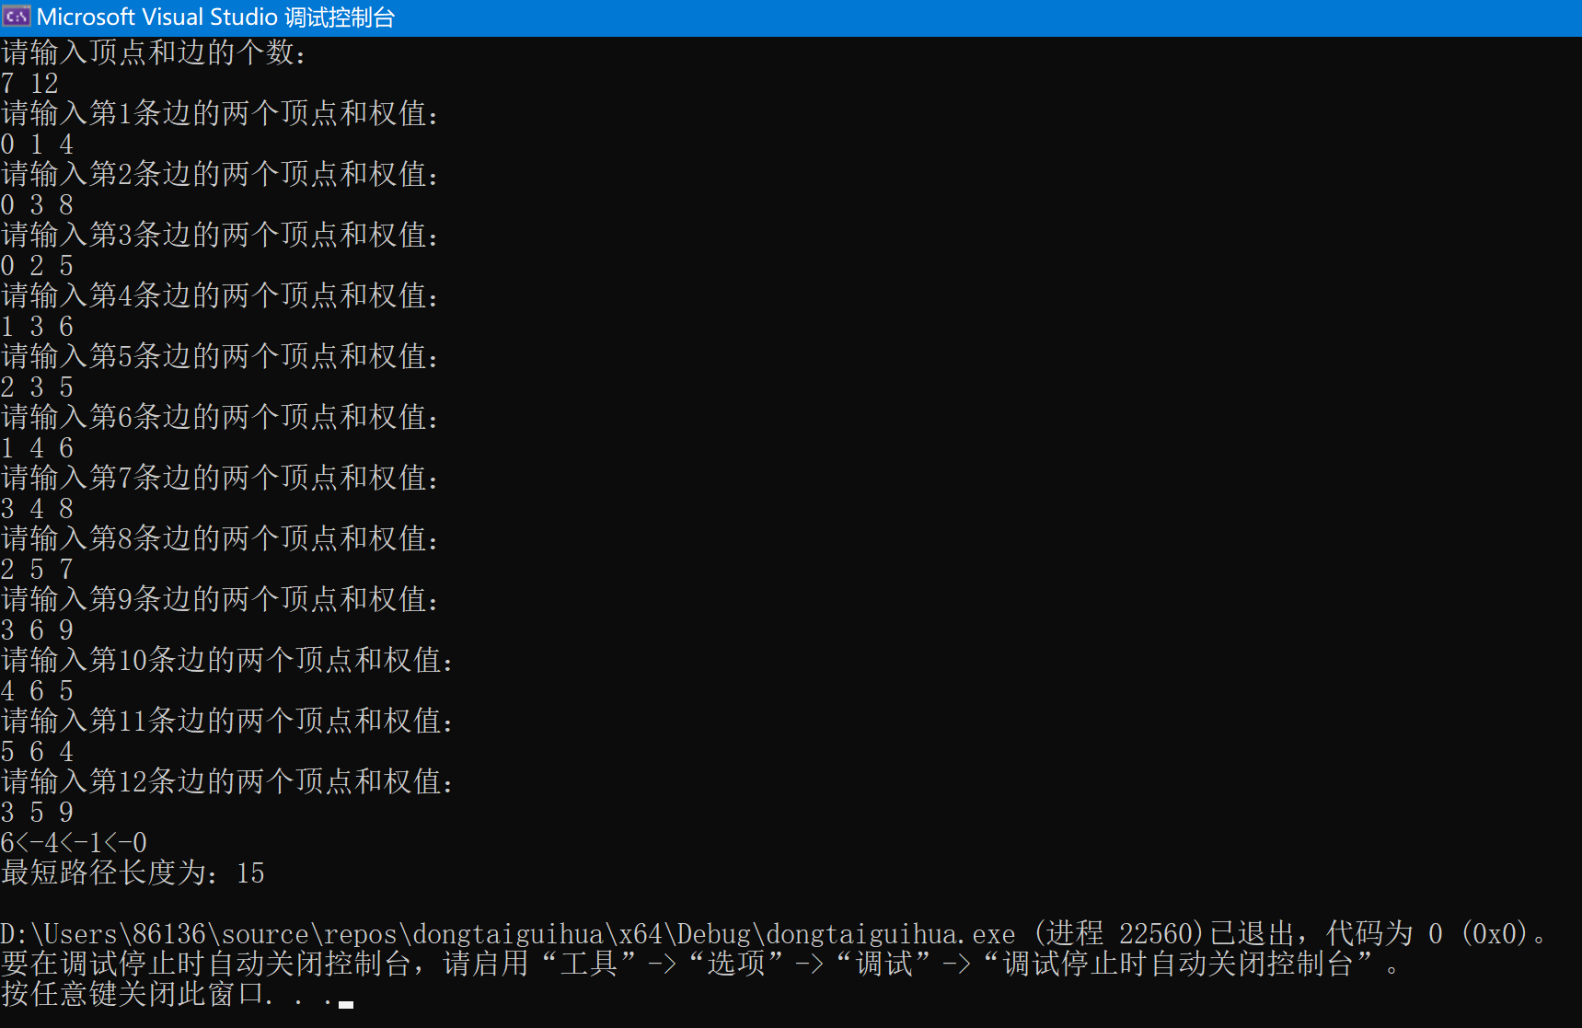

public class test21 {
private static final int N = 4; // 棋盘大小
private static int[] board = new int[N + 1]; // 存储每行皇后的列位置，索引从1开始
public static void main(String[] args) {
solveNQueens(1); // 从第1行开始放置皇后
}
// 检查当前位置是否可以放置皇后
private static boolean isSafe(int row, int col) {
for (int i = 1; i < row; i++) {
if (board[i] == col || Math.abs(board[i] - col) == Math.abs(i - row)) {
return false;
}
}
return true;
}
// 解决N皇后问题的核心函数
private static void solveNQueens(int row) {
for (int col = 1; col <= N; col++) {
if (isSafe(row, col)) {
board[row] = col; // 放置皇后
if (row == N) {
printSolution(); // 如果已经放置了所有皇后，打印解
} else {
solveNQueens(row + 1); // 继续放置下一行的皇后
}
}
}
}
// 打印当前解
private static void printSolution() {
for (int i = 1; i <= N; i++) {
for (int j = 1; j <= N; j++) {
if (board[i] == j) {
System.out.print("Q ");
} else {
System.out.print(". ");
}
}
System.out.println();
}
System.out.println();
}
}
