int CreateGraph()
{
int point, edge;
cout << "请输入顶点和边的个数：" << endl;
cin >> point >> edge;
for (int i = 0; i < point; i++) { // 初始化边的权值
for (int j = 0; j < point; j++) {
node[i][j] = INF;
}
}
int weight;
for (int k = 0; k < edge; k++) {
int i, j;
cout << "请输入第" << k + 1 << "条边的两个顶点和权值：" << endl;
cin >> i >> j >> weight;
node[i][j] = weight;
}
return point;
}
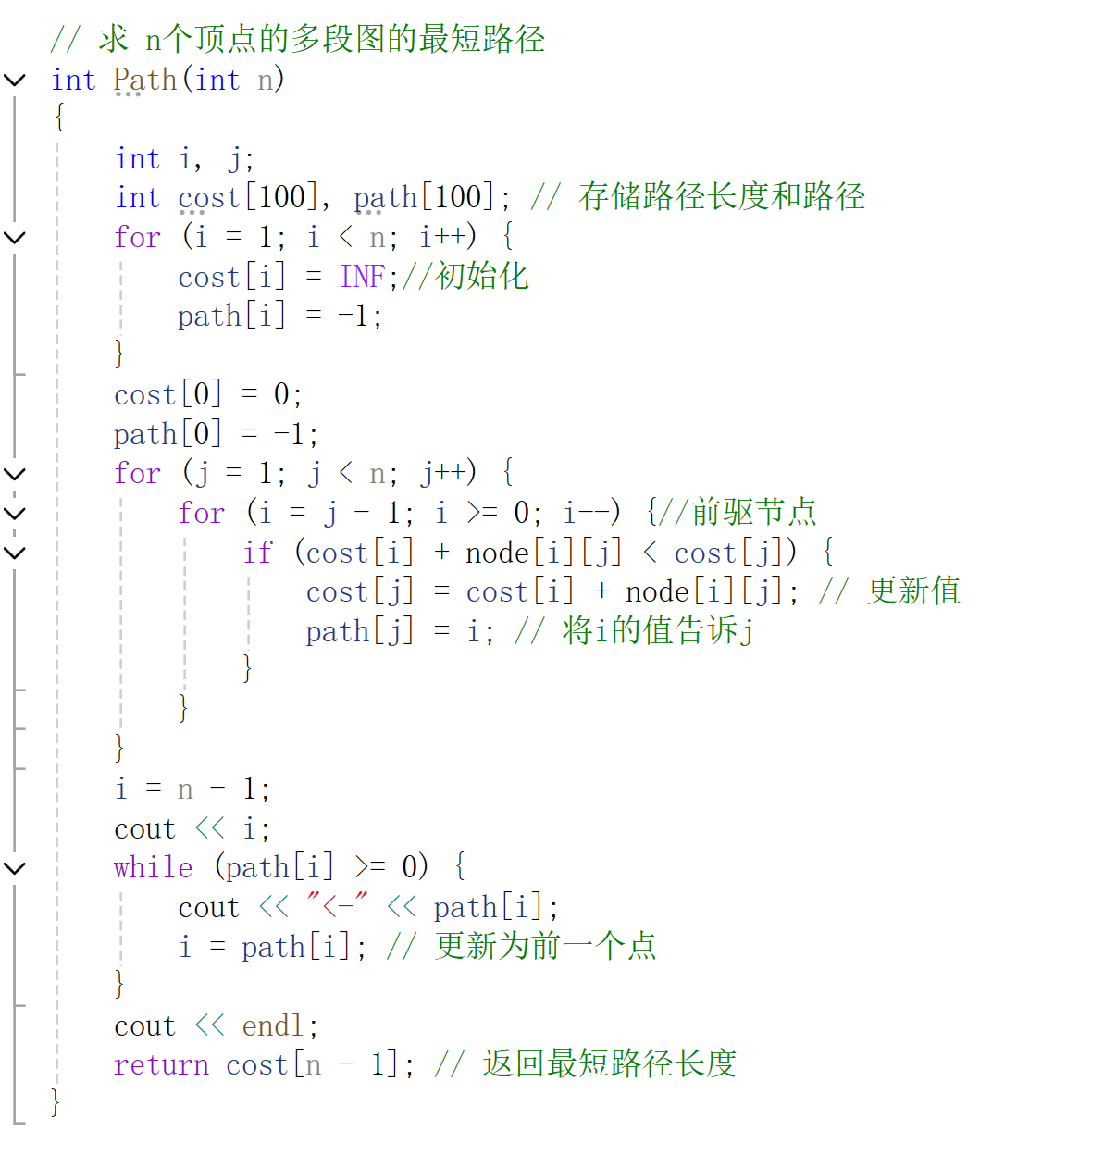
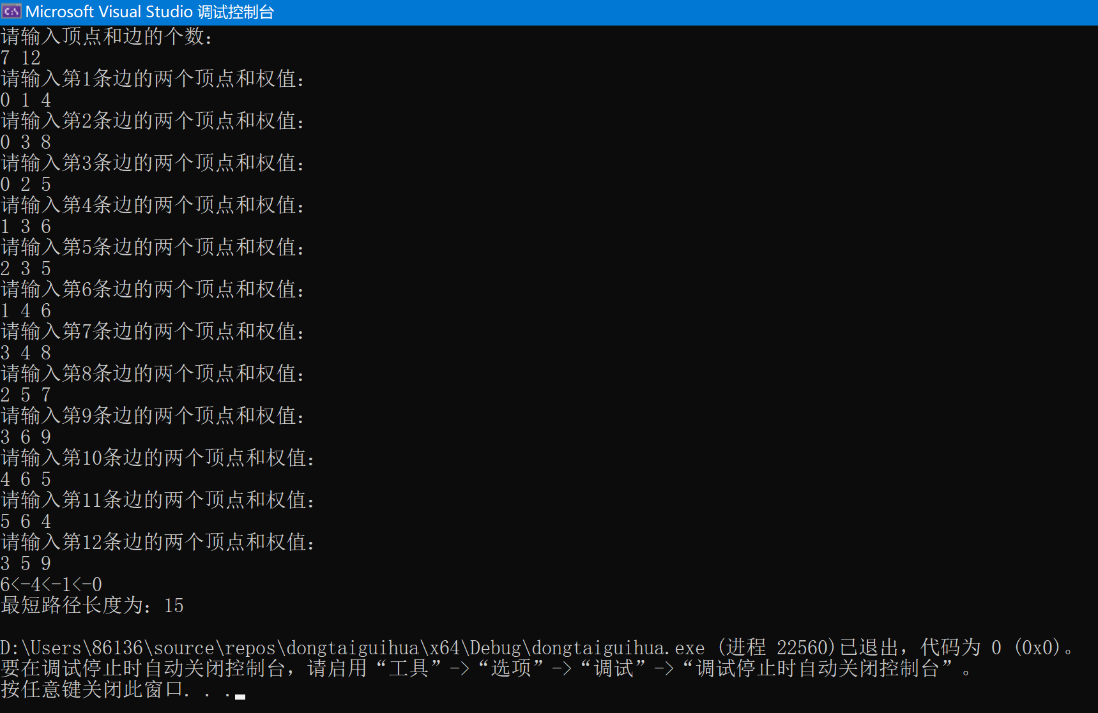
int is_correct(int i, int j, int (*Q)[4]){
int n, m = 0;
for (m = 0, n = i; m < 4; ++m){ //判断行，行不变，从第0 个元素开始找 如果有两个皇后，则返回0
if (Q[n][m] == 1 && m != j){
return 0;
}
}
for (m = j, n = 0; n < 4; ++n){ //判断列
if (Q[n][m] == 1 && n != i){
return 0;
}
}
for (n = i - 1, m = j - 1; m >= 0 && n >= 0; n--, m--){ //判断左上角
if (Q[n][m] == 1){
return 0;
}
}
for (n = i + 1, m = j - 1; m >= 0 && n < 4; n++, m--){ //判断左下角0
if (Q[n][m] == 1){
return 0;
}
}
for (n = i - 1, m = j + 1; m < 4 && n >= 0; n--, m++){ //判断右上角
if (Q[n][m] == 1){
return 0;
}
}
for (n = i + 1, m = j + 1; m < 4 && n < 4; n++, m++){ //判断右下角
if (Q[n][m] == 1){
return 0;
}
}
return 1; //所有条件满足则代表可以沿着该数继续往下搜索
}
void Queen(int j, int (*Q)[4])
{
int i = 0;
int k = 0;
//最后满足条件之后输出
if (j == 4){
for (i = 0; i < 4; i++){
for (j = 0; j < 4; j++){
printf("%d ", Q[i][j]);
}
printf("\n");
}
printf("\n");
count++;
return;
}
for (i = 0; i < 4; ++i){
if (is_correct(i, j, Q)){
//满足条件，置为1
Q[i][j] = 1;
//遍历列
Queen(j + 1, Q);
//该节点不满足条件，将该节点置为0
Q[i][j] = 0;
}
}
}
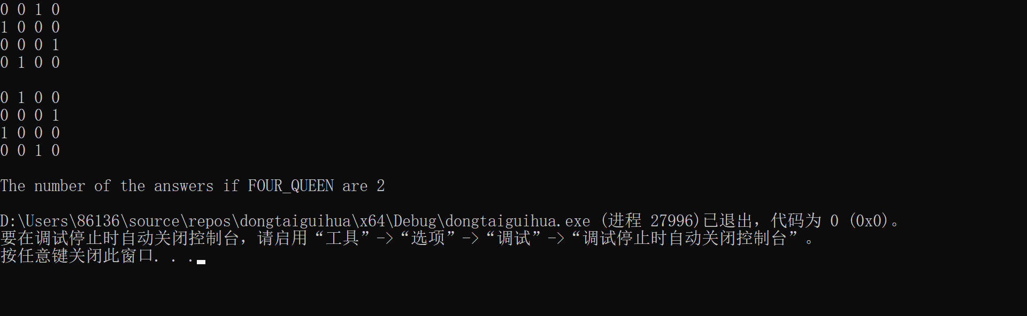
#include <iostream>
#include <cstring>
using namespace std;

const int maxn = 1005;
int G[maxn][maxn], color[maxn];//用于存储图中的边--用于存储每个节点的颜色
int n, m; //n表示图中节点的数量，m表示可供选择的颜色数目。

bool ok(int u, int c) {
for (int i = 1; i <= n; i++){
if (G[u][i] == 1 && color[i] == c)
return false;
}
return true;
}

bool dfs(int u) {
if (u > n)
return true;
for (int i = 1; i <= m; i++){
if (ok(u, i)){
color[u] = i;
if (dfs(u + 1))
return true;
color[u] = 0;
}
}
return false;
}

int main() {
memset(G, 0, sizeof(G)); //初始化邻接矩阵为0
memset(color, 0, sizeof(color));//初始化颜色为0
int e; //e表示图中边的数量
cout << "请输入顶点数和可用颜色数：" << endl;
cin >> n >> m;
cout << "请输入边数：" << endl;
cin >> e;
cout << "请输入相连接的顶点：" << endl; //顶点从1开始
for (int i = 0; i < e; i++){
int u, v;
cin >> u >> v;
G[u][v] = G[v][u] = 1;
}

if (dfs(1)){
for (int i = 1; i <= n; i++) //顶点从1开始
{
cout << "结点 " << i << " 的颜色为： " << color[i] << endl;
}
}
else
{
cout << "No solution" << endl;
}
return 0;
}
