X | Y | Cin | S | Cout | OF
00000000 | 00000000 | 0 | 00000000 | 0 | 0 | 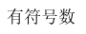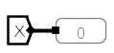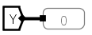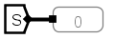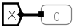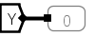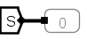
00000000 | 00000001 | 1 | 00000010 | 0 | 0 | 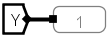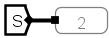
00000001 | 11111111 | 0 | 00000000 | 1 | 0 | 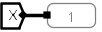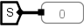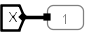
00000001 | 11111111 | 1 | 00000001 | 1 | 0 | 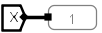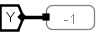
10000000 | 01111111 | 0 | 11111111 | 0 | 0 | 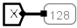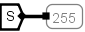
11111111 | 00000000 | 0 | 11111111 | 0 | 0
00000011 | 11000000 | 0 | 11000011 | 0 | 0 | 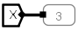

X | Y | Sub | S | CF | OF | ZF | SF
00000000  00000000  00000000  00000001 | 00000000  00000000  00000000  00000001 | 0 | 00000000  00000000  00000000  00000010 | 0 | 0 | 0 | 0 | 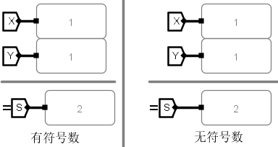
00000000  00000000  00000000  00000001 | 00000000  00000000  00000000  00000001 | 1 | 00000000  00000000  00000000  00000000 | 1 | 0 | 1 | 0 | 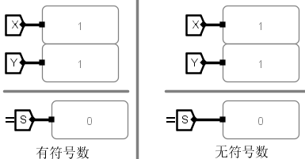
00000000  00000000  00000000  00000111 | 00000000  00000000  00000000  00001000 | 0 | 00000000  00000000  00000000  00001011 | 0 | 0 | 0 | 0 | 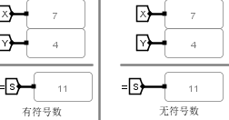
00000000  00000000  00000000  00000111 | 00000000  00000000  00000000  00001000 | 1 | 00000000  00000000  00000000  00000011 | 1 | 0 | 0 | 0 | 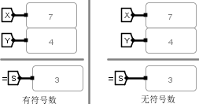
00000000  00000000  00000000  00000000 | 00000000  00000000  00000000  00000000 | 0 | 00000000  00000000  00000000  00000000 | 0 | 0 | 1 | 0 | 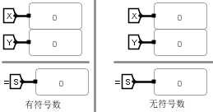
00000000  00000000  00000000  00000000 | 00000000  00000000  00000000  00000000 | 1 | 00000000  00000000  00000000  00000000 | 1 | 0 | 1 | 0 | 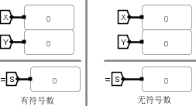
10000000  00000000  00000000  00000001 | 10000000  00000000  00000000  00000000 | 0 | 00000000  00000000  00000000  00000001 | 1 | 1 | 0 | 0 | 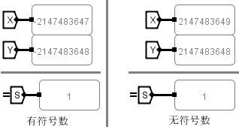
10000000  00000000  00000000  00000001 | 10000000  00000000  00000000  00000000 | 1 | 00000000  00000000  00000000  00000001 | 1 | 0 | 0 | 0 | 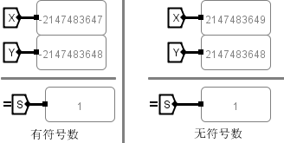
11111111  11111111  11111111  11111111 | 00000000  00000000  00000000  00000001 | 0 | 00000000  00000000  00000000  00000000 | 1 | 0 | 1 | 0 | 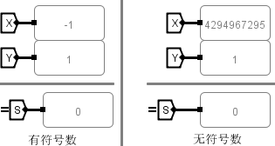
11111111  11111111  11111111  11111111 | 00000000  00000000  00000000  00000001 | 1 | 11111111  11111111  11111111  11111110 | 1 | 0 | 0 | 1 | 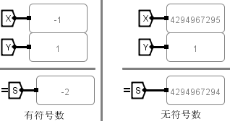
11111111  11111111  11111111  11111111 | 00000000  00000000  00000000  00000000 | 0 | 11111111  11111111  11111111  11111111 | 0 | 0 | 0 | 1 | 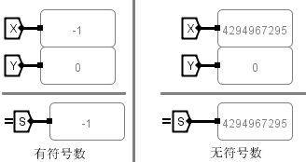
11111111  11111111  11111111  11111111 | 10000000  00000000  00000000  00000000 | 1 | 01111111  11111111  11111111  11111111 | 1 | 1 | 0 | 0 | 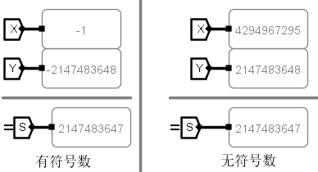
11111111  11111111  11111111  11111111 | 11111111  11111111  11111111  11111111 | 0 | 11111111  11111111  11111111  11111110 | 1 | 0 | 0 | 1 | 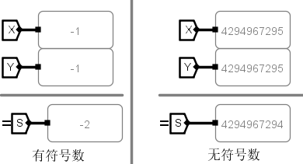
11111111  11111111  11111111  11111111 | 11111111  11111111  11111111  11111111 | 1 | 00000000  00000000  00000000  00000000 | 1 | 0 | 1 | 0 | 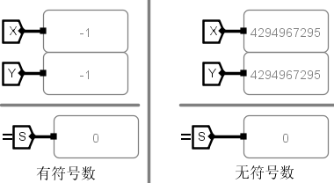

X | Y | AluOP | S | UOF | OF | ZF
00000000  00000000  00000000  00000001 | 00000000  00000000  00000000  00000000 | 000 | 00000000  00000000  00000000  00000001 | 0 | 0 | 0 | 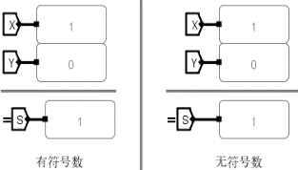
00000000  00000000  00000000  00000001 | 00000000  00000000  00000000  00000000 | 001 | 00000000  00000000  00000000  00000001 | 1 | 0 | 0 | 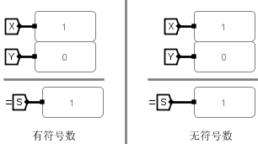
00000000  00000000  00000000  00000001 | 00000000  00000000  00000000  00000000 | 010 | 00000000  00000000  00000000  00000000 | 0 | 0 | 1 | 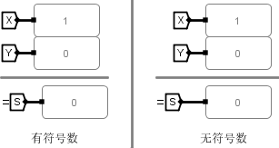
00000000  00000000  00000000  00000001 | 00000000  00000000  00000000  00000000 | 011 | 00000000  00000000  00000000  00000001 | 0 | 0 | 0 | 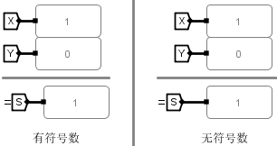
00000000  00000000  00000000  00000001 | 00000000  00000000  00000000  00000000 | 100 | 00000000  00000000  00000000  00000000 | 0 | 0 | 0 | 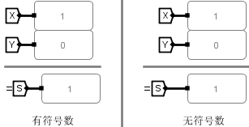
00000000  00000000  00000000  00000001 | 00000000  00000000  00000000  00000000 | 101 | 00000000  00000000  00000000  00000000 | 0 | 0 | 1 | 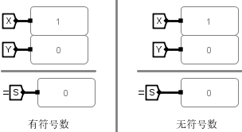
00000000  00000000  00000000  00000001 | 00000000  00000000  00000000  00000000 | 110 | 11111111  11111111  11111111  11111111 | 0 | 0 | 0 | 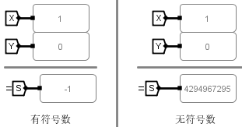
00000000  00000000  00000000  00000001 | 00000000  00000000  00000000  00000000 | 111 | 00000000  00000000  00000000  00000000 | 0 | 0 | 1 | 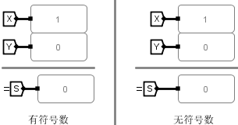
10000000  00000000  00000000  00000000 | 00000000  00000000  00000000  00000001 | 000 | 10000000  00000000  00000000  00000001 | 1 | 0 | 0 | 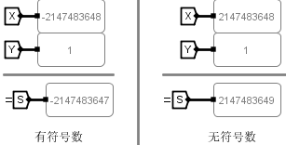
10000000  00000000  00000000  00000000 | 00000000  00000000  00000000  00000001 | 001 | 01111111  11111111  11111111  11111111 | 0 | 1 | 0 | 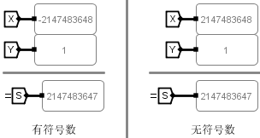
10000000  00000000  00000000  00000000 | 00000000  00000000  00000000  00000001 | 010 | 00000000  00000000  00000000  00000000 | 0 | 0 | 1 | 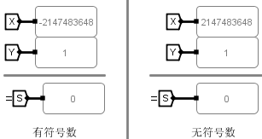
10000000  00000000  00000000  00000000 | 00000000  00000000  00000000  00000001 | 011 | 10000000  00000000  00000000  00000001 | 0 | 0 | 0 | 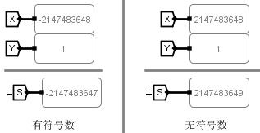
10000000  00000000  00000000  00000000 | 00000000  00000000  00000000  00000001 | 100 | 10000000  00000000  00000000  00000000 | 0 | 0 | 0 | 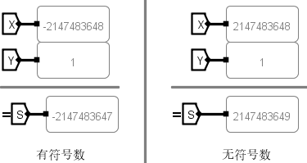
10000000  00000000  00000000  00000000 | 00000000  00000000  00000000  00000001 | 101 | 00000000  00000000  00000000  00000001 | 0 | 0 | 0 | 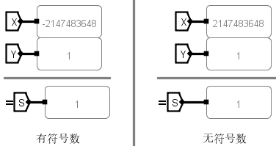
10000000  00000000  00000000  00000000 | 00000000  00000000  00000000  00000001 | 110 | 11111111  11111111  11111111  11111110 | 0 | 0 | 0 | 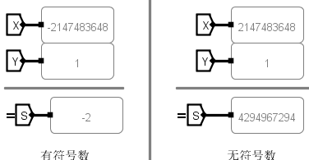
10000000  00000000  00000000  00000000 | 00000000  00000000  00000000  00000001 | 111 | 00000000  00000000  00000000  00000001 | 0 | 0 | 0 | 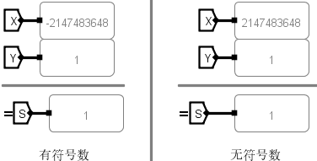

X | Y | S
00000001 | 00000001 | 00000000  00000001 | 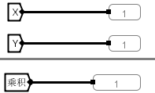
00000011 | 00000001 | 00000000  00000011 | 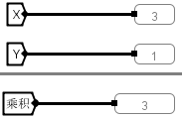
10000000 | 10000000 | 11000000  00000000 | 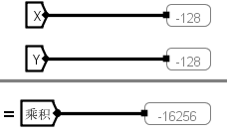
10000000 | 11111111 | 11100000  00000001 | 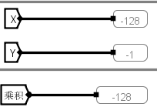
10000001 | 00000001 | 11100000  00000001 | 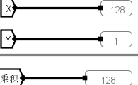
11111111 | 11111111 | 00000000  00000001 | 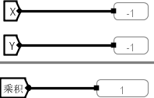
11111111 | 11111110 | 00000000  000000010 | 