**Coursera Capstone Project**

**Opening a New Pharmacy in Hanga Roa, Easter Island**

**By Aidar Kozhumov**

**Business Problem**

Hanga Roa is the main town, harbour and capital of Easter Island, a province of Chile. The population of 3,304 comprises 87 percent of the total population of the island. Easter Island is an island in the southeastern Pacific Ocean, at the southeasternmost point of the Polynesian Triangle in Oceania. Easter Island is most famous for its nearly 1,000 extant monumental statues, called moai, created by the early Rapa Nui people.

Considering that tourism is one of the most important industries in Easter Island, it is highly significant to provide safety and health care with the best quality and at full service to tourists.

The objective of this capstone project is to analyse how many pharmacies are there, and select the best locations in the city of Hanga Roa, Easter Island to open a new pharmacy. Using data science methodology, this project aims to provide solutions to answer the business question: is it necessary to open a new pharmacy in Hanga Roa and where to?

**Data Description**

* Data Requirements
  + Location Information (name, country, etc.)
  + Venue Information (name, category, coordinates)
* Data Sources
  + Wikipedia
  + Foursqaure.com
* Data Processing
  + Data cleaning is required
  + Data needs to be in a structured format

**Result**

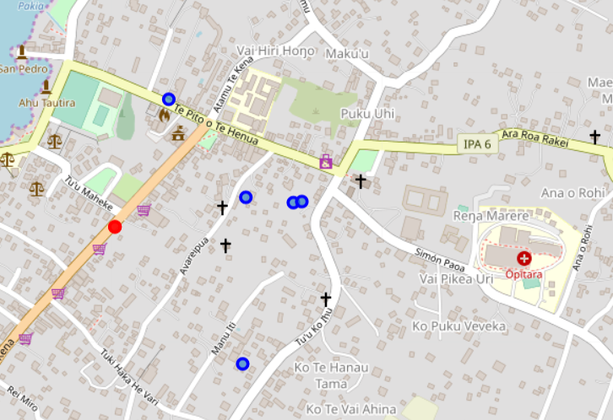

According to Foursquare API data, there are five hotels (blue) in Hanga Roa and only one pharmacy (red). The average distance between this farmacy and the hotels is 200-300 meters.

**Conclusion**

* Only one pharmacy for 3000 native people is enough, but considering tourist arrivals it would be a great decision to open a new one
* This new pharmacy should be opened near those 5 hotels as much close as possible. The best possible location is at the junction of Atamu Te Kena and Te Pito o Te henua streets due to minimum average distance between this locations and the hotels.
* The new pharmacy should be opened 24/7 considering that another pharmacy opens at 8:30 AM and closes at 10:00 PM (Google Map info).